KENYA CERTIFICATE OF BASIC EDUCATION

SENIOR SCHOOL ASSESSMENT

DECEMBER ASSIGNMENT 2026
GRADE 10 – THEATRE AND FILM
Time: 2 Hours
LEARNER’S DETAILS
Name: _____________________________________________________________. School: ____________________________________________.
Assessment Number: _______________________________________________. Date: ____________________________________________.
School Code: ______________________________________________________. Signature: _______________________________________.

INSTRUCTIONS TO CANDIDATES
- Write all the details as required above.
- This paper consists of two sections: A and B.
- Answer all questions in section A and section B.
- Answer the questions in English.
- All answers MUST be written in the spaces provided in the paper.
- Do NOT remove any page from this question paper.

FOR OFFICIAL USE ONLY (EXAMINER’S USE)
SECTION | SECTION A | SECTION B | % SCORE | EE1 | EE2 | ME1 | ME2 | AE1 | AE2 | BE1 | BE2
SCORE RANGE | 30 MARKS | 50 MARKS |  | 90-100 | 75-89 | 58-74 | 41-57 | 31-40 | 21-30 | 11-20 | 1-10
POINTS |  |  |  | 8 POINTS | 7 POINTS | 6 POINTS | 5 POINTS | 4 POINTS | 3 POINTS | 2 POINTS | 1 POINT
LEARNER’S TOTAL SCORE

SECTION A (30 MARKS)
Answer ALL questions in this section.
  - a) What is meant by the term theatre? (1 mark) ________________________________________________________________________________________________________________________________________________________________________________________
b) Define film as a form of artistic expression. (1 mark) ______________________________________________________________________________________________________________________________________________________________________________________________
c) State one similarity between theatre and film. (1 mark)
______________________________________________________________________________________________________________________________________________________________________________________________
d) State two differences between live theatre and film production. (2 marks)
Live Theatre | Film Production
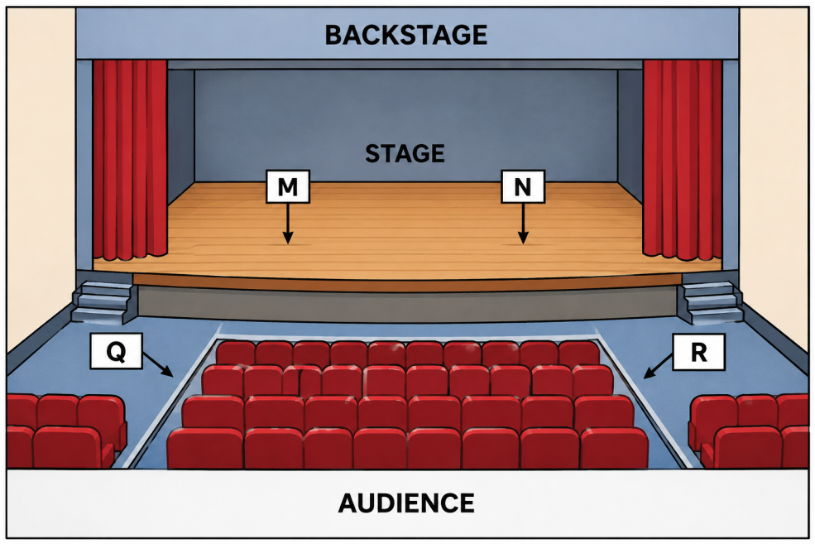
  - Study the stage diagram below.

a) Identify the stage position labelled M. ____________________________ (1 mark)
b) Identify the stage position labelled N. _____________________________ (1 mark)
c) Identify the two areas labelled Q and R. (2 marks)
Q: _________________________________________
R: _________________________________________
d) State one reason why actors need to understand stage directions. (1 mark)
______________________________________________________________________________________________________________________________________________________________________________________________

a) What is a costume in theatre? (1 mark)
______________________________________________________________________________________________________________________________________________________________________________________________
b) State two functions of costume in a theatrical production. (2 marks)
- _________________________________________________________________________________________
- _________________________________________________________________________________________

c) State two factors that a make-up artist should consider when preparing an actor for a performance. (2 marks)
- _________________________________________________________________________________________
- _________________________________________________________________________________________

Study the simplified camera illustrations below.
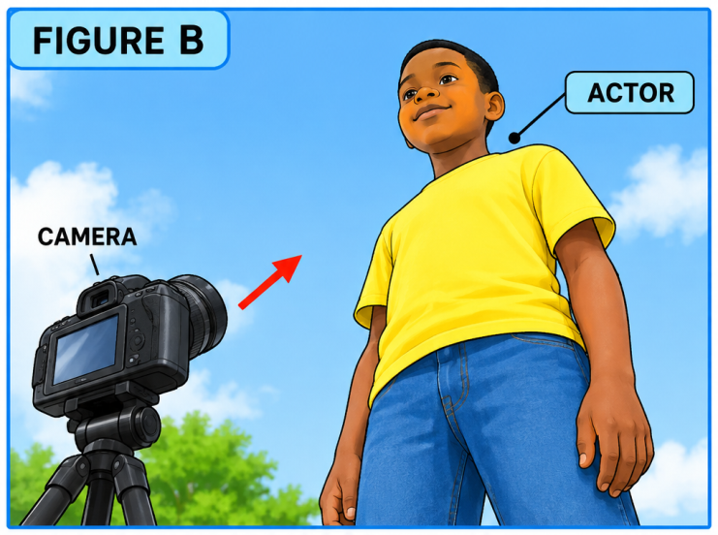
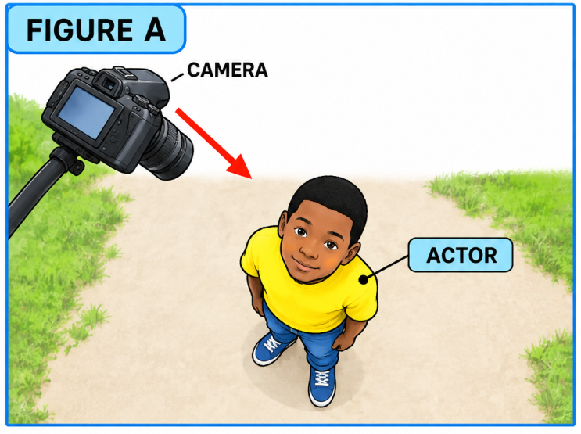
a) State the camera position represented in Figure A. _______________________________ (1 mark)
b) State the camera position represented in Figure B. _______________________________ (1 mark)
c) Name one type of camera shot that can be used to show the entire body of an actor. (1 mark)
______________________________________________________________________________________________________________________________________________________________________________________________
d) Give two reasons why camera angles are important in film production. (2 marks)
- _________________________________________________________________________________________
- _________________________________________________________________________________________
  - a) What is a rehearsal? (1 mark)
______________________________________________________________________________________________________________________________________________________________________________________________
b) State two activities that actors may undertake during rehearsals. (2 marks)
- _________________________________________________________________________________________
- _________________________________________________________________________________________
c) Give two reasons why rehearsals are important before a theatrical performance. (2 marks)
- _________________________________________________________________________________________
- _________________________________________________________________________________________
  - a) State one safety precaution when handling electrical theatre equipment. (1 mark)
________________________________________________________________________________________________________________________________________________________________________________________
b) Give two safety precautions to observe when constructing or arranging a stage set. (2 marks)
- _________________________________________________________________________________________
- _________________________________________________________________________________________
c) State two ethical practices that should be observed when producing a theatre or film production involving members of the community. (2 marks)
- _________________________________________________________________________________________
- _________________________________________________________________________________________

SECTION B: 50 MARKS
Answer ALL questions.
- Read the following extract and answer the questions that follow.
MAYA: Why did you leave the meeting without telling anyone?
KELVIN: I was afraid they would laugh at my idea.
MAYA: An idea cannot help anyone if you keep it hidden.
KELVIN: Perhaps you are right. I will speak to them tomorrow.
(Maya walks towards Kelvin and places a hand on his shoulder.)
a) Identify the two characters in the extract. (2 marks)
- _________________________________________________________________________________________
- _________________________________________________________________________________________
b) State the setting that could appropriately be used for this scene. Give a reason for your choice. (2 marks)
______________________________________________________________________________________________________________________________________________________________________________________________
c) Identify one stage direction contained in the extract. (1 mark)
_________________________________________________________________________________________
d) State the main conflict presented in the extract. (2 marks)
______________________________________________________________________________________________________________________________________________________________________________________________
e) Describe three ways in which an actor playing Kelvin could portray his emotions effectively. (3 marks)
- _________________________________________________________________________________________
- _________________________________________________________________________________________
- _________________________________________________________________________________________

- You have been appointed the director of a school play with six actors.
a) Define blocking in theatre. (2 marks)
_____________________________________________________________________________________________________________________________________________________________________________________________
b) State three factors you would consider when positioning actors on stage. (3 marks)
- _________________________________________________________________________________________
- _________________________________________________________________________________________
- _________________________________________________________________________________________
c) Explain two ways through which effective blocking improves a performance. (2 marks)
- _________________________________________________________________________________________
- _________________________________________________________________________________________
d) State three responsibilities of a theatre director during rehearsals. (3 marks)
- _________________________________________________________________________________________
- _________________________________________________________________________________________
- _________________________________________________________________________________________
- Your school is preparing a play set in a traditional Kenyan village.
a) Suggest two suitable stage-set features for the production. (2 marks)
- _________________________________________________________________________________________
- _________________________________________________________________________________________
b) Suggest two appropriate costume features for the characters. (2 marks)
- _________________________________________________________________________________________
- _________________________________________________________________________________________
c) Give two suitable props that could be used in the production. (2 marks)
- _________________________________________________________________________________________
- _________________________________________________________________________________________
d) State two ways of creating the appropriate atmosphere through lighting. (2 marks)
- _________________________________________________________________________________________
- _________________________________________________________________________________________
e) Explain two ways of using locally available materials in the production without compromising safety or artistic quality. (2 marks)
- _________________________________________________________________________________________
- _________________________________________________________________________________________
- A group of learners has decided to produce a five-minute short film about responsible use of social media.
a) State two activities involved in pre-production. (2 marks)
- _________________________________________________________________________________________
- _________________________________________________________________________________________
b) State two activities undertaken during production. (2 marks)
- _________________________________________________________________________________________
- _________________________________________________________________________________________
c) State two activities undertaken during post-production. (2 marks)
- _________________________________________________________________________________________
- _________________________________________________________________________________________
d) Explain two reasons why a storyboard is useful in film production. (2 marks)
- _________________________________________________________________________________________
- _________________________________________________________________________________________
e) State two ways of ensuring good-quality sound during filming. (2 marks)
- _________________________________________________________________________________________
- _________________________________________________________________________________________
- Your school has been invited to perform a short community theatre production on the importance of preserving Kenya's cultural heritage.
a) Identify two cultural aspects that could be incorporated into the performance. (2 marks)
- _________________________________________________________________________________________
- _________________________________________________________________________________________
b) State two methods of involving the community in developing the production. (2 marks)
- _________________________________________________________________________________________
- _________________________________________________________________________________________
c) Explain two ways theatre can help preserve cultural heritage. (2 marks)
- _________________________________________________________________________________________
- _________________________________________________________________________________________
d) Suggest two performance techniques that would make the production attractive to the audience. (2 marks)
- _________________________________________________________________________________________
- _________________________________________________________________________________________

e) State two ways of evaluating the success of the performance after presentation. (2 marks)
- _________________________________________________________________________________________
- _________________________________________________________________________________________

THIS IS THE LAST PRINTED PAGE

GRADE 10 THEATRE AND FILM TECHNOLOGY

MARKING SCHEME / ANSWERS
General instruction: Award any other correct, relevant and well-explained response. Do not penalise a learner for using a valid alternative term where the meaning is correct.

SECTION A: 30 MARKS

1
a) What is theatre?
Theatre is the art of presenting stories, ideas or experiences through live performance by actors before an audience.
(1 mark)
b) Define film.
Film is a recorded visual and/or audio-visual production that uses moving images, sound and other techniques to communicate a story, idea or message.
(1 mark)
c) One similarity between theatre and film:
Any one:
- Both use actors to portray characters.
- Both communicate stories, ideas or messages.
- Both use scripts.
- Both may use costumes, make-up, props, sound and lighting.
- Both are forms of artistic expression.
(1 mark)
d) Two differences between live theatre and film:
Any two:
Live theatre | Film
Performed live before an audience. | Recorded and viewed later.
Actors perform continuously on stage. | Scenes can be edited and rearranged.
Performance takes place in a stage environment. | Can be filmed in many locations.
Mistakes may not be easily corrected during a live performance. | Mistakes can be corrected through editing or retakes.
Audience interaction is usually immediate. | Audience interaction is generally indirect.
1 mark each = 2 marks

2
a) Position A:
Centre stage.
(1 mark)
b) Position B:
Centre stage/right side of the stage depending on the learner's interpretation of the diagram.
(1 mark)
Accept: Stage right where the learner correctly identifies the position from the actor's perspective.
c) C and D:
- C – Stage left
- D – Stage right
(1 mark each = 2 marks)
d) One reason actors need to understand stage directions:
Any one:
- To know where to move or stand.
- To maintain correct positioning.
- To coordinate movements with other actors.
- To improve audience visibility.
- To follow the director's instructions.
- To maintain continuity of the performance.
(1 mark)

3
a) What is a costume?
A costume is clothing and accessories worn by an actor to represent a particular character in a theatrical or film production.
(1 mark)
b) Two functions of costume:
Any two:
- Identifies the character.
- Shows the character's occupation or social status.
- Indicates the period or setting.
- Helps communicate personality.
- Enhances the visual appearance of the production.
- Helps establish cultural identity.
- Supports characterisation.
1 mark each = 2 marks
c) Two factors to consider when preparing make-up:
Any two:
- Character requirements.
- Lighting conditions.
- Skin safety.
- Age of the character.
- Setting/period of the production.
- Type of performance.
- Distance between performer and audience/camera.
- Type and quality of make-up materials.
1 mark each = 2 marks

4
a) Figure A:
Low-angle camera position/shot — where the camera is positioned below the subject and points upward.
(1 mark)
b) Figure B:
High-angle camera position/shot — where the camera is positioned above the subject and points downward.
(1 mark)
c) Type of shot showing the entire body:
Full shot/full-length shot.
(1 mark)
d) Two reasons camera angles are important:
Any two:
- Influence how the audience perceives a character.
- Create particular moods or effects.
- Show power or weakness.
- Direct audience attention.
- Improve visual storytelling.
- Provide different perspectives.
- Help establish relationships between characters and their surroundings.
1 mark each = 2 marks

5
a) Meaning of rehearsal:
A rehearsal is a practice session in which performers and the production team prepare and practise a performance before the actual presentation.
(1 mark)
b) Two activities during rehearsal:
Any two:
- Practising dialogue.
- Practising movements/blocking.
- Practising voice projection.
- Practising characterisation.
- Practising entrances and exits.
- Testing props and costumes.
- Practising lighting and sound cues.
- Receiving direction and corrections.
1 mark each = 2 marks
c) Two reasons rehearsals are important:
Any two:
- Improve performers' confidence.
- Help actors memorize lines.
- Correct mistakes.
- Improve coordination.
- Perfect stage movements.
- Test technical equipment.
- Improve timing.
- Help the director refine the performance.
1 mark each = 2 marks

6
a) One safety precaution when handling electrical equipment:
Any one:
- Keep electrical equipment away from water.
- Switch off equipment before making connections.
- Avoid touching electrical equipment with wet hands.
- Check cables for damage.
- Use properly installed electrical connections.
- Avoid overloading sockets.
(1 mark)
b) Two stage-set safety precautions:
Any two:
- Secure all structures properly.
- Keep walkways and exits clear.
- Avoid unstable structures.
- Use appropriate materials.
- Remove sharp or dangerous objects.
- Ensure props and set pieces cannot easily fall.
- Provide adequate lighting backstage.
- Avoid obstructing emergency exits.
1 mark each = 2 marks
c) Two ethical practices:
Any two:
- Obtain consent from participants.
- Respect people's privacy.
- Avoid discriminatory or offensive representation.
- Give credit to creators where appropriate.
- Avoid exploiting community members.
- Respect cultural practices.
- Obtain permission before recording people.
- Represent people and communities accurately and respectfully.
1 mark each = 2 marks

SECTION B 50 MARKS

7
a) Two characters:
- Maya
- Kelvin
1 mark each = 2 marks
b) Suitable setting and reason:
Possible answer:
Setting: School compound, classroom or school meeting area.
Reason: The characters could reasonably be discussing an idea related to a school activity or meeting.
2 marks
Award:
- Suitable setting – 1 mark
- Relevant reason – 1 mark
c) One stage direction:
“Maya walks towards Kelvin and places a hand on his shoulder.”
(1 mark)
d) Main conflict:
Kelvin is afraid of presenting/sharing his idea because he fears being laughed at, while Maya encourages him to express his idea.
2 marks
e) Three ways Kelvin could portray his emotions:
Any three:
- Use a hesitant or trembling voice.
- Avoid eye contact.
- Lower his head.
- Use nervous movements.
- Fidget with his hands.
- Use an anxious facial expression.
- Speak slowly or pause frequently.
- Adopt a withdrawn body posture.
1 mark each = 3 marks

8
a) Define blocking:
Blocking is the planned positioning and movement of actors on stage during a performance.
2 marks
Award:
- Planned positioning – 1 mark
- Movement of actors during performance – 1 mark
b) Three factors when positioning actors:
Any three:
- Audience visibility.
- Character relationships.
- Stage space.
- Lighting.
- Props and set.
- Movement requirements.
- Voice audibility.
- Safety.
- Dramatic effect.
- Camera position where applicable.
1 mark each = 3 marks
c) Two ways effective blocking improves performance:
Any two explained:
- Ensures actors are visible to the audience.
- Prevents actors from obstructing one another.
- Creates smooth movement.
- Strengthens dramatic action.
- Helps communicate relationships between characters.
- Improves coordination.
- Makes the production visually appealing.
1 mark each = 2 marks
d) Three responsibilities of a director during rehearsals:
Any three:
- Guide actors in character interpretation.
- Plan and correct blocking.
- Organise rehearsals.
- Interpret the script.
- Coordinate the technical team.
- Give actors feedback.
- Ensure appropriate use of props and costumes.
- Ensure the production communicates its intended message.
- Maintain discipline and teamwork.
1 mark each = 3 marks

9
The production is set in a traditional Kenyan village.
a) Two suitable stage-set features:
Any two:
- Traditional homestead.
- Hut.
- Fence.
- Village pathway.
- Cooking area.
- Traditional meeting area.
- Trees/plants.
- Traditional stools.
1 mark each = 2 marks
b) Two appropriate costume features:
Any two:
- Traditional fabrics.
- Appropriate cultural clothing.
- Traditional accessories.
- Beads.
- Headgear.
- Shawls/wrappings.
- Clothing appropriate to the selected community and historical period.
1 mark each = 2 marks
c) Two suitable props:
Any two:
- Traditional baskets.
- Calabashes.
- Stools.
- Farming tools.
- Cooking utensils.
- Walking sticks.
- Traditional musical instruments.
- Woven containers.
1 mark each = 2 marks
d) Two ways of creating atmosphere through lighting:
Any two:
- Use warm lighting to create a welcoming village atmosphere.
- Use dim lighting to represent evening/night.
- Use brighter lighting to represent daytime.
- Use focused lighting to draw attention to an important activity.
- Use changing intensity to create mood.
1 mark each = 2 marks
e) Two ways of using locally available materials safely:
Any two well-explained:
- Use reeds, cardboard or fabric to create scenery.
- Use recycled containers as props.
- Use locally available fabrics for costumes.
- Reuse safe household objects as props.
- Use natural materials that are clean, dry and structurally safe.
- Borrow materials from the community instead of purchasing them.
1 mark each = 2 marks

10
a) Two pre-production activities:
Any two:
- Scriptwriting.
- Storyboarding.
- Casting.
- Location scouting.
- Budgeting.
- Scheduling.
- Rehearsals.
- Obtaining filming permissions.
- Preparing equipment.
1 mark each = 2 marks
b) Two production activities:
Any two:
- Camera operation.
- Recording scenes.
- Directing actors.
- Recording sound.
- Setting up lighting.
- Capturing different shots.
- Monitoring performances.
1 mark each = 2 marks
c) Two post-production activities:
Any two:
- Video editing.
- Sound editing.
- Adding music.
- Adding titles/credits.
- Colour correction.
- Adding visual effects.
- Reviewing and exporting the final film.
1 mark each = 2 marks
d) Two reasons a storyboard is useful:
Any two:
- Provides a visual plan of scenes.
- Shows planned shots and camera angles.
- Helps organise the sequence of events.
- Helps the director communicate ideas to the production team.
- Saves time during filming.
- Helps identify required locations, props and actors.
- Reduces unnecessary retakes.
1 mark each = 2 marks
e) Two ways of ensuring good sound:
Any two:
- Use appropriate microphones.
- Position microphones correctly.
- Reduce background noise.
- Monitor sound levels during recording.
- Check cables and connections.
- Record in a suitable quiet location.
- Conduct sound tests before filming.
- Keep microphones at an appropriate distance from performers.
1 mark each = 2 marks

11
a) Two cultural aspects:
Any two:
- Traditional music.
- Traditional dance.
- Folklore.
- Traditional costumes.
- Traditional language.
- Oral narratives.
- Traditional instruments.
- Cultural ceremonies.
- Traditional games.
- Indigenous knowledge.
1 mark each = 2 marks
b) Two methods of involving the community:
Any two:
- Conduct interviews with community elders.
- Invite community members to share stories.
- Consult cultural experts.
- Involve local performers.
- Organise community discussions.
- Collect traditional songs and narratives.
- Invite community members to review the script.
- Allow community participation in the performance.
1 mark each = 2 marks
c) Two ways theatre preserves cultural heritage:
Any two explained:
- Passes traditional stories from one generation to another.
- Preserves traditional songs, dances and language.
- Documents cultural practices through performance.
- Educates young people about their heritage.
- Creates opportunities for elders to share knowledge.
- Promotes appreciation of cultural identity.
1 mark each = 2 marks
d) Two performance techniques:
Any two:
- Use of music.
- Dance.
- Storytelling.
- Effective voice projection.
- Audience participation.
- Humour.
- Gestures.
- Facial expressions.
- Appropriate costumes.
- Use of dramatic movement.
- Call-and-response.
1 mark each = 2 marks
e) Two methods of evaluating success:
Any two:
- Obtain audience feedback.
- Conduct interviews.
- Use questionnaires.
- Ask questions after the performance.
- Observe audience participation.
- Hold a production-team evaluation meeting.
- Assess whether the intended message was understood.
- Compare the performance against its objectives.
1 mark each = 2 marks

KENYA CERTIFICATE OF BASIC EDUCATION

SENIOR SCHOOL ASSESSMENT

TERM 3: EPROJECT BASED ASSESSMENT 2026
GRADE 10 – THEATRE AND FILM
Time: 2 Hours
LEARNER’S DETAILS
Name: _____________________________________________________________. School: ____________________________________________.
Assessment Number: _______________________________________________. Date: ____________________________________________.
School Code: ______________________________________________________. Signature: _______________________________________.

PROJECT TITLE

CREATE, REHEARSE AND PRESENT A SHORT THEATRE OR FILM PRODUCTION

PROJECT SCENARIO
Your school has identified a contemporary issue affecting young people and the community. As a Grade 10 Theatre and Film learner, you are required to work individually or in a small production group to develop and present a short creative production.
The production should communicate a clear message and demonstrate appropriate use of scriptwriting, acting, directing, theatre/film technology and production design.
Learners may choose ONE of the following themes:
- Environmental conservation.
- Responsible use of social media.
- Peer pressure.
- Cyberbullying.
- Preservation of Kenyan cultural heritage.
- Road safety.
- Respect and peaceful coexistence.
- Entrepreneurship among young people.
- Responsible use of technology.
- Any other relevant contemporary community issue approved by the teacher.

TASK REQUIREMENTS

A. SCRIPT/CONCEPT DEVELOPMENT
Prepare a short script or production concept containing:
- Title
- Theme/topic
- Characters
- Setting/location
- Plot/storyline
- Dialogue or narration
- Intended message
For a film project, the learner should additionally prepare a simple storyboard or shot plan.

B. PRODUCTION
Produce a 5–10 minute presentation.
The learner/group may choose either:

OPTION 1: THEATRE PRODUCTION
Present a short live theatrical performance using:
- Acting
- Dialogue
- Characterisation
- Voice
- Movement
- Costumes
- Make-up where appropriate
- Props
- Stage/set
- Lighting and/or sound

OPTION 2: SHORT FILM
Produce a short film using:
- Script
- Camera
- Appropriate shots
- Camera angles
- Acting
- Sound
- Lighting
- Editing
- Titles/credits

C. LEARNER'S PROJECT REPORT
Each learner should submit a brief report containing:

1. Project title

2. Purpose of the production

3. Theme/message

4. Characters and their roles

5. Production resources used

6. Production process

7. Challenges encountered

8. How the challenges were solved

9. What the learner learnt

10. Recommendations for improvement

ASSESSMENT RUBRIC – 20 MARKS
Assessment area | Performance indicator | Marks
1. Concept and theme | Clear, relevant and well-developed theme/message | 2
2. Script/story development | Coherent storyline, appropriate characters and dialogue/narration | 3
3. Acting/characterisation | Convincing portrayal of characters using voice, movement and expression | 3
4. Directing/organisation | Effective coordination, blocking, sequencing and teamwork | 2
5. Theatre/film technology | Appropriate use of camera, sound, lighting or other production technology | 3
6. Production design | Effective use of costumes, make-up, props, set or location | 2
7. Creativity and innovation | Original ideas and effective use of available/local resources | 2
8. Production report/reflection | Clear documentation, challenges, solutions and learning outcomes | 2
9. Presentation discipline | Time management, preparedness, safety and professional conduct | 1
TOTAL |  | 20

MARKING GUIDE

1. CONCEPT AND THEME – 2 MARKS
2 marks: Theme is highly relevant, clearly communicated and appropriate for the target audience.
1 mark: Theme is relevant but insufficiently developed.
0 marks: Theme is unclear or inappropriate.

2. SCRIPT/STORY DEVELOPMENT – 3 MARKS
Award:
- 1 mark – Clear beginning/introduction.
- 1 mark – Logical development/conflict.
- 1 mark – Appropriate conclusion/resolution.
For film, the storyboard/shot plan may be considered as part of this criterion.

3. ACTING/CHARACTERISATION – 3 MARKS
Award:
- 1 mark – Appropriate use of voice.
- 1 mark – Effective movement/body language.
- 1 mark – Convincing characterisation and emotional expression.

4. DIRECTING/ORGANISATION – 2 MARKS
Award:
- 1 mark – Effective organisation and sequencing.
- 1 mark – Appropriate positioning/blocking and coordination of performers.

5. THEATRE/FILM TECHNOLOGY – 3 MARKS
Award:
- 1 mark – Appropriate selection/use of technology.
- 1 mark – Effective sound/lighting/camera operation.
- 1 mark – Technology enhances communication and quality of the production.

6. PRODUCTION DESIGN – 2 MARKS
Award:
- 1 mark – Appropriate costumes, props, make-up and/or set.
- 1 mark – Creative and functional arrangement of production elements.

7. CREATIVITY AND INNOVATION – 2 MARKS
Award:
- 1 mark – Originality of ideas.
- 1 mark – Innovative use of locally available or recycled resources.

8. PROJECT REPORT/REFLECTION – 2 MARKS
Award:
- 1 mark – Clear documentation of the production process.
- 1 mark – Meaningful reflection on challenges, solutions and learning.

9. PRESENTATION DISCIPLINE – 1 MARK
Award 1 mark where the learner/group:
- Is adequately prepared.
- Observes safety requirements.
- Works within the allocated time.
- Demonstrates discipline and cooperation.

EXPECTED LEARNING OUTCOMES
By completing the project, the learner should demonstrate the ability to:
- Develop a simple theatrical or film concept.
- Apply principles of scriptwriting.
- Create and portray characters.
- Apply acting techniques.
- Use stage movement and blocking.
- Apply basic directing skills.
- Use theatre and film technology appropriately.
- Select and use production resources.
- Work collaboratively and creatively.
- Evaluate and reflect on a creative production.

TEACHER'S PROJECT ASSESSMENT SHEET
Learner's Name: ______________________________________
Admission No.: ______________________________________
Class: Grade 10
Project Title: ________________________________________
Criterion | Maximum | Score
Concept and theme | 2 | ____
Script/story development | 3 | ____
Acting/characterisation | 3 | ____
Directing/organisation | 2 | ____
Theatre/film technology | 3 | ____
Production design | 2 | ____
Creativity and innovation | 2 | ____
Project report/reflection | 2 | ____
Presentation discipline | 1 | ____
TOTAL | 20 | ____ / 20
Teacher's Comment:
_______________________________________________________________________________________________
_______________________________________________________________________________________________
_______________________________________________________________________________________________
Teacher's Name: __________________________________________________
Signature: __________________________________ Date: _______________________________

RECOMMENDED EVIDENCE TO BE SUBMITTED
The learner/group should provide:
- Final script or production concept.
- Storyboard/shot plan where applicable.
- List of characters and roles.
- Production photographs/video evidence where permitted.
- List of materials/equipment used.
- Final theatre presentation or short film.
- Individual project report/reflection.
TOTAL PROJECT SCORE: 20 MARKS

GRADE 10 THEATRE AND FILM TECHNOLOGY

END-OF-YEAR PRACTICAL PROJECT – SET 2

ANSWERS / MARKING SCHEME
TOTAL: 20 MARKS
Because this is a practical and creative project, there is no single model answer. The following is a teacher's marking scheme. Award marks for any valid, relevant and original response that satisfies the task.

1. PROJECT CONCEPT AND THEME – 2 MARKS

Expected learner response
The learner should identify:
- A suitable title.
- A clear and relevant theme/contemporary issue.
- A message appropriate for the intended audience.

Sample answer
Title: The Choice We Make
Theme: Peer pressure among young people.
Message: Young people should make responsible decisions and avoid negative peer influence.

Marking
Performance | Marks
Clear, relevant and well-developed theme with an appropriate message | 2
Theme identified but weakly developed | 1
Theme/message absent or irrelevant | 0
Maximum: 2 marks

2. SCRIPT/STORY DEVELOPMENT – 3 MARKS

Sample answer
Title: The Choice We Make
Characters:
- Brian – a learner experiencing peer pressure.
- Kevin – a friend who encourages irresponsible behaviour.
- Amina – a friend who gives positive advice.
- Teacher – provides guidance.
Setting: School and neighbourhood.
Storyline:
Beginning: Brian meets Kevin and other friends after school. Kevin encourages him to engage in irresponsible behaviour.
Development: Brian follows his friends and begins neglecting his studies and responsibilities. Amina notices the change and tries to advise him.
Climax: Brian realizes that his decisions are affecting his education, relationships and future.
Ending: Brian seeks guidance from his teacher and decides to make responsible choices.

Marking
- Clear introduction/beginning – 1 mark
- Logical development/conflict/climax – 1 mark
- Appropriate conclusion/resolution – 1 mark
Maximum: 3 marks

3. ACTING AND CHARACTERISATION – 3 MARKS
The learner should demonstrate effective portrayal of the assigned character.

Expected evidence
Voice
- Appropriate volume.
- Variation in pitch and tone.
- Clear pronunciation.
- Appropriate pace.
Movement
- Appropriate gestures.
- Suitable body posture.
- Controlled stage movement.
Characterisation
- Convincing portrayal of the character.
- Appropriate facial expressions.
- Appropriate emotional responses.

Marking
Skill | Marks
Effective use of voice | 1
Appropriate movement/body language | 1
Convincing characterisation/emotional expression | 1
Total | 3

4. DIRECTING AND ORGANISATION – 2 MARKS

Expected learner evidence
The director/learner should:
- Organise performers effectively.
- Plan entrances and exits.
- Position actors appropriately.
- Coordinate scenes.
- Guide performers during rehearsals.
- Maintain logical sequence of events.

Marking
- Effective organisation and sequencing – 1 mark
- Appropriate blocking/positioning and coordination – 1 mark
Maximum: 2 marks

5. THEATRE/FILM TECHNOLOGY – 3 MARKS

For a Theatre Production
The learner may demonstrate use of:
- Microphones.
- Speakers.
- Sound effects.
- Lighting.
- Music.
- Audio playback equipment.

For a Film Production
The learner may demonstrate:
- Camera/smartphone camera.
- Appropriate camera shots.
- Camera angles.
- Microphone/audio recording.
- Lighting.
- Video-editing software.

Marking
- Appropriate selection/use of technology – 1 mark
- Effective use of sound, lighting and/or camera technology – 1 mark
- Technology contributes to the quality and communication of the production – 1 mark
Maximum: 3 marks

6. PRODUCTION DESIGN – 2 MARKS

Expected learner evidence
Depending on the chosen production:
- Costumes.
- Make-up.
- Props.
- Backdrop.
- Stage set.
- Location.
- Furniture.
- Appropriate scenery.

Sample response
For a school scene, learners may use:
- School uniforms as costumes.
- Desks and chairs as stage furniture.
- Books and bags as props.
- Classroom as the setting.

Marking
- Appropriate costumes, props, make-up, set and/or location – 1 mark
- Effective, functional and creative arrangement – 1 mark
Maximum: 2 marks

7. CREATIVITY AND INNOVATION – 2 MARKS

Expected evidence
The learner should demonstrate:
- Original ideas.
- Creative presentation.
- Imaginative use of available resources.
- Appropriate use of recycled/local materials.
- Innovative storytelling or performance techniques.

Examples
- Using cardboard to create a backdrop.
- Using old clothes as costumes.
- Creating safe props from recycled materials.
- Using locally relevant characters and situations.
- Integrating music, movement or storytelling creatively.

Marking
- Originality of ideas – 1 mark
- Innovative use of local/recycled resources – 1 mark
Maximum: 2 marks

8. PROJECT REPORT AND REFLECTION – 2 MARKS
The learner should submit a brief report.

Model answer
Project Title: The Choice We Make
Purpose: To educate young people about the dangers of negative peer pressure.
Production process: The group developed the story, assigned characters, wrote dialogue, rehearsed scenes and presented the final production.
Challenges: Limited costumes and sound equipment.
Solutions: The group used available school uniforms, borrowed props and used a mobile phone for recording.
What I learnt: I learnt how to develop characters, work as part of a production team and use theatre techniques to communicate a message.

Marking
- Clear documentation of the production process – 1 mark
- Meaningful reflection on challenges, solutions and learning – 1 mark
Maximum: 2 marks

9. PRESENTATION DISCIPLINE – 1 MARK
Award 1 mark if the learner/group:
- Is prepared.
- Observes safety requirements.
- Works within the allocated time.
- Cooperates with other performers.
- Handles equipment responsibly.
- Demonstrates discipline throughout the production.
Maximum: 1 mark

COMPLETE PROJECT MARKING GRID
No. | Assessment area | Maximum | Score
1 | Concept and theme | 2 | ____
2 | Script/story development | 3 | ____
3 | Acting/characterisation | 3 | ____
4 | Directing/organisation | 2 | ____
5 | Theatre/film technology | 3 | ____
6 | Production design | 2 | ____
7 | Creativity and innovation | 2 | ____
8 | Project report/reflection | 2 | ____
9 | Presentation discipline | 1 | ____
 | TOTAL | 20 | ____ / 20

PERFORMANCE LEVEL GUIDE
For consistency across learners, the teacher may use the following interpretation:
Score | Performance level | Description
18–20 | Excellent | Highly creative, technically competent, well-organised and convincing production
15–17 | Very Good | Strong understanding and effective practical application with minor weaknesses
12–14 | Good | Satisfactory achievement of most project requirements
9–11 | Moderate | Some requirements achieved but significant areas need improvement
5–8 | Below Expected | Limited application of Theatre and Film skills
0–4 | Minimal | Very little evidence of the required competencies

TEACHER'S FINAL ASSESSMENT RECORD
Learner: _______________________________________________
Class: Grade 10
Project: Theatre and Film Production
Date: _________________________________________________
Criterion | Marks Awarded
Concept and theme | ____ / 2
Script/story development | ____ / 3
Acting/characterisation | ____ / 3
Directing/organisation | ____ / 2
Theatre/film technology | ____ / 3
Production design | ____ / 2
Creativity and innovation | ____ / 2
Report/reflection | ____ / 2
Presentation discipline | ____ / 1
FINAL SCORE | ____ / 20

