KENYA CERTIFICATE OF BASIC EDUCATION

SENIOR SCHOOL ASSESSMENT

DECEMBER ASSIGNMENT 2026
GRADE 10 – PHYSICAL EDUCATION
Time: 2 Hours
LEARNER’S DETAILS
Name: _____________________________________________________________. School: ____________________________________________.
Assessment Number: _______________________________________________. Date: ____________________________________________.
School Code: ______________________________________________________. Signature: _______________________________________.

INSTRUCTIONS TO CANDIDATES
- Write your full name in the space provided above.
- Indicate your school, stream, admission number, and date clearly.
- This paper has TWO sections: A and B.
- Attempt ALL questions in both sections.
- Show all working clearly where necessary.
- Write all answers in the spaces provided.
- Do NOT remove any page from this paper.

FOR OFFICIAL USE ONLY (EXAMINER’S USE)
SECTION | SECTION A | SECTION B | % SCORE | EE1 | EE2 | ME1 | ME2 | AE1 | AE2 | BE1 | BE2
SCORE RANGE | 30 MARKS | 50 MARKS |  | 90-100 | 75-89 | 58-74 | 41-57 | 31-40 | 21-30 | 11-20 | 1-10
POINTS |  |  |  | 8 POINTS | 7 POINTS | 6 POINTS | 5 POINTS | 4 POINTS | 3 POINTS | 2 POINTS | 1 POINT
LEARNER’S TOTAL SCORE

SECTION A (30 MARKS)
- a) Name two ways of controlling a football when it is received from a teammate. (2 marks)
- _________________________________________________________________________________________
- _________________________________________________________________________________________
b) State one reason why ball control is important in football. (1 mark)
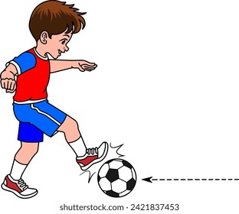
_______________________________________________________________________________________________
- Study the sequence below.

a) Identify the football skill represented. _____________________________(1 mark)
b) State two technical points that should be observed when performing the skill. (2 marks)
- _________________________________________________________________________________________
- _________________________________________________________________________________________
- a) What is meant by pivoting in netball? (1 mark)
____________________________________________________________________________________________________________________________________________________________________________________________________
b) State two situations in which pivoting can be useful to a netball player. (2 marks)
- _________________________________________________________________________________________
- _________________________________________________________________________________________
- Study the diagram below.

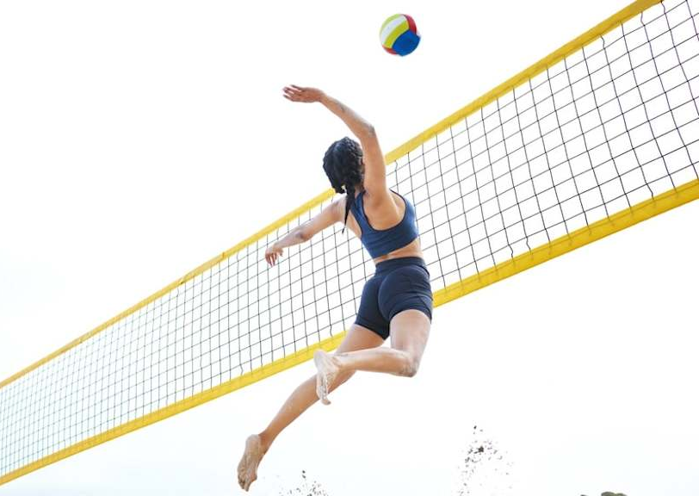
a) Identify the volleyball skill represented. _________________________________ (1 mark)
b) State two technical points to observe when performing the skill. (2 marks)
- _________________________________________________________________________________________
- _________________________________________________________________________________________
- a) Name one type of throw used to restart or continue play in handball. (1 mark)
__________________________________________________________
b) Explain two factors that determine the accuracy of a handball pass. (2 marks)
- _________________________________________________________________________________________
- _________________________________________________________________________________________
- a) What is meant by dribbling in basketball? (1 mark)
___________________________________________________________________________________________
b) State two purposes of dribbling during a basketball game. (2 marks)
- _________________________________________________________________________________________
- _________________________________________________________________________________________
- Study the illustration.
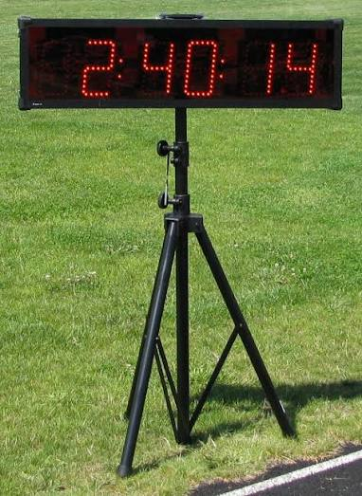
a) Identify the equipment illustrated. ____________________________________ (1 mark)
b) State two advantages of using a starting blocks in sprinting. (2 marks)
- _________________________________________________________________________________________
- _________________________________________________________________________________________
- State three technical considerations during the approach/run-up phase of a long jump. (3 marks)
- _________________________________________________________________________________________
- _________________________________________________________________________________________
- _________________________________________________________________________________________
- a) State one correct way of carrying a javelin before the throwing phase. (1 mark)
____________________________________________________________________________
b) Give two reasons why safety procedures are particularly important in javelin. (2 marks)
- _________________________________________________________________________________________
- _________________________________________________________________________________________
- a) Name one technique that may be used to put the shot. (1 mark)
___________________________________________________________________________
b) State two technical points that should be observed when putting the shot. (2 marks)
- _________________________________________________________________________________________
- _________________________________________________________________________________________

SECTION B: 50 MARKS
Answer ALL questions.
- A Grade 10 football team is preparing for an inter-school competition.

a) Describe four stages involved in performing a controlled inside-foot pass in football. (4 marks)
- _________________________________________________________________________________________
- _________________________________________________________________________________________
- _________________________________________________________________________________________
- _________________________________________________________________________________________

b) Explain three ways in which a football player can create space during an attacking situation. (3 marks)
- _________________________________________________________________________________________
- _________________________________________________________________________________________
- _________________________________________________________________________________________

c) State three responsibilities of an outfield player when the team is defending. (3 marks)
- _________________________________________________________________________________________
- _________________________________________________________________________________________
- _________________________________________________________________________________________

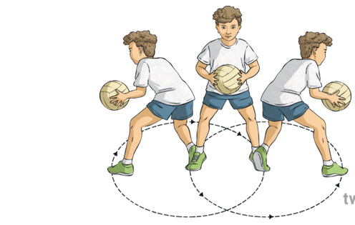
(a) NETBALL
Study the simplified movement below.

i. Identify the movement illustrated. _______________________________ (1 mark)
ii. Describe three important points to observe when performing the movement. (3 marks)
- _________________________________________________________________________________________
- _________________________________________________________________________________________
- _________________________________________________________________________________________
iii. State two advantages of effective footwork in netball. (2 marks)
- _________________________________________________________________________________________
- _________________________________________________________________________________________

(b) i. Name the skill used to send the ball forcefully over the net during an attacking volleyball play. (1 mark)
__________________________________________________
ii. Explain three technical points involved in executing this skill effectively. (3 marks)
- _________________________________________________________________________________________
- _________________________________________________________________________________________
- _________________________________________________________________________________________

(a) A player has possession of the ball and wants to move past a defender.
i. Explain three ways the player can use body movement to evade the defender in a handball game. (3 marks)
- _________________________________________________________________________________________
- _________________________________________________________________________________________
- _________________________________________________________________________________________
ii. State two qualities of an effective handball goalkeeper. (2 marks)
- _________________________________________________________________________________________
- _________________________________________________________________________________________

(b) A learner is practising dribbling around opponents.
i. Describe three important techniques for effective basketball dribbling. (3 marks)
- _________________________________________________________________________________________
- _________________________________________________________________________________________
- _________________________________________________________________________________________
ii. Explain two reasons why a player should avoid unnecessary dribbling during a game. (2 marks)
- _________________________________________________________________________________________
- _________________________________________________________________________________________

(a) Study the sprints sequence below.
A B C
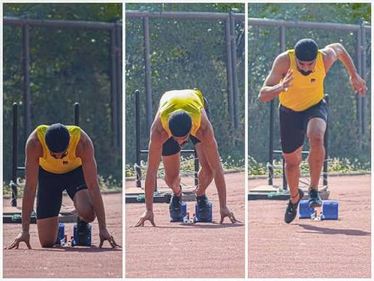
i. Identify the three stages represented by A, B and C. (3 marks)
A: _____________________________
B: _____________________________
C: _____________________________

ii. Explain two ways in which arm action contributes to effective sprinting. (2 marks)
- _________________________________________________________________________________________
- _________________________________________________________________________________________

(b) i. Name the four main phases of the long jump. (2 marks)
ii. Explain one important technique during the flight phase. (1 mark)
_________________________________________________________________________________________________
iii. State two safety measures to observe when performing long jump. (2 marks)
- _________________________________________________________________________________________
- _________________________________________________________________________________________

(a)
i. Distinguish between javelin and shot put according to the direction/manner in which the implement is propelled.
(2 marks)
________________________________________________________________________________________________________________________________________________________________________________________________________________________________________________________________________________________________________________________________________________________________________________________________________
ii. Explain two factors that can affect the distance achieved in a throwing event. (2 marks)
- _________________________________________________________________________________________
- _________________________________________________________________________________________

(b) The school has introduced optional sports to broaden learners' participation in Physical Education.
i. Name three optional sports studied at Grade 10 level. (3 marks)
- _________________________________________________________________________________________
- _________________________________________________________________________________________
- _________________________________________________________________________________________
ii. Choose one sport named in (b)(i) and state one basic skill used in it. (1 mark)
_______________________________________________________________________________________________

(c) State two benefits of regular participation in physical activities. (2 marks)
- _________________________________________________________________________________________
- _________________________________________________________________________________________

THIS IS THE LAST PRINTED PAGE

MARKING SCHEME / ANSWERS

SECTION A: STRUCTURED QUESTIONS

30 MARKS

QUESTION 1 – FOOTBALL (3 marks)
a) Two ways of controlling a football:
- Using the inside of the foot. ✓
- Using the sole of the foot. ✓
- Using the instep/laces. ✓
- Using the thigh. ✓
- Using the chest. ✓
- Using the head. ✓
Any two = 2 marks
b) Ball control enables a player to retain possession and prepare effectively for the next action such as passing, dribbling or shooting. ✓
1 mark

QUESTION 2 – FOOTBALL SKILL (3 marks)
a) Trapping/controlling the ball with the foot. ✓
1 mark
b) Technical points:
- Keep the eyes on the ball. ✓
- Position the supporting foot appropriately. ✓
- Withdraw/relax the receiving foot slightly on contact to cushion the ball. ✓
- Maintain balance and control of the body. ✓
- Direct the ball into a playable position. ✓
Any two = 2 marks

QUESTION 3 – NETBALL (3 marks)
a) Pivoting is a movement in which a player keeps one foot planted while turning the body on that foot to change direction or find a passing option. ✓
1 mark
b) Uses of pivoting:
- To evade an opponent. ✓
- To create space. ✓
- To find a teammate to pass to. ✓
- To change the direction of play. ✓
- To protect the ball from an opponent. ✓
Any two = 2 marks

QUESTION 4 – VOLLEYBALL (3 marks)
a) Spike/smash/attacking hit. ✓
1 mark
b) Technical points:
- Take an appropriate approach towards the ball. ✓
- Jump vertically/forward with good coordination. ✓
- Strike the ball with an open hand at the appropriate height. ✓
- Contact the ball above the net. ✓
- Direct the ball into the opponent's court. ✓
- Land safely with balanced knees. ✓
Any two = 2 marks

QUESTION 5– HANDBALL (3 marks)
a) Any one:
- Throw-off. ✓
- Free throw. ✓
- Throw-in. ✓
- Goalkeeper throw. ✓
- 7-metre throw. ✓
1 mark
b) Factors determining accuracy:
- Correct body/arm positioning. ✓
- Correct direction and target selection. ✓
- Appropriate force applied. ✓
- Proper timing of release. ✓
- Good concentration. ✓
Any two = 2 marks

QUESTION 6 – BASKETBALL (3 marks)
a) Dribbling is the controlled bouncing of the basketball continuously with one hand while moving around the court. ✓
1 mark
b) Purposes of dribbling:
- To move with the ball around the court. ✓
- To evade an opponent. ✓
- To create space. ✓
- To advance the ball towards the opponent's basket. ✓
- To improve a passing or shooting opportunity. ✓
Any two = 2 marks

QUESTION 7 – ATHLETICS: SPRINTS (3 marks)
a) race clock sports timer. ✓
1 mark
b) Advantages of starting blocks:
- Provide firm support during the start. ✓
- Enable the athlete to generate greater force when pushing off. ✓
- Improve acceleration from the starting position. ✓
- Help the athlete achieve an efficient starting posture. ✓
Any two = 2 marks

QUESTION 8 – LONG JUMP (3 marks)
Approach/run-up considerations:
- Maintain a controlled and progressively increasing speed. ✓
- Use consistent strides. ✓
- Maintain good body posture and balance. ✓
- Accurately approach the take-off board. ✓
- Coordinate arm and leg movements. ✓
- Maintain concentration on the take-off point. ✓
Any three = 3 marks

QUESTION 9 – JAVELIN (3 marks)
a) The javelin should be carried with the point facing forward/upwards and held securely at the grip. ✓
1 mark
b) Reasons for safety procedures:
- Javelin is a sharp/heavy implement that can cause serious injury. ✓
- Accidental throwing can injure athletes or spectators. ✓
- The implement travels at high speed. ✓
- Proper procedures prevent collisions during retrieval and throwing. ✓
Any two = 2 marks

QUESTION 10 – SHOT PUT (3 marks)
a) Any one:
- Glide technique. ✓
- Rotational/spin technique. ✓
1 mark
b) Technical points:
- Hold the shot against the neck/base of the neck. ✓
- Keep the elbow elevated. ✓
- Push rather than throw the shot. ✓
- Transfer body weight from the rear to the front. ✓
- Extend the throwing arm powerfully. ✓
- Maintain balance after release. ✓
Any two = 2 marks

SECTION B: 50 MARKS

QUESTION 11 – FOOTBALL

10 MARKS

a) Four stages of performing an inside-foot pass
4 marks
1. Preparation/approach:
Move towards the ball and position the body appropriately while identifying the intended target. ✓
2. Supporting foot:
Place the non-kicking foot beside the ball, pointing generally towards the intended target. ✓
3. Contact:
Use the inside surface of the kicking foot to strike through the centre of the ball. ✓
4. Follow-through:
Continue the kicking leg towards the target while maintaining balance and preparing for the next action. ✓
4 × 1 = 4 marks

b) Ways of creating space during an attacking situation
3 marks
Any three:
- Move away from the defender into open space. ✓
- Make a quick change of direction. ✓
- Use a change of pace to lose the defender. ✓
- Make a supporting run behind or ahead of the ball carrier. ✓
- Use feints to deceive the defender. ✓
- Spread out to make the playing area wider. ✓
3 × 1 = 3 marks

c) Responsibilities of an outfield defender/player
3 marks
Any three:
- Mark opposing players. ✓
- Prevent opponents from progressing towards goal. ✓
- Intercept or tackle safely to regain possession. ✓
- Cover teammates when necessary. ✓
- Maintain appropriate defensive positioning. ✓
- Communicate with teammates. ✓
3 × 1 = 3 marks
TOTAL = 10 MARKS

QUESTION 12 – NETBALL AND VOLLEYBALL

10 MARKS

(a) NETBALL

i) Identify the movement
Pivoting. ✓
1 mark

ii) Points to observe during pivoting
3 marks
- Keep one foot firmly planted as the pivot foot. ✓
- Maintain balance while turning. ✓
- Keep the body controlled and avoid dragging/lifting the pivot foot illegally. ✓
- Scan for a teammate or passing opportunity. ✓
- Protect the ball from the opponent. ✓
Any three = 3 marks

iii) Advantages of effective footwork
2 marks
- Helps the player maintain balance. ✓
- Enables quick changes of direction. ✓
- Helps evade opponents. ✓
- Creates space for passing or receiving. ✓
- Reduces unnecessary loss of possession. ✓
Any two = 2 marks

(b) VOLLEYBALL

i) Skill used to send the ball forcefully over the net
Spike/smash. ✓
1 mark

ii) Technical points in executing a spike
3 marks
- Make an appropriate approach towards the ball. ✓
- Coordinate the arm swing with the jump. ✓
- Jump and reach high towards the ball. ✓
- Strike the ball with an open hand at the appropriate point. ✓
- Direct the ball forcefully into the opponent's court. ✓
- Land safely and maintain balance. ✓
Any three = 3 marks
TOTAL = 10 MARKS

QUESTION 13 – HANDBALL AND BASKETBALL

10 MARKS

(a) HANDBALL

i) Ways of evading a defender
3 marks
Any three:
- Sidestep: Move quickly sideways around the defender. ✓
- Feint: Use a deceptive body movement to make the defender move in the wrong direction. ✓
- Change of direction: Suddenly change direction to escape the defender. ✓
- Change of pace: Accelerate or decelerate suddenly. ✓
- Body dodge: Move the upper body to deceive the defender before moving past. ✓
3 × 1 = 3 marks

ii) Qualities of an effective goalkeeper
2 marks
Any two:
- Quick reaction time. ✓
- Good agility. ✓
- Courage/confidence. ✓
- Good concentration. ✓
- Good anticipation. ✓
- Effective communication. ✓
- Flexibility. ✓
Any two = 2 marks

(b) BASKETBALL

i) Techniques for effective dribbling
3 marks
- Keep the ball close to the body and under control. ✓
- Use the fingertips rather than the palm to control the ball. ✓
- Keep the knees slightly bent and maintain a low centre of gravity. ✓
- Keep the head up to observe teammates and opponents. ✓
- Use the appropriate hand and change hands when necessary. ✓
- Protect the ball from defenders using the body. ✓
Any three = 3 marks

ii) Why unnecessary dribbling should be avoided
2 marks
- It may lead to loss of possession. ✓
- It can slow down attacking play. ✓
- A teammate may be in a better position to receive a pass. ✓
- Excessive dribbling allows defenders to regroup. ✓
- It can reduce opportunities for effective passing or shooting. ✓
Any two = 2 marks
TOTAL = 10 MARKS

QUESTION 14 – ATHLETICS

10 MARKS

(a) SPRINTS

i) Identify A, B and C
3 marks
- A – On your marks. ✓
- B – Set. ✓
- C – Acceleration/drive phase after the starting signal. ✓
3 marks

ii) Contribution of arm action
2 marks
- Helps maintain balance and coordination. ✓
- Assists in generating forward momentum. ✓
- Complements the movement of the legs. ✓
- Helps maintain an efficient sprinting rhythm. ✓
Any two = 2 marks

(b) LONG JUMP

i) Four phases
2 marks
- Approach/run-up. ✓
- Take-off. ✓
- Flight. ✓
- Landing. ✓
2 marks

ii) Flight technique
1 mark
Any correct technique:
- Maintain body control while in the air and prepare the legs for landing. ✓
- Use an appropriate flight technique such as the hang or hitch-kick. ✓
- Keep the body balanced and extend the legs forward in preparation for landing. ✓
1 mark

iii) Safety measures
2 marks
- Ensure the landing pit contains suitable, level and soft sand. ✓
- Ensure the runway is dry and free from obstacles. ✓
- Ensure the landing area is clear before each jump. ✓
- Learners should wait for their turn and follow the teacher's instructions. ✓
- Avoid walking across the runway during jumping. ✓
Any two = 2 marks
TOTAL = 10 MARKS

QUESTION 15 – FIELD EVENTS, OPTIONAL SPORTS AND PHYSICAL FITNESS

10 MARKS

(a) FIELD EVENTS

i) Difference between javelin and shot put
2 marks
- Javelin: The implement is thrown overarm into the throwing sector. ✓
- Shot put: The shot is pushed/put from the neck using a powerful extending action rather than thrown. ✓
2 marks

ii) Factors affecting distance in throwing events
2 marks
Any two:
- Speed of the implement at release. ✓
- Angle of release. ✓
- Height of release. ✓
- Strength and power of the athlete. ✓
- Correct technique. ✓
- Effective transfer of body weight. ✓
- Coordination and timing. ✓
Any two = 2 marks

(b) OPTIONAL SPORTS

i) Three optional sports
3 marks
Any three:
- Hockey. ✓
- Swimming. ✓
- Softball. ✓
- Baseball. ✓
- Cricket. ✓
- Table tennis. ✓
- Tennis. ✓
- Badminton. ✓
Any three = 3 marks

ii) One basic skill
1 mark
Accept any correctly identified skill appropriate to the sport selected.
Examples:
- Hockey: dribbling, passing, hitting. ✓
- Swimming: kicking, floating, breathing, arm stroke. ✓
- Softball: batting, throwing, catching. ✓
- Baseball: batting, pitching, catching. ✓
- Cricket: batting, bowling, fielding. ✓
- Table tennis: serving, forehand drive, backhand drive. ✓
- Tennis: serving, forehand, backhand, volley. ✓
- Badminton: serving, clear, smash, drop shot. ✓
1 mark

(c) PHYSICAL FITNESS

Two benefits of regular physical activity
2 marks
Any two:
- Improves cardiovascular endurance. ✓
- Increases muscular strength and endurance. ✓
- Improves flexibility. ✓
- Improves coordination and agility. ✓
- Helps maintain healthy body weight. ✓
- Reduces the risk of lifestyle-related diseases. ✓
- Promotes mental and emotional well-being. ✓
- Improves overall physical fitness. ✓
- Promotes healthy social interaction. ✓
Any two = 2 marks

KENYA CERTIFICATE OF BASIC EDUCATION

SENIOR SCHOOL ASSESSMENT

TERM 3 PROJECTS BASED ASSIGNMENT 2026
GRADE 10 – PHYSICAL EDUCATION
LEARNER’S DETAILS
Name: _____________________________________________________________. School: ____________________________________________.
Assessment Number: _______________________________________________. Date: ____________________________________________.
School Code: ______________________________________________________. Signature: _______________________________________.

PROJECT ASSESSMENT EXAMINATION – 20 MARKS
Instructions:
- This project should be completed individually or in a small group as directed by the teacher.
- Use locally available materials and facilities.
- Demonstrate the activities safely and correctly.
- Record your observations and findings.
- The teacher will assess both the practical performance and the submitted work.

PROJECT: PERSONAL FITNESS AND PHYSICAL ACTIVITY PLAN
Scenario:
Your school intends to promote a healthy and physically active lifestyle among Grade 10 learners. You have been selected to design and demonstrate a simple fitness programme that can be carried out using locally available facilities and equipment.

Tasks
1. Fitness Assessment – 5 marks
Carry out three physical fitness tests from the following:
- 30-metre sprint – speed
- Standing broad jump – power
- Sit-ups – muscular endurance
- Push-ups – muscular endurance
- Sit-and-reach – flexibility
- 800-metre run – cardiovascular endurance
Record your results in a table showing:
Fitness test | Fitness component | Your result
Test 1
Test 2
Test 3
(5 marks)
2. Personal Fitness Programme – 6 marks
Using your results from Task 1, prepare a one-week fitness programme containing at least four physical activities.
Your programme should indicate:
- Activity
- Duration/repetitions
- Frequency
- Fitness component developed
- Safety precaution
(6 marks)
3. Practical Demonstration – 5 marks
Demonstrate three exercises or physical activities from your programme.
The teacher will assess:
a) Correct technique – 2 marks
b) Coordination and control – 1 mark
c) Appropriate intensity/effort – 1 mark
d) Safety during performance – 1 mark
(5 marks)
4. Reflection and Evaluation – 4 marks
After completing the project:
a) State two benefits you expect to gain from following your fitness programme. (2 marks)
b) Identify one challenge you experienced and explain how you would overcome it. (1 mark)
c) State one way you would improve your programme in future. (1 mark)
TOTAL: 20 MARKS

GRADE 10 PHYSICAL EDUCATION

PROJECT ASSESSMENT – MARKING SCHEME
TOTAL: 20 MARKS

1. FITNESS ASSESSMENT – 5 MARKS
Award 1 mark for each correctly completed fitness test, provided the learner records the result appropriately.
Item | Expected evidence | Marks
a) | Correctly performs and records Test 1 | 1
b) | Correctly performs and records Test 2 | 1
c) | Correctly performs and records Test 3 | 1
d) | Correctly identifies the fitness component for the tests | 1
e) | Accurate and clear recording of results | 1
Total |  | 5
Acceptable fitness components: speed, power, muscular endurance, flexibility, cardiovascular endurance.

2. PERSONAL FITNESS PROGRAMME – 6 MARKS
Award as follows:
Criterion | Marks
Four or more appropriate physical activities identified | 2
Appropriate duration/repetitions indicated | 1
Frequency of activities correctly indicated | 1
Correct fitness component developed identified | 1
Appropriate safety precaution given | 1
Total | 6
Examples of acceptable activities: jogging, sprinting, skipping, sit-ups, push-ups, squats, lunges, stretching, shuttle runs, cycling, dancing and aerobic exercises.

3. PRACTICAL DEMONSTRATION – 5 MARKS
Criterion | Description | Marks
a) Correct technique | Performs the selected exercises using appropriate technique | 2
b) Coordination and control | Demonstrates controlled and coordinated movements | 1
c) Appropriate intensity/effort | Performs with suitable effort according to the activity | 1
d) Safety | Observes safety procedures before and during performance | 1
Total |  | 5

4. REFLECTION AND EVALUATION – 4 MARKS
a) Two benefits of the fitness programme – 2 marks
Award 1 mark each for any two relevant benefits:
- Improves physical fitness.
- Improves cardiovascular endurance.
- Builds muscular strength/endurance.
- Improves flexibility.
- Helps maintain healthy body weight.
- Reduces risk of lifestyle-related diseases.
- Improves mental well-being.
- Promotes discipline and healthy habits.
- Improves coordination and body control.
b) One challenge and how to overcome it – 1 mark
- Correctly identifies a realistic challenge – ½ mark
- Gives an appropriate solution – ½ mark
Examples: lack of equipment, limited time, fatigue, lack of facilities, poor motivation or bad weather.
c) One improvement to the programme – 1 mark
Award 1 mark for a relevant improvement, such as:
- Increasing training gradually.
- Including more fitness components.
- Improving time management.
- Using additional locally available equipment.
- Increasing the number of training sessions appropriately.
- Including adequate warm-up and cool-down.

MARK DISTRIBUTION
Task | Marks
1. Fitness Assessment | 5
2. Personal Fitness Programme | 6
3. Practical Demonstration | 5
4. Reflection and Evaluation | 4
TOTAL | 20 MARKS

