KENYA CERTIFICATE OF BASIC EDUCATION

SENIOR SCHOOL ASSESSMENT

DECEMBER ASSIGNMENT 2026
GRADE 10 – METAL TECHNOLOGY
Time: 2 Hours
LEARNER’S DETAILS
Name: _____________________________________________________________. School: ____________________________________________.
Assessment Number: _______________________________________________. Date: ____________________________________________.
School Code: ______________________________________________________. Signature: _______________________________________.

INSTRUCTIONS TO CANDIDATES
- Write your name in the spaces provided above.
- Write the name of your school and your stream in the spaces provided.
- Write your admission number and the date of the assessment in the spaces provided.
- This paper consists of two sections: A and B.
- Answer all questions in section A and section B.
- Answer the questions in English.
- All answers MUST be written in the spaces provided in the paper.
- Do NOT remove any page from this question paper.

FOR OFFICIAL USE ONLY (EXAMINER’S USE)
SECTION | SECTION A | SECTION B | % SCORE | EE1 | EE2 | ME1 | ME2 | AE1 | AE2 | BE1 | BE2
SCORE RANGE | 30 MARKS | 50 MARKS |  | 90-100 | 75-89 | 58-74 | 41-57 | 31-40 | 21-30 | 11-20 | 1-10
POINTS |  |  |  | 8 POINTS | 7 POINTS | 6 POINTS | 5 POINTS | 4 POINTS | 3 POINTS | 2 POINTS | 1 POINT
LEARNER’S TOTAL SCORE

SECTION A (40 MARKS)
Answer ALL questions in this section.
  - A learner enters a metalwork workshop and notices that some tools are scattered on workbenches, metal off-cuts are lying on the floor, and a gas cylinder has been placed close to a source of heat.
a) Identify two unsafe conditions from the situation. (2 marks)
i. _________________________________________________________________
ii. ________________________________________________________________
b) State two measures that should be taken to make the workshop safer. (2 marks)
i. _________________________________________________________________
ii. ________________________________________________________________
  - Study the following simplified illustration.
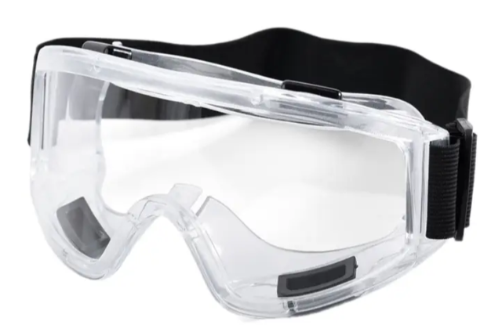
a) Identify the item of personal protective equipment represented by the illustration. (1 mark)
__________________________________________________________________
b) State TWO reasons for wearing appropriate personal protective equipment in a metalwork workshop. (2 marks)
i. _____________________________________________________________________________________________
ii. ____________________________________________________________________________________________
  - a) Name the appropriate tool used for each operation.
i. Measuring the length of a metal component accurately. ________________________ (1 mark)
ii. Making a fine line on a metal surface before cutting. __________________________ (1 mark)
iii. Checking whether two surfaces are at right angles. ____________________________ (1 mark)
b) State one reason for cleaning a metal surface before marking out. (1 mark) ______________________________________________________________________________________________________________________________________________________________________________________________
  - a) Define the following terms:
i. Hardness (1 mark) ______________________________________________________________________________________________________________________________________________________________________________________________
ii. Toughness (1 mark) ______________________________________________________________________________________________________________________________________________________________________________________________

b) Distinguish between malleability and ductility. (2 marks)
________________________________________________________________________________________________________________________________________________________________________________________________________________________________________________________________________________________________________________________________________________________________________________________________________________________________
  - a) Give two examples of ferrous metals. (2 marks)
i. _________________________________________________________________
ii. ________________________________________________________________
b) Give two examples of non-ferrous metals. (2 marks)
i. _________________________________________________________________
ii. ________________________________________________________________
  - Define the terms metals and metalwork. (2marks)
____________________________________________________________________________________________________________________________________________________________________________________________________________________________________________________________________________________________________________________________________________________________________________________________
  - Name any TWO careers in the field of metalwork. (2 marks)
i. ___________________________________________________________________
ii. __________________________________________________________________
  - Name the TWO aspects of safety. (2 marks)
i. ___________________________________________________________________________________________
ii. ___________________________________________________________________________________________
  - List any TWO safety rules in a metal workshop. (2 marks)
i. _____________________________________________________________________________________________
ii. ____________________________________________________________________________________________
  - Metal cutting tools should be made using hard materials.Explain why and name those two metals. (2marks)
____________________________________________________________________________________________________________________________________________________________________________________________________________________________________________________________________________________________________________________________________________________________________________________________
  - Give two differences between Steel and aluminium. (2marks)
i. _____________________________________________________________________________________________
ii. ____________________________________________________________________________________________
  - The figure shows a tool used in measuring and checking.
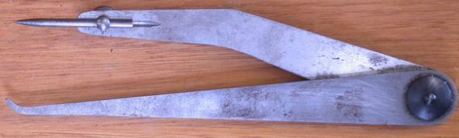
  - Give the name of the tool and name the material used for making it. (2marks)
Tool name | Material used
  - Give two uses of the tool. (2marks)
i. _____________________________________________________________________________________________
ii. ____________________________________________________________________________________________
  - Why is the cutting edge of a cold chisel hardened while the end struck by a hammer tempered. (2marks)
_____________________________________________________________________________________________________________________________________________________________________________________________________________________________________________________________________________________________
  - The figure below shows a tool used in cutting metals.
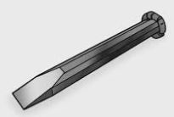
Name the problem that the tool has ,state the cause of it and explain how to correct it. (2marks)
Problem
Cause
Correction
  - The figure below shows a metal cutting tool.
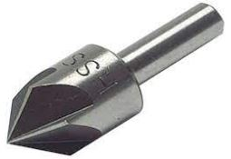
  - Give the name of the tool and its use. (2marks)
Tool: _________________________________.
Use: _____________________________________________________________________________________
  - State two reasons for notching edges of sheet metal. (2marks)
i. _____________________________________________________________________________________________
ii. ____________________________________________________________________________________________

SECTION B: 50 MARKS
Answer ALL questions.
  - Figure 2 shows orthographic views of a machined block drawn in third angle projection.
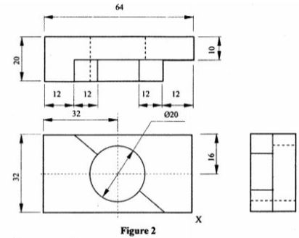
On the grid paper provided, draw the isometric view of the block taking X as the lowest point.
Show three main dimensions. (15 marks)
  - A learner is required to cut, hold, file and finish a mild-steel workpiece.
a) Name a suitable tool for each of the following operations. (4 marks)
i. Holding the workpiece firmly: _____________________________________
ii. Cutting the metal: ______________________________________________
iii. Removing small amounts of metal: ________________________________
iv. Checking a right angle: __________________________________________
b) Explain two factors that should be considered when selecting a file for a metalworking operation. (2 marks)
i. _________________________________________________________________
ii. ________________________________________________________________
c) State two safety precautions when using a hacksaw. (2 marks)
i. _________________________________________________________________
ii. ________________________________________________________________
d) State two ways of maintaining hand tools. (2 marks)
i. _________________________________________________________________
ii. ________________________________________________________________
  - A school workshop wants to manufacture the following items:
- A school gate;
- Electrical connecting wire;
- A lightweight sheet-metal container;
- A component that must resist corrosion.
a) Select a suitable metal for each item. (4 marks)
i. School gate: _____________________________________________________
ii. Electrical connecting wire: ______________________________________
iii. Lightweight sheet-metal container: _______________________________
iv. Corrosion-resistant component: __________________________________
b) Give two properties of mild steel that make it suitable for fabrication work. (2 marks)
i. _________________________________________________________________
ii. ________________________________________________________________
c) State two advantages of using aluminium in sheet-metal work. (2 marks)
i. _________________________________________________________________
ii. ________________________________________________________________
d) State two factors that influence the choice of a metal for a particular product. (2 marks)
i. _________________________________________________________________
ii. ________________________________________________________________
  - Study the object below.
80 mm
┌────────────────┐
/│ /│
/ │ / │
/ │ / │
└───┼────────────┘ │
│ │ │ │
│ │ │ │ 50 mm
│ └────────────┼───┘
│ / │ /
│ / │ /
│/_______________│/
40 mm
a) Identify the type of pictorial drawing represented above. __________________________________ (1 mark)
b) State two characteristics of this type of drawing. (2 marks)
i. _________________________________________________________________
ii. ________________________________________________________________

c) State the purpose of using a scale in technical drawing. (2 marks)
________________________________________________________________________________________________________
________________________________________________________________________________________________________
d) Name three instruments that can be used to produce accurate technical drawings. (3 marks)
i. _________________________________________________________________
ii. ________________________________________________________________
iii. _______________________________________________________________
e) State two qualities of a good technical drawing. (2 marks)
i. _________________________________________________________________
ii. ________________________________________________________________
  - Study the three simplified joints below.
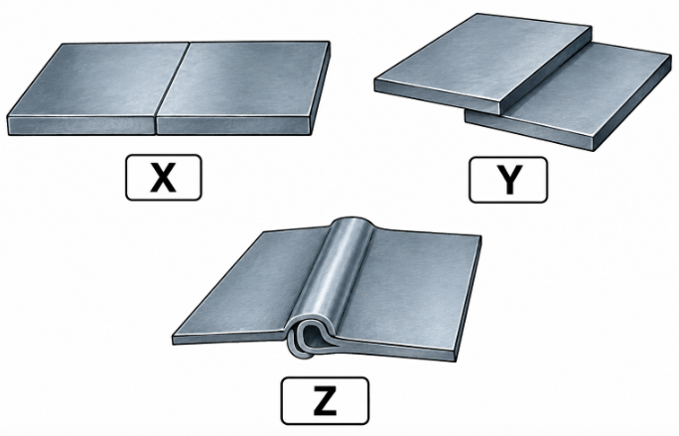
a) Identify joints X, Y and Z. (3 marks)
X: _________________________________________________________________
Y: _________________________________________________________________
Z: _________________________________________________________________
b) State three methods of joining sheet metal. (3 marks)
i. _________________________________________________________________
ii. ________________________________________________________________
iii. _______________________________________________________________
c) Describe how a riveted joint is produced from two pieces of sheet metal. (3 marks)
________________________________________________________________________________________________________
________________________________________________________________________________________________________
________________________________________________________________________________________________________
d) State one safety precaution when drilling holes in sheet metal. (1 mark)
________________________________________________________________________________________________________
________________________________________________________________________________________________________
  - A learner is required to make a small metal dustpan from a sheet of mild steel.
a) State four operations that may be carried out during the manufacture of the dustpan. (4 marks)
i. _____________________________________________________________________________________________
ii. _____________________________________________________________________________________________
iii. ____________________________________________________________________________________________
iv. ____________________________________________________________________________________________
b) Explain the importance of marking out before cutting the sheet metal. (2 marks)
________________________________________________________________________________________________________
________________________________________________________________________________________________________
c) State two methods that could be used to join parts of the dustpan. (2 marks)
i. _____________________________________________________________________________________________
ii. ____________________________________________________________________________________________
d) State two ways of evaluating the completed dustpan. (2 marks)
i. _____________________________________________________________________________________________
ii. ____________________________________________________________________________________________

THIS IS THE LAST PRINTED PAGE

GRADE 10 KENYA – METAL TECHNOLOGY

TERM 3: DECEMBER ASSIGNMENT 2026

MARKING SCHEME / ANSWERS

SECTION A – 40 MARKS

1
a) Two unsafe conditions – 2 marks
Any two, 1 mark each:
- Tools are scattered on workbenches.
- Metal off-cuts are lying on the workshop floor.
- Gas cylinder is placed close to a source of heat.
b) Two safety measures – 2 marks
Any two, 1 mark each:
- Store tools properly after use.
- Remove and dispose of metal off-cuts safely.
- Keep gas cylinders away from sources of heat.
- Secure gas cylinders in an upright position.
- Keep the workshop clean and well organised.

2
a) Identification – 1 mark
- Safety goggles / protective goggles – 1 mark.
b) Reasons for wearing PPE – 2 marks
Any two, 1 mark each:
- Protects the eyes from flying metal particles.
- Protects against sparks and hot metal particles.
- Reduces the risk of burns and injuries.
- Protects against metal dust.
- Reduces the severity of workshop accidents.

3
a) Appropriate tools
i. Measuring length accurately:
- Steel rule – 1 mark.
ii. Making a fine line on metal:
- Scriber – 1 mark.
iii. Checking whether surfaces are at right angles:
- Try square – 1 mark.
b) Reason for cleaning metal before marking out – 1 mark
- To remove dirt, grease, rust, scale or other contaminants so that clear and accurate marking lines can be produced.

4
a) Definitions
i. Hardness – 1 mark
- The ability of a metal to resist scratching, indentation, wear or penetration.
ii. Toughness – 1 mark
- The ability of a metal to absorb energy and withstand shock or impact without breaking.
b) Malleability and ductility – 2 marks
- Malleability: Ability of a metal to be hammered or rolled into thin sheets without breaking – 1 mark.
- Ductility: Ability of a metal to be drawn into wires without breaking – 1 mark.

5
a) Ferrous metals – 2 marks
Any two, 1 mark each:
- Mild steel
- Cast iron
- Wrought iron
- High-carbon steel
- Stainless steel
b) Non-ferrous metals – 2 marks
Any two, 1 mark each:
- Aluminium
- Copper
- Zinc
- Tin
- Brass
- Bronze
- Lead

6
Metals – 1 mark
- Materials, usually obtained from ores, which possess metallic properties such as strength, conductivity and ability to be shaped.
Metalwork – 1 mark
- The process of cutting, shaping, forming, joining and finishing metals to make useful products.

7
Any two, 1 mark each:
- Metal fabricator
- Welder
- Fitter
- Machinist
- Sheet-metal worker
- Blacksmith
- Boilermaker
- Plumber
- Toolmaker
- Mechanical technician
- Automotive technician

8
1 mark each:
- Personal safety
- Workshop/environmental safety
Accept equivalent terminology such as:
- Safety of the person
- Safety of property/equipment/workshop

9
Any two, 1 mark each:
- Wear appropriate PPE.
- Keep the workshop clean and tidy.
- Use the correct tool for the correct job.
- Do not run or engage in horseplay in the workshop.
- Store tools properly after use.
- Report damaged tools and unsafe conditions.
- Do not use machines without authorisation or instruction.
- Keep loose clothing and hair away from moving machinery.
- Dispose of metal off-cuts safely.

10
Explanation – 1 mark
- Cutting tools must be made from materials that are hard enough to retain a sharp cutting edge and resist wear.
Suitable metals/materials – 1 mark
Any two appropriate materials, depending on the intended cutting tool:
- High-carbon steel
- High-speed steel (HSS)
- Tool steel
- Tungsten carbide
Award ½ mark each for two correctly named materials.

11
Any two valid differences, 1 mark each:
- Steel is generally heavier than aluminium, while aluminium is lightweight.
- Steel is stronger/harder than aluminium in many common applications.
- Steel is more susceptible to rusting than aluminium, which has good corrosion resistance.
- Aluminium is generally easier to form than many steels.
- Aluminium has a higher electrical conductivity than ordinary steel.
- Steel is generally cheaper than aluminium.

12.
(a) Give the name of the tool and the material used for making it. (2 marks)
- Odd-leg calipers – 1 mark
- High-carbon steel (HCS) – 1 mark
(b) State two uses of the tool. (2 marks)
- Used for marking lines parallel to a given datum edge – 1 mark
- Used for finding/locating the centre of a round bar – 1 mark

13. (2 marks)
- The cutting edge is hardened to increase its hardness and resistance to wear, cutting and denting during metal cutting – 1 mark.
- The struck end is tempered to increase its toughness so that it can absorb the shock of repeated hammer blows without cracking or breaking – 1 mark.

14.
(a) Name the problem that the tool has, state its cause and explain how it can be corrected. (2 marks)
- Problem: Mushroomed head – ½ mark
- Cause: Repeated hammering causes the metal at the struck end to spread/build up – ½ mark
- Correction: Grind/file off the mushroomed portion and dress/chamfer the head properly – 1 mark

15.
(a) Give the name of the tool and state its use. (2 marks)
- Tool: Countersink bit – 1 mark
- Use: Used for producing a conical recess at the mouth of a drilled hole, allowing a countersunk screw head to sit flush with the surface – 1 mark
b) Reasons for notching sheet-metal edges – 2 marks
Any two, 1 mark each:
- To allow the sheet to be folded or bent accurately.
- To prevent overlapping material from interfering with the fold.
- To enable corners to be formed neatly.
- To reduce excess material at corners.
- To prevent wrinkling or distortion during folding.
- To facilitate joining of sheet-metal parts.

SECTION B – 50 MARKS

16
The learner is required to draw the isometric view of the block from the given orthographic views, taking X as the lowest point, and show three main dimensions.

Suggested marking allocation
1. Construction/interpretation – 3 marks
- Correct interpretation of the orthographic views – 1 mark
- Correct location of X as the lowest point – 1 mark
- Correct transfer of major dimensions – 1 mark
2. Isometric construction – 6 marks
- Correct isometric axes – 1 mark
- Correct overall length – 1 mark
- Correct overall width/depth – 1 mark
- Correct overall height – 1 mark
- Correct shape/features – 2 marks
3. Accuracy and line work – 3 marks
- Correct visible outlines – 1 mark
- Correct positioning/proportion – 1 mark
- Neat and accurate drawing – 1 mark
4. Dimensions – 3 marks
Three main dimensions correctly shown:
- First dimension – 1 mark
- Second dimension – 1 mark
- Third dimension – 1 mark
TOTAL: 15 MARKS
Award drawing marks progressively. A learner who demonstrates correct construction but makes a minor measurement error should retain the marks for the correct construction principles.

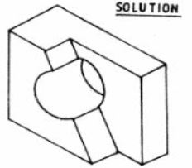

17

a) Suitable tools – 4 marks
i. Holding the workpiece firmly:
- Bench vice – 1 mark.
ii. Cutting the metal:
- Hacksaw – 1 mark.
iii. Removing small amounts of metal:
- File – 1 mark.
iv. Checking a right angle:
- Try square – 1 mark.

b) Factors when selecting a file – 2 marks
Any two, 1 mark each:
- Type/shape of file – selected according to the shape of the surface being worked.
- Coarseness/cut – rough files remove metal quickly; fine files give a smoother finish.
- Length/size – should be suitable for the size of the workpiece.
- Required finish – a finer file is selected for a smooth finish.
- Material being filed – the file should be appropriate for the metal.

c) Hacksaw safety precautions – 2 marks
Any two, 1 mark each:
- Secure the workpiece firmly in a vice.
- Wear safety goggles.
- Use a suitable blade.
- Ensure the blade is correctly tensioned.
- Keep fingers away from the cutting path.
- Do not use a damaged blade.
- Use controlled cutting strokes.

d) Maintenance of hand tools – 2 marks
Any two, 1 mark each:
- Clean tools after use.
- Store tools in their proper places.
- Oil metal surfaces to prevent rust.
- Keep cutting edges protected.
- Repair or replace damaged tools.
- Keep tools dry.

18

a) Suitable metals – 4 marks
i. School gate:
- Mild steel – 1 mark.
ii. Electrical connecting wire:
- Copper – 1 mark.
iii. Lightweight sheet-metal container:
- Aluminium – 1 mark.
iv. Corrosion-resistant component:
- Stainless steel – 1 mark.
Accept aluminium for iv where appropriately justified.

b) Properties of mild steel – 2 marks
Any two, 1 mark each:
- Strong
- Tough
- Ductile
- Easily welded
- Easily machined
- Easily formed
- Relatively inexpensive
- Readily available

c) Advantages of aluminium in sheet-metal work – 2 marks
Any two, 1 mark each:
- Lightweight
- Good corrosion resistance
- Easy to form
- Good appearance
- Good thermal conductivity
- Recyclable
- Good strength-to-weight ratio

d) Factors influencing choice of metal – 2 marks
Any two, 1 mark each:
- Strength required
- Cost
- Availability
- Corrosion resistance
- Weight
- Hardness
- Ductility
- Malleability
- Intended use
- Ease of fabrication
- Appearance
- Electrical/thermal conductivity

19

a) Type of pictorial drawing – 1 mark
- Oblique drawing – 1 mark.

b) Characteristics – 2 marks
Any two, 1 mark each:
- The front face is normally drawn in its true shape and size.
- Receding lines are drawn at an angle, commonly 45°.
- Parallel lines remain parallel.
- Depth is represented by receding lines.
- It gives a three-dimensional appearance.

c) Purpose of scale – 2 marks
1 mark each:
- To represent an object larger or smaller than its actual size while maintaining its proportions.
- To enable objects that are too large or too small to be conveniently represented on a drawing sheet.

d) Drawing instruments – 3 marks
Any three, 1 mark each:
- Drawing board
- T-square
- Set square
- Scale rule
- Compass
- Protractor
- Ruler
- Pencil
- Drawing instrument set

e) Qualities of a good technical drawing – 2 marks
Any two, 1 mark each:
- Accurate
- Neat
- Clear
- Properly dimensioned
- Correctly scaled
- Well proportioned
- Uses standard conventions
- Correct line work
- Legible

20

a) Identification of X, Y and Z – 3 marks
The actual three joint diagrams are not visible in the supplied text. Use the diagrams in the printed paper to determine the exact identification.
If the intended diagrams correspond to the common three sheet-metal joints:
- X – Butt joint – 1 mark
- Y – Lap joint – 1 mark
- Z – Seam joint – 1 mark

b) Methods of joining sheet metal – 3 marks
Any three, 1 mark each:
- Riveting
- Soldering
- Brazing
- Welding
- Screwing/bolting
- Seaming/folding

c) Production of a riveted joint – 3 marks
Award 1 mark for each correctly described stage:
- Mark out the position of the joint and rivet holes on the two sheets.
- Place/align the sheets and drill or punch the rivet holes through them.
- Insert the rivet through the holes and form the rivet head using suitable riveting tools so that the sheets are firmly joined.

d) Safety precaution when drilling sheet metal – 1 mark
Any one:
- Wear safety goggles.
- Secure the workpiece firmly.
- Do not hold the workpiece by hand while drilling.
- Use the correct drill bit.
- Keep loose clothing and hair away from rotating parts.
- Remove swarf using a brush, not bare hands.

21

a) Four manufacturing operations – 4 marks
Any four, 1 mark each:
- Measuring
- Marking out
- Cutting
- Filing/deburring
- Bending
- Folding
- Seaming
- Riveting
- Soldering
- Finishing

b) Importance of marking out – 2 marks
1 mark each:
- It establishes the correct dimensions and shape before cutting.
- It reduces errors, material wastage and inaccurate cutting.

c) Methods of joining dustpan parts – 2 marks
Any two, 1 mark each:
- Riveting
- Soldering
- Brazing
- Welding
- Screwing/bolting
- Seaming

d) Evaluation of completed dustpan – 2 marks
Any two, 1 mark each:
- Check that dimensions conform to the design.
- Check that joints are strong and secure.
- Check that all sharp edges have been removed.
- Test whether the dustpan performs its intended function.
- Inspect the surface finish.
- Check overall appearance and workmanship.
- Check strength and stability.

KENYA CERTIFICATE OF BASIC EDUCATION

SENIOR SCHOOL ASSESSMENT

TERM 3: PROJECT BASED ASSESSMENT 2026
GRADE 10 – METAL TECHNOLOGY
Time: 2 Hours
LEARNER’S DETAILS
Name: _____________________________________________________________. School: ____________________________________________.
Assessment Number: _______________________________________________. Date: ____________________________________________.
School Code: ______________________________________________________. Signature: _______________________________________.

PRACTICAL PROJECT ASSESSMENT — 20 MARKS
Project: Fabrication of a Small Metal Tool Holder

Instructions to the Learner
- Read all instructions carefully before starting the project.
- Observe all workshop safety rules.
- Use the appropriate tools and equipment correctly.
- Measure and mark all dimensions accurately before cutting or forming.
- Produce a neat, functional and durable finished product.
- Submit the completed project together with your working area cleaned.

TASK
Using mild-steel sheet, fabricate a small wall-mounted tool holder suitable for storing small workshop tools such as screwdrivers, pliers and spanners.
The finished tool holder should consist of:
- A rectangular metal back plate.
- A bent lower support/lip for holding tools.
- Two mounting holes.
- Smooth and safe edges.
- A neat surface finish.

Suggested Dimensions
Part | Dimension
Overall back plate | 200 mm × 150 mm
Lower supporting lip | 200 mm × 40 mm
Mounting holes | 2 holes, approximately Ø8 mm
Distance between mounting holes | 140 mm
Material | 1.2–1.5 mm mild-steel sheet
Note: The teacher may adjust the dimensions depending on the available material and workshop facilities.

ASSESSMENT CRITERIA — 20 MARKS
No. | Assessment Area | Marks
1 | Interpretation of drawing and planning of work | 2
2 | Accurate measurement and marking out | 3
3 | Correct cutting/shearing of metal | 2
4 | Accurate drilling and positioning of holes | 2
5 | Correct bending/forming of the support lip | 3
6 | Quality of joints/assembly and structural strength | 2
7 | Accuracy of dimensions and overall shape | 2
8 | Surface finishing and removal of sharp edges | 2
9 | Safe use of tools, equipment and PPE | 1
10 | Housekeeping and time management | 1
TOTAL |  | 20

Expected Final Product
The completed tool holder should:
- Be correctly shaped and firmly constructed.
- Have accurately positioned mounting holes.
- Have the support lip bent to the required angle.
- Have no dangerous sharp edges.
- Be free from excessive scratches, burrs and deformation.
- Be strong enough to hold the intended tools.
- Demonstrate accurate use of measuring, marking, cutting, drilling, bending and finishing techniques.
Materials: Mild-steel sheet, abrasives and suitable fasteners.
Tools/equipment: Steel rule, scriber, try square, centre punch, hacksaw/shears, files, drilling machine, vice, hammer and bending equipment as appropriate.

GRADE 10 METAL TECHNOLOGY

PRACTICAL PROJECT — MARKING SCHEME
Project: Fabrication of a Small Metal Tool Holder
Total: 20 Marks
No. | Assessment Area | Expected Evidence / Performance | Marks
1 | Interpretation and planning | Identifies the required components, selects suitable material and plans the sequence of operations correctly. | 2
2 | Measurement and marking out | Measures accurately; marks the 200 mm × 150 mm plate; correctly locates the support lip and mounting holes; uses scriber, rule and try square correctly. | 3
3 | Cutting/shearing | Cuts the mild-steel sheet to the required dimensions with reasonably straight and accurate edges and minimum wastage. | 2
4 | Drilling | Correctly centre-punches and drills the two Ø8 mm mounting holes in the required positions; holes are clean and properly aligned. | 2
5 | Bending/forming | Forms the lower 40 mm support lip accurately; bend is straight, uniform and at the required angle. | 3
6 | Assembly/structural strength | Components are firmly assembled; finished holder is rigid, stable and capable of supporting small workshop tools. | 2
7 | Dimensional accuracy and shape | Overall dimensions and hole positions are within reasonable workshop tolerance; product is square and properly proportioned. | 2
8 | Finishing | Files and removes burrs/sharp edges; surfaces are reasonably smooth and the finished product has a neat appearance. | 2
9 | Safety | Uses PPE and tools safely; follows correct workshop procedures, particularly during cutting, drilling and bending. | 1
10 | Housekeeping and time management | Completes the task within the allocated time and leaves the work area and tools clean and orderly. | 1
 | TOTAL |  | 20

MARK ALLOCATION
1. Interpretation and planning — 2 marks
- Correct interpretation of the task/drawing — 1 mark
- Logical sequence of operations and appropriate tool/material selection — 1 mark
2. Measurement and marking out — 3 marks
- Accurate measurement of 200 mm × 150 mm plate — 1 mark
- Accurate marking of 40 mm support lip — 1 mark
- Correct location and marking of mounting holes — 1 mark
3. Cutting/shearing — 2 marks
- Correct cutting to required size — 1 mark
- Straight, reasonably accurate and clean edges — 1 mark
4. Drilling — 2 marks
- Correct centre-punching and positioning — 1 mark
- Correctly drilled, clean and properly aligned holes — 1 mark
5. Bending/forming — 3 marks
- Correct setting and clamping of work — 1 mark
- Straight and accurate bend — 1 mark
- Correct angle and uniform support lip — 1 mark
6. Assembly/strength — 2 marks
- Correct assembly/fixing — 1 mark
- Strong, rigid and functional product — 1 mark
7. Dimensional accuracy — 2 marks
- Dimensions conform reasonably to the specified sizes — 1 mark
- Product is square, symmetrical and properly proportioned — 1 mark
8. Finishing — 2 marks
- Removal of burrs and sharp edges — 1 mark
- Smooth and neat overall finish — 1 mark
9. Safety — 1 mark
- Correct PPE and safe handling of tools/equipment throughout — 1 mark
10. Housekeeping/time management — 1 mark
- Completes work on time and leaves the workshop clean and orderly — 1 mark

TOTAL: 20 MARKS

