KENYA CERTIFICATE OF BASIC EDUCATION

SENIOR SCHOOL ASSESSMENT

DECEMBER ASSIGNMENT 2026
GRADE 10 – MEDIA TECHNOLOGY
Time: 2 Hours
LEARNER’S DETAILS
Name: _____________________________________________________________. School: ____________________________________________.
Assessment Number: _______________________________________________. Date: ____________________________________________.
School Code: ______________________________________________________. Signature: _______________________________________.

INSTRUCTIONS TO CANDIDATES
- Write your details as required in the spaces above.
- This paper consists of two sections: A and B.
- Answer all questions in section A and section B.
- Answer the questions in English.
- All answers MUST be written in the spaces provided in the paper.
- Do NOT remove any page from this question paper.

FOR OFFICIAL USE ONLY (EXAMINER’S USE)
SECTION | SECTION A | SECTION B | % SCORE | EE1 | EE2 | ME1 | ME2 | AE1 | AE2 | BE1 | BE2
SCORE RANGE | 30 MARKS | 50 MARKS |  | 90-100 | 75-89 | 58-74 | 41-57 | 31-40 | 21-30 | 11-20 | 1-10
POINTS |  |  |  | 8 POINTS | 7 POINTS | 6 POINTS | 5 POINTS | 4 POINTS | 3 POINTS | 2 POINTS | 1 POINT
LEARNER’S TOTAL SCORE

SECTION A (30 MARKS)
Answer ALL questions in this section.
  - a) Explain the meaning of media content. (1 mark)
________________________________________________________________________________________________________
________________________________________________________________________________________________________
b) State three characteristics of effective media content. (3 marks)
i. _____________________________________________________________________________________________
ii. ____________________________________________________________________________________________
iii. ___________________________________________________________________________________________
c) Give two examples of media content that can be used to educate learners. (2 marks)
i. ____________________________________ ii. ___________________________________
  - a) Name the three major components of a media production. (3 marks)
i. _______________________________________________________________
ii. _______________________________________________________________
iii. _______________________________________________________________
b) State one importance of combining different media components when creating content. (1 mark)
________________________________________________________________________________________________________
________________________________________________________________________________________________________
c) Give one example of a multimedia production. (1 mark)
________________________________________________
  - A school environmental club wants to create a three-minute video encouraging learners to conserve water.
a) State two pieces of information that should be established before production begins. (2 marks)
i. ____________________________________________________________________________________________
ii. ____________________________________________________________________________________________
b) Explain three reasons why planning is important in media production. (3 marks)
i. ____________________________________________________________________________________________
ii. ____________________________________________________________________________________________
iii. ___________________________________________________________________________________________
  - a) State two safety precautions when handling media production equipment. (2 marks)
i. _____________________________________________________________________________________________
ii. _____________________________________________________________________________________________
b) State two ways of maintaining media equipment. (2 marks)
i. ____________________________________________________________________________________________
ii. ____________________________________________________________________________________________
  - a) What is meant by a target audience? (1 mark)
________________________________________________________________________________________________________
________________________________________________________________________________________________________

b) State two factors that can influence the choice of language in media content. (2 marks)
i. _____________________________________________________________________________________________
ii. ____________________________________________________________________________________________
c) Explain two reasons why media creators should understand their target audience. (2 marks)
i. _____________________________________________________________________________________________
ii. _____________________________________________________________________________________________

a) State two benefits of using social media to distribute media content. (2 marks)
i. _______________________________________________________________
ii. _______________________________________________________________
b) Identify one danger associated with sharing unverified media content online. (1 mark)
________________________________________________________________________________________________________
________________________________________________________________________________________________________
c) State two measures that can help a media creator verify information before publishing it. (2 marks)
i. _____________________________________________________________________________________________
ii. _____________________________________________________________________________________________

SECTION B: 50 MARKS
Answer ALL questions in this section.
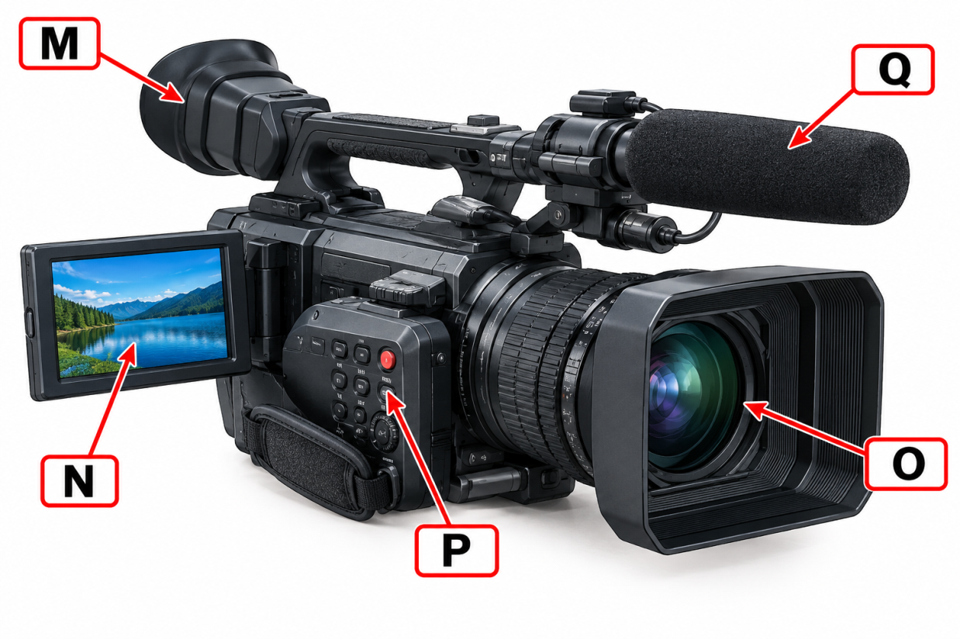
  - Study the simplified diagram of a video camera below.

a) Identify the components labelled A, B, C, D and E. (5 marks)
M. _________________________________________________________________
N. _________________________________________________________________
O. _________________________________________________________________
P. _________________________________________________________________
Q. _________________________________________________________________
b) State the function of the following:
i. Viewfinder _________________________________________________________________________ (1 mark)
ii. Lens _____________________________________________________________________________ (1 mark)
iii. Microphone _______________________________________________________________________(1 mark)
c) State two factors to consider when selecting a camera for a particular production. (2 marks)
i. _____________________________________________________________________________________________
ii. ____________________________________________________________________________________________
  - A learner is taking a photograph of a cultural performance at school.
a) State four principles or techniques of photographic composition that the learner could apply. (4 marks)
i. ____________________________________________________________________________________________
ii. ____________________________________________________________________________________________
iii. ____________________________________________________________________________________________
iv. ____________________________________________________________________________________________
b) Explain how each of the following can improve a photograph:
i. Rule of thirds (2 marks)
________________________________________________________________________________________________________
________________________________________________________________________________________________________
ii. Leading lines (2 marks)
________________________________________________________________________________________________________
________________________________________________________________________________________________________

c) State two factors that can make a photograph poorly composed. (2 marks)
i. ____________________________________________________________________________________________
ii. ____________________________________________________________________________________________
  - Study the audio recording arrangement below.
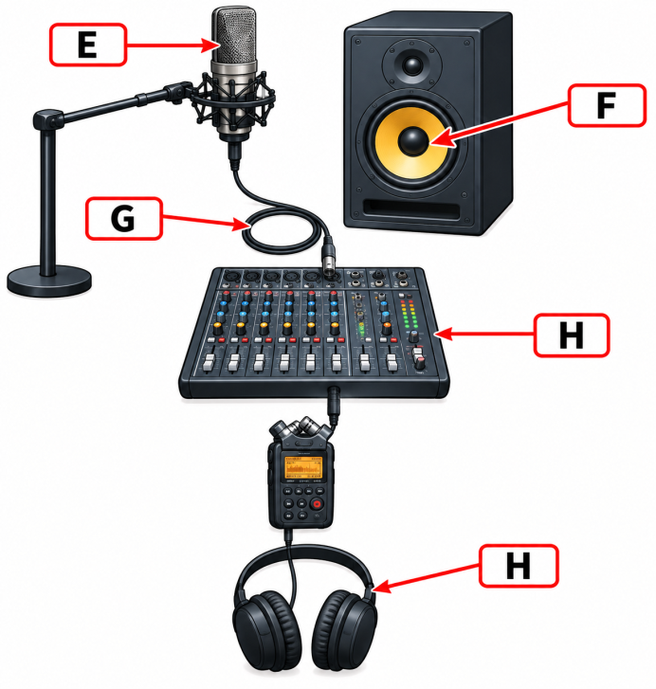
a) Identify the four pieces of equipment represented in the diagram. (4 marks)
i. _____________________________________________________________________________________________
ii. _____________________________________________________________________________________________
iii. ____________________________________________________________________________________________
iv. ____________________________________________________________________________________________
b) State the function of:
i. Audio mixer (1 mark)
________________________________________________________________________________________________________
________________________________________________________________________________________________________
ii. Audio recorder (1 mark)
________________________________________________________________________________________________________
________________________________________________________________________________________________________
iii. Headphones (1 mark)
________________________________________________________________________________________________________
________________________________________________________________________________________________________
c) Explain three causes of poor-quality sound during recording. (3 marks)
i. _____________________________________________________________________________________________
ii. _____________________________________________________________________________________________
iii. ____________________________________________________________________________________________
  - A media club produces a short news bulletin. During editing, the learners discover that some footage is unnecessary, the sound levels vary greatly and the opening lacks a title.
a) Identify three editing operations that should be performed. (3 marks)
i. _____________________________________________________________________________________________
ii. _____________________________________________________________________________________________
iii. ____________________________________________________________________________________________
b) Explain how each of the following can improve the final production:
i. Trimming (1 mark)
________________________________________________________________________________________________________
________________________________________________________________________________________________________
ii. Audio adjustment (1 mark)
________________________________________________________________________________________________________
________________________________________________________________________________________________________
iii. Adding titles (1 mark)
________________________________________________________________________________________________________
________________________________________________________________________________________________________
c) State two visual elements that may be added during video editing. (2 marks)
i. _____________________________________________________________________________________________
ii. _____________________________________________________________________________________________
d) State two considerations when choosing an output format for a video. (2 marks)
i. _____________________________________________________________________________________________
ii. _____________________________________________________________________________________________

  - A Grade 10 learner has developed skills in photography, video production and graphic design. The learner plans to start a small media enterprise serving schools and local businesses.
a) Identify three services that the learner could offer to clients. (3 marks)
i. _____________________________________________________________________________________________
ii. _____________________________________________________________________________________________
iii. ____________________________________________________________________________________________
b) Explain two ways the learner could market the media enterprise. (2 marks)
i. _____________________________________________________________________________________________
ii. _____________________________________________________________________________________________
c) State three factors that should be considered when setting prices for media services. (3 marks)
i. _____________________________________________________________________________________________
ii. _____________________________________________________________________________________________
iii. ____________________________________________________________________________________________
d) State two qualities of a successful media entrepreneur. (2 marks)
i. _____________________________________________________________________________________________
ii. _____________________________________________________________________________________________

THIS IS THE LAST PRINTED PAGE

GRADE 10 MEDIA TECHNOLOGY

MARKING SCHEME / ANSWERS

SECTION A 30 MARKS

1:
a) Meaning of media content
Media content refers to information, messages, ideas or materials created and communicated to an audience through a media platform. (1)
b) Characteristics of effective media content
Any three:
- Clear and understandable.
- Accurate and factual.
- Relevant to the target audience.
- Engaging/interesting.
- Appropriate to the purpose.
- Creative.
- Well organised.
- Ethical and responsible.
3 × 1 = 3 marks
c) Media content used to educate learners
Any two:
- Educational videos.
- Podcasts/audio lessons.
- Digital presentations.
- Educational photographs/infographics.
- E-books.
- Educational television programmes.
- Online tutorials.
- Documentaries.
2 × 1 = 2 marks

2:
a) Three major media components
Accept:
i. Text (1)
ii. Images/graphics (1)
iii. Audio/video (1)
Other appropriate media components such as animation may be accepted where correctly explained.
b) Importance of combining different media components
- It makes content more engaging and easier to understand by presenting information in different forms. (1)
c) Example of a multimedia production
Any one:
- Educational presentation containing text, images, sound and video.
- Interactive website.
- Multimedia advertisement.
- Digital documentary.
- Educational video with graphics and narration.
(1)

3:

a) Information to establish before production
Any two:
- Purpose/objective of the video.
- Target audience.
- Main message.
- Content/topic.
- Duration.
- Location.
- Available resources.
- Production schedule.
- Budget.
- Required personnel/equipment.
2 × 1 = 2 marks

b) Importance of planning
Any three explained points:
- Saves time – Activities are organised before production begins. (1)
- Controls resources/costs – Equipment, personnel and finances can be planned properly. (1)
- Improves quality – Proper preparation helps producers achieve the intended message and production standards. (1)
Other acceptable points:
- Reduces errors.
- Ensures appropriate equipment is available.
- Clarifies roles and responsibilities.
- Helps meet deadlines.
- Identifies potential problems early.
3 × 1 = 3 marks

4:

a) Safety precautions
Any two:
- Handle equipment carefully.
- Keep electrical equipment away from water.
- Switch off equipment before connecting/disconnecting cables where appropriate.
- Avoid overloading electrical sockets.
- Store equipment safely after use.
- Use equipment according to manufacturer's instructions.
- Keep cables properly arranged to prevent tripping.
- Do not operate damaged equipment.
2 × 1 = 2 marks

b) Equipment maintenance
Any two:
- Clean equipment regularly.
- Store equipment in appropriate cases.
- Keep equipment dry and dust-free.
- Charge/store batteries appropriately.
- Inspect cables regularly.
- Carry out regular servicing.
- Protect lenses with caps.
- Keep equipment away from excessive heat/moisture.
2 × 1 = 2 marks

5:

a) Target audience
The target audience is the specific group of people for whom a media message or production is intended. (1)

b) Factors influencing choice of language
Any two:
- Age of audience.
- Education level.
- Cultural background.
- Language proficiency.
- Purpose of the media content.
- Location of audience.
- Nature of the subject.
- Formality required.
2 × 1 = 2 marks

c) Importance of understanding the target audience
Any two explained:
- Helps select appropriate language and presentation style so that the audience can understand the message. (1)
- Makes content more relevant and engaging to the intended audience. (1)
Other acceptable answers:
- Helps select the appropriate media platform.
- Helps determine suitable images and sounds.
- Improves communication effectiveness.
- Helps meet audience needs.
- Can increase audience participation.
2 × 1 = 2 marks

6:

a) Benefits of social media distribution
Any two:
- Reaches a large audience quickly.
- Allows rapid sharing.
- Enables audience interaction and feedback.
- Relatively inexpensive to distribute.
- Allows multimedia content.
- Can reach audiences beyond geographical boundaries.
- Content can be updated easily.
2 × 1 = 2 marks

b) Danger of sharing unverified content
Any one:
- Spreads misinformation/disinformation.
- Can damage someone's reputation.
- May cause fear or confusion.
- Can lead to conflict.
- May result in legal or ethical consequences.
(1 mark)

c) Ways of verifying information
Any two:
- Check reliable/authoritative sources.
- Compare information from several credible sources.
- Check the original source of the information.
- Verify the date and context.
- Consult recognised experts or official institutions.
- Check whether photographs/videos have been manipulated or taken out of context.
2 × 1 = 2 marks

7:

a) Identification [5 marks]
Based on Figure 1:
A. Viewfinder (1)
B. LCD screen/display (1)
C. Lens (1)
D. Control/button (1)
E. Microphone (1)
Note: Where the learner identifies D more specifically as a recording control, shutter/record button or camera control, award the mark if appropriate to the indicated position.

b) Functions
i. Viewfinder
Used to view and frame the subject/scene being captured. (1)
ii. Lens
Collects and focuses light to form an image on the camera sensor. (1)
iii. Microphone
Captures sound/audio during recording. (1)

c) Factors when selecting a camera
Any two:
- Image/video quality or resolution.
- Sensor quality.
- Lens compatibility.
- Zoom capability.
- Low-light performance.
- Storage capacity.
- Battery life.
- Portability.
- Cost/budget.
- Recording features.
- Audio inputs.
- Intended purpose of production.
2 × 1 = 2 marks

8:

a) Four principles/techniques of composition
Any four:
- Rule of thirds.
- Leading lines.
- Balance.
- Symmetry.
- Framing.
- Depth.
- Perspective.
- Pattern/repetition.
- Negative space.
- Proper background selection.
- Appropriate point of view.
4 × 1 = 4 marks

b) Explanation
i. Rule of thirds
Divides the image into a grid of nine sections and places important subjects along the lines or at their intersections to create a balanced and visually appealing composition. (2)
ii. Leading lines
Uses lines within the scene to guide the viewer's eyes towards the main subject or through the photograph. (2)

c) Causes of poor composition
Any two:
- Distracting background.
- Poor framing.
- Subject placed awkwardly.
- Excessive empty space.
- Poor balance.
- Unwanted objects in the frame.
- Incorrect camera angle.
- Subject cut off unintentionally.
- Poor lighting affecting visibility.
2 × 1 = 2 marks

9:

a) Equipment identification [4 marks]
i. Microphone (1)
ii. Audio mixer (1)
iii. Audio recorder (1)
iv. Headphones (1)

b) Functions
i. Audio mixer
Combines, balances and controls audio signals from different sources. (1)
ii. Audio recorder
Records and stores audio signals for later playback/editing. (1)
iii. Headphones
Allow the sound operator to monitor the recorded/ incoming audio and detect problems such as noise or distortion. (1)

c) Causes of poor-quality sound
Any three:
- Background/environmental noise.
- Microphone placed too far from the speaker.
- Excessively high or low recording levels.
- Damaged microphone/cables.
- Wind noise.
- Electrical interference.
- Poor microphone positioning.
- Acoustic echo/reverberation.
- Failure to monitor sound.
- Distortion caused by excessive volume.
3 × 1 = 3 marks

10:

a) Editing operations
Any three:
- Trimming/cutting unwanted footage. (1)
- Adjusting audio levels. (1)
- Adding titles. (1)
- Arranging clips in sequence.
- Adding transitions.
- Colour correction.
- Adding background music.
- Removing unwanted audio.
- Adding captions.
3 × 1 = 3 marks

b) How the operations improve the production
i. Trimming
Removes unnecessary footage and makes the programme shorter, clearer and more focused. (1)
ii. Audio adjustment
Balances sound levels so that speech can be heard clearly and audio is not excessively loud or quiet. (1)
iii. Adding titles
Identifies the programme, speakers, topics or sections and provides viewers with useful information. (1)

c) Visual elements
Any two:
- Titles.
- Captions.
- Graphics.
- Logos.
- Transitions.
- Photographs.
- Animation.
- Lower-thirds.
- Charts/infographics.
2 × 1 = 2 marks

d) Output format considerations
Any two:
- Intended playback/distribution platform.
- Compatibility with devices/software.
- Required video quality/resolution.
- File size.
- Available storage/bandwidth.
- Compression requirements.
- Audio/video quality.
2 × 1 = 2 marks

11:

a) Services the learner could offer
Any three:
- Photography services.
- Video recording.
- Video editing.
- Graphic design.
- Poster/banner design.
- Social media content creation.
- Event coverage.
- Advertisement production.
- Audio recording.
- Logo design.
- Documentary production.
- Livestreaming services.
3 × 1 = 3 marks

b) Ways of marketing the enterprise
Any two explained:
- Social media marketing – Display samples of work and services on suitable social media platforms to reach potential customers. (1)
- Direct/local promotion – Visit schools and businesses, distribute promotional materials or use referrals to attract clients. (1)
Other acceptable answers:
- Website/online portfolio.
- Word-of-mouth referrals.
- Posters and brochures.
- Networking.
- Promotional offers.
- Community events.
- Partnerships with organisations.
2 × 1 = 2 marks

c) Factors when setting prices
Any three:
- Cost of equipment and materials.
- Time required for the job.
- Labour/personnel costs.
- Transport costs.
- Complexity of the assignment.
- Client requirements.
- Quality of service.
- Market/competitor prices.
- Business operating expenses.
- Desired profit.
- Editing requirements.
- Number of deliverables.
3 × 1 = 3 marks

d) Qualities of a successful media entrepreneur
Any two:
- Creativity.
- Innovation.
- Good communication skills.
- Technical competence.
- Business skills.
- Time management.
- Reliability.
- Adaptability.
- Problem-solving ability.
- Persistence.
- Professionalism.
- Ability to work with clients.
2 × 1 = 2 marks

KENYA CERTIFICATE OF BASIC EDUCATION

SENIOR SCHOOL ASSESSMENT

TERM 3 PROJECT BASED ASSESSMENT 2026
GRADE 10 – MEDIA TECHNOLOGY
Time: 2 Hours
LEARNER’S DETAILS
Name: _____________________________________________________________. School: ____________________________________________.
Assessment Number: _______________________________________________. Date: ____________________________________________.
School Code: ______________________________________________________. Signature: _______________________________________.

INSTRUCTIONS TO CANDIDATES

GRADE 10 MEDIA TECHNOLOGY

PROJECT ASSESSMENT — 20 MARKS
Project Title: Production of a Digital Promotional Poster

TASK
Design and produce a digital promotional poster for a school event, educational programme, community activity or school club.
The poster should promote the event clearly and attractively using appropriate media technology principles and digital design skills.

REQUIREMENTS
The poster should contain:
- A suitable title/headline.
- Appropriate images or graphics.
- Relevant information such as date, venue, time and contact information.
- Appropriate font styles and sizes.
- Suitable colour combinations.
- Good layout and spacing.
- A clear visual hierarchy.
- A final design that can be shared digitally or printed.
The learner may use available software such as Canva, Microsoft PowerPoint, Publisher, Photoshop, GIMP or another suitable digital design application.

MARKING SCHEME — 20 MARKS
Assessment Area | Marks
1. Interpretation of project brief and planning | 2
2. Appropriate selection and arrangement of text | 2
3. Selection and use of images/graphics | 3
4. Application of colour principles | 2
5. Layout, composition and spacing | 3
6. Use of typography/fonts | 2
7. Technical use of digital media software | 2
8. Creativity and originality | 2
9. Accuracy and completeness of information | 1
10. Presentation and file management | 1
TOTAL | 20

ASSESSMENT
1. Planning — 2 marks
- Clear interpretation of the brief — 1
- Evidence of planning/sketch or appropriate design concept — 1
2. Text — 2 marks
- Relevant and well-organised information — 1
- Clear hierarchy between heading, subheadings and body text — 1
3. Images/Graphics — 3 marks
- Appropriate images/graphics selected — 1
- Images positioned and sized appropriately — 1
- Images contribute effectively to the message — 1
4. Colour — 2 marks
- Appropriate colour combination — 1
- Good contrast and readability — 1
5. Layout and Composition — 3 marks
- Balanced arrangement of elements — 1
- Appropriate spacing and alignment — 1
- Clear focal point/visual hierarchy — 1
6. Typography — 2 marks
- Appropriate font styles — 1
- Consistent and readable font sizes — 1
7. Digital Software Skills — 2 marks
- Correct use of design tools such as text, shapes, images and alignment — 1
- Effective editing/resizing/cropping or other relevant digital techniques — 1
8. Creativity and Originality — 2 marks
- Creative approach to the design — 1
- Original and visually appealing final product — 1
9. Accuracy — 1 mark
- All important information is accurate, complete and free from spelling errors — 1
10. Presentation and File Management — 1 mark
- Final poster is neatly presented, correctly saved/exported and ready for digital sharing or printing — 1

EXPECTED PRODUCT
The learner should submit:
- One completed digital promotional poster
- The editable project file, where applicable
- A final exported copy in PDF, PNG or JPEG format
TOTAL: 20 MARKS

GRADE 10 MEDIA TECHNOLOGY

PROJECT ASSESSMENT — MARKING SCHEME
Project: Production of a Digital Promotional Poster
Total: 20 Marks
No. | Assessment Area | Marking Points | Marks
1 | Interpretation and planning | Correctly interprets the brief – 1; develops a suitable design concept/plan – 1 | 2
2 | Text content and arrangement | Relevant information – 1; clear organisation/hierarchy of text – 1 | 2
3 | Images and graphics | Appropriate images – 1; proper placement/scaling – 1; images support the message – 1 | 3
4 | Colour application | Suitable colour combination – 1; good contrast/readability – 1 | 2
5 | Layout and composition | Balanced arrangement – 1; effective spacing/alignment – 1; clear focal point – 1 | 3
6 | Typography | Appropriate font selection – 1; readable and consistent font sizes/styles – 1 | 2
7 | Digital technical skills | Correct use of design tools – 1; effective editing, cropping, resizing or positioning – 1 | 2
8 | Creativity and originality | Creative design concept – 1; originality and visual appeal – 1 | 2
9 | Accuracy of information | Correct spelling, dates, venue, time and other details – 1 | 1
10 | Presentation and file management | Neat final product, correctly saved/exported and suitable for sharing/printing – 1 | 1
 | TOTAL |  | 20

PERFORMANCE DESCRIPTORS
19–20 marks: EE — highly creative, technically proficient and professionally presented.
16–18 marks: ME — effective design with only minor weaknesses.
10–15 marks: AE — meets most requirements with some areas needing improvement.
-basic requirements achieved but significant improvement needed.
0–9 marks: BE — incomplete or demonstrates limited application of media technology skills.
TOTAL: 20 MARKS

