KENYA CERTIFICATE OF BASIC EDUCATION

SENIOR SCHOOL ASSESSMENT

DECEMBER ASSIGNMENT 2026
GRADE 10 – MARINE TECHNOLOGY
Time: 2 Hours
LEARNER’S DETAILS
Name: _____________________________________________________________. School: ____________________________________________.
Assessment Number: _______________________________________________. Date: ____________________________________________.
School Code: ______________________________________________________. Signature: _______________________________________.

INSTRUCTIONS TO CANDIDATES
- Write your details as required above
- This paper consists of two sections: A and B.
- Answer all questions in section A and section B.
- Answer the questions in English.
- All answers MUST be written in the spaces provided in the paper.
- Do NOT remove any page from this question paper.

FOR OFFICIAL USE ONLY (EXAMINER’S USE)
SECTION | SECTION A | SECTION B | % SCORE | EE1 | EE2 | ME1 | ME2 | AE1 | AE2 | BE1 | BE2
SCORE RANGE | 30 MARKS | 50 MARKS |  | 90-100 | 75-89 | 58-74 | 41-57 | 31-40 | 21-30 | 11-20 | 1-10
POINTS |  |  |  | 8 POINTS | 7 POINTS | 6 POINTS | 5 POINTS | 4 POINTS | 3 POINTS | 2 POINTS | 1 POINT
LEARNER’S TOTAL SCORE

SECTION A (30 MARKS) Answer ALL questions in this section.
  - a) Define the following terms:
i. Fisheries resource (1 mark)
.............................................................................................................................................................................................
.................................................................................................................... ……………………………………………….
ii. Capture fisheries (1 mark)
.............................................................................................................................................................................................
.................................................................................................................... ……………………………………………….
iii. Fishery (1 mark)
.............................................................................................................................................................................................
.................................................................................................................... ……………………………………………….
b) State three importance of fisheries resources to Kenyan communities. (3 marks)
i. .................................................................................................................
ii. .................................................................................................................
iii. .................................................................................................................
  - Study the illustration below.
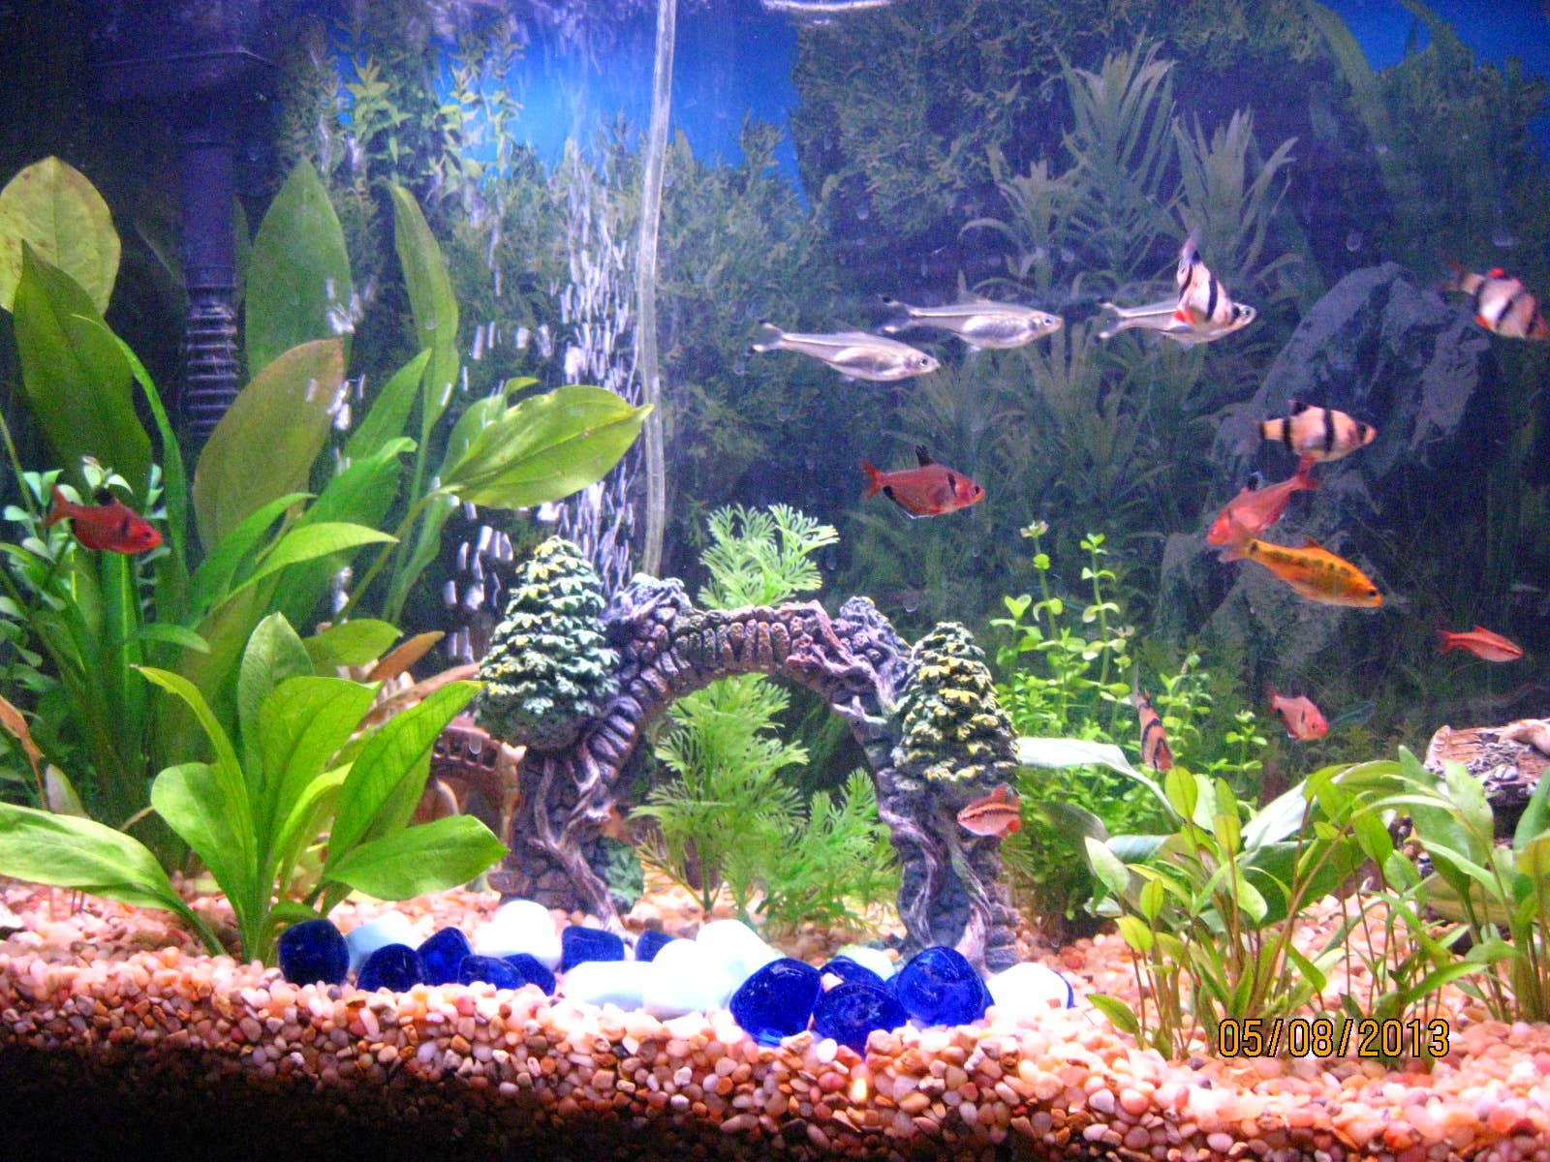
a) Identify the aquatic habitat represented by the illustration. (1 mark)
....................................................................................................................
b) State two biotic factors found in an aquatic ecosystem. (2 marks)
i. .................................................................................................................
ii. .................................................................................................................
c) State three abiotic factors that influence fish distribution in an aquatic ecosystem. (3 marks)
i. .................................................................................................................
ii. .................................................................................................................
iii. .................................................................................................................

  - Study the simplified fish diagram below.
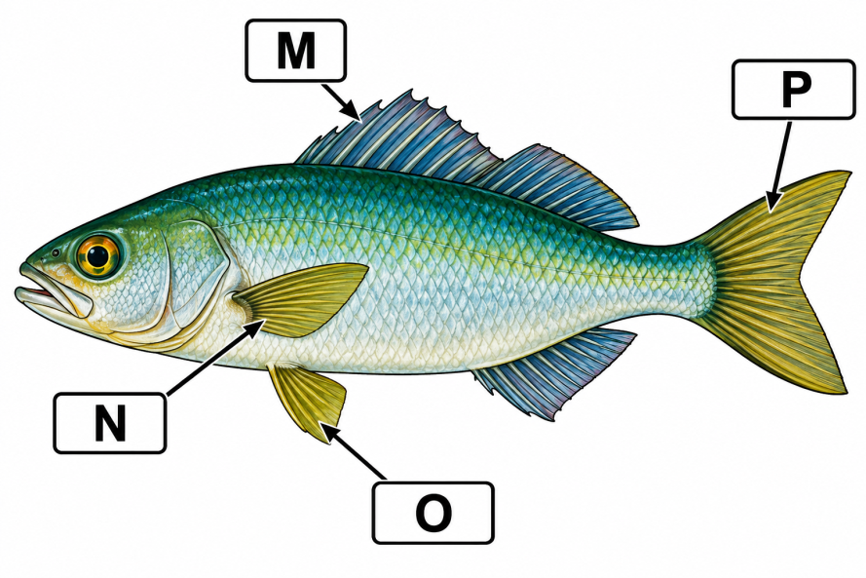
a) Identify the structures labelled M, N, O and P. (4 marks)
M. ...............................................................................................................
N. ...............................................................................................................
O. ...............................................................................................................
P. ...............................................................................................................
b) State two functions of fins in fish. (2 marks)
i. .........................................................................................................................................................................................
ii. ................................................................................................................. …………………………………..…………
  - A farmer wants to establish a fish pond on a piece of land near a river.
a) State four characteristics of a suitable site for fish pond construction. (4 marks)
i. ..........................................................................................................................................................................................
ii. ..........................................................................................................................................................................................
iii. ........................................................................................................................................................................................
iv. .........................................................................................................................................................................................

b) State two dangers of establishing a fish pond in a polluted area. (2 marks)
i. ...........................................................................................................................................................................................
ii. .....................................................................................................................................................................……………
  - a) Give three signs that may indicate poor health in cultured fish. (3 marks)
i. ..........................................................................................................................................................................................
ii. ..........................................................................................................................................................................................
iii. ........................................................................................................................................................................................
b) State three measures used to maintain good water quality in a fish pond. (3 marks)
i. ..........................................................................................................................................................................................
ii. ..........................................................................................................................................................................................
iii. ........................................................................................................................................................................................

SECTION B: 50 MARKS Answer ALL questions.
  - Fish possess various structural and physiological features that enable them to survive in aquatic environments.
a) Explain four ways in which the streamlined body of a fish contributes to survival in water. (4 marks)
i. ..........................................................................................................................................................................................
ii. ..........................................................................................................................................................................................
iii. ........................................................................................................................................................................................
iv. .........................................................................................................................................................................................
b) Explain the role of each of the following structures:
i. Gills (2 marks)
.............................................................................................................................................................................................
.................................................................................................................... ……………………………………………….
ii. Lateral line (2 marks)
.............................................................................................................................................................................................
.................................................................................................................... ……………………………………………….
c) State two adaptations that enable fish to maintain buoyancy. (2 marks)
i. ..........................................................................................................................................................................................
ii. ..........................................................................................................................................................................................
  - A school intends to establish a fish production project for learning and income generation.
a) Describe three types of aquaculture production systems. (6 marks)
i. ..........................................................................................................................................................................................
ii. ..........................................................................................................................................................................................
iii. ........................................................................................................................................................................................
b) A fish farmer stocks 2,000 fingerlings in a pond. During harvesting, 1,700 fish are recovered. Calculate the percentage survival rate. (3 marks)

c) State one reason why survival rate is important to an aquaculture farmer. (1 mark)
..........................................................................................................................................................................................................
....................................................................................................................……………………………………………………….…………………………
  - A farmer observes that fish in a pond are growing slowly despite regular feeding.
a) State four factors that should be considered when selecting fish feed. (4 marks)
i. ..........................................................................................................................................................................................
ii. ..........................................................................................................................................................................................
iii. ........................................................................................................................................................................................
iv. .........................................................................................................................................................................................
b) Explain three consequences of using poor-quality or inappropriate feed. (3 marks)
i. ..........................................................................................................................................................................................
ii. ..........................................................................................................................................................................................
iii. ........................................................................................................................................................................................
c) Explain three good feeding practices that a fish farmer should observe. (3 marks)
i. ..........................................................................................................................................................................................
ii. ..........................................................................................................................................................................................
iii. ........................................................................................................................................................................................
  - Study the fishing gear illustrations below.
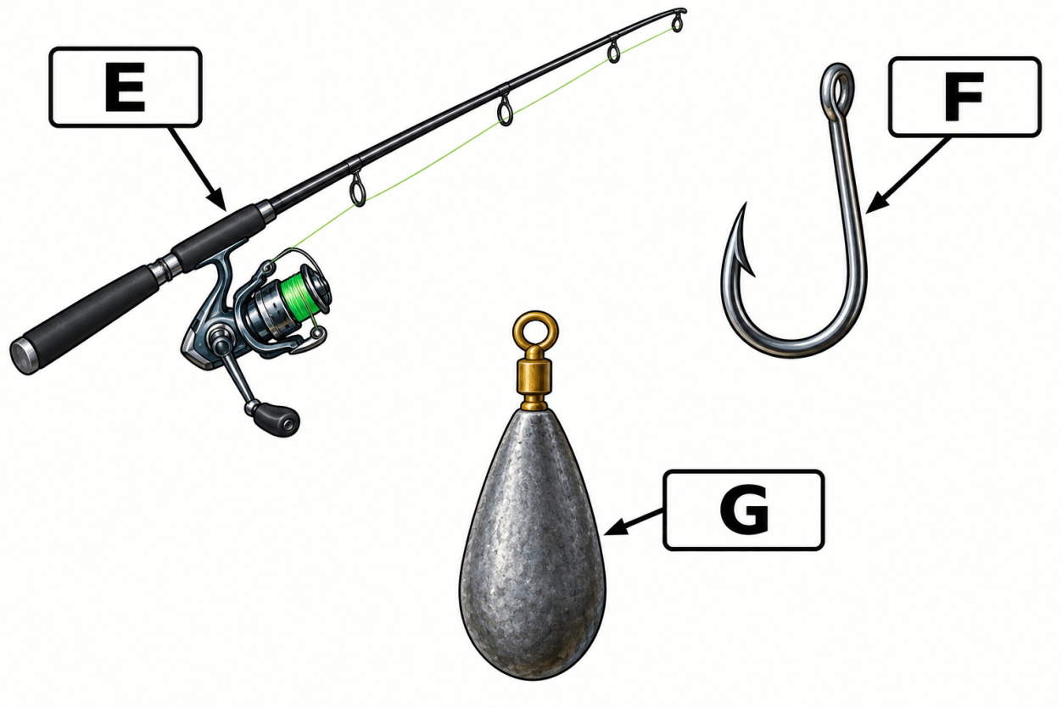

a) Identify the fishing gear represented by E, F and G. (3 marks)
E. ...............................................................................................................
F. ...............................................................................................................
G. ...............................................................................................................
b) State one advantage of each fishing tool. (3 marks)
E. ......................................................................................................................................................................................
F. .......................................................................................................................................................................................
G. .............................................................................................................................................................……………….
c) State two factors that should be considered when selecting fishing gear. (2 marks)
i. ..........................................................................................................................................................................................
ii. ..........................................................................................................................................................................................
d) Give two examples of responsible fishing practices. (2 marks)
i. ..........................................................................................................................................................................................
ii. ..........................................................................................................................................................................................
  - A group of learners visits a fishing community to study fishing operations. Before the fishing activity begins, the fisheries officer gives them safety instructions.
a) State four safety precautions that should be observed when working on or near water. (4 marks)
i. ..........................................................................................................................................................................................
ii. ..........................................................................................................................................................................................
iii. ........................................................................................................................................................................................
iv. .........................................................................................................................................................................................

b) Explain the importance of the following:
i. Life jacket/PFD (1 mark)
..........................................................................................................................................................................................................
....................................................................................................................……………………………………………………….…………………………
ii. First-aid kit (1 mark)
..........................................................................................................................................................................................................
....................................................................................................................……………………………………………………….…………………………
c) Explain two ways of conserving fisheries resources. (2 marks)
i. ..........................................................................................................................................................................................
ii. ..........................................................................................................................................................................................
d) State two entrepreneurial opportunities in marine and fisheries technology. (2 marks)
i. ..........................................................................................................................................................................................
ii. ..........................................................................................................................................................................................

THIS IS THE LAST PRINTED PAGE

GRADE 10 KENYA – MARINE TECHNOLOGY

MARKING SCHEME / ANSWERS

SECTION A — 30 MARKS

1:

a) Definitions
i. Fisheries resource
A living aquatic resource that can be harvested or utilised by people, such as fish and other aquatic organisms. (1 mark)
ii. Capture fisheries
The harvesting of fish and other aquatic organisms from their natural habitats without farming them. (1 mark)
iii. Fishery
An organised activity or industry involving the catching, processing, marketing and utilisation of fish and other aquatic resources. (1 mark)

b) Importance of fisheries resources
Any three:
- Provide food and nutritional protein.
- Create employment.
- Generate income for individuals and communities.
- Provide raw materials for fish-processing industries.
- Generate government revenue.
- Earn foreign exchange through exports.
- Promote development of fishing communities.
- Provide opportunities for entrepreneurship.
(3 marks)

2:

a) Identify the aquatic habitat.
Freshwater aquatic habitat/ecosystem. (1 mark)

b) Biotic factors
Any two:
- Fish.
- Aquatic plants.
- Algae.
- Plankton.
- Aquatic microorganisms.
- Predators.
- Decomposers.
(2 marks)

c) Abiotic factors
Any three:
- Water temperature.
- Dissolved oxygen.
- Salinity.
- Light penetration.
- Water depth.
- pH.
- Water currents.
- Turbidity.
- Nutrient concentration.
(3 marks)

3:

a) Identification
Accept the structure corresponding to the indicated position in the diagram:
M – Dorsal fin (1 mark)
N – Pectoral fin (1 mark)
O – Pelvic fin (1 mark)
P – Caudal fin/tail fin (1 mark)

b) Functions of fins
Any two:
- Provide propulsion.
- Assist in steering/direction.
- Maintain balance.
- Stabilise the fish.
- Assist in braking.
- Assist in changing direction.
(2 marks)

4:

a) Characteristics of a suitable fish-pond site
Any four:
- Reliable supply of clean water.
- Suitable soil, preferably soil with good water-retention capacity.
- Relatively level or gently sloping land.
- Free from flooding.
- Adequate sunlight.
- Accessible to roads and markets.
- Secure location.
- Suitable drainage.
- Adequate space.
- Free from sources of pollution.
(4 marks)

b) Dangers of establishing a pond in a polluted area
Any two:
- Fish may become sick or die.
- Water quality may deteriorate.
- Fish may accumulate harmful substances.
- Fish growth may be reduced.
- The fish may become unsafe for human consumption.
- Reproductive performance may be affected.
(2 marks)

5:

a) Signs of poor fish health
Any three:
- Loss of appetite.
- Slow growth.
- Abnormal swimming.
- Fish gasping at the water surface.
- External wounds or lesions.
- Discolouration.
- Excessive mucus production.
- Unusual mortality.
- Separation from the school.
- Damaged fins.
(3 marks)

b) Measures for maintaining good water quality
Any three:
- Regularly monitor water quality.
- Avoid overfeeding.
- Remove excess organic matter.
- Maintain appropriate stocking density.
- Control pollution.
- Maintain adequate dissolved oxygen.
- Remove dead fish promptly.
- Carry out appropriate water exchange.
- Prevent excessive accumulation of waste.
(3 marks)

SECTION B — 50 MARKS

6:

a) Ways the streamlined body assists fish survival
Any four:
- Reduces resistance/friction as the fish moves through water. (1)
- Allows efficient swimming. (1)
- Enables the fish to move rapidly when escaping predators. (1)
- Makes movement towards prey more efficient. (1)
- Reduces energy expenditure during swimming. (1)
Maximum: 4 marks

b) Functions
i. Gills
- Extract dissolved oxygen from water for respiration. (2 marks
Accept: They also assist in removing carbon dioxide.
ii. Lateral line
- Detects vibrations, pressure changes and movements in surrounding water, helping fish locate prey, avoid predators and maintain position. (2 marks)

c) Adaptations for buoyancy
Any two:
- Presence of a swim bladder in many bony fish.
- Adjustment of gas volume in the swim bladder.
- Control of body density.
- Use of fins and body movement to maintain position in water.
(2 marks)

7:

a) Types of aquaculture production systems
Any three well-described systems.
1. Pond culture
Fish are reared in constructed or modified earthen or concrete ponds. (2 marks)
2. Cage culture
Fish are kept in cages or net enclosures placed in natural water bodies such as lakes. (2 marks)
3. Tank culture
Fish are reared in artificial tanks where water and feeding conditions can be controlled. (2 marks)
Other acceptable systems include raceways and other recognised aquaculture production systems.
Maximum: 6 marks

b) Survival rate
Number stocked = 2,000
Number recovered = 1,700
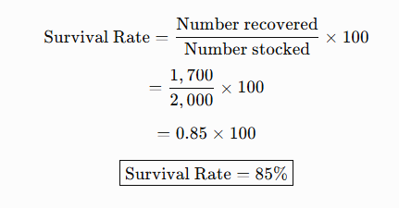

Award:
- Correct formula – 1 mark
- Correct substitution/calculation – 1 mark
- Correct answer – 1 mark
(3 marks)

c) Importance of survival rate
Any one:
- Helps determine the success of fish production.
- Helps the farmer estimate production losses.
- Assists in evaluating management practices.
- Helps in calculating expected harvest and income.
(1 mark)

8:

a) Factors considered when selecting fish feed
Any four:
- Nutritional requirements of the fish.
- Fish species.
- Size/age of fish.
- Growth stage.
- Digestibility of the feed.
- Availability of the feed.
- Cost of the feed.
- Water stability of the feed.
- Quality of ingredients.
- Feeding habits of the fish.
(4 marks)

b) Consequences of poor-quality/inappropriate feed
Any three explained:
1. Slow growth – fish do not receive adequate nutrients for proper development. (1)
2. Poor fish health – nutritional deficiencies may weaken fish and increase susceptibility to disease. (1)
3. Poor water quality – excess or uneaten feed decomposes and pollutes the pond. (1)
Other acceptable responses:
- Increased mortality.
- Poor feed-conversion efficiency.
- Increased production costs.
- Uneven growth.
- Reduced productivity.
(3 marks)

c) Good feeding practices
Any three:
- Feed fish at regular and appropriate times.
- Use feed appropriate for the species and size of fish.
- Provide the correct quantity.
- Spread feed evenly over the feeding area.
- Avoid overfeeding.
- Observe fish feeding behaviour.
- Adjust the ration according to fish growth and environmental conditions.
- Store feed in a cool, dry and clean place.
- Remove or manage excessive uneaten feed.
(3 marks)

9:

a) Identification of fishing methods
E – Fishing rod
F – Fishing hook
G – Sinker
Total: 3 marks

b) Advantages
E. Easy to use and suitable for catching fish individually.
F. Simple and inexpensive fishing equipment.
G. Helps the fishing line sink deeper into the water.
(1 mark)

c) Factors determining choice of fishing gear
Any two:
- Target species.
- Fish size.
- Fishing-ground depth.
- Type of water body.
- Behaviour of the fish.
- Cost of equipment.
- Fishing regulations.
- Availability of equipment.
(2 marks)

d) Responsible fishing practices
Any two:
- Use appropriate mesh sizes.
- Avoid catching juvenile fish.
- Observe closed seasons.
- Observe fishing quotas and regulations.
- Avoid destructive fishing methods.
- Protect breeding grounds.
- Avoid overfishing.
- Release protected/non-target species where required.
(2 marks)

10:

a) Safety precautions when working on or near water
Any four:
- Wear a properly fitted life jacket/PFD.
- Check weather and water conditions before departure.
- Inspect the boat before use.
- Do not overload the boat.
- Carry adequate communication equipment.
- Carry a first-aid kit.
- Have appropriate emergency/survival equipment.
- Follow navigation and fishing regulations.
- Avoid operating on water during dangerous weather.
- Ensure crew members understand emergency procedures.
(4 marks)

b) Importance of safety equipment
i. Life jacket/PFD
- Keeps a person afloat and reduces the risk of drowning if they fall into water. (1 mark)
ii. First-aid kit
- Provides materials for immediate treatment of injuries and minor emergencies. (1 mark)

c) Conservation of fisheries resources
Any two explained:
1. Use appropriate fishing gear and mesh sizes – prevents excessive capture of juvenile fish and allows stocks to reproduce. (1 mark)
2. Establish closed seasons or protected areas – allows fish to breed and nursery habitats to recover. (1 mark)
Other acceptable answers:
- Enforce fishing regulations.
- Control fishing effort.
- Protect breeding and nursery grounds.
- Prevent pollution.
- Control destructive fishing methods.
- Promote community participation in fisheries management.
(2 marks)

d) Entrepreneurial opportunities
Any two:
- Aquaculture farming.
- Fish trading.
- Fish processing.
- Fish transportation.
- Fish-feed production.
- Fishing gear manufacture or repair.
- Boat construction and repair.
- Fish hatchery operation.
- Fisheries consultancy.
- Marine equipment services.
(2 marks)

KENYA CERTIFICATE OF BASIC EDUCATION

SENIOR SCHOOL ASSESSMENT

TERM 3: PROJECT BASED ASSESSMENT 2026
GRADE 10 – MARINE TECHNOLOGY
LEARNER’S DETAILS
Name: _____________________________________________________________. School: ____________________________________________.
Assessment Number: _______________________________________________. Date: ____________________________________________.
School Code: ______________________________________________________. Signature: _______________________________________.

GRADE 10 MARINE TECHNOLOGY

PROJECT EXAMINATION — 20 MARKS
Project Title: Construction and Demonstration of a Simple Model Boat
Time: 2 Hours
Total Marks: 20

PROJECT TASK
Construct a simple model boat using locally available materials. The model should demonstrate basic principles of marine technology, including buoyancy, stability, propulsion and safe handling.
The completed model should be capable of floating on water and carrying a small load without capsizing.

SUGGESTED MATERIALS
- Light wood, cardboard, plastic sheet or other suitable material
- Adhesive, nails or suitable fasteners
- String/wire
- Small piece of plastic, wood or metal for a rudder
- Recycled materials where appropriate
- Small weight/load for testing

PROJECT REQUIREMENTS
The learner should:
- Prepare a simple design/sketch of the boat.
- Select appropriate materials.
- Construct the hull.
- Provide a suitable rudder or steering arrangement.
- Provide a simple propulsion system, such as a paddle, sail or rubber-band mechanism.
- Test the boat in water.
- Demonstrate that the boat floats and remains reasonably stable.
- Make improvements based on the test results.
- Observe workshop and water-safety procedures.
- Present the completed model and briefly explain how it works.

ASSESSMENT CRITERIA — 20 MARKS
No. | Assessment Area | Marks
1 | Interpretation of task and design/sketch | 2
2 | Selection and preparation of materials | 2
3 | Construction of the boat hull | 3
4 | Buoyancy and stability | 3
5 | Propulsion system | 2
6 | Steering/rudder system | 2
7 | Accuracy, workmanship and finishing | 2
8 | Testing and improvement of the model | 2
9 | Safety and responsible use of materials/tools | 1
10 | Presentation and explanation of the project | 1
TOTAL |  | 20

EXPECTED LEARNING OUTCOME
By the end of the project, the learner should demonstrate the ability to:
- Apply basic marine engineering principles in a practical situation.
- Explain how buoyancy enables a vessel to float.
- Demonstrate the importance of stability in boat design.
- Construct a simple marine model using appropriate materials.
- Apply basic techniques of fabrication, assembly and testing.
- Identify weaknesses in a design and make suitable improvements.
TOTAL: 20 MARKS

GRADE 10 MARINE TECHNOLOGY

PROJECT EXAMINATION — MARKING SCHEME
Project: Construction and Demonstration of a Simple Model Boat
Total: 20 Marks
No. | Assessment Area | Expected Performance | Marks
1 | Task interpretation and design | Correctly interprets the task – 1; produces a suitable labelled sketch/design before construction – 1 | 2
2 | Materials selection and preparation | Selects suitable lightweight materials – 1; prepares and uses materials appropriately – 1 | 2
3 | Hull construction | Constructs a suitable hull shape – 1; joins/components are secure – 1; hull is reasonably watertight – 1 | 3
4 | Buoyancy and stability | Boat floats – 1; remains stable without easily capsizing – 1; demonstrates understanding/application of buoyancy – 1 | 3
5 | Propulsion system | Provides a functional propulsion mechanism – 1; demonstrates movement through water – 1 | 2
6 | Steering/rudder system | Correctly fits a rudder/steering arrangement – 1; demonstrates reasonable directional control – 1 | 2
7 | Accuracy, workmanship and finishing | Accurate construction and good proportions – 1; neat, secure and safe finishing – 1 | 2
8 | Testing and improvement | Tests the model appropriately – 1; identifies a weakness and makes a suitable improvement – 1 | 2
9 | Safety | Uses tools/materials safely and observes appropriate water/workshop safety procedures – 1 | 1
10 | Presentation and explanation | Presents the completed model neatly and clearly explains its construction and operation – 1 | 1
 | TOTAL |  | 20

MARKING GUIDE
1. Task interpretation and design — 2 marks
- Correct interpretation of the model boat requirements — 1 mark
- Suitable labelled sketch/design showing the intended boat — 1 mark
2. Materials selection and preparation — 2 marks
- Appropriate materials selected according to the design — 1 mark
- Materials prepared and handled correctly — 1 mark
3. Hull construction — 3 marks
- Appropriate hull constructed — 1 mark
- Components securely joined — 1 mark
- Hull is sufficiently watertight — 1 mark
4. Buoyancy and stability — 3 marks
- Model floats successfully — 1 mark
- Model remains reasonably stable on water — 1 mark
- Demonstrates practical application of buoyancy/stability principles — 1 mark
5. Propulsion — 2 marks
- Functional propulsion mechanism fitted — 1 mark
- Boat moves through water under its own propulsion — 1 mark
6. Steering/rudder — 2 marks
- Suitable rudder/steering system fitted — 1 mark
- Rudder provides reasonable directional control — 1 mark
7. Workmanship and finishing — 2 marks
- Accurate and well-proportioned construction — 1 mark
- Neat, secure and safe finish — 1 mark
8. Testing and improvement — 2 marks
- Conducts a practical water test — 1 mark
- Makes an appropriate improvement based on test results — 1 mark
9. Safety — 1 mark
- Correctly observes safety procedures when using tools, materials and water — 1 mark
10. Presentation and explanation — 1 mark
- Clearly presents and explains how the model works — 1 mark

TOTAL: 20 MARKS

