KENYA CERTIFICATE OF BASIC EDUCATION

SENIOR SCHOOL ASSESSMENT

DECEMBER ASSIGNMENT 2026
GRADE 10 – GENERAL SCIENCE
Time: 2 Hours
LEARNER’S DETAILS
Name: _____________________________________________________________. School: ____________________________________________.
Assessment Number: _______________________________________________. Date: ____________________________________________.
School Code: ______________________________________________________. Signature: _______________________________________.

INSTRUCTIONS TO CANDIDATES
- Write your name in the spaces provided above.
- Write the name of your school and your stream in the spaces provided.
- Write your admission number and the date of the assessment in the spaces provided.
- This paper consists of two sections: A and B.
- Answer all questions in section A and section B.
- Answer the questions in English.
- All answers MUST be written in the spaces provided in PAPER.
- Do NOT remove any page from this question paper.

FOR OFFICIAL USE ONLY (EXAMINER’S USE)
SECTION | SECTION A | SECTION B | % SCORE | EE1 | EE2 | ME1 | ME2 | AE1 | AE2 | BE1 | BE2
SCORE RANGE | 35 MARKS | 45 MARKS |  | 90-100 | 75-89 | 58-74 | 41-57 | 31-40 | 21-30 | 11-20 | 1-10
POINTS |  |  |  | 8 POINTS | 7 POINTS | 6 POINTS | 5 POINTS | 4 POINTS | 3 POINTS | 2 POINTS | 1 POINT
LEARNER’S TOTAL SCORE

SECTION A (35 MARKS)
Answer ALL questions in this section.

1. a) Explain what is meant by scientific knowledge. (1 mark)
______________________________________________________________________________________________________________________________________________________________________________________________
b) State three ways in which science and technology have improved life in Kenya. (3 marks)
- _________________________________________________________________________________________
- _________________________________________________________________________________________
- _________________________________________________________________________________________

c) State one reason why scientific investigations should be based on evidence. (1 mark)
_______________________________________________________________________________________________


2. Study the apparatus represented below.

a) Identify the apparatus shown. (1 mark)
_________________________________________________
b) State two uses of this apparatus in a science laboratory. (2 marks)
- _________________________________________________________________________________________
- _________________________________________________________________________________________
c) State two precautions that should be observed when heating substances in a laboratory. (2 marks)
- _________________________________________________________________________________________
- _________________________________________________________________________________________

3. A learner observed cells from a leaf under a light microscope.
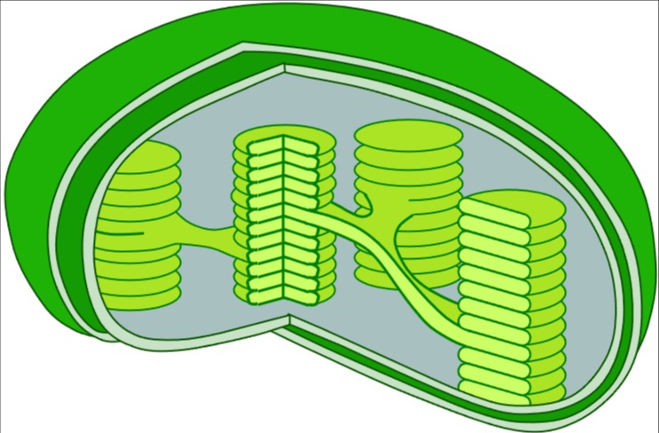
a) Identify the type of cell most likely represented by the diagram. (1 mark)
__________________________________________________
b) Name the structures represented by the small oval bodies marked in the diagram. (1 mark)
__________________________________________________
c) State the function of these structures. (1 mark)
_____________________________________________________________________________________________
d) Give two differences between a plant cell and an animal cell. (2 marks)
 | Plant cell | Animal cell

i

ii

4.
Grass → Grasshopper → Frog → Snake → Hawk
a) Identify the producer in the food chain. _____________________________________(1 mark)
b) Identify the primary consumer. _____________________________________(1 mark)
c) State the role of decomposers in an ecosystem. (1 mark)
__________________________________________________________________________________________
d) Explain what would happen to the frog population if the number of grasshoppers decreased greatly. (2 marks)

________________________________________________________________________________________________________________________________________________________________________

5. A mixture contains sand, salt and water.
a) Name the first method that can be used to remove the sand from the mixture. (1 mark)
_________________________________________________________
b) Describe how salt can be recovered from the remaining solution. (2 marks)

________________________________________________________________________________________________________________________________________________________________________________________________________________________________________________________________________________________________________________________________________________
c) State one difference between a physical change and a chemical change. (1 mark)

________________________________________________________________________________________________________________________________________________________________________
d) Give one example of a chemical change in everyday life. (1 mark)

________________________________________________________________________________________________________________________________________________________________________

6. The figure below shows a hydraulic press P which is used to raise a load of 10KN. A force F of 25N is applied at the end of a lever pivoted at O to raise the load
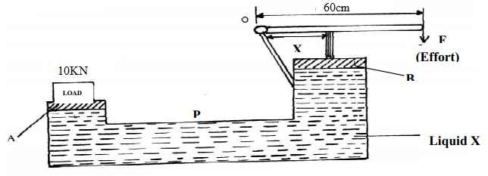
a) State one property of liquid X
______________________________________________________________________________________________________________________________________________________________________________________________

b) Determine the distance x indicated on the press if force on piston B is 100N
______________________________________________________________________________________________________________________________________________________________________________________________
c) State one way of increasing pressure when the applied force remains constant. (1 mark)

______________________________________________________________________________________________________________________________________________________________________________________________

SECTION B: 50 MARKS
Answer ALL questions in this section.

7. A learner carried out an experiment to investigate the importance of light in photosynthesis. Part of a healthy plant was covered with opaque paper and the plant was exposed to sunlight for several hours. The leaf was later tested for starch.
a) State the purpose of covering part of the leaf with opaque paper. (1 mark)
______________________________________________________________________________________________________________________________________________________________________________________________
b) Name the food substance tested for in the leaf. (1 mark) ______________________________________________________________________________________________________________________________________________________________________________________________
c) Name the reagent used to test for the substance in (b). (1 mark) ______________________________________________________________________________________________________________________________________________________________________________________________
d) State the colour change expected when the test is positive. (1 mark) ______________________________________________________________________________________________________________________________________________________________________________________________
e) Write the word equation for photosynthesis. (2 marks) ______________________________________________________________________________________________________________________________________________________________________________________________
f) State two conditions necessary for photosynthesis apart from light. (2 marks)
- _________________________________________________________________________________________
- _________________________________________________________________________________________

8. Study the diagram of the female reproductive system.

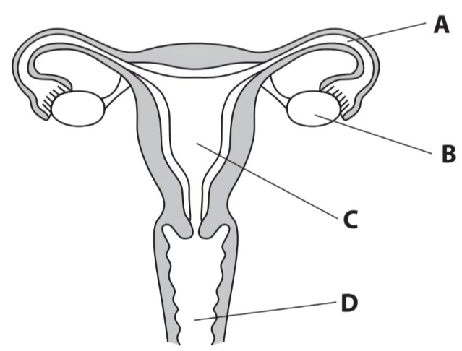
a) Name the part marked C. (1 mark)
____________________________________________________
b) State the function of the marked A. (2 marks)
_____________________________________________________________________________________________
c) Define fertilisation. (2 marks)
______________________________________________________________________________________________________________________________________________________________________________________________
d) Distinguish between puberty and adolescence. (2 marks)
______________________________________________________________________________________________________________________________________________________________________________________________
e) State one importance of reproductive health education among adolescents. (1 mark)
______________________________________________________________________________________________________________________________________________________________________________________________

9. A community experiences an outbreak of a water-borne disease after heavy rainfall. Several residents develop diarrhoea and vomiting.
a) Explain how contaminated water can cause disease. (2 marks)
______________________________________________________________________________________________________________________________________________________________________________________________

b) State three measures that can be used to prevent water-borne diseases. (3 marks)
- _________________________________________________________________________________________
- _________________________________________________________________________________________
- _________________________________________________________________________________________
c) Distinguish between a pathogen and a vector. (2 marks)
______________________________________________________________________________________________________________________________________________________________________________________________
d) Give one example of a disease transmitted by a vector. (1 mark)
______________________________________________________________________________________________________________________________________________________________________________________________

10. A learner placed dilute hydrochloric acid in a flask and added calcium carbonate chips. The flask was connected to a gas collection system.
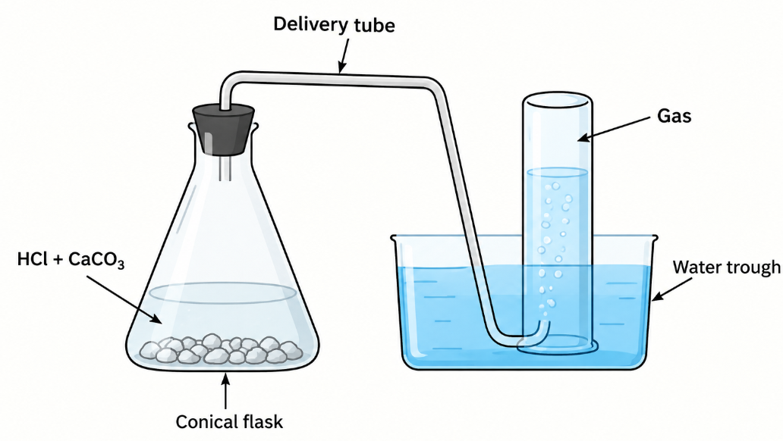
a) Name the gas produced in the reaction. (1 mark)
_____________________________________________
b) Describe a simple test for the gas. (2 marks)
______________________________________________________________________________________________________________________________________________________________________________________________
c) Write the word equation for the reaction. (2 marks)
______________________________________________________________________________________________________________________________________________________________________________________________
d) State two observations that would be made during the reaction. (2 marks)
- _________________________________________________________________________________________
- _________________________________________________________________________________________

e) Explain the meaning of the law of conservation of mass. (2 marks)
______________________________________________________________________________________________________________________________________________________________________________________________

11. A learner uses a simple machine to raise a load of 400 N by applying an effort of 100 N.
a) Define a machine. (1 mark)
______________________________________________________________________________________________________________________________________________________________________________________________
b) Calculate the mechanical advantage of the machine. (2 marks)

c) State two advantages of using machines. (2 marks)
- _________________________________________________________________________________________
- _________________________________________________________________________________________
d) If the machine has a velocity ratio of 5, calculate its efficiency. (2 marks)

e) Give one example of a simple machine used in the home. (1 mark)
__________________________________________________________________

12. Study the circuit below.
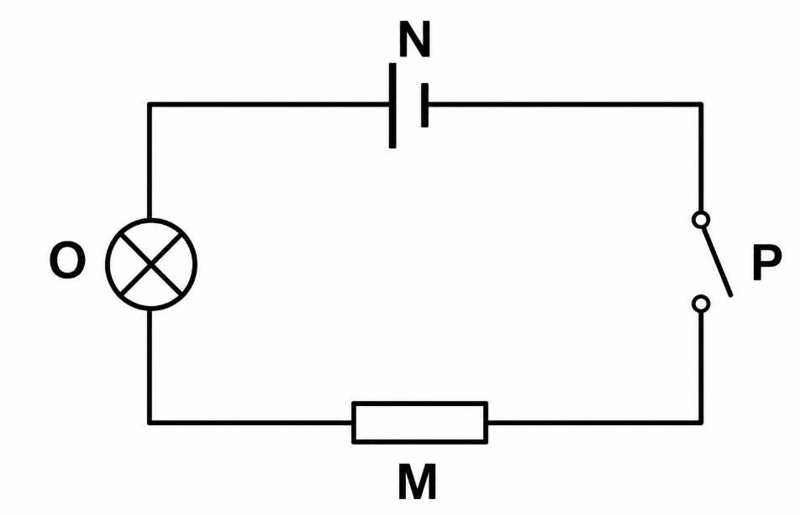
a) Identify component O. _______________________________ (1 mark)
b) Identify component N. ________________________________ (1 mark)
c) State the function of part labeled P. (1 mark)
d) Distinguish between conductors and insulators. (2 marks)
e) State two causes of electrical accidents in the home. (2 marks)
- _________________________________________________________________________________________
- _________________________________________________________________________________________
f) State two measures for preventing electrical accidents. (2 marks)
- _________________________________________________________________________________________
- _________________________________________________________________________________________

13. A metal block has a mass of 540 g and a volume of 200 cm³.
a) Define density. (1 mark)
______________________________________________________________________________________________________________________________________________________________________________________________
b) State the formula for density. (1 mark)

c) Calculate the density of the metal block. (2 marks)

d) State whether the block would float or sink in water if the density of water is 1 g/cm³. Give a reason for your answer. (2 marks)

e) State two factors that determine whether an object floats or sinks in a fluid. (2 marks)
- _________________________________________________________________________________________
- _________________________________________________________________________________________

THIS IS THE LAST PRINTED PAGE

GRADE 10 GENERAL SCIENCE

END OF YEAR EXAMINATION – SET 2

MARKING SCHEME / ANSWERS

SECTION A – 30 MARKS

1.
a) Scientific knowledge is knowledge obtained through systematic observation, experimentation, investigation and evidence.
(1 mark)
b) Any three:
- Improves medical care and treatment.
- Improves agricultural production.
- Promotes communication and transportation.
- Provides solutions to environmental problems.
- Improves access to clean water and sanitation.
- Promotes technological development.
- Improves industrial production.
(3 marks)
c) Evidence helps scientists to support or reject conclusions objectively and make reliable decisions.
(1 mark)

2.
a) The apparatus is a test tube.
(1 mark)
b) Any two:
- Holding small quantities of substances.
- Carrying out chemical reactions.
- Heating small quantities of substances.
- Observing changes during an experiment.
(2 marks)
c) Any two:
- Wear appropriate protective equipment.
- Do not point the mouth of a heated test tube towards yourself or another person.
- Use a test-tube holder when heating.
- Heat gently and uniformly.
- Do not look directly into a heated test tube.
- Allow hot apparatus to cool before handling.
(2 marks)

3.
a) Plant cell.
(1 mark)
b) Chloroplasts.
(1 mark)
c) Chloroplasts contain chlorophyll, which absorbs light energy for photosynthesis.
(1 mark)
d) Any two:
Plant cell | Animal cell
Has a cell wall | No cell wall
Has chloroplasts in photosynthetic cells | No chloroplasts
Has a large permanent vacuole | Usually lacks a large permanent vacuole
Usually has a more fixed shape | Usually has an irregular/flexible shape
(2 marks)

4.
Food chain:
Grass → Grasshopper → Frog → Snake → Hawk
a) Producer: Grass.
(1 mark)
b) Primary consumer: Grasshopper.
(1 mark)
c) Decomposers break down dead organisms and organic matter, releasing nutrients back into the ecosystem.
(1 mark)
d) If grasshoppers decrease greatly, the frogs would have less food available. Therefore, the frog population would likely decrease because of increased competition for food/starvation.
(2 marks)

5.
a) Filtration.
(1 mark)
b) The filtrate containing salt and water is heated to evaporate the water. The salt remains behind and can be collected. Alternatively, the solution may be concentrated and allowed to cool for crystallisation.
(2 marks)
c) A physical change does not produce a new substance, while a chemical change produces one or more new substances.
(1 mark)
d) Any one:
- Rusting of iron.
- Burning of wood.
- Cooking food.
- Digestion of food.
- Fermentation.
(1 mark)

6.
a) Pressure is the force acting normally per unit area.
(1 mark)
b)
P=FAP=\frac{F}{A}
(1 mark)
c) Given:
6
a.– Incompressible
– Not corrosive
– Has low freezing point and high boiling point (any one)
b. h₁p₁g = h₂p₂g
h₂ = h₁p₁
p2
= 0.7 x 13600 Kg/m³ ✓1
1000kgm⁻³
= 9.52m
(2 marks)
c) Decrease the area of contact.
(1 mark)

SECTION B – 50 MARKS

7.
a) To prevent light from reaching that part of the leaf and provide a control for investigating whether light is necessary for photosynthesis.
(1 mark)
b) Starch.
(1 mark)
c) Iodine solution.
(1 mark)
d) The part containing starch turns blue-black.
(1 mark)
e)
Carbon dioxide + Water → Glucose + Oxygen
In the presence of light energy and chlorophyll.
(2 marks)
f) Any two:
- Carbon dioxide.
- Chlorophyll.
- Suitable temperature.
- Water.
(2 marks)

8.
a) Uterus.
(1 mark)
b) The fallopian tube:
- Provides the passage through which the ovum moves from the ovary towards the uterus.
- Is the usual site where fertilisation occurs.
(2 marks)
c) Fertilisation is the fusion of the male and female gametes to form a zygote.
(2 marks)
d)
- Puberty is the period when a person's body undergoes physical and hormonal changes that lead to sexual maturity.
- Adolescence is the broader stage of development between childhood and adulthood involving physical, emotional, psychological and social changes.
(2 marks)
e) Any one:
- Promotes responsible reproductive decisions.
- Helps prevent sexually transmitted infections.
- Helps prevent unintended pregnancies.
- Promotes personal hygiene and healthy relationships.
- Enables adolescents to seek appropriate health services.
(1 mark)

9.
a) Contaminated water may contain pathogenic microorganisms or their toxins. When a person drinks the water, the pathogens enter the digestive system, multiply or produce toxins and cause disease.
(2 marks)
b) Any three:
- Boil drinking water.
- Treat water using appropriate disinfectants.
- Use clean and protected water sources.
- Wash hands with soap.
- Dispose of human waste properly.
- Protect water sources from contamination.
- Wash fruits and vegetables using safe water.
(3 marks)
c)
- A pathogen is a disease-causing organism or agent.
- A vector is an organism that carries and transmits a pathogen from one host to another.
(2 marks)
d) Any one:
- Malaria.
- Yellow fever.
- Dengue fever.
- Sleeping sickness.
(1 mark)

10.
a) Carbon dioxide (CO₂).
(1 mark)
b) Pass the gas through limewater. The limewater turns milky/cloudy, confirming the presence of carbon dioxide.
(2 marks)
c)
Hydrochloric acid + Calcium carbonate → Calcium chloride + Water + Carbon dioxide
(2 marks)
d) Any two:
- Effervescence/bubbling occurs.
- A gas is produced.
- Calcium carbonate chips gradually dissolve.
- The reaction mixture may show a temperature change.
(2 marks)
e) The law of conservation of mass states that mass is neither created nor destroyed during a chemical reaction. Therefore, the total mass of the reactants equals the total mass of the products in a closed system.
(2 marks)

11.
a) A machine is a device that makes work easier by changing the size or direction of an applied force, or both.
(1 mark)
b)
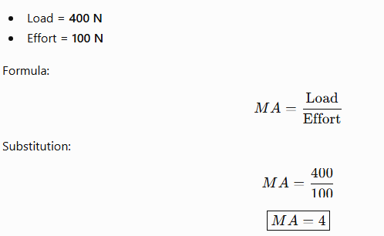
(2 marks)
c) Any two:
- Reduces the effort required.
- Changes the direction of an applied force.
- Enables heavy loads to be moved more easily.
- Increases speed or distance of movement where appropriate.
- Improves efficiency of performing certain tasks.
(2 marks)
d)
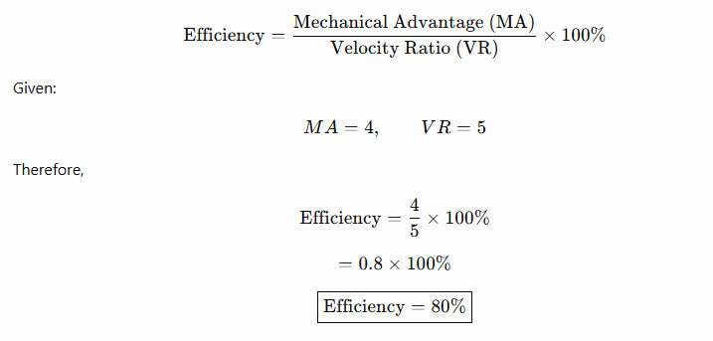
(2 marks)
e) Any one:
- Bottle opener.
- Pair of scissors.
- Wheelbarrow.
- Pliers.
- Knife.
- Screwdriver.
(1 mark)

12.
a) O-Electric bulb/lamp.
(1 mark)
b) N-Dry cell/Battery.
(1 mark)
c) A switch is used to open or close an electric circuit, thereby stopping or allowing the flow of current.
(1 mark)
d)
- Conductors are materials that allow electric current to flow through them easily.
- Insulators are materials that strongly resist the flow of electric current.
(2 marks)
e) Any two:
- Damaged or exposed wires.
- Overloading sockets.
- Handling electrical appliances with wet hands.
- Faulty electrical appliances.
- Poor wiring.
- Inserting objects into electrical sockets.
- Contact with live wires.
(2 marks)
f) Any two:
- Repair damaged wires immediately.
- Avoid overloading sockets.
- Keep electrical appliances away from water.
- Switch off appliances when not in use.
- Use properly rated fuses/circuit breakers.
- Ensure electrical installations are carried out by qualified personnel.
(2 marks)

13.
a) Density is the mass per unit volume of a substance. (1 mark)
b)
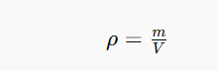
(1 mark)
c) Given:
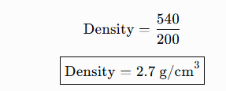
(2 marks)
d) The block will sink.
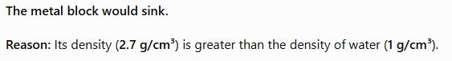
The density of the metal block is greater than the density of water.
(2 marks)
e) Any two:
- Density of the object.
- Density of the fluid.
- Shape/volume of the object.
- Buoyant force acting on the object.
- Weight of the object relative to the upthrust.
(2 marks)

KENYA CERTIFICATE OF BASIC EDUCATION

SENIOR SCHOOL ASSESSMENT

TERM 3: PROJECT BASED ASSESSMENT 2026
GRADE 10 – GENERAL SCIENCE
LEARNER’S DETAILS
Name: _____________________________________________________________. School: ____________________________________________.
Assessment Number: _______________________________________________. Date: ____________________________________________.
School Code: ______________________________________________________. Signature: _______________________________________.

PROJECT: INVESTIGATING THE EFFECT OF TEMPERATURE ON THE RATE OF DISSOLVING

Background
A learner observes that sugar dissolves faster in hot tea than in cold water. The learner wants to investigate whether temperature affects the rate at which a solid dissolves in water.
You are provided with:
- Three transparent beakers/cups
- Water
- Sugar
- Measuring cylinder
- Thermometer
- Stopwatch/phone timer
- Stirring rod/spoon
- Balance, where available

Safety Precautions
Observe the following precautions:
- Handle hot water carefully.
- Do not taste any chemicals or materials used during the experiment.
- Handle glassware carefully.
- Keep the working area dry and clean.
- Follow the teacher's instructions throughout the investigation.

SECTION A: PLANNING THE INVESTIGATION — 5 MARKS

1. State the aim of the investigation. (1 mark)
______________________________________________________________________________________________
______________________________________________________________________________________________

2. Identify the:
a) Independent variable: (1 mark)
________________________________________
b) Dependent variable: (1 mark)
________________________________________

3. State one variable that should be kept constant. (1 mark)
_______________________________________________________________________________

4. State a suitable hypothesis for the investigation. (1 mark)
______________________________________________________________________________________________
______________________________________________________________________________________________
______________________________________________________________________________________________

SECTION B:7 MARKS
Use approximately 100 cm³ of water in each container.
Prepare three water samples at approximately:
- Cold water
- Room-temperature water
- Warm water
Add the same mass of sugar to each sample and record the time taken for the sugar to dissolve completely.

5. Carry out the investigation and complete the table below. (4 marks)
Water temperature | Temperature (°C) | Mass of sugar (g) | Time taken to dissolve (s)
Cold
Room temperature
Warm
Marking:
- Appropriate temperature measurements: 1 mark
- Correct/consistent mass of sugar: 1 mark
- Accurate recording of time: 1 mark
- Complete and properly presented table: 1 mark

6. State two observations made during the investigation. (2 marks)
i. ____________________________________________________________________________________________
ii. ____________________________________________________________________________________________

7. State one difficulty experienced during the experiment and how you overcame it. (1 mark)
Difficulty:
_______________________________________________________________________________
How it was overcome:
_____________________________________________________________________________________________
____________________________________________________________________________________________

SECTION C: 5 MARKS

8. Which water sample dissolved the sugar fastest? (1 mark)
______________________________________________________________________________________________

9. Which water sample dissolved the sugar slowest? (1 mark)
______________________________________________________________________________________________

10. What conclusion can you make from your investigation? (2 marks)
_____________________________________________________________________________________________
_____________________________________________________________________________________________

11. Give one everyday application of your findings. (1 mark)
_____________________________________________________________________________________________
_____________________________________________________________________________________________

SECTION D: 3 MARKS

12. State one safety precaution that was important during the investigation. (1 mark)
___________________________________________________________________________________________

13. Suggest one improvement that could make the investigation more reliable. (1 mark)
___________________________________________________________________________________________

14. If you were to repeat the investigation, what would you do differently? (1 mark)
___________________________________________________________________________________________

TEACHER'S MARKING SCHEME
Question | Expected response | Marks
1 | Appropriate aim, e.g. To investigate the effect of temperature on the rate of dissolving sugar in water. | 1
2a | Temperature of water | 1
2b | Time taken for sugar to dissolve / rate of dissolving | 1
3 | Same volume of water / same mass and type of sugar / same stirring conditions | 1
4 | Appropriate hypothesis, e.g. Increasing temperature increases the rate at which sugar dissolves. | 1
5 | Temperature readings, consistent mass, time readings and complete table | 4
6 | Any two valid observations based on practical work | 2
7 | Valid difficulty + appropriate solution | 1
8 | Warm/hot water | 1
9 | Cold water | 1
10 | Temperature affects dissolving rate; higher temperature generally results in faster dissolving | 2
11 | Any valid application, e.g. preparing tea, coffee, beverages or dissolving substances in cooking | 1
12 | Any appropriate safety precaution | 1
13 | Repeat experiment several times / use more accurate instruments / maintain equal conditions | 1
14 | Any reasonable improvement | 1
TOTAL |  | 20

