KENYA CERTIFICATE OF BASIC EDUCATION

SENIOR SCHOOL ASSESSMENT

DECEMBER ASSIGNMENT 2026
GRADE 10 – ELECTRICITY TECHNOLOGY
Time: 2 Hours
LEARNER’S DETAILS
Name: _____________________________________________________________. School: ____________________________________________.
Assessment Number: _______________________________________________. Date: ____________________________________________.
School Code: ______________________________________________________. Signature: _______________________________________.

INSTRUCTIONS TO CANDIDATES
- Write your full name in the space provided above.
- Indicate your school and stream clearly.
- Fill in your admission number and the date.
- The paper is divided into Section A and Section B.
- Attempt all questions in both sections.
- Respond to all questions in English.
- Write all answers in the spaces provided in the question paper.
- Do not tear or remove any page from this paper.

FOR OFFICIAL USE ONLY (EXAMINER’S USE)
SECTION | SECTION A | SECTION B | % SCORE | EE1 | EE2 | ME1 | ME2 | AE1 | AE2 | BE1 | BE2
SCORE RANGE | 30 MARKS | 50 MARKS |  | 90-100 | 75-89 | 58-74 | 41-57 | 31-40 | 21-30 | 11-20 | 1-10
POINTS |  |  |  | 8 POINTS | 7 POINTS | 6 POINTS | 5 POINTS | 4 POINTS | 3 POINTS | 2 POINTS | 1 POINT
LEARNER’S TOTAL SCORE

SECTION A (30 MARKS)
Answer ALL questions in this section.

1. a) Define electric charge. (1 mark)
______________________________________________________________________________________________________________________________________________________________________________________________
b) State the SI unit of electric charge. _____________________________(1 mark)
c) Name the two types of electric charge. (1 mark)
- _________________________________________________________________________________________
- _________________________________________________________________________________________

2. a) What is an electrical source? (1 mark)
______________________________________________________________________________________________________________________________________________________________________________________________
b) Name two sources of electrical energy commonly used in Kenya. (2 marks)
- _________________________________________________________________________________________
- _________________________________________________________________________________________

3. a) State the purpose of insulation around an electrical conductor. (1 mark)
______________________________________________________________________________________________________________________________________________________________________________________________
b) Give two materials commonly used for insulating electrical conductors. (2 marks)
- _________________________________________________________________________________________
- _________________________________________________________________________________________

4. a) Define potential difference. (1 mark)
______________________________________________________________________________________________________________________________________________________________________________________________
b) State its SI unit. (1 mark)
______________________________________________________________________________________________________________________________________________________________________________________________
c) Name the instrument used to measure potential difference. (1 mark)
____________________________________________

5. A resistor has a resistance of 6 Ω and carries a current of 2 A.
a) Write the formula relating voltage, current and resistance. (1 mark)

b) Calculate the potential difference across the resistor. (2 marks)

6. State the function of each of the following:
a) Resistor. (1 mark) ______________________________________________________________________________________________________________________________________________________________________________________________
b) Capacitor. (1 mark) ______________________________________________________________________________________________________________________________________________________________________________________________c) Switch. (1 mark) ______________________________________________________________________________________________________________________________________________________________________________________________7. a) What is a short circuit? (1 mark) ______________________________________________________________________________________________________________________________________________________________________________________________
b) State two possible causes of short circuits in electrical installations. (2 marks) ______________________________________________________________________________________________________________________________________________________________________________________________8. a) State one effect produced when electric current flows through a conductor. (1 mark)
______________________________________________________________________________________________________________________________________________________________________________________________
b) Name the device that uses the magnetic effect of electric current to produce mechanical motion. (1 mark)
______________________________________________________________________________________________________________________________________________________________________________________________

c) Give one application of such a device. (1 mark)

______________________________________________________________________________________________________________________________________________________________________________________________9. An electrical appliance operates at 240 V and draws a current of 5 A.
a) Write the formula for electrical power. (1 mark)
______________________________________________________________________________________________________________________________________________________________________________________________b) Calculate the power rating of the appliance. (2 marks)

10. State three reasons why electrical installations should be properly earthed. (3 marks)
- _________________________________________________________________________________________
- _________________________________________________________________________________________
- _________________________________________________________________________________________

SECTION B: 50 MARKS
Answer ALL questions.

11. Study the simplified diagrams below.
A B C
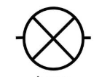

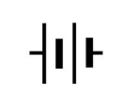

a) Identify component A.____________________________ (1 mark)
b) Identify component B._________________________ (1 mark)
c) Identify component C.____________________________ (1 mark)
d) State one function of component A. (1 mark)
______________________________________________________________________________________________________________________________________________________________________________________________
e) State one function of component B. (1 mark)
______________________________________________________________________________________________________________________________________________________________________________________________f) State one function of component C. (1 mark)
______________________________________________________________________________________________________________________________________________________________________________________________g) Explain why a resistor is used in an electrical circuit. (2 marks)
______________________________________________________________________________________________________________________________________________________________________________________________h) State one safety precaution when replacing a faulty electrical component. (1 mark)
______________________________________________________________________________________________________________________________________________________________________________________________i) State the unit used to measure resistance. (1 mark)
______________________________________________________________________________________________________________________________________________________________________________________________

12. Consider the two arrangements below.

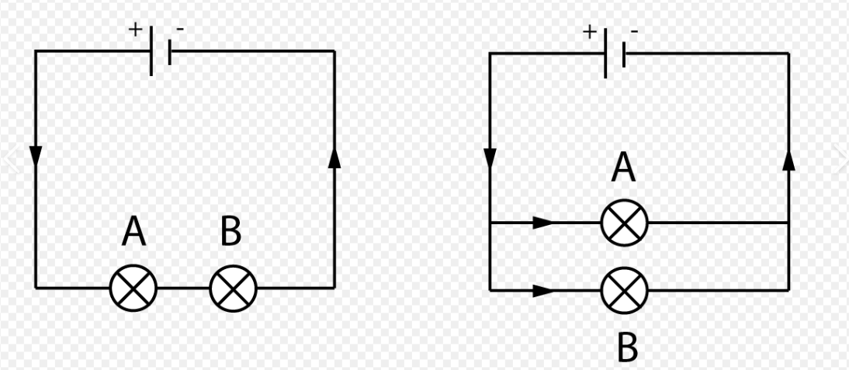

Arrangement A Arrangement B

a) Identify arrangement A.___________________________________ (1 mark)
b) Identify arrangement B. ____________________________________(1 mark)
c) State two characteristics of a arrangement A. (2 marks)
- _________________________________________________________________________________________
- _________________________________________________________________________________________
d) State two characteristics of arrangement B. (2 marks)
- _________________________________________________________________________________________
- _________________________________________________________________________________________
e) Explain why domestic lighting circuits are normally connected in parallel. (2 marks)
______________________________________________________________________________________________________________________________________________________________________________________________
f) What happens to L2 in arrangement A if L1 develops an open circuit? (1 mark)
______________________________________________________________________________________________________________________________________________________________________________________________
g) What happens to L2 in arrangement B if L1 develops an open circuit? (1 mark)

______________________________________________________________________________________________________________________________________________________________________________________________13. The cell in the figure below has an emf of 2.1V and negligible internal resistance.
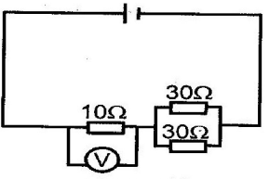

a) Determine the
    - Total resistance in the circuit (2 marks)

    - Current in the circuit (1 mark)

    - Reading on the voltmeter (2 marks)

b) Explain why an ammeter is connected in series. (2 marks)
______________________________________________________________________________________________________________________________________________________________________________________________
c) Explain why a voltmeter is connected in parallel. (2 marks)
______________________________________________________________________________________________________________________________________________________________________________________________
d) State one precaution when taking electrical measurements. (1 mark)
______________________________________________________________________________________________________________________________________________________________________________________________

14. Study the simplified domestic installation arrangement below.
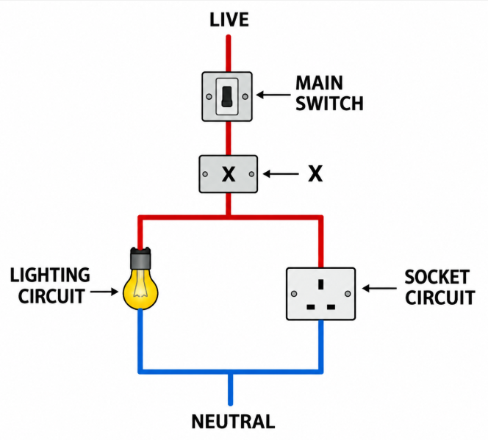
a) Identify the device labelled X. (1 mark)
_______________________________________________________________________________________________
b) State the main function of the parts you have identified in 14(a) above. (2 marks)
______________________________________________________________________________________________________________________________________________________________________________________________
c) Explain what happens when the current flowing through a protected circuit becomes excessively high. (2 marks)
______________________________________________________________________________________________________________________________________________________________________________________________
d) State two advantages of using an MCB instead of a conventional fuse. (2 marks)
- _________________________________________________________________________________________
- _________________________________________________________________________________________

e) State three precautions that should be observed when carrying out domestic electrical installation work. (3 marks)
- _________________________________________________________________________________________
- _________________________________________________________________________________________
- _________________________________________________________________________________________

15.A school workshop operates the following appliances:
Appliance | Power Rating | Daily Operating Time
Electric kettle | 2,000 W | 1 hour
Drill | 750 W | 2 hours
Lighting | 500 W | 6 hours
Assume the workshop operates for 5 days.
a) Calculate the energy consumed by the electric kettle in one day in kWh. (2 marks)

b) Calculate the energy consumed by the drill in one day in kWh. (2 marks)

c) Calculate the energy consumed by the lighting system in one day in kWh. (2 marks)

d) Calculate the total electrical energy consumed by all three appliances in five days. (3 marks)

e) State one practical measure the school could take to reduce electricity consumption. (1 mark)
_________________________________________________________________________________________
_________________________________________________________________________________________

THIS IS THE LAST PRINTED PAGE

GRADE 10 ELECTRICITY TECHNOLOGY

MARKING SCHEME

SECTION A: 30 MARKS

1.
a) Electric charge is a physical property of matter responsible for electrical effects/interactions.
(1 mark)
b) Coulomb (C).
(1 mark)
c) The two types are:
- Positive charge
- Negative charge
(1 mark)

2.
a) An electrical source is a device or system that supplies electrical energy/potential difference to an electrical circuit.
(1 mark)
b) Any two:
- Hydroelectric power
- Geothermal power
- Solar power
- Wind power
- Thermal power
- Biomass
(1 mark each = 2 marks)

3.
a) Insulation prevents electric shock, leakage of current and accidental contact between conductors.
(1 mark)
b) Any two:
- PVC
- Rubber
- XLPE
- Polythene
- Bakelite
(1 mark each = 2 marks)

4.
a) Potential difference is the work done or energy transferred per unit charge between two points in an electrical circuit.
(1 mark)
b) Volt (V).
(1 mark)
c) Voltmeter.
(1 mark)

5.
a) Formula:
V=IRV=IR
(1 mark)
b)
V=2×6V=12V
Answer: 12 V
(2 marks)

6.
a) Resistor: Limits or controls the flow of electric current in a circuit.
(1 mark)
b) Capacitor: Stores electrical charge/energy temporarily.
(1 mark)
c) Switch: Opens or closes a circuit to control the flow of current.
(1 mark)

7.
a) A short circuit is an unintended low-resistance path through which a large current flows.
(1 mark)
b) Any two:
- Damaged insulation exposing conductors.
- Live and neutral conductors coming into direct contact.
- Loose or incorrectly connected wires.
- Faulty electrical equipment.
- Moisture entering an electrical installation.
(1 mark each = 2 marks)

8.
a) A magnetic field is produced around the conductor.
(1 mark)
b) Electric motor.
(1 mark)
c) Any one:
- Electric fan
- Water pump
- Electric drill
- Washing machine
- Electric mixer
(1 mark)

9.
Given:
V=240VV=240V I=5AI=5A
a)
P=VIP=VI
(1 mark)
b)
P=240×5P=240\times5 P=1200WP=1200W
Therefore:
Power = 1,200 W or 1.2 kW
(2 marks)

10.
Any three:
- Provides a safe path for fault current to flow to earth.
- Helps prevent electric shock.
- Helps protective devices operate during faults.
- Protects electrical equipment from damage.
- Reduces the risk of electrical fires.
- Prevents exposed metal parts from becoming dangerously live.
(1 mark each = 3 marks)

SECTION B: 50 MARKS

11.
a) Component A: Cell.
(1 mark)
b) Component B: Diode.
(1 mark)
c) Component C: Lamp/bulb.
(1 mark)
d) Function of the cell:
- Supplies electrical energy/potential difference to the circuit.
(1 mark)
e) Function of the resistor:
- Limits or controls the flow of electric current.
(1 mark)
f) Function of the lamp:
- Converts electrical energy mainly into light and heat energy.
(1 mark)
g) A resistor is used to:
- Control/limit the amount of current flowing through the circuit.
- Protect other components from excessive current.
(2 marks)
h) Any one:
- Switch off and isolate the power supply before replacing the component.
- Use the correct replacement component.
- Use appropriate insulated tools.
- Test that the circuit is dead before working on it.
(1 mark)
i) Ohm (Ω).
(1 mark)

12. a) Arrangement A: Series circuit.
(1 mark)
b) Arrangement B: Parallel circuit.
(1 mark)
c) Characteristics of a series circuit:
Any two:
- It has only one path for current.
- The same current flows through all components.
- If one component becomes open circuit, the whole circuit is interrupted.
- The supply voltage is divided among the components.
(1 mark each = 2 marks)
d) Characteristics of a parallel circuit:
Any two:
- It has two or more branches.
- Current divides among the branches.
- Each branch receives the supply potential difference.
- Failure of one branch does not necessarily affect the other branches.
(1 mark each = 2 marks)
e) Domestic lighting circuits are connected in parallel because:
- Each lamp receives the full supply voltage.
- Each lamp can operate independently.
- If one lamp fails, the others can continue operating.
Any two = 2 marks
f) In arrangement A, if L1 develops an open circuit, L2 goes off because the circuit is broken.
(1 mark)
g) In arrangement B, if L1 develops an open circuit, L2 continues to operate because it has its own parallel branch.
(1 mark)

13.
    - Parallel circuit ¹/₃₀ + ¹/₂₀ = ⁵/₆₀
R= 5.3V
Total resistance = 10 + 12 = 22Ω
    - I = ^{V}/_{R} = ^{2.1}/₂₂ = 0.095A
    - V= IR = 10 x ^{2.1}/₂₂
= 0.95V
b) An ammeter is connected in series because:
- The same current flowing through the circuit/component must pass through the ammeter.
- An ammeter has very low resistance and therefore should not be connected directly across a supply.
(2 marks)
c) A voltmeter is connected in parallel because:
- It measures the potential difference between two points.
- A voltmeter has very high resistance so that it draws very little current from the circuit.
(2 marks)
d) Any one:
- Select the correct range before taking a measurement.
- Observe correct polarity.
- Ensure proper connections.
- Do not exceed the instrument's rated range.
- Use a properly functioning meter.
(1 mark)

14.
a) The device is a fuse or Miniature Circuit Breaker (MCB).
(1 mark)
b) Its main function is to protect the electrical circuit and equipment by automatically interrupting the supply when excessive current flows.
(2 marks)
c) When excessive current flows:
- The protective device operates.
- A fuse element melts or an MCB trips.
- The circuit is opened and current stops flowing.
Any two well-explained points = 2 marks
d) Advantages of an MCB over a conventional fuse:
Any two:
- It can be reset after tripping.
- It operates quickly during excessive current conditions.
- It is more convenient to use.
- It does not require replacement after every fault.
- It provides reliable circuit protection.
(1 mark each = 2 marks)
e) Any three:
- Switch off and isolate the supply before working.
- Use correctly rated cables and protective devices.
- Use insulated tools.
- Avoid working with wet hands.
- Ensure proper earthing.
- Make secure and properly insulated connections.
- Test the installation before energising it.
- Do not work on live circuits unless appropriately authorised and trained.
(1 mark each = 3 marks)

15.

a) Electric kettle
Given:
P=2000W=2kWP=2000W=2kW t=1ht=1h
Using:
E=Pt E=2kWh
Answer: 2 kWh
(2 marks)

b) Drill
Given:
P=750W=0.75kWP=750W=0.75kW t=2ht=2h E=0.75×2E=0.75\times2 E=1.5kWhE=1.5kWh
Answer: 1.5 kWh
(2 marks)

c) Lighting system
Given:
P=500W=0.5kWP=500W=0.5kW t=6ht=6h E=0.5×6E=0.5\times6 E=3kWhE=3kWh
Answer: 3 kWh
(2 marks)

d) Total energy consumed in five days
First calculate the total energy consumed per day:
Edaily=2+1.5+3E=6.5kWh
For five days:
E5days=6.5×5=32.5kWh
Answer: 32.5 kWh
(3 marks)

e) One practical measure to reduce electricity consumption
Any one:
- Switch off appliances when not in use.
- Use energy-efficient lighting.
- Avoid unnecessary use of electrical appliances.
- Switch off lights when leaving the workshop.
- Maintain appliances properly.
- Use appliances only for the required period.
(1 mark)

KENYA CERTIFICATE OF BASIC EDUCATION

SENIOR SCHOOL ASSESSMENT

TERM 3: PROJECT BASED ASSESSMENT 2026
GRADE 10 – ELECTRICITY TECHNOLOGY
Time: 2 Hours
LEARNER’S DETAILS
Name: _____________________________________________________________. School: ____________________________________________.
Assessment Number: _______________________________________________. Date: ____________________________________________.
School Code: ______________________________________________________. Signature: _______________________________________.

PROJECT: CONSTRUCTION AND TESTING OF A SIMPLE D.C. ELECTRICAL CIRCUIT

Learning Area
Electricity Technology

Strand
1.0 Fundamentals of Electricity

Sub-Strand
1.2 D.C. Electric Circuits
The task is based on KICD outcomes requiring learners to describe properties of resistors in D.C. circuits, analyse D.C. circuits using circuit laws, construct resistor networks and troubleshoot D.C. circuits.

PROJECT TASK
Your school electrical workshop has received a request to demonstrate a simple low-voltage D.C. lighting circuit for use in a small model room.
Working individually, construct and test a simple D.C. circuit that can operate two bulbs using a battery/cell source and switches.
Your circuit should demonstrate safe connection of electrical components and correct circuit construction.

Materials and Tools
Use the available materials:
- Battery/cells
- Two small bulbs and holders
- Connecting wires
- Two switches
- Resistors, where applicable
- Ammeter
- Voltmeter or multimeter
- Screwdriver
- Side cutter/wire stripper
- Test board/breadboard, where available

CANDIDATE'S TASKS

1. Circuit Design – 4 marks
Before constructing the circuit:
a) Draw a neat circuit diagram showing the battery, two bulbs, switches and connecting wires.
(2 marks)
b) Label at least four components correctly. (2 marks)

2. Circuit Construction – 6 marks
Construct the circuit from your diagram.
Award marks for:
Skill | Marks
Correctly identifies and selects components | 1
Connects the battery/cells correctly | 1
Connects the bulbs correctly | 1
Connects the switches correctly | 1
Makes secure and orderly connections | 1
Produces a functioning circuit | 1
Total | 6

3. Testing and Measurement – 4 marks
a) Test the circuit and demonstrate that the bulbs operate when the circuit is closed. (1 mark)
b) Use a multimeter/voltmeter to determine the voltage supplied by the battery. (1 mark)
c) Record the voltage obtained.
Voltage = __________ V (1 mark)
d) State one observation made during testing. (1 mark)

4. Fault Finding and Troubleshooting – 3 marks
The teacher introduces one fault into the circuit, such as:
- loose terminal;
- disconnected wire;
- open switch; or
- faulty connection.
Identify the fault and correct it.
Performance | Marks
Identifies the fault correctly | 1
Explains the likely cause | 1
Corrects the fault and restores the circuit | 1
Total | 3
The troubleshooting component reflects the KICD emphasis on using measuring and testing instruments to trace faults such as open circuits, short circuits, faulty components, dry joints and loose terminals.

5. Safety and Workshop Practice – 3 marks
Demonstrate the following throughout the project:
a) Observes electrical safety precautions. (1 mark)
b) Uses tools and equipment correctly. (1 mark)
c) Keeps the work area and materials properly arranged. (1 mark)

MARK ALLOCATION
Assessment Area | Marks
1. Circuit design and diagram | 4
2. Circuit construction | 6
3. Testing and measurement | 4
4. Fault finding and troubleshooting | 3
5. Safety and workshop practice | 3
TOTAL | 20 MARKS

PERFORMANCE LEVEL
Score | Performance
17–20 | Exceeds Expectations
13–16 | Meets Expectations
9–12 | Approaches Expectations
0–8 | Below Expectations

Teacher's Assessment Record
Learner's Name: __________________________________________
Admission/Assessment No.: _________________________________
School: _________________________________________________
Criterion | Maximum | Score
Circuit design | 4
Circuit construction | 6
Testing and measurement | 4
Troubleshooting | 3
Safety/workshop practice | 3
TOTAL | 20
Performance Level
Teacher's Name: __________________________________________
Signature: ____________________ Date: __________________

