KENYA CERTIFICATE OF BASIC EDUCATION


SENIOR SCHOOL ASSESSMENT

DECEMBER ASSIGNMENTS 2026
GRADE 10 – BUILDING CONTRUCTION
Time: 2 Hours
LEARNER’S DETAILS
Name: _____________________________________________________________. School: ____________________________________________.
Assessment Number: _______________________________________________. Date: ____________________________________________.
School Code: ______________________________________________________. Signature: _______________________________________.

INSTRUCTIONS TO CANDIDATES
- Write your name in the spaces provided above.
- Write the name of your school and your stream in the spaces provided.
- Write your admission number and the date of the assessment in the spaces provided.
- This paper consists of two sections: A and B.
- Answer all questions in section A and section B.
- Answer the questions in English.
- All answers MUST be written in the spaces provided in the paper.
- Do NOT remove any page from this question paper.

FOR OFFICIAL USE ONLY (EXAMINER’S USE)
SECTION | SECTION A | SECTION B | % SCORE | EE1 | EE2 | ME1 | ME2 | AE1 | AE2 | BE1 | BE2
SCORE RANGE | 30 MARKS | 50 MARKS |  | 90-100 | 75-89 | 58-74 | 41-57 | 31-40 | 21-30 | 11-20 | 1-10
POINTS |  |  |  | 8 POINTS | 7 POINTS | 6 POINTS | 5 POINTS | 4 POINTS | 3 POINTS | 2 POINTS | 1 POINT
LEARNER’S TOTAL SCORE

SECTION A (30 MARKS)
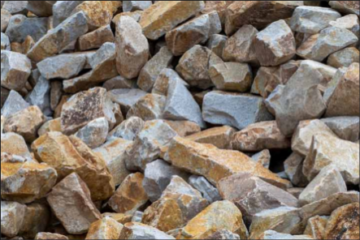
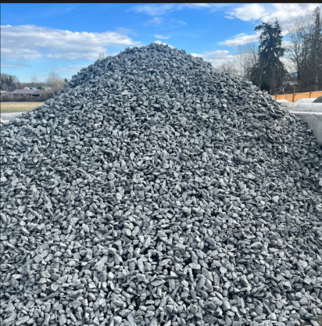
Answer ALL questions in this section. 1. Study the samples represented below and answer the questions.
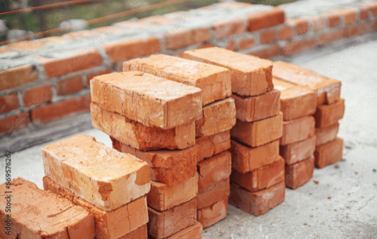

A B C

a) Identify the building materials represented by A, B and C. (3 marks)
A. ......................................................................................
B. ......................................................................................
C. ......................................................................................
b) State one use of material A in building construction. (1 mark)
...................................................................................................................................................................................
c) State one property of a good building stone. (1 mark)
......................................................................................................................................................................................

2. Study the simplified cross-section below.

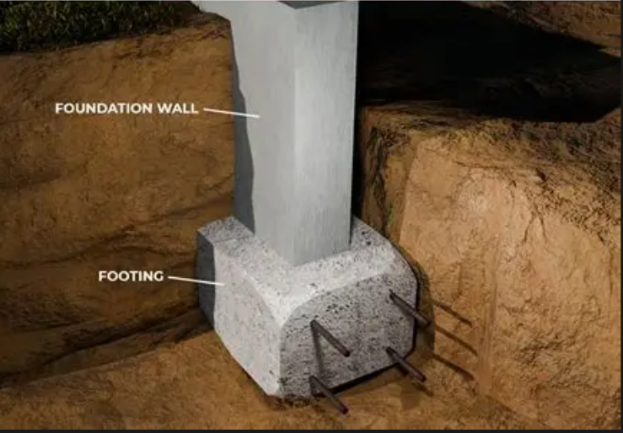
X
a) Identify the component labelled X. (1 mark)
..............................................................................................
b) State two functions of X. (2 marks)
i. .................................................................................................................................................................................
ii. ................................................................................................................................................................................
c) State two factors that influence foundation depth. (2 marks)
i. ..........................................................................................................................................................................................
ii. ........................................................................................................................................................................................

3. Study the tools shown below.
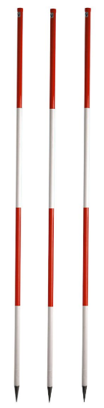
A B

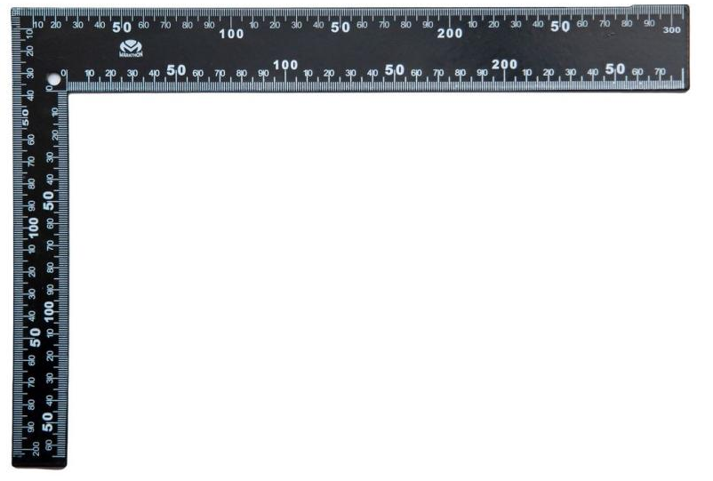

a) Identify any two setting-out tools represented above. (2 marks)
A. ......................................................................................
B. ...................................................................................
b) State one use of a builder's square. (1 mark)
...................................................................................................................................................................................

4. Study the line below.
A ●────────────────────────────● B
600 mm
The line represents a wall on a building drawing. The actual wall is 6 metres long.
a) Calculate the scale of the drawing. (2 marks)

b) State one importance of scale in building drawing. (1 mark)
...........................................................................................................................................................................................................................................................................................................................................................................................

5. Study the simplified building representation.
FRONT ELEVATION

┌─────────────┐
│ ┌───────┐ │
│ │ │ │
│ │ │ │
│ └───────┘ │
│ ┌──┐ │
│ │ │ │
└─────┴──┴────┘
a) Identify the type of building drawing shown. (1 mark)
..............................................................................................
b) State two pieces of information that may be obtained from this type of drawing. (2 marks)
i. ............................................................................................
ii. ...........................................................................................

6. Susan was asked to list the materials used in making concrete.

a) Identify the four basic materials. (4 marks)
A. ......................................................................................
B. ......................................................................................
C. ......................................................................................
D. ......................................................................................
b) State one purpose of water in concrete. (1 mark)
...........................................................................................................................................................................................................................................................................................................................................................................................

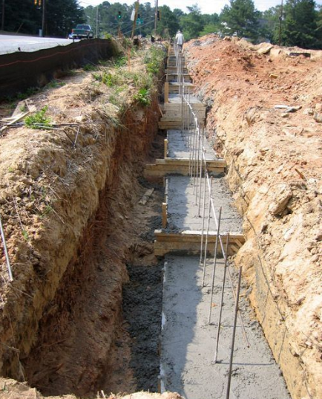
7. Study the excavation shown below.

a) Identify the construction activity represented by the diagram. (1 mark)
...............................................................................................................................................................
b) Name one danger associated with unsupported deep excavations.(1 mark)
.......................................................................................................................................................................................
c) State one method of preventing collapse of the excavation sides.(1 mark)
...................................................................................................................................................................................

8. Study the diagram below.
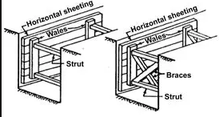
  - Identify the construction support represented by the shaded members. .

...........................................................................................................................................
b) State two reasons for providing this support. (2 marks)
i. ..................................................................................................................................................................................
ii. ...................................................................................................................................................................................

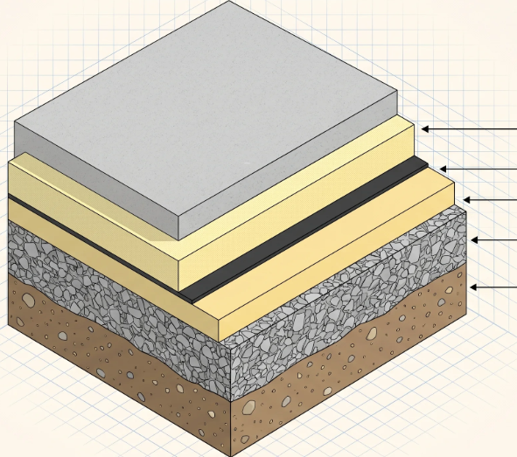
9. Study the simplified floor construction.

T

a) Identify the layer represented by the T. (1 mark)
..............................................................................................

b) State one purpose of hardcore in floor construction. (1 mark)
..............................................................................................
c) State one reason for compacting the ground before laying a floor. (1 mark)
...................................................................................................................................................................................

10. Study the pipe fittings below.
A B C
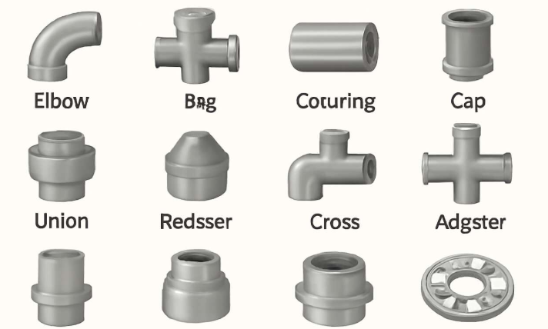

a) Identify fittings A, B and C. (3 marks)
A. ......................................................................................
B. ......................................................................................
C. ......................................................................................
b) State one function of a tee fitting. (1 mark)
.........................................................................................................................................................................................
c) Name one material used for manufacturing water pipes. (1 mark)
.................................................................................................................................................................................

SECTION B: 50 MARKS
Answer ALL questions.

11. A contractor has been given a piece of land on which a residential building is to be constructed. The site contains bushes, tree stumps, loose soil and some stones.

a)Identify four activities that should be undertaken during site preparation.(4 marks)
- .........................................................................................................................................................................
- .........................................................................................................................................................................
- .........................................................................................................................................................................
- ..........................................................................................................................................................................

b)Explain three factors that should be investigated before construction begins.(3 marks)
- .........................................................................................................................................................................
- .........................................................................................................................................................................
- .........................................................................................................................................................................

c) State three reasons why setting out must be accurate. (3 marks)
- .........................................................................................................................................................................
- .........................................................................................................................................................................
- .........................................................................................................................................................................

12. Study the setting-out illustration below.
A────────────────────────B
│ │
│ │
│ │
│ │
D────────────────────────C

AB = DC
AD = BC

a)
Identify the shape of the building being set out. (1 mark)
..............................................................................................

b) Explain four steps involved in setting out the building shown above. (4 marks)
- .........................................................................................................................................................................
- .........................................................................................................................................................................
- .........................................................................................................................................................................
- ..........................................................................................................................................................................

c) State three methods/tools that can be used to ensure that corners A, B, C and D are accurately positioned.
(3 marks)
- .........................................................................................................................................................................
- .........................................................................................................................................................................
- .........................................................................................................................................................................

d) State two checks that should be made before excavation begins. (2 marks)
i. ............................................................................................................................................................................
ii. ..........................................................................................................................................................................

13. Study the simplified plan below.

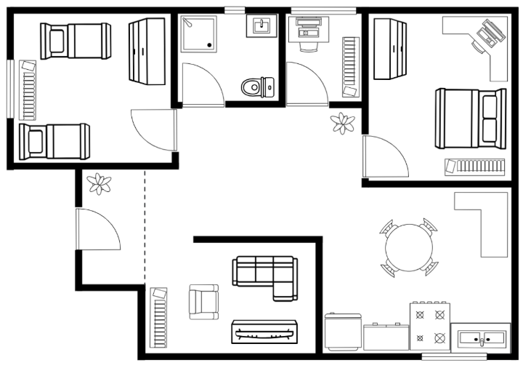

a) Identify the type of drawing shown. (1 mark)
..............................................................................................

b) Name four features visible on the drawing. (4 marks)
- .........................................................................................................................................................................
- .........................................................................................................................................................................
- .........................................................................................................................................................................
- ..........................................................................................................................................................................

c) The actual length of the building is 8 metres. On a drawing it measures 16 cm.
Calculate the scale. (3 marks)

d) State two reasons why dimensions are included on building drawings. (2 marks)
i. ..............................................................................................................................................................................
ii. ..............................................................................................................................................................................
14.

a) Identify four components shown in the cross-section. (4 marks)
i. ............................................................................................
ii. ...........................................................................................
iii. ..........................................................................................
iv. ..........................................................................................

b) Explain three functions of the foundation. (3 marks)
i. ..........................................................................................................................................................................................
ii. .........................................................................................................................................................................................
iii. ........................................................................................................................................................................................

c)State three requirements of a good ground floor.(3 marks)
i. .........................................................................................................................................................................................
ii. ......................................................................................................................................................................................
iii. ......................................................................................................................................................................................

15.Study the two illustrations below.

A. CONCRETE MIXING
WATER
↓
┌───────────────┐
│ CEMENT │
│ + SAND │
│ + AGGREGATE │
└───────────────┘
↓
MIXING
↓
CONCRETE

B. PLUMBING SYSTEM
WATER TANK
│
│
▼
┌─────────┐
│ VALVE │
└────┬────┘
│
├───────────┐
│ │
▼ ▼
TAP TAP

a)
From illustration A, state four operations involved in producing good concrete. (4 marks)
i. ............................................................................................
ii. ...........................................................................................
iii. ..........................................................................................
iv. ..........................................................................................

b)
State three functions of a valve in a water-supply system. (3 marks)
i. ............................................................................................
ii. ...........................................................................................
iii. ..........................................................................................

c)
State three safety precautions when carrying out plumbing work.
(3 marks)
i. ............................................................................................
ii. ...........................................................................................
iii. ..........................................................................................

GRADE 10 – BUILDING CONSTRUCTION

MARKING SCHEME

1.
a) Identify the materials:
A. Stone – 1 mark
B. Brick – 1 mark
C. Aggregate/ballast – 1 mark
b) One use of stone:
- Construction of walls.
- Construction of foundations.
- Construction of retaining walls.
- Road works.
Any one – 1 mark
c) One property of good building stone:
- Strong.
- Durable.
- Hard.
- Resistant to weathering.
- Free from cracks.
- Has good appearance.
Any one – 1 mark

2.
a) The component identified as FOOTING is the foundation footing/base.
1 mark
b) Two functions of a foundation/footing:
- Transfers building loads safely to the ground.
- Distributes the load over a larger area of soil.
- Provides a stable base for the building.
- Prevents excessive settlement.
Any 2 × 1 = 2 marks
c) Two factors influencing foundation depth:
- Type and bearing capacity of soil.
- Load/weight of the building.
- Depth of firm bearing stratum.
- Groundwater conditions.
- Nature of the site.
Any 2 × 1 = 2 marks

3.
a) Identification:
The intended setting-out tools are:
A. Ranging rod – 1 mark
B. Builder's square – 1 mark
Accept another correctly identified setting-out tool where the learner's identification matches the intended illustration.
b) Use of a builder's square:
- To set out/check a right angle of 90°.
- To ensure corners of a building are square.
1 mark
Total: 3 marks

4.
Actual length = 6 m = 600 cm
Drawing length = 600 mm = 60 cm
Therefore:
Scale=60600\text{Scale}=\frac{60}{600} =110=\frac{1}{10}

Scale = 1:10
2 marks
Note: The original question illustration states 600 mm while the text states 6 metres. Therefore, the correct interpretation is that the drawing line is 600 mm, giving a scale of 1:10.
b) Importance of scale:
- Allows large objects/buildings to be represented on a manageable drawing sheet.
- Maintains proportional accuracy.
- Enables actual dimensions to be determined from the drawing.
Any 1 – 1 mark

5.
a) The drawing is a front elevation.
1 mark
b) Information obtained from an elevation:
- External appearance of the building.
- Position and size of doors.
- Position and size of windows.
- Height of the building.
- Roof shape.
- Vertical dimensions.
- External finishes.
Any 2 × 1 = 2 marks

6.
a) Identification of the four basic materials:
A. Cement – 1 mark
B. Sand/fine aggregate – 1 mark
C. Coarse aggregate/ballast – 1 mark
D. Water – 1 mark
b) Purpose of water:
- It reacts with cement during hydration.
- It makes the mixture workable.
- It assists in bonding the ingredients.
Any one – 1 mark

7.
a) Excavation of a foundation trench.
1 mark
b) One danger:
- Collapse of trench sides.
- Burial of workers.
- Injury or death.
- Falling materials into the excavation.
Any one – 1 mark
c) One method of preventing collapse:
- Timbering/shoring.
- Proper battering/sloping of sides.
- Providing suitable excavation support.
Any one – 1 mark

8.
a) The support is timbering/shoring of an excavation.
1 mark
b) Two reasons for timbering:
- Prevents collapse of excavation sides.
- Protects workers from being buried or injured.
- Maintains the shape and dimensions of the trench.
- Improves safety during excavation.
Any 2 × 1 = 2 marks
Total: 3 marks

9.
a) The shaded layer is hardcore.
1 mark
b) One purpose of hardcore:
- Provides a firm and stable base for the floor slab.
- Helps raise the floor level.
- Improves drainage and reduces settlement when properly selected and compacted.
Any one – 1 mark
c) Reason for compacting ground:
- To reduce settlement.
- To provide a firm and stable base.
- To increase the bearing capacity of the ground.
Any one – 1 mark

10.
a) Identification:
A. Elbow– 1 mark
B. Union – 1 mark
C. Cross – 1 mark
b) Function of a tee:
- Provides a branch connection from the main pipe.
- Divides/directs water into another pipe.
1 mark
c) One material used for water pipes:
- PVC/uPVC.
- Copper.
- PEX.
- Galvanised steel.
Any one – 1 mark

11.

a) Four site-preparation activities
- Clearing vegetation – removing bushes, grass and unwanted trees.
- Removing tree stumps and roots – clearing obstacles that may interfere with construction.
- Removing stones and debris – preparing a clean construction area.
- Demolition/removal of unwanted structures where applicable.
- Levelling/grading the site.
- Disposal of waste to an appropriate location.
Any 4 × 1 = 4 marks

b) Three factors to investigate before construction
- Soil condition – determine the type and bearing capacity of soil.
- Site levels/topography – establish slopes and levels of the land.
- Drainage/groundwater – determine water conditions and drainage requirements.
- Access – determine how workers, materials and equipment will reach the site.
- Availability of services – establish water, electricity and other services.
- Boundaries – establish the correct site boundaries.
Any 3 × 1 = 3 marks

c) Three reasons for accurate setting out
- Ensures the building is positioned correctly on the site.
- Ensures correct building dimensions.
- Ensures walls are correctly aligned.
- Ensures corners are accurately positioned.
- Prevents costly construction errors.
- Ensures the building follows the approved drawings.
Any 3 × 1 = 3 marks

Question 11 = 10 marks

12.

a)
The shape is a rectangle/rectangular building.
1 mark

b) Four steps in setting out
A suitable procedure is:
- Study the building plan and establish the required dimensions.
- Establish a baseline from which the building will be measured.
- Fix pegs at the required positions.
- Stretch string lines between the pegs to indicate wall positions.
- Establish right angles using a builder's square or 3:4:5 method.
- Measure the required length and width.
- Check the diagonals to ensure the corners are correctly positioned.
- Fix profile boards outside the excavation area.
Any 4 × 1 = 4 marks

c) Three methods/tools for accurate positioning
- Builder's square.
- Tape measure.
- 3:4:5 method.
- Theodolite.
- Ranging rods.
- Spirit level.
- Optical/laser level.
- Checking diagonals.
Any 3 × 1 = 3 marks

d) Two checks before excavation
- Check the building dimensions against the working drawing.
- Check that corners are square/right-angled.
- Check the diagonals.
- Check alignment and levels.
- Confirm the building is correctly positioned within the site boundaries.
Any 2 × 1 = 2 marks

Question 12 = 10 marks

13.

a)
The drawing is a building plan/floor plan.
1 mark

b) Four features visible
Any four:
- Bedrooms.
- Living room.
- Kitchen.
- Internal walls.
- External walls.
- Room divisions.
- Dimensions.
- Door/window positions.
Any 4 × 1 = 4 marks

c) Scale calculation
Actual length = 8 metres
Convert to centimetres:
8m=800cm8m = 800cm
Drawing length = 16 cm
Scale=16800\text{Scale}=\frac{16}{800} =150=\frac{1}{50}

Scale = 1:50
Working – 2 marks
Answer – 1 mark

d) Two reasons for including dimensions
- To indicate the actual size of building components.
- To guide the construction team during construction.
- To enable accurate setting out.
- To reduce construction errors.
- To indicate distances between different building elements.
Any 2 × 1 = 2 marks

Question 13 = 10 marks

14.

a) Four components shown
Any four:
i. Wall – 1 mark
ii. Foundation wall – 1 mark
iii. Footing – 1 mark
iv. Hardcore – 1 mark
v. Compacted ground – 1 mark
Any 4 = 4 marks

b) Three functions of a foundation
- Transfers the load of the building safely to the ground.
- Distributes the building load over a suitable area.
- Provides stability to the building.
- Reduces excessive settlement.
- Prevents movement caused by unstable ground.
Any 3 × 1 = 3 marks

c) Three requirements of a good ground floor
- It should be strong enough to carry imposed loads.
- It should be level and even.
- It should be durable.
- It should resist ground moisture.
- It should be properly compacted and supported.
- It should have an appropriate finish.
- It should provide suitable thermal insulation where required.
Any 3 × 1 = 3 marks

Question 14 = 10 marks

15.

a) Four operations involved in producing good concrete
- Batching/measuring the ingredients in the required proportions.
- Mixing cement, sand and aggregate thoroughly.
- Adding water in the correct quantity.
- Placing the concrete in the required position.
- Compacting the concrete to remove trapped air.
- Finishing the surface.
- Curing the concrete adequately.
Any 4 × 1 = 4 marks

b) Three functions of a valve
- Controls the flow of water.
- Stops the flow of water when necessary.
- Allows sections of the plumbing system to be isolated for maintenance or repair.
- Regulates water flow in suitable applications.
Any 3 × 1 = 3 marks

c) Three plumbing safety precautions
- Wear appropriate PPE such as gloves and safety footwear.
- Use the correct tools for each task.
- Turn off the water supply before repairing or modifying pipes.
- Keep the working area clean and free from hazards.
- Handle sharp tools carefully.
- Ensure electrical equipment is kept away from water.
- Inspect tools before use.
Any 3 × 1 = 3 marks

KENYA CERTIFICATE OF BASIC EDUCATION

SENIOR SCHOOL ASSESSMENT

TERM 3: PROJECT BASED ASSESSMENT 2026
GRADE 10 – BUILDING CONTRUCTION
Time: 2 Hours
LEARNER’S DETAILS
Name: _____________________________________________________________. School: ____________________________________________.
Assessment Number: _______________________________________________. Date: ____________________________________________.
School Code: ______________________________________________________. Signature: _______________________________________.

PROJECT-BASED ASSESSMENT TEST

PROJECT BRIEF
You have been asked to design and construct a simple masonry structure suitable for a small domestic building.
The project should demonstrate your ability to:
- Interpret a building requirement.
- Prepare a simple floor plan.
- Produce a basic building drawing.
- Select appropriate materials and tools.
- Set out the structure.
- Construct a masonry wall section.
- Observe safety requirements.
- Evaluate the completed project.
The teacher will provide or approve the available materials before construction begins.

SECTION A: PROJECT DESIGN AND FLOOR PLAN – 6 MARKS

1. Prepare a simple floor plan of a small building containing:
- One main room
- One additional room
- A door
- At least two windows
- Internal dimensions
- External dimensions
(4 marks)

Space for floor plan:

2. Label the following on your floor plan:
a) Door – ½ mark
b) Windows – ½ mark
c) Rooms – ½ mark
d) Dimensions – ½ mark
Total: 2 marks

Drawing requirements
The learner should demonstrate:
- Use of appropriate drawing instruments.
- Reasonable proportion and neatness.
- Correct use of conventional building symbols.
- Clear labelling and dimensions.

SECTION B: PROJECT PLANNING – 3 MARKS

3. List THREE materials required for the construction project.(1½ marks)
i. ....................................................................................
ii. ...................................................................................
iii. ..................................................................................

4. List THREE tools/equipment required for the project.(1½ marks)
i. ....................................................................................
ii. ...................................................................................
iii. ..................................................................................

SECTION C: PRACTICAL CONSTRUCTION – 8 MARKS
Using your approved plan, construct a small section of the proposed masonry wall.
The wall section should demonstrate appropriate:
Assessment Indicator | Marks
Setting out according to the plan | 1
Correct selection and preparation of materials | 1
Preparation and appropriate use of mortar | 1
Correct laying of bricks/blocks | 2
Maintaining line, level and verticality | 1
Correct bonding | 1
Neatness and quality of workmanship | 1
TOTAL | 8

SECTION D: SAFETY AND WORKSITE MANAGEMENT – 2 MARKS

5. Demonstrate the following during the project:
a) Safe and correct use of tools and equipment – 1 mark
b) Proper organisation and cleanliness of the work area – 1 mark

SECTION E: PROJECT EVALUATION – 1 MARK

6. State ONE challenge experienced during the project and explain how you addressed it.(1 mark)
Challenge:
............................................................................................................................................................................................................................................................................................................................................................................................
How it was addressed:
...........................................................................................................................................................................................................................................................................................................................................................................................

PROJECT ASSESSMENT RUBRIC
Competency Area | Exceeds Expectations | Meets Expectations | Approaching Expectations | Below Expectations
Floor plan/drawing | Accurate, neat, correctly dimensioned and well labelled | Generally accurate with minor errors | Several errors in symbols/dimensions | Incomplete or poorly presented
Planning | Materials and tools selected appropriately | Most requirements identified | Some requirements identified | Poor planning
Construction | Excellent workmanship, alignment and bonding | Good workmanship with minor errors | Some construction errors | Major errors/incomplete work
Safety | Consistently demonstrates safe practices | Generally safe | Requires occasional reminders | Frequently ignores safety requirements
Evaluation | Clearly identifies problem and solution | Identifies problem and solution | Limited explanation | Unable to evaluate project

TEACHER'S PROJECT RECORD
Learner's Name: __________________________________________
Grade: 10 ____________
Admission No.: __________________
Date: __________________
No. | Assessment Area | Max. Marks | Score
1 | Floor plan and building drawing | 6
2 | Project planning | 3
3 | Practical construction | 8
4 | Safety and worksite management | 2
5 | Project evaluation | 1
 | TOTAL | 20
Teacher's Observation:
..............................................................................................................
..............................................................................................................
Teacher's Name: __________________________________________
Signature: ______________________
Date: __________________________

GRADE 10 BUILDING TECHNOLOGY

PROJECT-BASED ASSESSMENT – MARKING SCHEME
Project: Design and Construction of a Simple Masonry Structure
Total Marks: 20

SECTION A: DRAWING AND FLOOR PLAN – 6 MARKS

1. Floor Plan – 4 Marks
Award marks as follows:
Requirement | Marks
Correct overall layout/proportion of the building | 1
Correct representation of walls and room arrangement | 1
Appropriate door and window positions/symbols | 1
Neatness and use of appropriate drawing conventions | 1
Total | 4

2. Labelling and Dimensioning – 2 Marks
Requirement | Marks
Rooms clearly labelled | ½
Door correctly indicated/labelled | ½
Windows correctly indicated/labelled | ½
Internal/external dimensions shown appropriately | ½
Total | 2
Section A Total = 6 Marks

SECTION B: PROJECT PLANNING – 3 MARKS

3. Materials – 1½ Marks
Award ½ mark for each correct material, up to 3 materials.
Accept:
- Bricks/blocks
- Cement
- Sand
- Water
- Damp-proof materials
- Timber where applicable
- Other appropriate building materials
Maximum = 1½ marks

4. Tools/Equipment – 1½ Marks
Award ½ mark for each correct tool/equipment, up to 3.
Accept:
- Brick trowel
- Spirit level
- Tape measure
- Plumb bob
- Builder's line
- Mason's square
- Shovel
- Bucket
- Straight edge
- Other appropriate tools
Maximum = 1½ marks
Section B Total = 3 Marks

SECTION C: PRACTICAL CONSTRUCTION – 8 MARKS
Assessment Indicator | Marking Points | Marks
Setting out | Correctly transfers dimensions/layout from the plan to the work area | 1
Material selection/preparation | Selects and handles suitable materials correctly | 1
Mortar preparation/use | Prepares/uses mortar appropriately and consistently | 1
Laying bricks/blocks | Correct positioning and laying of units | 2
Line, level & verticality | Maintains straightness, level and plumb | 1
Bonding | Applies an appropriate masonry bond correctly | 1
Workmanship/neatness | Joints, corners and finished work are neat | 1
TOTAL |  | 8

Detailed Awarding Guidance
Setting out – 1 mark
- Correct measurements and positions – ½
- Correct use of line/square or other setting-out method – ½
Material selection/preparation – 1 mark
- Correct materials selected – ½
- Materials properly prepared/handled – ½
Mortar – 1 mark
- Appropriate mixing/preparation – ½
- Appropriate application – ½
Laying bricks/blocks – 2 marks
- Correct positioning – 1
- Proper and consistent laying – 1
Line, level and verticality – 1 mark
- Maintains horizontal alignment – ½
- Maintains verticality/plumb – ½
Bonding – 1 mark
- Correct bond selected – ½
- Bond correctly maintained – ½
Workmanship – 1 mark
- Neat joints/finish – ½
- Overall quality of construction – ½

SECTION D: SAFETY AND WORKSITE MANAGEMENT – 2 MARKS

5. Safety Practices
Requirement | Marks
Uses tools and equipment safely and correctly | 1
Maintains a clean, organised and safe working area | 1
Total | 2
Award only when the learner actually demonstrates the practice during the project.

SECTION E: PROJECT EVALUATION – 1 MARK

6. Challenge and Solution
Award:
- Correctly identifies a realistic challenge – ½ mark
- Gives an appropriate way of addressing the challenge – ½ mark
Total = 1 mark
Examples of acceptable challenges:
- Shortage of materials
- Difficulty maintaining alignment
- Incorrect mortar consistency
- Limited working space
- Difficulty maintaining dimensions

PERFORMANCE LEVEL
Score | Performance
17–20 | Exceeds Expectations
13–16 | Meets Expectations
9–12 | Approaching Expectations
0–8 | Below Expectations
Teacher's Overall Comment:
.............................................................................................................................................................................................................................................................................................................................................................................................

