KALA TRIAL EXAMINATION – JULY 2026
Kenya Certificate of Secondary Education

JULY 2026
TIME: 2 HOURS
232/2
PHYSICS PAPER 2

Name: ………………………………… Admission No ………..….
Class: …………………...…………….. Date: …………………….
School: ………………………………… Signature ………………..
Instructions to Candidates
- This paper consists of TWO Sections: A and B.
- Answer ALL the questions in section A and B in the spaces provided.
- All working MUST be clearly shown.
- KNEC mathematical tables and silent non-programmable electronic calculators may be used.
- This paper consists of 13 printed pages. Candidates should check the question paper to ascertain that all the pages are printed as indicated and that no questions are missing.
- Candidates should answer the questions in English.
For Examiner’s Use Only

Section | Question | Maximum  Score | Candidate’s  Score
A | 1 – 13 | 25
B | 14 | 11
B | 15 | 12
B | 16 | 12
B | 17 | 10
B | 18 | 10
 | TOTAL  SCORE | 80

Section A (25 marks)
(Answer all the questions in the spaces provided)
- State one difference between a virtual image formed by a plane mirror and one formed by a concave mirror. (1 mark)
……………………………………………………………………………………………………………………………………………………………………………………………………………………………………………………………………………………………….
- Explain why the vent caps of a lead-acid accumulator should be left open while the battery is being charged. (1 mark)
………………………………………………………………………………………………………………………………………………………………………………………………………………………………………………………………………………………………
- Figure below shows a current-carrying conductor AB placed between the poles of a magnet.
N
S
B
A
Direction of current

(a) Indicate on the diagram the direction of the force acting on the conductor. (1 mark)
(b) State one factor that determine the direction of the force acting on the conductor. (1 mark)
………………………………………………………………………………………………………………………………………………

- During an experiment on electrostatics, a positively charged electroscope is placed on a bench. A positively charged glass rod is then brought close to the cap of the electroscope without touching it. It is observed that the divergence of the gold leaf increases. Explain this observation. (2 marks)
……………………………………………………………………………………………………………………………………………………………………………………………………………………………………………………………………………………………….………………………………………………………………………………………………………………………………………………………………………………………………………………………………………………………………………………………..…
- A student standing some distance from a high wall claps once and hears an echo. State the two measurements required in order to determine the speed of sound in air. (2 marks)
………………………………………………………………………………………………………………………………………………………………………………………………………………………………………………………………………………………………
- Figure below shows an object O at the bottom of a beaker filled with water. When the object is viewed from above, its image appears displaced by a distance d from the bottom and by a distance y from the surface of the water.
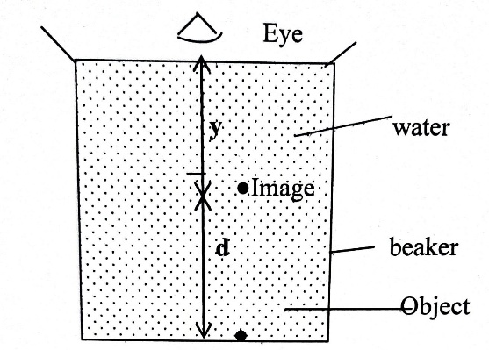
Show that the refractive index n, y, and d, are related by $y=\frac{d}{n-1}$ (2marks)

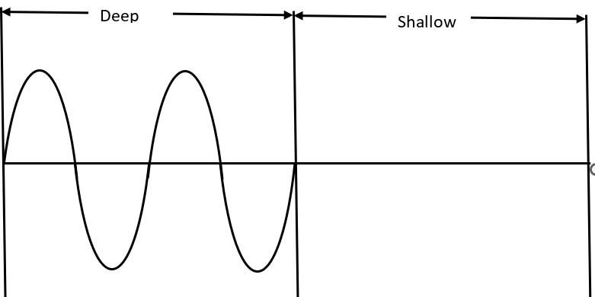
- Figure below shows a plane progressive water wave travelling from deep water towards shallow water

Complete the diagram to show the wave after crossing the boundary. (2 marks)
- An electric lamp is rated 75 W, 240 V. Calculate the resistance of the lamp. (2 marks)
……………………………………………………………………………………………………………………………………………………………………………………………………………………………………………………………………………………………….……………………………………………………………………………………………………………………………………………………………………………………………………………………………………………………………………………………………
- Figure below shows the main components of a cathode ray oscilloscope (CRO)
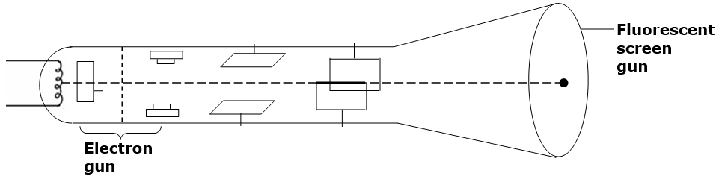
A
B

(a) State the function of the parts labelled A and B (1 mark)
…………………………………………………………………………………………………………………………………………………………………………………………………………………………………………………………………………………………………..
(b) The brightness of the spot on the screen of a cathode ray oscilloscope can be adjusted using the grid. Explain how the grid may be adjusted to make the spot brighter. (2 marks)
……………………………………………………………………………………………………………………………………………………………………………………………………………………………………………………………………………………………….……………………………………………………………………………………………………………………………………………………………………………………………………………………………………………………………………………………………….
- Chart below represents part of the electromagnetic spectrum.
Radiowaves | A | Infrared | Visible light | B | X-rays | C

(a) Identify the type of electromagnetic radiation represented by B (1 mark)
………………………………………………………………………………………………………………………………………………
(b) State one application of the radiation represented by A. (1 mark)
………………………………………………………………………………………………………………………………………………………………………………………………………………………………………………………………………………………………
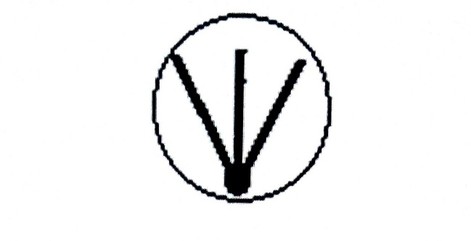
- Figure below shows tracks formed by particles from a radioactive substance as observed in a cloud chamber.

State with a reason the type of radiation emitted (2 marks)
……………………………………………………………………………………………………………………………………………………………………………………………………………………………………………………………………………………………….………………………………………………………………………………………………………………………………………………

- Claire, a Form Four student at Kala High School, uses a curved mirror to project the image of a candle flame onto a screen during a Physics practical lesson. The image formed is three times the size of the candle flame. If the distance between the candle and the screen is 96 cm, determine the focal length of the mirror. (3 marks)
……………………………………………………………………………………………………………………………………………………………………………………………………………………………………………………………………………………………………………………………………………………………………………………………………………………………………………………………………………………………………………………………………………………………………………………………….
- Figure below shows a three-pin plug with parts labeled A, B, and C. Use the diagram to answer the questions below.

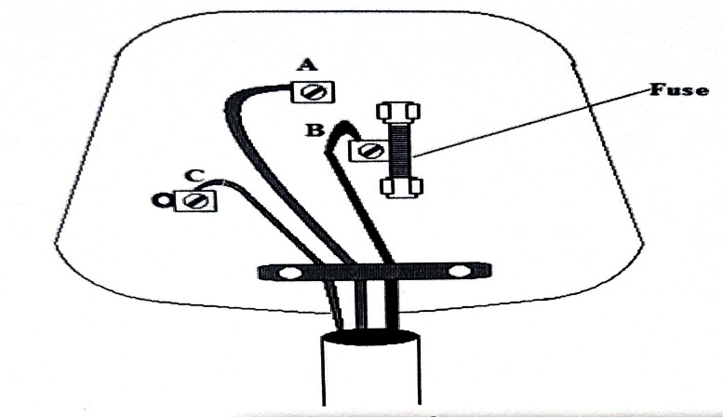

Pin A is practically longer than the other two. Give one reasons for this. (1 mark)
…………………………………………………………………………………………………………………………………………………………………………………………………………………………………………………………………………………………

Section B (55 marks)
(Answer all the questions in the spaces provided)

- (a) State Ohm's Law. (1 mark)
……………………………………………………………………………………………………………………………………………………………………………………………………………………………………………………………………………………………………
(b) What causes electrical resistance in conductors? (1 mark)
………………………………………………………………………………………………………………………………………………………………………………………………………………………………………………………………………………………………
(c) you are provided with two resistors 3Ω and 7Ω
(i) Draw a circuit diagram to show the arrangement of the resistors which gives a maximum effective resistance with a 12V source. (1 mark)

(ii) Determine the voltage across a 3Ω resistor. (3 marks) ………………………………………………………………………………………………………………………………………………………………………………………………………………………………………………………………………………………………………………………………………………………………………………………………………………………………………………

(d) Figure below shows the variation of the terminal potential difference, V, of a battery with the current, I, drawn from it.
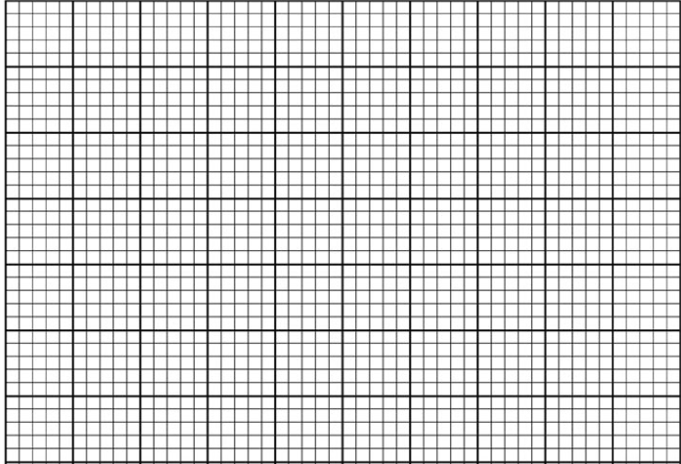
0
1.0
2.0
3.0
0.1
0.2
0.3
0.4
Current, I (A)
Terminal Voltage, V (V)

(i) Draw the circuit that could be used to obtain the results shown on the graph. (2 marks)

(ii) Given that $E=V+Ir$ where E is the e.m.f. of the battery and r is its internal resistance, determine the value of the internal resistance of the battery. (3 marks)
………………………………………………………………………………………………………………………………………………………………………………………………………………………………………………………………………………………………………………………………………………………………………………………………………………………………………………………………………………………………………………………………………………………………………………………………

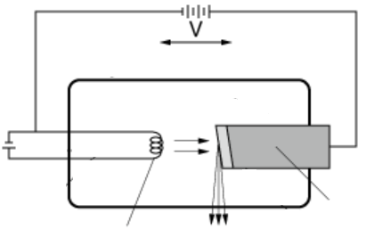
- (a) Figure below shows the essential parts of an X-ray tube.
Vacuum
Electron beam
E.H.T
Q
P
X-rays
Target

(i) Name the parts labelled P and Q. (2 marks)
………………………………………………………………………………………………………………………………………………………………………………………………………………………………………………………………………………………………
(ii) Explain how X-rays are produced (2 marks)
………………………………………………………………………………………………………………………………………………………………………………………………………………………………………………………………………………………………………………………………………………………………………………………………………………………………………………………………………………………………………………………………………………………………………………………………
(iii) The machine is almost entirely surrounded by a metal shield. Name the metal and give a reason why this metal must surround it. (2 marks)
………………………………………………………………………………………………………………………………………………………………………………………………………………………………………………………………………………………………
(iv) State with a reason the effect on the wavelength of the X-rays produced when the tube current is increased. (1 mark)
………………………………………………………………………………………………………………………………………………………………………………………………………………………………………………………………………………………………

(b) Figure below shows part of the National Grid System

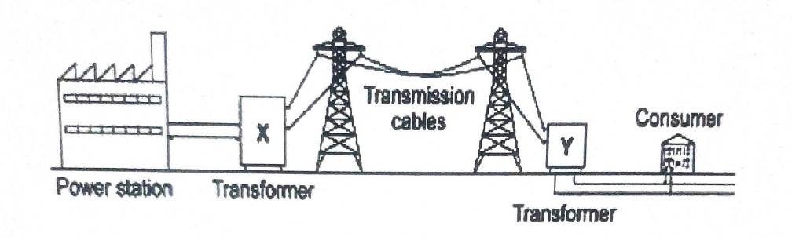

i. With a reason, state the type of transformer marked X (2 marks)

………………………………………………………………………………………………………………………………………………………………………………………………………………………………………………………………………………………………
………………………………………………………………………………………………………………………………………………
ii. In a consumer unit, circuit breakers are preferred over fuse wires. Explain (1 mark)

………………………………………………………………………………………………………………………………………………………………………………………………………………………………………………………………………………………………

(c) A house lighting circuit has one 100 W bulb, two 60 W bulbs, and three 40 W bulbs. Determine the cost of operating all the bulbs for 70 hours, given that the cost of electricity is 120 cents per kilowatt-hour. (2 marks)
………………………………………………………………………………………………………………………………………………………………………………………………………………………………………………………………………………………………
………………………………………………………………………………………………………………………………………………

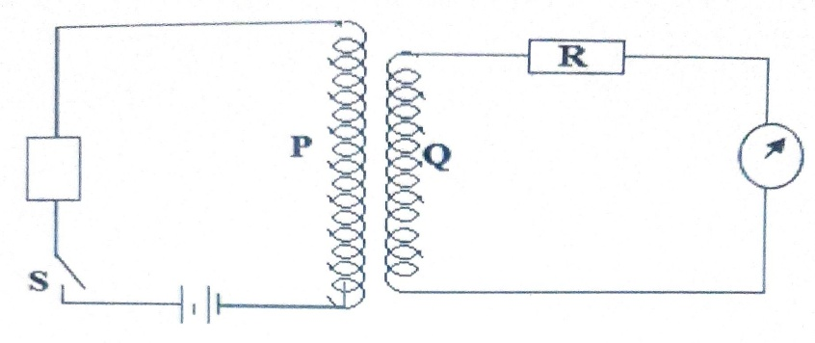
- (a) The figure below shows a setup used to demonstrate a phenomenon in Physics.

It is observed that, as the switch is closed, the galvanometer deflects and then goes back to zero. Explain this observation (2marks)
……………………………………………………………………………………………………………………………………………………………………………………………………………………………………………………………………………………………………………….
……………………………………………………………………………………………………………………………………………………..
(b) Figure below shows a transformer with current I_{p} and I_{s} flowing through primary and secondary coils with voltages V_{p} and V_{s}, respectively.

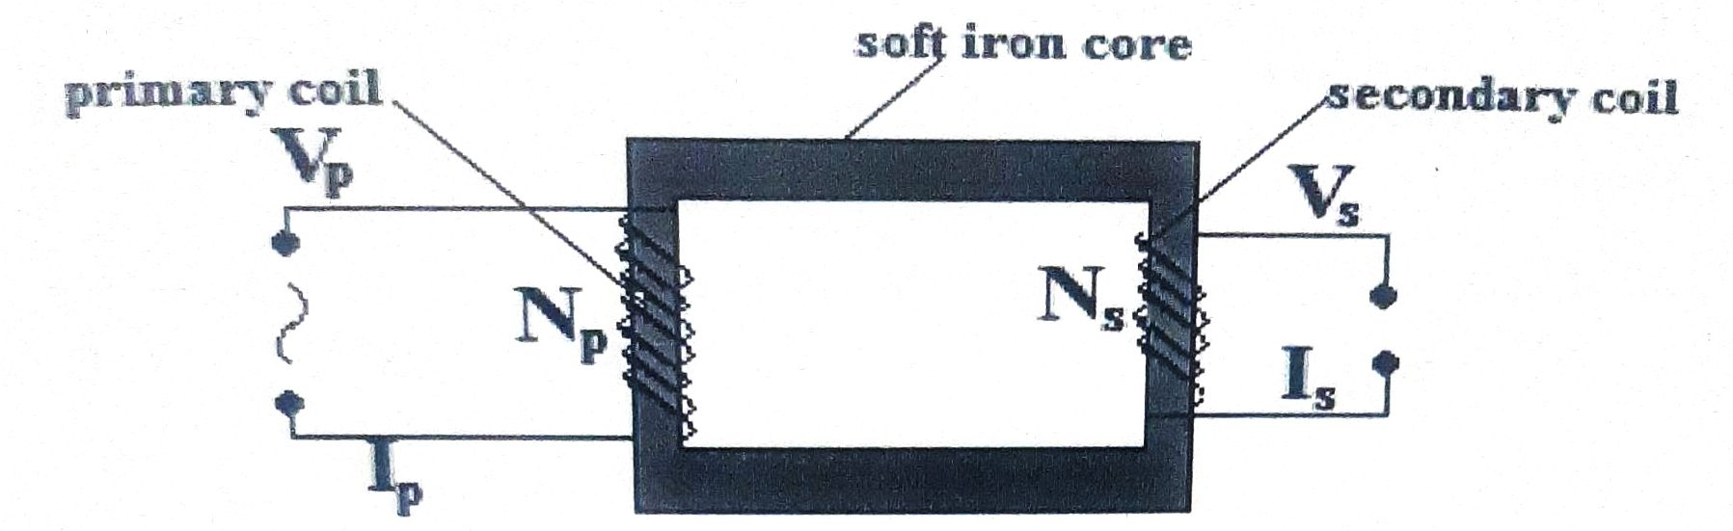
(i) Assuming there are no energy losses in the transformer, derive an expression for the ratio of currents I_{p}/I_{s} in terms of V_{p} and V_{s}. (2 marks)
………………………………………………………………………………………………………………………………………………………………………………………………………………………………………………………………………………………………………………………………………………………………………………………………………………………………………………………………………………………………………
(ii) An ideal transformer has 1000 turns in the primary coil and 4000 in the secondary circuit. When the primary circuit is connected to a 200 V a.c source, the power delivered to a resistor in the secondary circuit is found to be 1000 W.

- Determine the current in the secondary circuit (2 marks)

………………………………………………………………………………………………………………………………………………………………………………………………………………………………………………………………………………………………
………………………………………………………………………………………………………………………………………………

- Determine the current in the primary circuit (2 marks)

………………………………………………………………………………………………………………………………………………………………………………………………………………………………………………………………………………………………
………………………………………………………………………………………………………………………………………………

(c) The figure below shows an arrangement of capacitors.
10V
3µF

5µF

2µF

(i) Calculate the effective capacitance of the arrangement. (2 marks)
………………………………………………………………………………………………………………………………………………………………………………………………………………………………………………………………………………………………
………………………………………………………………………………………………………………………………………………………………………………………………………………………………………………………………………………………………
(ii) Determine the charge stored on the 3 μF capacitor. (2 marks)
………………………………………………………………………………………………………………………………………………………………………………………………………………………………………………………………………………………………………………………………………………………………………………………………………………………………………………………………………………………………………………………………………………………………………………………………
- (a) State one factor that determines the speed of photoelectrons emitted from a metal surface. (1 mark)
………………………………………………………………………………………………………………………………………………………………………………………………………………………………………………………………………………………………
(b) Figure below shows a photocell connected in a circuit containing a battery, a variable resistor and a microammeter. The photocell is illuminated using monochromatic light of frequency greater than the threshold frequency.
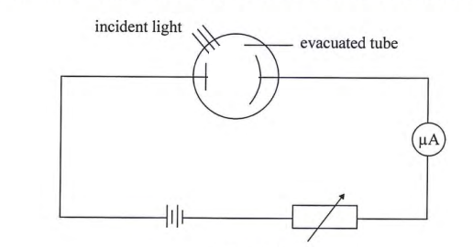

(i) State and explain the effect on the microammeter reading when the intensity of the incident light is increased without changing its frequency. (2 marks)
………………………………………………………………………………………………………………………………………………………………………………………………………………………………………………………………………………………………
………………………………………………………………………………………………………………………………………………

(ii) Give a reason why the photocell tube is evacuated. (1 mark)
………………………………………………………………………………………………………………………………………………………………………………………………………………………………………………………………………………………………………………………………………………………………………………………………………………………………………………
(b) The photocell in (b) was illuminated using radiation of different frequencies and the maximum kinetic energy (K. E_{Max}) of photoelectrons for each frequency, f was measured. The results obtained are shown in the graph below.

K. Emax (x 10⁻¹⁹ J
Frequency, f (x 10¹⁵ Hz
0
2.0
4.0
8.0
6.0
1.0
2.0
3.0
4.0
5.0
6.0
7.0

Use the graph to determine:
(i) Planck's constant, h. (3 marks)
………………………………………………………………………………………………………………………………………………………………………………………………………………………………………………………………………………………………
………………………………………………………………………………………………………………………………………………………………………………………………………………………………………………………………………………………………
(ii) The threshold wavelength λ_{o} given that the C is 3.0 x 10⁸ ms⁻¹. (3 marks)
………………………………………………………………………………………………………………………………………………………………………………………………………………………………………………………………………………………………………………………………………………………………………………………………………………………………………………………………………………………………………………………………………………………………………………………………
- (a) A certain extrinsic semiconductor is made by introducing small quantities of group III elements into the structure of an intrinsic semiconductor.
(i) State the electronic name of the process described above (1 mark)

………………………………………………………………………………………………………………………………………………………………………………………………………………………………………………………………………………………………

(ii) Give the type of semiconductor formed. (1 mark)
………………………………………………………………………………………………………………………………………………………………………………………………………………………………………………………………………………………………
(iii) Justify the use of group three elements in ii above. (1 mark)

………………………………………………………………………………………………………………………………………………………………………………………………………………………………………………………………………………………………

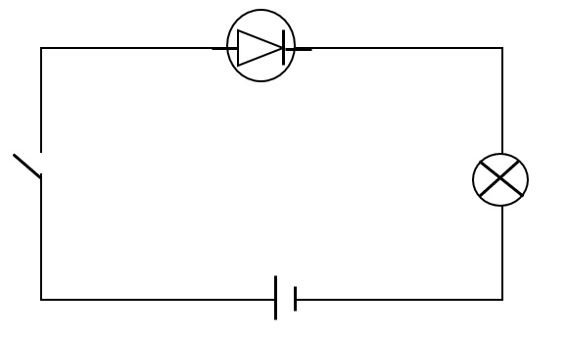
(b) The figure below shows a semiconductor diode connected in a circuit.
S

State and explain what happens to the depletion layer when the S is closed. (3 marks) ……………………………………………………………………………………………………………………………………………………………………………………………………………………………………………………………………………………………………

(c) Figure shows an arrangement used to investigate interference of light using a double slit.
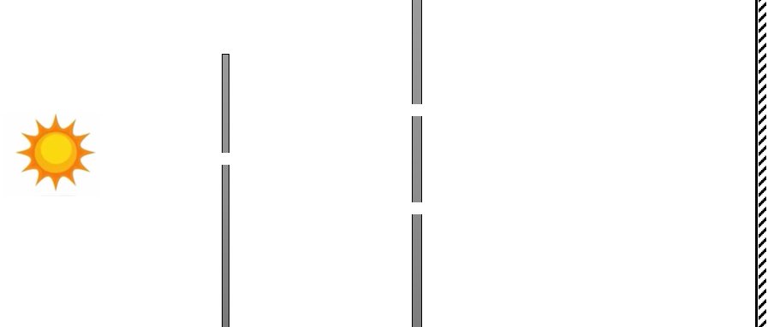
S₁
S₂
Monochromatic light source
slit
Double slit

(i) State the function of the following:
I. Double slit. (1 mark)
………………………………………………………………………………………………………………………………………………………………………………………………………………………………………………………………………………………………
(ii) State and explain the observation made on the screen. (2 marks)
………………………………………………………………………………………………………………………………………………………………………………………………………………………………………………………………………………………………
(iii) State what would be observed if the monochromatic light source was replaced with white light. (1 mark)
………………………………………………………………………………………………………………………………………………………………………………………………………………………………………………………………………………………………

THIS IS THE LAST PRINTED PAGE

