KALA TRIAL EXAMINATION – JULY 2026
Kenya Certificate of Secondary Education

JULY 2026
TIME: 2 HOURS
232/2
PHYSICS PAPER 2

Name: ………………………………… Admission No ………..….
Class: …………………...…………….. Date: …………………….
School: ………………………………… Signature ………………..
Instructions to Candidates
- This paper consists of TWO Sections: A and B.
- Answer ALL the questions in section A and B in the spaces provided.
- All working MUST be clearly shown.
- KNEC mathematical tables and silent non-programmable electronic calculators may be used.
- This paper consists of 13 printed pages. Candidates should check the question paper to ascertain that all the pages are printed as indicated and that no questions are missing.
- Candidates should answer the questions in English.
For Examiner’s Use Only

Section | Question | Maximum  Score | Candidate’s  Score
A | 1 – 13 | 25
B | 14 | 11
B | 15 | 12
B | 16 | 12
B | 17 | 10
B | 18 | 10
 | TOTAL  SCORE | 80

Section A (25 marks)
(Answer all the questions in the spaces provided)
- State one difference between a virtual image formed by a plane mirror and one formed by a concave mirror. (1 mark)
Plane mirror forms a virtual image of the same size as the object while a concave mirror forms a virtual image that is magnified (enlarged). ✓1
- Explain why the vent caps of a lead-acid accumulator should be left open while the battery is being charged. (1 mark)
To allow the hydrogen and oxygen gases produced during charging to escape, preventing pressure build-up/explosion. ✓1

- Figure below shows a current-carrying conductor AB placed between the poles of a magnet.
N
S
B
A
Direction of current

(a) Indicate on the diagram the direction of the force acting on the conductor. (1 mark)
- Correct direction shown according to Fleming's Left-Hand Rule. ✓1
(Award only if arrow is correctly indicated.)

(b) State one factor that determine the direction of the force acting on the conductor. (1 mark)
Any one:
- Direction of current. ✓1
- Direction of magnetic field. ✓1
- During an experiment on electrostatics, a positively charged electroscope is placed on a bench. A positively charged glass rod is then brought close to the cap of the electroscope without touching it. It is observed that the divergence of the gold leaf increases. Explain this observation. (2 marks)
• electrons are attracted towards the cap ✓1
• This leaves the stem and gold leaf more positively charged, increasing repulsion and hence greater divergence. ✓1
- A student standing some distance from a high wall claps once and hears an echo. State the two measurements required in order to determine the speed of sound in air. (2 marks)
Distance between the student and the wall. ✓1
Time taken for the echo to be heard. ✓1
- Figure below shows an object O at the bottom of a beaker filled with water. When the object is viewed from above, its image appears displaced by a distance d from the bottom and by a distance y from the surface of the water.
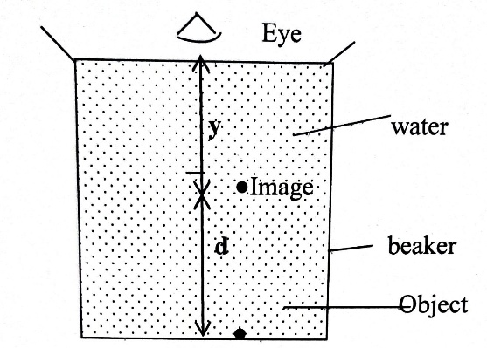
Show that the refractive index n, y, and d, are related by $y=\frac{d}{n-1}$ (2marks)
$$\text{Real depth}=y+d$$
$$Apparent depth=y$$
$$n=\frac{y+d}{y} \\ y=\frac{d}{n-1}$$
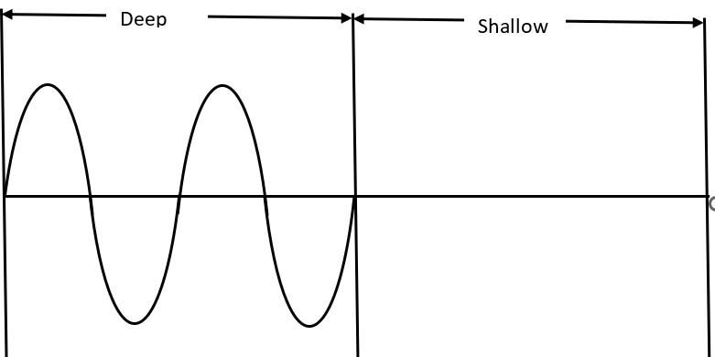
- Figure below shows a plane progressive water wave travelling from deep water towards shallow water

Complete the diagram to show the wave after crossing the boundary. (2 marks)
- (shorter wavelength). ✓1
- Wave speed decreases while amplitude and frequency remains constant.

- An electric lamp is rated 75 W, 240 V. Calculate the resistance of the lamp. (2 marks)
$$R=\frac{V^{2}}{P} \\ =\frac{{240}^{2}}{75} \\ =768$$

- Figure below shows the main components of a cathode ray oscilloscope (CRO)
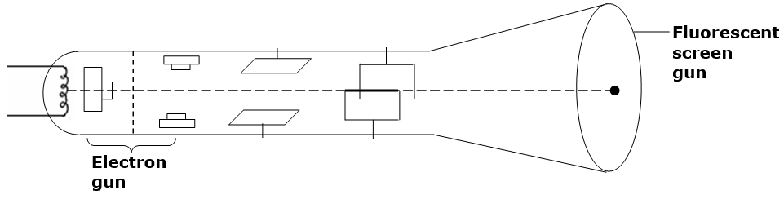
A
B

(a) State the function of the parts labelled A and B (1 mark)
Deflects the electron beam
(b) The brightness of the spot on the screen of a cathode ray oscilloscope can be adjusted using the grid. Explain how the grid may be adjusted to make the spot brighter. (2 marks)
• Make the grid less negative (or more positive) relative to the cathode. ✓1
• This allows more electrons to pass through, increasing beam intensity and hence brighter spot. ✓1
- Chart below represents part of the electromagnetic spectrum.
Radiowaves | A | Infrared | Visible light | B | X-rays | C

(a) Identify the type of electromagnetic radiation represented by B (1 mark)
Ultraviolet
(b) State one application of the radiation represented by A. (1 mark)
Any one:
- Satellite communication ✓1
- Radar ✓1
- Mobile phone communication ✓1
- Microwave cooking ✓1

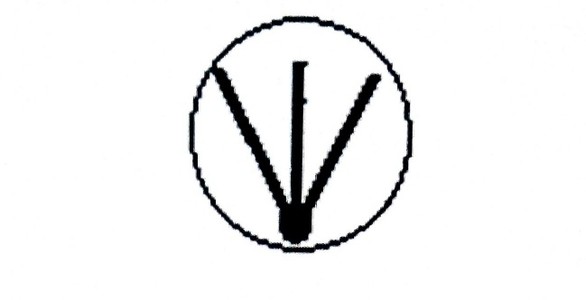
Figure below shows tracks formed by particles from a radioactive substance as observed in a cloud
- chamber.

State with a reason the type of radiation emitted (2 marks)
Alpha particles ✓1
Reason:
- They produce short, thick tracks because they are highly ionising.
- OR have short range in air.
Reason ✓1

- Claire, a Form Four student at Kala High School, uses a curved mirror to project the image of a candle flame onto a screen during a Physics practical lesson. The image formed is three times the size of the candle flame. If the distance between the candle and the screen is 96 cm, determine the focal length of the mirror. (3 marks)
Magnification
$$m=\frac{v}{u}=3$$
Therefore
$$v=3u$$
Object + image distance
$$u+v=96 \\ u+3u=96 \\ u=24\text{ cm} \\ v=72\text{ cm}$$
Mirror formula
$$\frac{1}{f}=\frac{1}{u}+\frac{1}{v} \\ =\frac{1}{24}+\frac{1}{72} \\ =\frac{4}{72} \\ =\frac{1}{18} \\ f=18\text{ cm}$$
- Figure below shows a three-pin plug with parts labeled A, B, and C. Use the diagram to answer the questions below.

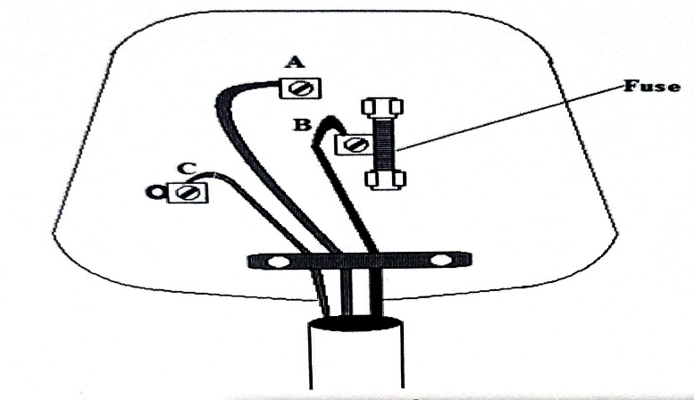

Pin A is practically longer than the other two. Give one reasons for this. (1 mark)
Any one:
- Ensures the earth connection is made before the live and neutral pins. ✓1
- Ensures earth is disconnected last. ✓1
- Opens the safety shutters before the live and neutral pins enter the socket. ✓1

Section B (55 marks)
(Answer all the questions in the spaces provided)

- (a) State Ohm's Law. (1 mark)
The current flowing through a conductor is directly proportional to the potential difference across it, provided the temperature (or other physical conditions) remains constant. ✓1

(b) What causes electrical resistance in conductors? (1 mark)
Resistance is caused by collisions of free electrons with vibrating atoms/ions of the conductor, which oppose the flow of current. ✓1
(c) you are provided with three resistors 3Ω and 7Ω
(i) Draw a circuit diagram to show the arrangement of the resistors which gives a maximum effective resistance with a 12V source. (1 mark)

All the resistors should be connected in series with the 12 V source.
(ii) Determine the voltage across a 3Ω resistor. (3 marks) ✓ M1
Current
$$I=\frac{V}{R}=\frac{12}{13}=0.923A$$
✓ M1
Voltage across one 3 Ω resistor
$$V=IR=\frac{12}{13}×3=\frac{36}{13}=2.77V \\ \boxed{V≈2.8V}$$

(d) Figure below shows the variation of the terminal potential difference, V, of a battery with the current, I, drawn from it.
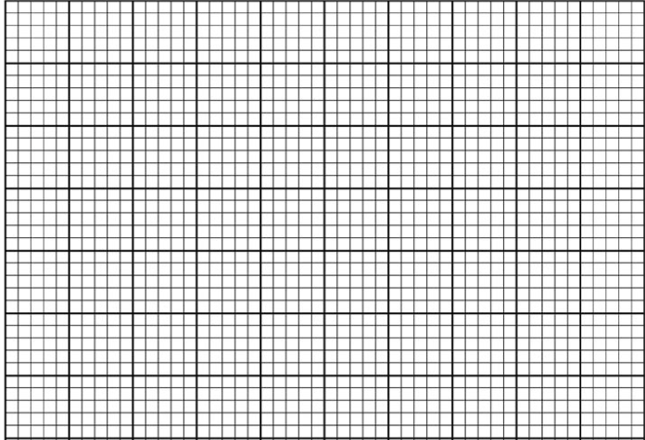
0
1.0
2.0
3.0
0.1
0.2
0.3
0.4
Current, I (A)
Terminal Voltage, V (V)

(i) Draw the circuit that could be used to obtain the results shown on the graph. (2 marks)
Marking
- Correct series circuit with ammeter and rheostat ✓1
- Voltmeter correctly connected across the battery ✓1
(ii) Given that $E=V+Ir$ where E is the e.m.f. of the battery and r is its internal resistance, determine the value of the internal resistance of the battery. (3 marks)
From graph
At
$$I=0A,V=3.0V$$
Hence
$$E=3.0V$$
✓ M1
Using another point from graph
For example
$$I=0.4A,V=2.2V$$
Substitute
$$2.2=3.0-(0.4)r \\ 0.4r=0.8 \\ r=2Ω$$
OR
Gradient
$$r=\frac{ΔV}{ΔI}=\frac{3.0-2.2}{0.4}=2Ω$$
✓ M1
$$\boxed{r=2Ω}$$

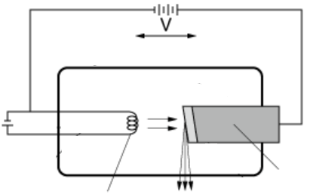
- (a) Figure below shows the essential parts of an X-ray tube.
Vacuum
Electron beam
E.H.T
Q
P
X-rays
Target

(i) Name the parts labelled P and Q. (2 marks)
- P – Cathode (filament/heated cathode) ✓1
- Q – Anode ✓1
(ii) Explain how X-rays are produced. (2 marks)
- Electrons are emitted from the heated cathode by thermionic emission and accelerated towards the target by a high potential difference. ✓1
- On striking the metal target, the electrons are rapidly decelerated and lose kinetic energy, which is emitted as X-rays. ✓1
(iii) the machine is almost entirely surrounded by a metal shield. Name the metal and give a reason why this metal must surround it. (2 marks)
Metal:
- Lead ✓1
Reason:
- Lead absorbs/stops X-rays, preventing harmful radiation from escaping and protecting the operator/patient from unnecessary exposure. ✓1
(iv) State with a reason the effect on the wavelength of the X-rays produced when the tube current is increased. (1 mark)
- The wavelength remains unchanged. ✓1
Reason: Increasing the tube current increases the number (intensity) of X-rays produced but does not change the accelerating potential, hence the energy and wavelength remain the same.

(b) Figure below shows part of the National Grid System

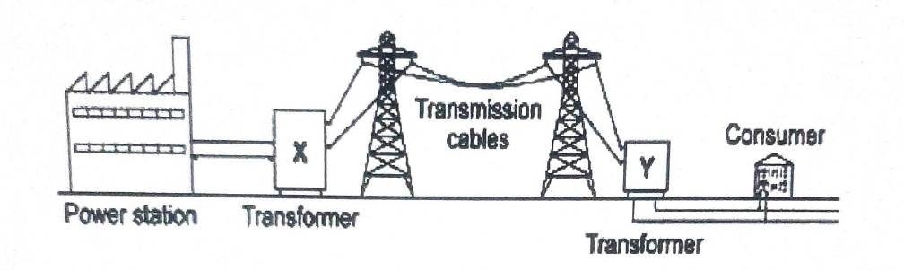
(i) With a reason, state the type of transformer marked X. (2 marks)
- Step-up transformer. ✓1
Reason:
- It increases the voltage before transmission (or decreases the current), thereby reducing power loss due to heating in transmission cables. ✓1

(ii) In a consumer unit, circuit breakers are preferred to fuse wires. Explain. (1 mark)
Any one:
- They can be reset and reused after tripping.
- They disconnect the circuit more quickly and accurately.
- They are more reliable and safer than fuse wires.
✓1

(iii) A house lighting circuit has one 100 W bulb, two 60 W bulbs and three 40 W bulbs. Determine the cost of operating all the bulbs for 70 hours if electricity costs 120 cents per kWh. (2 marks)
Total power
$$P=100+2(60)+3(40) \\ =340W=0.34kW$$
✓ M1
Energy consumed
$$E=0.34×70 \\ =23.8kWh$$
Cost
$$=23.8×120 \\ =2856\text{ cents}$$
or
$$=KSh 28.56$$

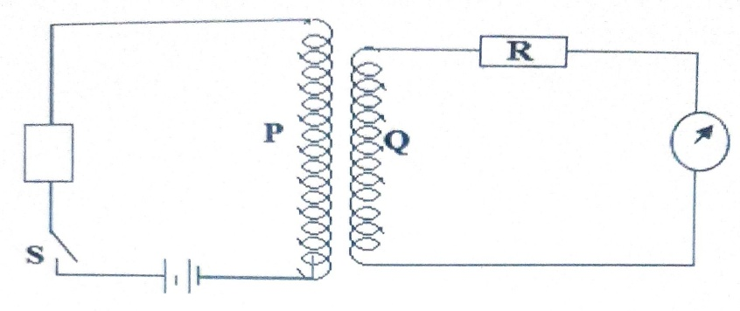
- (a) The figure below shows a setup used to demonstrate a phenomenon in Physics.

It is observed that, as the switch is closed, the galvanometer deflects and then goes back to zero. Explain this observation (2marks)
• When the switch is closed, the current in the primary coil rises from zero, producing a changing magnetic field that links the secondary coil and induces an e.m.f./current, causing the galvanometer to deflect. ✓1
• After a short time, the current in the primary becomes steady, the magnetic field becomes constant, and no further e.m.f. is induced, so the galvanometer returns to zero. ✓1
(b) Figure below shows a transformer with current I_{p} and I_{s} flowing through primary and secondary coils with voltages V_{p} and V_{s}, respectively.

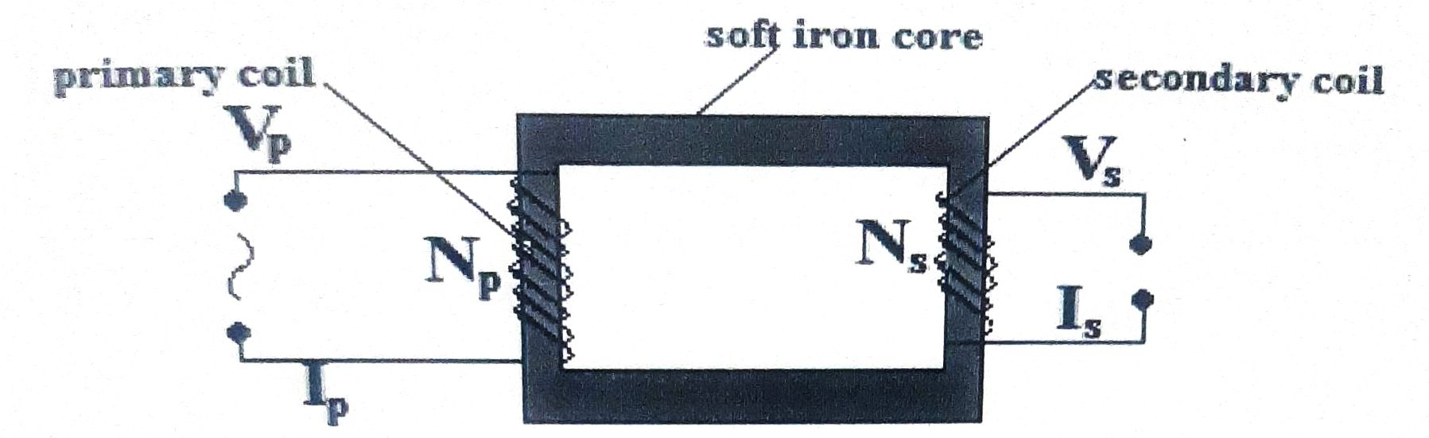
16 (b)
(i) Assuming there are no energy losses in the transformer, derive an expression for the ratio $\frac{I_{p}}{I_{s}}$in terms of $V_{p}$and $V_{s}$. (2 marks)
For an ideal transformer,
$$P_{p}=P_{s} \\ V_{p}I_{p}=V_{s}I_{s}$$
✓ M1
Therefore,
$$\boxed{\frac{I_{p}}{I_{s}}=\frac{V_{s}}{V_{p}}}$$
✓ A1

(ii) An ideal transformer has 1000 turns in the primary and 4000 turns in the secondary. The primary is connected to a 200 V a.c. source. The power delivered to the secondary resistor is 1000 W.
I. Determine the current in the secondary circuit. (2 marks)
Voltage ratio
$$\frac{V_{s}}{V_{p}}=\frac{N_{s}}{N_{p}} \\ V_{s}=\frac{4000}{1000}×200 \\ =800V$$
✓ M1
Power
$$P=V_{s}I_{s} \\ I_{s}=\frac{1000}{800} \\ =1.25A \\ \boxed{I_{s}=1.25A}$$
✓ A1

II. Determine the current in the primary circuit. (2 marks)
For an ideal transformer,
$$P_{p}=P_{s} \\ 1000=200×I_{p} \\ I_{p}=5A$$
OR
$$\frac{I_{p}}{I_{s}}=\frac{V_{s}}{V_{p}} \\ =\frac{800}{200}=4 \\ I_{p}=4×1.25=5A$$
✓ M1
$$\boxed{I_{p}=5A}$$
✓ A1

16 (c)
The figure shows an arrangement of capacitors.
(i) Calculate the effective capacitance of the arrangement. (2 marks)
The 2 μF and 3 μF capacitors are in parallel.
$$C_{p}=2+3=5μF$$
This 5 μF combination is in series with the 5 μF capacitor.
$$\frac{1}{C}=\frac{1}{5}+\frac{1}{5} \\ \frac{1}{C}=\frac{2}{5} \\ \boxed{C=2.5μF}$$
Parallel combination ✓1
Correct effective capacitance ✓1

(ii) Determine the charge stored on the 3 μF capacitor. (2 marks)
Charge in the series combination
$$Q=CV \\ =(2.5×{10}^{-6})(10) \\ =25×{10}^{-6}C$$
✓ M1
Voltage across the parallel combination
$$V=\frac{Q}{C}=\frac{25}{5}=5V$$
Charge on 3 μF capacitor
$$Q=CV \\ =3×5=15μC \\ \boxed{Q=15μC}$$
✓ A1

17 (a)
State one factor that determines the speed of photoelectrons emitted from a metal surface. (1 mark)
- Frequency of the incident radiation. ✓1
Accept: Energy of the incident photons.
(b) Figure below shows a photocell connected in a circuit containing a battery, a variable resistor and a microammeter. The photocell is illuminated using monochromatic light of frequency greater than the threshold frequency.
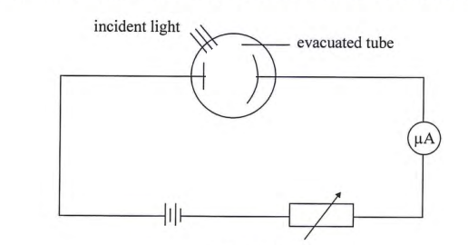

17 (b)
(i) State and explain the effect on the microammeter reading when the intensity of the incident light is increased without changing its frequency. (2 marks)
- The microammeter reading increases. ✓1
- This is because increasing the intensity increases the number of photons incident per second, hence more photoelectrons are emitted per second, resulting in a larger photocurrent. ✓1
(ii) Give a reason why the photocell tube is evacuated. (1 mark)
- To prevent collisions between photoelectrons and air molecules (allowing photoelectrons to move freely to the anode). ✓1
(b) The photocell in (b) was illuminated using radiation of different frequencies and the maximum kinetic energy (K. E_{Max}) of photoelectrons for each frequency, f was measured. The results obtained are shown in the graph below.

K. Emax (x 10⁻¹⁹ J
Frequency, f (x 10¹⁵ Hz
0
2.0
4.0
8.0
6.0
1.0
2.0
3.0
4.0
5.0
6.0
7.0

Use the graph to determine:
(i) Determine Planck's constant, $h$. (3 marks)
Using:
$$K.E_{max}=hf-ϕ$$
Hence,
Gradient of the graph = Planck's constant.
Choose two points on the straight line, for example:
$$\left(2×{10}^{15},1×{10}^{-19}\right)$$
and
$$\left(8×{10}^{15},5×{10}^{-19}\right)$$
Gradient
$$h=\frac{ΔKE}{Δf} \\ =\frac{(5-1)×{10}^{-19}}{(8-2)×{10}^{15}} \\ =\frac{4×{10}^{-19}}{6×{10}^{15}} \\ =6.7×{10}^{-35}\text{ J s} \\ \boxed{h≈6.6×{10}^{-34}\text{ J s}}$$
Marking
- Correct method (finding gradient) ✓1
- Correct substitution ✓1
- Correct value (accept 6.3–6.9 × 10⁻³⁴ Js, depending on graph reading) ✓1

(ii) Determine the threshold wavelength, $λ_{0}$. (3 marks)
From the graph,
Threshold frequency
$$f_{0}=1.0×{10}^{15}\text{ Hz}$$
✓ M1
Using
$$λ=\frac{c}{f} \\ =\frac{3.0×{10}^{8}}{1.0×{10}^{15}}$$
✓ M1

$$\boxed{λ_{0}=3.0×{10}^{-7}\text{ m}}$$
18 (a)
(i) State the electronic name of the process described. (1 mark)
- Doping ✓1

(ii) Give the type of semiconductor formed. (1 mark)
- P-type semiconductor ✓1

(iii) Justify the use of Group III elements in (ii) above. (1 mark)
- Group III atoms have three valence electrons, one less than silicon/germanium (which have four), creating holes that act as majority charge carriers. ✓1
Accept:
- They produce holes.
- They are trivalent impurities.

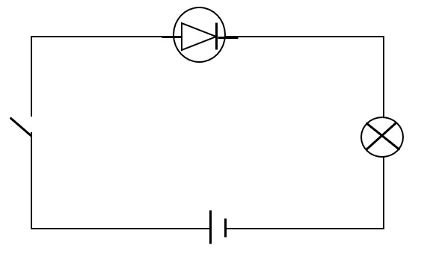
(b) The figure below shows a semiconductor diode connected in a circuit.
S

Expected circuit: diode is forward biased.
- The depletion layer becomes thinner (narrows). ✓1
- Majority charge carriers are driven towards the junction. ✓1
- They recombine at the junction, reducing the width of the depletion layer and allowing current to flow easily. ✓1

(c) Figure shows an arrangement used to investigate interference of light using a double slit.
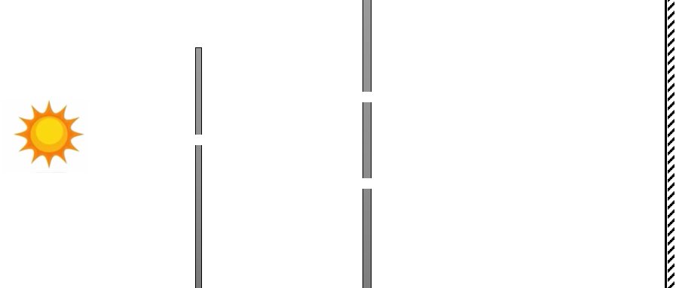
S₁
S₂
Monochromatic light source
slit
Double slit

(i) State the function of the double slit. (1 mark)
- To produce two coherent sources of light (two coherent wavefronts). ✓1

(ii) State and explain the observation made on the screen. (2 marks)
Observation
- Alternate bright and dark fringes are formed on the screen. ✓1
Explanation
- Bright fringes occur where waves meet in phase (constructive interference).
- Dark fringes occur where waves meet out of phase (destructive interference). ✓1

(iii) State what would be observed if the monochromatic light source was replaced with white light. (1 mark)
- A central white fringe is observed with coloured fringes on either side, which gradually fade due to overlap of colours. ✓1
Accept:
- White central fringe surrounded by coloured fringes.

THIS IS THE LAST PRINTED PAGE

