MATHEMATICS
GRADE 6
TIME: 1hour 20 minutes
1. Patrick got the equivalent fraction to 12/20. Which one below is an equivalent fraction to 12/20?
A. 1.8/30
B. 4/5
C. 36/60
D. 24/30
2.Okisa rounded off 9.99999 to the nearest thousandths. What did she get?
A. 9.99
B. 10.000
C. 10.0
D. 10.00
3. The capacity of a jerrican is 22 litres. What is the capacity of the jerrican in cubic centimetres?
A. 22000
B. 2200
C. 220
D. 22
4. In Barazani school, there are 3243 learners. Each learner was given 3 face masks. How many face masks were given out altogether?
A. 9629
B. 9729
C. 96129
D. 97129
5. In a farm 0.48 of the land was planted beans and the rest was planted maize. What fraction was planted maize?
A. 12/25
B. 48/100
C. 52/1000
D. 13/25
6. A tree nursery had 368593 seedlings. Customers bought 27364 seedlings in a day. How many tree seedlings remained?
A. 395957
B. 341239
C. 341229
D. 94953
7. A milk processing factory produced 19468 packets of milk. How many packets of milk to the nearest thousands were produced?
A. 20000
B. 19500
C. 19470
D. 19000
8. In a hospital, 436587 children were vaccinated against polio in a certain year. What is the total value of digit 6 in the number?
A. 600
B. 6000
C. 60000
D. 600000
9. What is the next number in the pattern?
8, 24, 72, 216, ____
A. 232
B. 264
C. 360
D. 648
10. Work out the following.
24 ÷ 3 + 9 × 6 - 4
A. 8
B. 26
C. 58
D. 98
11. Musa spent 2/5 of his salary on food. He also spent 1/4 of the salary on rent. What is the total fraction of the salary that Musa spent on food and rent?
A. 13/20
B. 7/20
C. 3/20
D. 9/20
12. The height of water in a dam increased by 9cm after it rained. What is the increase in the height of water in millimetres?
A. 90
B. 900
C. 9000
D. 90000
13. A ribbon is 31cm 6mm long. Rehema cut 5cm 3mm of the ribbon to make a flower. What length of the ribbon remained?
A. 26cm 3mm
B. 34cm 3mm
C. 36cm 9mm
D. 36cm 3mm
14. What is the value of 9 5/6 - 1 1/3?
A. 11 1/6
B. 9 1/6
C. 8 2/3
D. 8 1/2
15. Mr. Odhicho drew the following shape on the board.

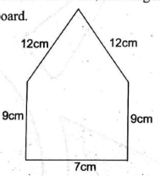

What is the perimeter of the shape above?
A. 45cm
B. 49cm
C. 47cm
D. 48cm
16. The area of a rectangular piece of paper is 72cm². The length of the paper is 9cm. What is the width of the paper in millimetres?
A. 0.8
B. 8
C. 80
D. 800
17. Ndemo assists his father to sell clothes in their shop. He sold a dress for sh 1675. He made a profit of sh 390 after selling the dress. What was the buying price of the dress?
A. Sh 1285
B. Sh 2065
C. Sh 1325
D. Sh 1385
18. Omondi measured the angle drawn below using a protractor.
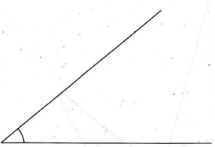

What correct measure did he get?
A. 100°
B. 80°
C. 60°
D. 40°
19. During geometry lesson, learners were asked to describe the faces of a cylinder, pyramid, cube and cuboid. Which of the following descriptions is correct?
A. A cylinder has a square face
B. A cube has a rectangular face
C. A pyramid has a triangular face
D. A cuboid has a circular face
20. A carpenter joined five pieces of timber to form a window frame as shown.
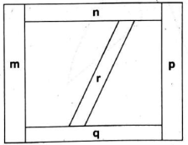

Which of the following pieces of timber are parallel?
A. r and p
B. n and q
C. m and n
D. r and q
21. While picking litter in the school compound, Munya picked the following 3-D object.
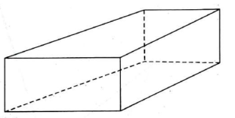

How many edges does the object have?
A. 6
B. 8
C. 9
D. 12
22. A flower company exported 4850000 kilograms of fresh flowers. How many tonnes of fresh flowers did the company export?
A. 4850
B. 485
C. 48500
D. 485000
23. Kimeto drinks 3.7 litres of water everyday. How many millilitres of water does he drink?
A. 37
B. 370
C. 3700
D. 37000
24. A wall of a rabbit hutch is in the shape of a rectangle and triangle as shown.
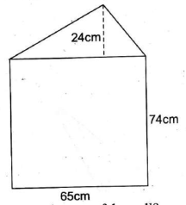

What is the area of the wall?
A. 4810cm²
B. 6370cm²
C. 3185cm²
D. 5590cm²
25. Wambua represented his school in a music festival. He began his performance in the afternoon at the time shown on the clock face below.
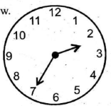

At what time did Wambua begin his performance?
A. 2.35am
B. 3.35pm
C. 2.35pm
D. 3.35am
26. A tea processing factory distributed fertilizer to farmers using 4 lorries. Each lorry carried 24 tonnes 235 kilograms of fertilizer. What was the total mass of fertilizer distributed?
A. 96 tonnes 920 kilograms
B. 96 tonnes 940 kilograms
C. 96 tonnes 840 kilograms
D. 86 tonnes 940 kilograms
27. Moses took 8 minutes 40 seconds to prepare tea and also took 15 minutes 45 seconds to cook ugali. How much time did he spend cooking altogether?
A. 24 minutes 25 seconds
B. 23 minutes 85 seconds
C. 24 minutes 85 seconds
D. 23 minutes 25 seconds
28. A self-help group shared some money among 50 women. Each woman in the group got sh 8500. Use letter x to represent the amount of money shared. Which one of the following equations correctly represents this information?
A. 50x = 8500
B. 50 ÷ x = 8500
C. x ÷ 50 = 8500
D. x + 50 = 8500
29. The table below shows the number of patients who were treated for various diseases in a dispensary. Some information is missing in the table.
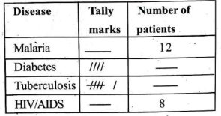

How many patients were treated altogether?
A. 29
B. 30
C. 18
D. 40
30. Wangeci made a necklace using red and green beads. The red beads used were 25% while the rest were green. Which of the following decimals represent the green beads?
A. 0.0075
B. 0.075
C. 0.75
D. 7.5

ENGLISH: LANGUAGE
GRADE 6
TIME: 1hour
Read the dialogue below and then answer questions 1 to 5
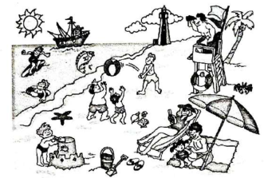

Agnes: It is quite hot here in Diani, Kwale County. The best solution is to go to the beach for a swim. My brother, sister and parents are at the beach.
Francis: Apart from having fun, have you finished the assignment of Mr. Mukira on animals?
Agnes: I have done the one on the Crocodile. I browsed and got some information from the internet. What about you?
Francis: I have done the one on the Warthog. I got some information from the internet as well.
Agnes: When are you coming back?
Francis: I think we shall be back to Busia in a fortnight's time to be precise.
Agnes: I must go now. I can hear the thunder. I have to go and remove the washing from the line before the downpour and dusk.
Francis: I look forward to seeing you then.
Agnes: It is okay my good friend. I will call you later.
Francis: Before you hang up, have you been taking care of Sherry?
Agnes: Oh! That silly cat of yours tried to steal my milk.
Francis: Then it seems you don't feed it well.
Agnes: I do feed it. I am taking good care of it, by the way.
Francis: Say hi to your parents for me, bye.
Agnes: I will surely pass your greetings, bye too.
1. How many family members were at Diani for vacation?
A. Three
B. Four
C. Five
D. Six
2. What was the source of information on the learners' research?
A. From the cyber
B. From the internet
C. From library
D. From resource persons
3. The word dusk is used in the dialogue, its opposite would be
A. evening
B. midnight
C. afternoon
D. morning
4. Fortnight is a word used in the above conversation. What does it mean?
A. Two weeks
B. One month
C. One week
D. Two months
5. Sherry is a pet that belongs to
A. Agnes
B. the two families
C. Francis
D. cat

Read the passage below carefully and then answer questions 6 to 9
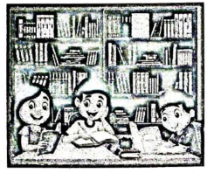

Kibutu, a grade six learner, was taken by his teacher to search for information about child labour. Kibutu decided to visit a public library and with the librarian's help, he selected the most suitable books. He found the following information in the books.
Child labour is defined as the exploitation of the children through any form of work that deprives them of their childhood. It also involves activities that are mentally, physically, morally and socially harmful to their wellbeing. In addition child labour denies the victims the opportunity to attend regular schooling. Such kinds of activities are considered illegal worldwide. However, not all the activities or works done by children are a form of child labour. Some are responsibilities of children; these include family duties, chores and supervised training. Most children who are engaged in child labour are from low-income families or those that are orphaned or kidnapped. These children can be forced to work in areas such as big plantations, factories or mining sites.
6. Why did Kibutu go to the library?
A. To seek for help from the librarian.
B. To read some articles.
C. To search for information on child labour.
D. To borrow some relevant books.
7. Who assisted Kibutu in selecting the most suitable books for his research?
A. His teacher.
B. The library attendants.
C. Good Samaritan.
D. The librarian.
8. Child labour involves activities that harm the wellbeing of children in the following ways except
A. physically.
B. socially.
C. spiritually.
D. mentally.
9. The majority of children engaged in child labour are
A. school drop outs.
B. those without parents.
C. those from families experiencing violence.
D. those under peer pressure.
Read the passage below and then answer questions 10 to 12.
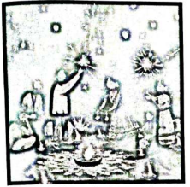
Diwali is popularly known as the festival of lights. It is the most awaited and the most celebrated festival among the Hindus in every part of the world. People in every nook and cranny across the globe welcome the festival with enthusiastic gesture. This wonderful festival is celebrated for five days. The events are arranged in such ways that each day has an activity to be performed.
On the first day, there is the Dhanteras. This is the worshipping of Lord Yama. It also includes buying metal objects. On the second day, the events performed include Choti Diwali, Roop Chaturdashi, Narak and Chturdasi. Luxmi and Ganesh Pujan are the events celebrated on the third day. This is the ritual of Diwali. On this day, there is the lighting of Dyas ceremony where candles are lit and placed all around the house. The Hindus then worship the Luxmi Ganesha to summon health and wealth. On the fourth day, Gorardhan Puja is perfomed and finally on the fifth day also known as Bhai Dooj or Bhaj brothers and sisters are prayed for and blessed.
10. Which people celebrate Diwali?
A. Hebrews
B. Pagans
C. Muslims
D. Hindus
11. On which occasion are metal objects bought according to the passage?
A. Dhanteras
B. Choti Diwali
C. Bhai Dooj
D. Lighting of Dya's
12. The following activities take place on the second day of the festival except
A. Roop Chaturdashi
B. Lighting of Dyas
C. Chturdasi
D. Choti Diwali
Read the passage below and then answer questions 13 to 15 correctly.
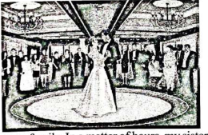

It was a very important day for our family. In a matter of hours, my sister was to tie the knot with her long-time friend in a colourful ceremony. The wedding was scheduled to take place at the Holy Family Basilica in Nairobi. Being one of the pageboys, I had to look my best. The night before was my busiest day. We had to do rehearsals and final touches to ensure everything was in order. My sister, who had spent almost the whole day in the beauty parlour, was at our aunt's house. When the clock ticked eight, we all boarded the vehicles and headed for my aunt's house. We picked my sister and then proceeded to the church.
My sister was immaculately dressed in a snow-white gown. She indeed looked beautiful. After exchanging greetings and pleasantries, our convoy snaked its way through the streets of Nairobi to the Holy Family Basilica, which was just a stone's throw distance away. Mr. Martin, the groom, was neatly dressed in a white suit and a red bow tie similar to the outfit his groomsmen and I had worn. From the look of things, it seemed patience was retreating out of him, but when he saw his bride, a handsome grin plastered all over his face exposing his pearl teeth. Right Reverend Bishop Simon Peter Kamome was already at the altar ready to do his job. My sister, sandwiched between my parents, began to walk at a snail's pace to the altar as the guests watched in admiration.
13. What occasion is described in the passage?
A. Family celebration.
B. The writer's sister celebrating her birthday.
C. Wedding ceremony.
D. Family come together.
14. What is the relationship between the narrator and Mr. Martin?
A. Nephew and uncle.
B. Brothers.
C. Brothers-in-law.
D. Close relatives.
15. Bride is to bridegroom just as ____ is to bachelor.
A. niece
B. best maid
C. lady
D. spinster
Fill in the blank spaces with the correct word from the choices provided.
I had just left the house when it started raining __16. I was determined to reach home before nightfall, so I decided I would not wait for the rain to stop. I therefore began walking __17. I took the shortest route through the forest. I __18 use this route because I know that short cuts are __19 wrong cuts. Gripped with fear, I hurried __20 stream which I was also aware was full of crocodiles.
16. A. big B. heavy C. heavily D. serious
17. A. hurriedly B. hurry C. quick D. hurryingly
18. A. always B. every day C. often D. rarely
19. A. never B. often C. not D. rarely
20. A. across B. inside C. down D. behind
For questions 21 to 23, complete the given analogies
21. Eat is to verb as because is to ____
A. adjective
B. adverb
C. conjunction
D. pronoun
22. Fish is to fingerling as goose is to____
A. gooseling
B. gosling
C. chick
D. egg
23. Bull is to cow just as ram is to____
A. goat
B. she-ram
C. lamb
D. ewe
For questions 24 and 25, choose the correct question tags
24. They were not defeated in the tournament, ____?
A. weren't they
B. were they
C. isn't it
D. should they
25. You must do your homework, ____?
A. should you
B. shan't you
C. must you
D. mustn't you
Choose a similar word to the underlined word
26. I really need your assistance immediately.
A. Money
B. Cash
C. Help
D. Helper
27. The rain has not ceased.
A. started
B. stopped
C. rained
D. commenced
28. I don't have sufficient time to travel up country.
A. more
B. much
C. little
D. enough
For questions 29 and 30, select the correct word to complete the sentences
29. ____ the carrots before cooking them.
A. Greet
B. Great
C. Crate
D. Grate
30. I waited for him for a ____ hour.
A. hole
B. whole
C. owl
D. wall

ENGLISH: COMPOSITION
GRADE 6
TIME: 40 mins
Write a letter to your parent or guardian telling him or her of how you are at school and share with him or her your preparations for the upcoming KPSEA exams in the month of October this year.

KISWAHILI: LUGHA
GREDI YA SITA
MUDA: SAA 1
Soma mazungumzo haya kisha ujibu swali la 1 hadi la 5
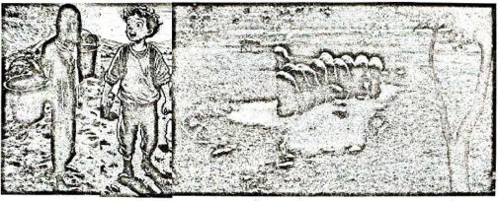

(Ni adhuhuri. Pato na Lisa wanakutana bwawani. Ni msimu wa masika.)
Pato: Hujambo mwenzangu. U hali gani?
Lisa: Sijambo. Shikamoo.
Pato: Marahaba. Mbona ukafikiria kuja hapa bwawani? Umekuja kufanya nini hapa. Kwa kawaida mimi nimeleta kondoo wakonge kiu.
Lisa: Pia mimi nimekujia maji ya kunywesha mbuzi wangu. Alizaa pacha siku ya Jumapili. Nina bidii kumtunza vyema ili wawe wengi. Namshukuru Mungu kwa kumtunza.
Pato: Heko. Mvumilivu hula mbivu. Ungekuwa umemwuza usingepata faida kama hiyo.
Lisa: Mwisho wa mwaka najua nitakuwa na mbuzi zaidi ya watano.
Pato: Bora uwatunze vyema na uwatafutie tabibu ambaye atakuwa akiwatibu nakuwapa chanjo mara kwa mara. Bila shaka utakuwa na faida tele.
Lisa: Sina budi kufuata ushauri wako kwa kuwa una tajriba kubwa ya ufugaji.
Pato: Nitakushika mkono popote utanihitaji. Nitakuelekeza na utakuwa tajiri wa mifugo.
1. Kulingana na mazungumzo haya ni kweli kusema kuwa
A. Lisa alikuwa mdogo kuliko Pato
B. Pato alikuwa mdogo wa Lisa
C. Pato na Lisa walikutana mtoni
D. Lisa alikuwa na mbuzi wengi
2. Pato alikuwa na shughuli gani walipokutana na Lisa?
A. Kuchotea wanyama maji
B. Kumsalimia rafiki yake
C. Kuwalisha kondoo wake
D. Kunywesha wanyama maji
3. Lisa alikuwa na wanyama wangapi?
A. Watatu
B. Wengi
C. Mmoja
D. Wawili
4. Chagua neno lenye maana sawa na tabibu.
A. Mkulima
B. Nesi
C. Daktari
D. Muuguzi
5. Ni nini maana ya nahau nitakushika mkono?
A. Nitakusabahi
B. Nitakusaidia
C. Nitakubeza
D. Nitakupa
Soma kifungu kifuatacho kisha ujibu swali la 6 hadi la 9
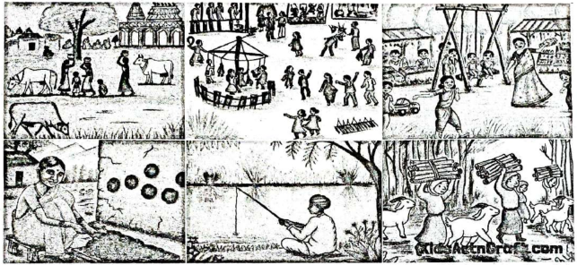
Eneo la Jitegemee limo Kaskazini mwa kaunti ya Kambini. Jitegemee ina vijiji vitano. Fanaka ndicho kijiji kidogo zaidi hapo Jitegemee. Ni kijiji ambacho huwavutia na kuwashangaza wengi.
Wanakijiji wa Fanaka ni mchwa. Mtu anapotembelea Fanaka alfajiri hukutana na misafara ya watu; wake kwa waume, wazee kwa vijana. Wao huenda kutafuta riziki. Wapo wanaobeba vibuyu na mitungi, wanaenda kutafuta maji mtoni au kwenye vibanda vya maji. Wengine hubeba majembe kuelekea mashambani. Imani yao huwa, achanikaye kwenye mpini hafi njaa.
Wapo wachuuzi wanaosukuma mikokoteni yenye madebe ya maziwa ya kuuza. Wapo wanaoenda kufanya kazi kwenye majengo na viwanda. Wengine wamevaa suti na tai, wanaelekea ofisini au shuleni kufundisha. Vilevile, wapo wanafunzi wanaoelekea shuleni na vyuoni. Hakika, kila mja katika kijiji hiki hushughulika. Bidii ya wakazi wa Fanaka imewawezesha kujitegemea. Fanaka haijawahi kukosa chakula. Japo mvua hainyeshi kila msimu, maghala ya wenyeji huwa yamejaa chakula. Ukiwauliza vipi wanaweza kuwa na chakula kila msimu, wao hukuambia kuwa ukame haumzuii mtu kuilisha familia yake. Wao wamechimba visima vya maji. Wananyunyizia mimea yao maji. Hii ndiyo maana kijiji cha Fanaka kinavipatia vijiji vingine chakula.
6. Wanakijiji wa Fanaka ni mchwa. Sentensi hii imetumia fani gani ya lugha?
A. Istiara
B. Tashbihi
C. Methali
D. Nahau
7. Achanikaye kwenye mpini hafi njaa ni methali ambayo inatuhimiza tuwe watu wenye
A. ubahili
B. bidii
C. uzembe
D. utu
8. Ni kina nani huvaa suti na tai?
A. Askari
B. Wanafunzi
C. Wakulima
D. Walimu
9. Wakulima waliotajwa katika kifungu hiki hutoa maji wapi ya kunyunyizia mimea?
A. Visiwani
B. Baharini
C. Visimani
D. Ghalani
Wanafunzi wa gredi ya sita waliambiwa waandae jedwali linaloonyesha wanyama mbalimbali. Tazama jedwali hili kisha ujibu swali la 10 hadi la 12:
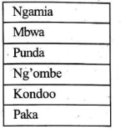

10. Ni mnyama yupi hutumika katika shughuli za usafiri?
A. Punda
B. Mbwa
C. Paka
D. Kondoo
11. Chagua mnyama ambaye hutupa kinywaji ambacho huwa na protini.
A. Kondoo
B. Ng'ombe
C. Mbwa
D. Punda
12. Chagua mnyama ambaye hula wanyama wanaoharibu nafaka.
A. Ngamia
B. Kondoo
C. Mbwa
D. Paka
Soma kifungu kifuatacho kisha ujibu swali la 13 hadi la 15
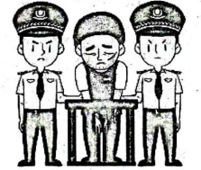

Alasiri moja, askarikanzu walikuwa wakitembea kijijini. Walipokuwa wakipita kando ya kichaka walimwona Potovu. Alikuwa akivuta bangi. Alipowaona maafisa wa polisi alitimua mbio lakini askari walimtia mbaroni. Alifungwa pingu mikononi na kupelekwa katika kituo cha polisi. Katika kituo cha polisi aliwekwa rumande. Siku iliyofuata, alipelekwa mahakamani. Askari waliogopa asitoroke. Kwa hivyo, aliposimama katika kizimba walimfunga pingu.
Kesi iliposikilizwa, Potovu alihukumiwa kifungo cha miaka saba katika jela. Hakimu alimwambia kuwa alikuwa na nafasi ya kukata rufaa kabla ya wiki mbili kuisha. Potovu aliangua kilio. Alilia sana. Lakini kilio si dawa. Hakuamini kuwa amekuwa mfungwa. Aliogopa kukaa katika seli za gerezani.
13. Kwa nini Potovu alishikwa?
A. Alikuwa akitumia bangi
B. Alitimua mbio
C. Aliwakosea askari
D. Alikataa kufuata askari
14. Unafikiri ni kwa nini Potovu aliwekwa pingu mikononi?
A. Ili asitoroke
B. Ili asipigane
C. Ili atulie
D. Ili afike mahakamani
15. Potovu alihukumiwa na nani?
A. Hakimu
B. Askari
C. Maafisa
D. Kanzu
Soma kifungu kifuatacho. Kina nafasi 16 hadi 20. Umepewa majibu manne hapo. Chagua jibu lifaalo zaidi kati ya yale uliyopewa.
Timu yetu ya Bidii ___16 ikicheza dhidi ya timu ya Simba. Timu yetu ilicheza na kuwa washindi. Ushindi ___17 ulitokana na ushirikiano ___18 wachezaji ambao kila wakati ___19 kama kinu na mchi wakifanya mazoezi. Walipewa zawadi kwa ___20 wao.
16. A. yalikuwa B. ulikuwa C. ilikuwa D. lilikuwa
17. A. wao B. lao C. chao D. yao
18. A. la B. cha C. wa D. ya
19. A. walitengana B. walishirikiana C. walizembea D. walidhoofika
20. A. ufanisi B. kushinda C. mafanikio D. bidii
Kutoka swali la 21 hadi la 30, chagua jibu sahihi kulingana na maagizo uliyopewa.
21. Chagua neno lenye silabi nne.
A. Mzazi
B. Mwelekeo
C. Kaka
D. Viazi
22. Chagua jozi iliyo na vielezi pekee.
A. Pole, haraka
B. Jana, vizuri
C. Mtu, ua
D. Mbaya, mwepesi

23. Ni nomino gani ambayo huwa katika ngeli ya LI-LI?
A. Mawe
B. Gari
C. Giza
D. Darasa
24. Je, chakula ambacho huliwa wakati wa adhuhuri huitwaje?
A. Kishuka
B. Kisebeho
C. Pamba
D. Chajio
25. Kamilisha: Konda kama ____
A. sindano
B. nyasi
C. ng'onda
D. mgonjwa
26. Chagua sentensi ambayo imetumia kiwakilishi.
A. Mtoto yule ameoga
B. Kile kimepatikana uwanjani
C. Mchezaji aliumia jana
D. Mnyama mnono ni nguruwe
27. Jaza pengo: Karai ____ lilivunjika nikifua
A. lile
B. ile
C. yale
D. kile
28. Chagua neno mwafaka kujaza pengo: Wenyeji walikula ugali ____ nyama ya kuku.
A. ni
B. pia
C. na
D. kwa
29. Chagua neno lililoendelezwa vizuri
A. Bibilia
B. Mschana
C. Muhogo
D. Maskio

30. Ni ishara gani kwenye kompyuta ambayo huonyesha 'Chapa koza.'
A. B
B. I
C. U
D. X

KISWAHILI: INSHA
GREDI YA SITA
MUDA: DAKIKA 40
Andika insha ya kusisimua juu ya:
JINSI YA KUPIKA UGALI

INTEGRATED SCIENCE
GRADE 6
Time: 1hr 40mins
SECTION A: SCIENCE & TECHNOLOGY
1. Magina was seen using the lever below.
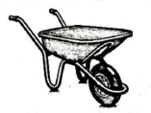

What are other examples of lever that belong to the same class as the lever in the picture above?
A. A pair of scissors, tweezers
B. Nutcracker, bottle opener
C. Coal tongs, human arm
D. Nailcutter, crowbar
2. Grade 6 learners made an instrument below.
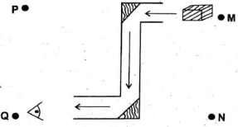

The position of the image when observing the object will be at
A. N
B. M
C. Q
D. P
3. Mr. Koech is a cook in Tutini Primary school kitchen. He can reduce smoke from the fire in the kitchen by doing all the following except
A. instal chimneys
B. use improved jiko
C. kitchen to have large doors and windows
D. block all the windows
4. All the following are uses of oxygen except
A. used in breathing process
B. used in photosynthesis process
C. for rusting
D. supports burning
5. One afternoon just before it started raining, Rono and Atieno saw rainbow in the sky. The rainbow was formed when there
A. is darkness and water droplets
B. is quietness and water droplets
C. is sunshine and water droplets
D. are clouds and water droplets
6. The following are examples of fungi. Which one is correct?
A. Mushroom, mould, toadstool
B. Algae, fern, lichens
C. Maize, beans, peas
D. Yeasts, moss, mucor
7. The chart below shows invertebrates
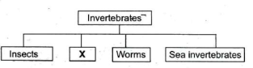

The part labelled X can be filled with
A. grasshopper
B. earthworm
C. spider
D. octopus
8. The circulatory system consists of the following except
A. blood
B. heart
C. blood vessels
D. liver
9. All arteries carry oxygenated blood except
A. aorta
B. pulmonary vein
C. pulmonary artery
D. venacava
10. The chart below shows the changes of states of matter.
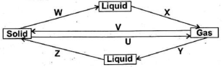

Which of the labelled processes require cooling?
A. W
B. Z
C. X
D. U
11. The picture below shows a vertebrate.
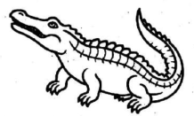

The vertebrate shown above possess the following characteristics. Which one is not?
A. Warm blooded
B. Lays eggs
C. Body covered with scales
D. Breathes through lungs
12. A grade 6 learner gave the following points about sound. Which one is wrong?
A. Reflected sound is called echo
B. Sound travels in one direction
C. Loud sound affects ears
D. Sound is a form of energy
13. Charity drew a flower as shown below.
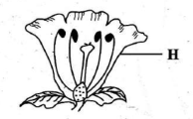

What is the function of the part marked H?
A. Receives pollen grains
B. Develops into fruit
C. Protects flower at bud stage
D. Attracts insects for pollination
14. A ship floats on water because of its
A. shape
B. mass
C. density
D. size
15. Njoroge had a mixture of maize flour and metallic paper clips. He can use all the three methods below to separate the mixture except
A. sieving
B. use of magnet
C. filtering
D. picking
16. Covid-19 is a disease of the breathing system. It has the following signs and symptoms except
A. fever
B. running nose
C. loss of taste and smell
D. coughing
17. Lucy collected samples of non-flowering plants. Which one did she collect?
A. Moss, mushroom, ferns
B. Wheat, grass, beans
C. Cacti, sisal, banana
D. Mould, lichens, grass
18. John held a metal nail over candle fire as shown.
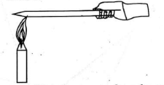

How did the heat move from the candle fire to John's hand? Through
A. convection
B. radiation
C. evaporation
D. conduction
19. Which one of the following consists of floaters only?
A. Wax and pin
B. Glass and feather
C. Ice cubes and leaf
D. Bottle tops and nail
20. Harmful substances that cause pollution in water are called
A. materials
B. objects
C. solutes
D. pollutants
21. Digestion of food takes place in the following parts of the digestive system. Which one is not correct?
A. Small intestine
B. Rectum
C. Stomach
D. Mouth
22. The diagram below shows a part of a plant.
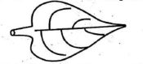

The main function of the part of the plant above is
A. absorbs water in soil
B. develops into fruits
C. makes plant food
D. supports the plant
23. To ensure healthy digestive system you should avoid the following foods. Which one is it?
A. Biscuits
B. Milk
C. Cassava
D. Oranges
24. A certain matter has the following properties;
i) fixed shape
ii) fixed volume
iii) fixed mass
The matter is likely to be
A. maize flour
B. air
C. steam
D. water
25. The following solid wastes can be reused at home except
A. plastic bottles
B. empty jerricans
C. old tyres
D. banana peelings
SECTION B: AGRICULTURE
26. Why is it advisable not to puncture the polythene sheet when constructing a raised moist bed? To
A. control weeds
B. prevent evaporation
C. prevent water loss
D. improve soil fertility
27. Grade 6 learners have formed a crocheting club. They can make the following items except
A. socks
B. gumboots
C. table mats
D. neck scarf
28. The following substances are used to remove grass stain on a garment. Which one is it?
A. Baking soda
B. Salt
C. Vinegar
D. Methylated spirit
29. Grade 6 girls should maintain good menstrual hygiene by carrying out the following practices except
A. change sanitary towels regularly
B. bathe regularly
C. avoid wearing very tight underwear
D. wear sanitary pads for days
30. Jane wants to bake a cake using the rubbing-in method. She needs all the following ingredients except
A. wheat flour
B. eggs
C. spices
D. milk
31. Nekesa covered fruits and vegetables with a net when sun-drying. This was to
A. enable it dry faster
B. improve flavour
C. preserve colour
D. keep off flies and birds
32. When constructing the roof of a hutch, grade six learners made sure that it was slightly sloping. Why do you think they did so? To
A. allow rain water to slide off
B. prevent pests
C. ventilate the hutch
D. kill the germs
33. Omoto uses safe traps to capture wild animals in her farm. What should he do with the wild animals caught?
A. Eat them
B. Release them to the forest
C. Kill them
D. Keep them in the farm
34. The diagram below shows a way of controlling a certain type of soil erosion.
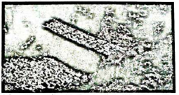

The soil erosion being controlled is called
A. sheet erosion
B. splash erosion
C. gulley erosion
D. rill erosion
35. A farmer grew his vegetable crops in the type of bed shown in the picture.
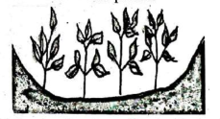

The main advantage of the bed is that it
A. controls weeds
B. adds nutrients to soil
C. conserves soil moisture
D. makes crops grow upright
36. Rael used the needlework tool below when sewing.
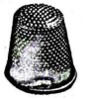

It is used to
A. protect fingers
B. measure garments
C. store needles
D. cut garments
37. A grade 6 learner was using a protective equipment that should not be shared. Which one is it?
A. Head gear
B. Hand gloves
C. Overall
D. Face mask
38. Jery is cleaning the house and using the tool below.


The cleaning tool above is used for
A. sweeping the floor
B. disposing wastes
C. mopping the floor
D. dusting the house
39. After visiting the toilet, you should
A. wash your hands
B. eat food
C. drink water
D. clean the toilet
40. When shallow frying eggs, Odera should observe the following safety precautions except
A. pour cooking oil carefully
B. do not touch the hot frying pan with fingers
C. touch the hot frying pan with fingers
D. hold the frying pan with insulated handle
41. Koros ate a balanced diet. Koros was likely to have eaten
A. bread, milk, eggs
B. ugali, oranges, chicken
C. spinach, rice, mangoes
D. meat, chapati, soda
42. The picture below shows a domestic animal.

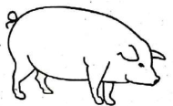

The meat of the animal above is called
A. mutton
B. chevon
C. beef
D. pork

43. A grade 6 learner was advised to consume fruits in her diet. This was to
A. protect body against infections
B. build body tissues
C. provide energy to the body
D. repair worn out tissues
Nyamnyam saw the structure in the picture in a certain farm. Use it to answer questions 44 and 45.
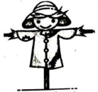

44. The structure is used for
A. attracting animals
B. making farm beautiful
C. keeping off wild animals
D. feeding birds
45. The structure can be used to control all the following animals except
A. monkey
B. hare
C. antelopes
D. buffalo
46. Sharon was asked to mention the gardening practice that is done to conserve soil moisture and reduce growth of weeds in a seedbed. The gardening practice is known as
A. weeding
B. mulching
C. training
D. shading
47. Loiman made the stitch below on a garment.
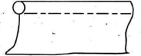

The type of stitch is called
A. tacking stitch
B. running stitch
C. back stitch
D. hemming stitch
48. When laundering a fast coloured item, Eunice added vinegar to the final rinsing water. This was to
A. bleach the garment
B. brighten colour
C. remove stains
D. remove creases
49. Four learners arrived in school one morning. The teacher on duty checked who among them was not well groomed. Who was he?
A. Ben - had well combed hair
B. Baraza - had unkempt hair
C. Bosire - had well pressed shirt
D. Boss - had well polished shoes
50. A child suffering from scurvy lacks
A. vitamin D
B. iodine
C. iron
D. vitamin C

CREATIVE ARTS
GRADE 6
Time: 1hr 40mins
1. A music teacher asked learners to draw the notes of the following rhythmic pattern.
taa ta-te taa-aa.
Who drew the correct rhythm?
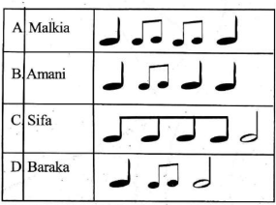

2. Which of the following hand signs is not correctly matched with the correct solfa syllable?
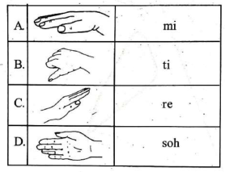

3. Gor is playing notes on a descant recorder. Which of the notes is played when the backhole is open?
A. Note D¹
B. Note A
C. Note C¹
D. Note E

4. Amang drew the rest symbol of minim. Which one did he draw?
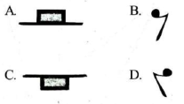

Study the figure on performance of a certain race in athletics. Use it to answer question 5.
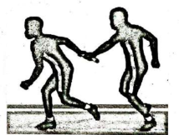

5. What is the name of the equipment used in the activity?
A. Bat
B. Javelin
C. Baton
D. Rod
6. Karendi, a grade six learner was a fielder in a game of rounders. She collected the ball after the opponent batted and touched a post with the ball before the incoming player got to the post. The skill of touching the post with the ball is called
A. batting
B. fielding
C. bowling
D. stumping
7. A player used the type of kicking below to pass a ball to his teammate in a game of football.
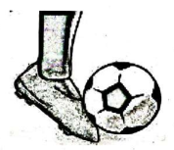

The type of kicking technique is called
A. instep kick
B. outside the foot kick
C. toe kick
D. inside the foot kick
8. Koikai made a decoration on his garment using the technique shown.
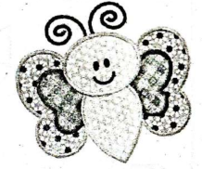

The decoration technique is known as
A. tie and dye
B. flat wash
C. applique
D. printing
9. Malua mixed the colours below during Creative Arts lesson.
Blue + Red = [ ]
What colour did he get?
A. Orange
B. Yellow
C. Purple
D. Green
10. Oduor was playing the wind instrument below.
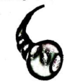

Which community in Kenya plays the instrument above?
A. Kuria
B. Luhya
C. Luo
D. Kisii
11. When carving you can use all the following tools except
A. panga
B. adze
C. carving knife
D. razor blade
12. Grade 6 learners of Best Care primary school were playing musical instruments ensemble. Which one below represents percussion instruments they were likely to play?
A. Drum, Kayamba, Adongo
B. Abu, Olwika, Mulele
C. Obutu, Ishiriri, Litungu
D. Nyatiti, Obokano, Nzumari
13. Zuma wants to tune a drum. What will he do?
A. Enlarge the mouth hole
B. Put the drum in the sun
C. Tighten the strings
D. Block the finger holes
14. Folk songs are performed during the following occasions except
A. naming ceremony
B. wedding ceremony
C. soothing the baby
D. funeral ceremony
15. The East African Community Anthem is sung during the following occasions. Which one is it?
A. National Days
B. World Men's Day
C. Christmas Day
D. During Sunday Service
16. Nyapara performed the gymnastic skill shown in the picture.
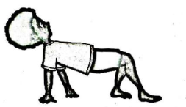

The gymnastic skill is called
A. swan balance
B. handwalk
C. V-balance
D. crabwalk
17. Grade 6 learners were asked to run back and forth before gymnastic activities. Why did the learners jog? To
A. enjoy themselves
B. entertaining fans
C. prepare body muscles
D. get injury
18. What should an athlete do upon the command "Set" when performing medium sprint start?
A. Run to the finish line
B. Position on the start line
C. Push the knee of rear leg forward
D. Raise hips above the shoulders
19. Boaz created a montage composition themed "ball games". What would be the first step when creating the montage?
A. Cut out pictures
B. Collect materials
C. Glue the cut outs
D. Display finished work
20. Roy improvised a ball using strings. In order to make the ball strong they used the type of knot shown below.
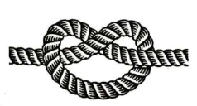

The type of knot used is called
A. overhand knot
B. square knot
C. bowline knot
D. sheet bend knot

21. Peris and Beris are passing ball using the type of pass shown below.
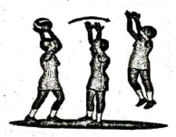

The following are true when performing the skill. Which one is wrong?
A. Bends knees slightly
B. Spread fingers well
C. Be in sitting position
D. Stand one foot slightly forward
22. The following musical instrument is called the musical bow. Which one is it?
A. Litungu
B. Entono
C. Kimengeng
D. Adeudeu
23. Muge improvised rhythms in three-beat patterns on percussion instruments. Which one shows a three-beat pattern?
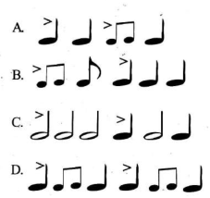

24. The tune of a musical sound is known as
A. melody
B. pitch
C. volume
D. tempo
25. The diagram below shows a long jump field.

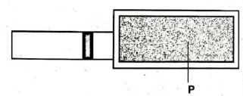

What step in long jump takes place at the part marked P?
A. Approach
B. Landing
C. Flight
D. Take-off
26. Which one is a dotted minim?
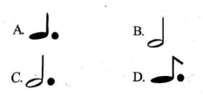

27. When performing high jump you need the following equipment. Which one is not?
A. Horizontal bar
B. Discus
C. Upright bar
D. Landing gear
28. Jared performed the skill shown in the picture below in volleyball.
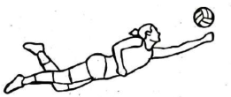

The skill is known as
A. dig
B. volley
C. single hand dig
D. underarm serve
29. Habil carried weaving as shown.
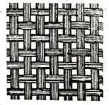

She could have used the materials below except
A. raffia
B. banana leaf
C. waste paper
D. grass
30. A form of pottery treatment in which the surface of pot is polished using a hard smooth surface is known as
A. burnishing
B. kneading
C. stamping
D. wedging

SOCIAL STUDIES & RELIGIOUS EDUCATION
GRADE 6
Time: 1hr 40mins
SECTION A: SOCIAL STUDIES
Study the map of Kenya below and answer questions 1 and 2
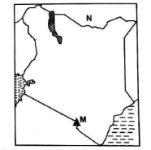

1. Lumba visited the mountain marked M. The mountain was formed through a process called
A. folding
B. faulting
C. downwarping
D. volcanicity
2. The country marked N is headed by
A. King
B. Prime Minister
C. President
D. Chancellor
3. Kaya drew drainage feature in her book. She drew all the following except
A. hills
B. lakes
C. swamps
D. rivers
4. One of the following is a historic built environment found in Sudan. Which one is it?
A. Roman Kiosk
B. Fort Jesus
C. People's Palace
D. Namugongo Shrine
5. Gracia found Steve quarreling with Martin over a stolen pen. What should Gracia do to resolve the conflict between Steven and Martin?
A. Give Martin the pen
B. Give Steve the pen
C. Mediate between them
D. Ask them to fight
6. The following are examples of political human rights. Which one is not?
A. Freedom of speech
B. Right to education
C. Right to vote
D. Freedom of worship
7. Grade 6 learners can demonstrate patriotism in the following ways except
A. supporting the national teams when playing
B. singing the national anthem
C. participating in National Environmental Day
D. destroying and burning the National flag
8. Among the Nyamwezi, who was the head of a Gunguli?
A. Ntemi
B. Minule
C. Kikoma
D. Wanyukulu
9. Bobi was a member of the Buganda kingdom parliament. Among the Buganda kingdom the parliament was called
A. Gombola
B. Lukiiko
C. Balangole
D. Amassaza
10. Which of the countries in Eastern Africa is not correctly matched with the mineral it mines?
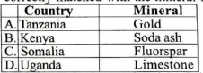

11. Nyasore visited a National Park in Kenya. Which one below did he visit?
A. Amboseli National Park
B. Maasai Mara
C. Serengeti
D. Ras Dashen
12. Pombe is a marine fisherman. He uses the method shown below in marine fishing.
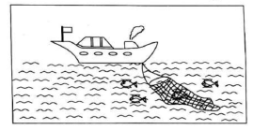

The method is called
A. trawling
B. net drifting
C. long line
D. purse-seining
13. A group of people who originate from the same ancestor is called
A. community
B. age group
C. clan
D. society
14. The original homeland of the Bantus was
A. Horn of Africa
B. South Sudan
C. Ethiopia
D. Congo
15. Asha is a Semite. Semites migrated due to the following reasons. Which one is it?
A. To search for farming land
B. To spread Islam
C. Drought and famine
D. Looking for pasture and water

The diagram below represents a vegetation zone in Eastern Africa. Use it to answer questions 16 and 17.
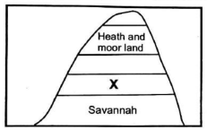

16. The vegetation zone above is called
A. mountain vegetation
B. swamp vegetation
C. mangrove vegetation
D. desert vegetation
17. The main economic activity of people living in arid and semi-arid areas is
A. coffee farming
B. dairy farming
C. pastoralism
D. tea farming
18. A climatic region has the following characteristics;
i) long dry season
ii) high temperatures throughout the year
iii) rainfall range between 250mm to 700mm
The climatic region is called
A. equatorial climate
B. tropical climate
C. desert climate
D. semi-desert climate
19. Jordan listed down examples of Horst mountains in Eastern Africa. Which ones are correct?
A. Mt. Elgon, mt. Kenya, mt. Longonot
B. Mt. Meru, mt. Usambara, mt. Kilimanjaro
C. Mt. Kenya, mt. Peru, mt. Ruwenzori
D. Mt. Peru, mt. Ruwenzori, mt. Usambara
20. The immediate neighbour to Sudan to the South is
A. South Sudan
B. Kenya
C. Uganda
D. Eritrea
21. The arm of the Kenyan government that amends the laws is called
A. judiciary
B. legislature
C. executive
D. the army
22. How many elected women representatives are there in the National Assembly?
A. 47
B. 12
C. 290
D. 20
23. Wamaye's grandfather used the following traditional means of communication. Which one is it?
A. Mobile phone
B. Ululations
C. Emails
D. Radio
24. A grade 6 learner suggested ways of promoting tourism in Kenya. Which one is correct?
A. Allowing poaching of wild animals
B. Charging high fees
C. Ensuring safety and security of tourists
D. Destroying forests and other vegetations
25. There are many road accidents occurring recently in Kenyan roads. The following are likely causes except
A. overspeeding
B. ignorance of traffic rules
C. road worthy vehicles
D. poor state of roads
26. The following are similarities between the Maasai and Ameru early form of government. Which one is not?
A. Law and order maintained by elders
B. Leadership in form of age sets
C. Had council of elders
D. Both had prophet
27. The traditional leader among the Agiriama was called
A. Kivoi wa Mwendwa
B. Mekatilili wa Menza
C. Nabongo Mumia
D. Lenana
28. The safest place to cross a busy road in a city is
A. foot bridge
B. zebra crossing
C. road junctions
D. near traffic lights
29. Which mineral is used to manufacture cement?
A. Soda ash
B. Petroleum
C. Limestone
D. Gold
30. One of the following is the head of the county government in Kenya. Who is he or she?
A. President
B. Governor
C. Senator
D. County Commissioner
SECTION B: RELIGIOUS EDUCATION
PART 1: CRE
31. Human beings are described as special according to Genesis on the creation story. Which of the following statements shows that?
A. He was moulded from clay
B. He was created in the image of God
C. He was created by God's word
D. God created him on the last day
32. During a study on the use of talents, learners were asked to state the values needed to nurture their talents. Who among them was wrong?
A. Abel - respect
B. John - love
C. James - integrity
D. Joan - disobedience
33. "This is now bone of my bones and flesh of my flesh. She shall be called woman." (Genesis 2:23). Who among the following said these words?
A. Abraham
B. Adam
C. Eve
D. Noah
34. Which of the following type of marriage is correctly matched with its description?
A. Civil marriage - conducted in a mosque
B. Christian marriage - conducted by a pastor or priest
C. African customary marriage - conducted in the church
D. Come we stay - conducted by priest
35. On which day did God take a rest after creating everything?
A. First day
B. Fifth day
C. Third day
D. Seventh day
36. The following are inappropriate ways of using leisure time except
A. smoking bhang
B. fighting
C. gossiping
D. visiting the sick
37. Who among the following people wrote the book of Romans?
A. Paul
B. John
C. Luke
D. Peter
38. Do not kill is one of the commandments. Who among the following people disobeyed the above commandment?
A. Cain and Ahab
B. Cain and Abel
C. Naboth and Joseph
D. Isaac and Ibrahim
39. Samson used a jawbone of a donkey to kill Philistines.
A. 7
B. 200
C. 100
D. 1000
40. Who among the following prophets of God applied faith to recover an axe head from water by making it float?
A. Elijah
B. Isaiah
C. Elisha
D. Daniel
41. As a Christian, which lesson do we learn from the story of Jacob wrestling with God?
A. We should fight with God
B. We should be persistent in prayers
C. We should stop praying if our prayers are not answered
D. God does not like answering our prayers
42. Jesus called twelve people to be His disciples. Who among them were brothers?
A. Peter and Matthew
B. John and Peter
C. James and John
D. Matthew and James
43. Worship the Lord your God and serve Him only. (Luke 4:8) These words were said by Jesus when He was
A. tempted
B. about to die
C. transfigured
D. baptised
44. Which of the following miracles was not performed by Jesus Christ?
A. Healing of the Roman Officer's servant
B. Healing of the bleeding woman
C. Raising of Lazarus
D. Healing of the crippled at the beautiful gate
45. Jesus used parables to teach His teachings. Which of the following teaches about the recovery of lost human beings?
A. The ten virgins
B. The prodigal son
C. Friend at midnight
D. Lost sheep
46. From the story of Amnon and Tamar, we learn that we can protect ourselves from sexual abuse by
A. accepting gifts from strangers
B. walking alone in unsafe places
C. not meeting people of the opposite sex when you are alone
D. going into a lonely room with some one of the opposite sex when you are alone
47. Which one of the following is not a fruit of the Holy Spirit?
A. Selfishness
B. Joy
C. Kindness
D. Patience
48. The following values promotes good citizenship except
A. hardworking
B. laziness
C. honest
D. respect
49. Complete the following statement that is found in the Apostles' Creed.
"I believe in God the father Almighty ____."
A. The mighty one
B. The Holy Catholic church
C. Creator of heaven and earth
D. Born of the virgin Mary
50. The following are harmful and commonly abused substances in our society except
A. bhang
B. cocaine
C. miraa
D. juice

PART 2: IRE
31. "Then you will surely be asked that Day about pleasure." This is a verse extracted from surah
A. Al-Takathur
B. Al-Qariah
C. Al-Humaza
D. Al-Asr
32. Jamal, a grade 6 learner wrote down the following deeds as ways of pleasing Allah(S.W.T). Which statement talks about teaching on Hadith on planting? We should
A. not imitate the opposite gender in our dressing
B. spend our youth wisely before we grow old
C. plant trees in order to earn sadaqatul jaariyah
D. be sincere in heart and actions
33. Allah(S.W.T) has ninety-nine attributes known as Asmaul-Husna. Which attribute will you use when asking Allah(S.W.T) for beneficial knowledge?
A. Al-Hafeedh
B. Al-Aaliim
C. Al-Hakam
D. Al-Hayyu
34. Belief in Angels is one of the pillars of Iman. Which statement best explains why belief in Angels can shape the character of a Muslim?
A. Makes us strive to perform good deeds and avoid bad deeds
B. Makes us become closer to Allah(S.W.T)
C. Makes us accept what happens in our lives
D. Guides us to follow the commands of Allah(S.W.T)
35. In a group discussion, grade 6 learners discussed the qualities of Al-Muttaqin. Who gave the correct quality?
A. Salmon - sometimes misses prayers
B. Sahra - does not believe in the Hereafter
C. Hajr - believe in the unseen
D. Ali - heedless in their prayer
36. What quality of prophet Yusuf (A.S) helped him stay righteous in prison?
A. Anger
B. Patience
C. Arrogance
D. Wealth
37. The following are virtues we learn from prophets of Allah(S.W.T). Which one is the main virtue we learn from the story of prophet Yusuf(A.S)?
A. Obedience
B. Forgiveness
C. Patience
D. Tolerance
38. The following are actions a Muslim can practice to help him or her attain Tawbah. Which one of the following is not one of them?
A. Practising self-control
B. Reciting Astaghfirullah
C. Repeating the sins committed
D. Asking for forgiveness
39. Which one of the following is the main reason why Muslims perform saum in the Holy month of Ramadhan?
A. Our sins are forgiven
B. Fasting is good for our health
C. Fasting is a commandment from Allah (S.W.T)
D. To remember the poor
40. Hafsa and her friends were discussing qualities of Mutawakkil. Which one of the following people are not entirely exempted from fasting according to the teachings of Islam?
A. Those who are permanently sick
B. Those in the old age
C. Those on regular medication
D. A traveller
41. Which pillar of Iman helps a Muslim to follow and practise Allah's(S.W.T) command? Belief in
A. the Last Day
B. Allah's messengers
C. Allah's Angels
D. Allah's Books
42. From the statement below, identify the situations where a Muslim is supposed to perform a compulsory ghusl for purification.
A. Before Friday prayers
B. After experiencing nifas
C. Before entering the state of Ihraam
D. After reverting to Islam
43. According to the teachings of the Qur'an, three of the following people are recipients of zakat except one. Which one is it?
A. The debtors
B. The needy
C. The orphans
D. The slaves
44. Jamila, a grade 6 learner was asked to state examples of acts that make one to be in a state of Hadath Akbar. Which one of the following is true?
A. Urinating
B. Releasing wind
C. Sleeping
D. Heidh
45. The following are importance of Tawbah in the life of a Muslim except one. Which one is it?
A. Tawbah purifies our hearts
B. Tawbah leads to success in this life and the Hereafter
C. Allah(S.W.T) forgives those who seek His forgiveness
D. Allah(S.W.T) will punish us when we seek His forgiveness
46. Hadath Asghar is also known as minor ritual. Impurities are removed by performing
A. ghusl
B. wudhu
C. tawaf
D. rituals
47. Islam is built on five pillars. Which one is the third pillar of Islam?
A. Zakat
B. Shahadah
C. Saum
D. Swalah
48. The following are reasons as to why a Muslim can perform Tayammum. Which one is not?
A. When water is unavailable
B. When water is too cold
C. When water is too expensive
D. When there is danger near the source of water
49. Which one of the following categories of statements is untrue about a Mutawakkil?
A. Believes in Allah's(S.W.T) power
B. Is firm and steadfast
C. Puts his trust in Allah(S.W.T)
D. Does not strive to achieve his goals
50. During Hajj, Anwar entered into state of Ihaam and performed Umrah. He remained in the same state until he finished his Hajj. Which type of Hajj did he perform?
A. Ifraad
B. Qiran
C. Tamattu
D. Umrah

GRADE 6
MARKING SCHEME
MATHS
1. C
2. A
3. B
4. D
5. C
6. B
7. A
8. B
9. D
10. C
11. A
12. A
13. A
14. D
15. A
16. C
17. A
18. D
19. C
20. B
21. D
22. A
23. C
24. D
25. C
26. B
27. A
28. D
29. B
30. C

ENGLISH
1. C
2. B
3. D
4. A
5. C
6. C
7. D
8. C
9. B
10. D
11. A
12. B
13. C
14. C
15. D
16. C
17. A
18. D
19. B
20. C
21. C
22. B
23. D
24. B
25. D
26. C
27. B
28. D
29. D
30. B

KISWAHILI
1. A
2. D
3. D
4. C
5. B
6. A
7. B
8. D
9. C
10. A
11. B
12. D
13. A
14. A
15. A
16. C
17. B
18. C
19. B
20. A
21. B
22. A
23. D
24. B
25. C
26. B
27. A
28. C
29. C
30. A

INTEG-SCIENCE
1. B
2. A
3. D
4. B
5. C
6. A
7. C
8. D
9. C
10. D
11. D
12. B
13. A
14. A
15. C
16. B
17. A
18. D
19. C
20. D
21. B
22. C
23. A
24. A
25. D
26. C
27. B
28. D
29. D
30. C
31. D
32. A
33. B
34. C
35. C
36. A
37. D
38. C
39. A
40. C
41. B
42. D
43. A
44. C
45. D
46. B
47. A
48. C
49. B
50. D
CREATIVE ARTS
1. D
2. A
3. A
4. A
5. C
6. D
7. A
8. C
9. C
10. B
11. D
12. A
13. B
14. D
15. A
16. C
17. C
18. D
19. B
20. A
21. C
22. B
23. C
24. B
25. D
26. A
27. B
28. A
29. C
30. A
SST & RELIGIOUS EDU
SST
1. D
2. A
3. A
4. A
5. C
6. B
7. D
8. A
9. B
10. C
11. A
12. B
13. C
14. D
15. D
16. A
17. C
18. D
19. D
20. A
21. B
22. A
23. B
24. C
25. C
26. D
27. B
28. A
29. C
30. B
CRE
31. B
32. D
33. B
34. B
35. D
36. D
37. A
38. A
39. D
40. C
41. B
42. C
43. A
44. D
45. D
46. C
47. A
48. B
49. C
50. D
IRE
31. A
32. C
33. B
34. A
35. C
36. B
37. C
38. C
39. C
40. D
41. B
42. B
43. C
44. D
45. D
46. B
47. A
48. C
49. D
50. B

