KALA TRIAL EXAMINATION-2026

Kenya Certificate of Secondary Education

312/2 GEOGRAPHY Paper 2

JULY, 2026
2hrs 45min



Name: …………………………………...........................Admission………..….Class……Date……......

Signature……………… School……………………….......

Instructions to Candidates:
- This paper has two Sections, A and B.
- Answer all the questions in Section A.
- In Section B, answer question 6 and any other two questions.
- All answers must be written in the foolscaps provided.

For Examiner’s Use Only

SECTION | Questions | Maximum Score | Candidate’s score
A | 1-5 | 25
B | 6 | 25
 |  | 25
 |  | 25
 | Total Score | 100%

SECTION A
1. a) Give two main Branches of Geography. (2mks)
b) State three ways in which Geography is related to agriculture. (3mks)
2. a) Define forestry. (2mks)
(b) State three characteristics of coniferous forests. (3mks)
3. The map below shows cocoa growing areas in Ghana. Use it and answer question (a)

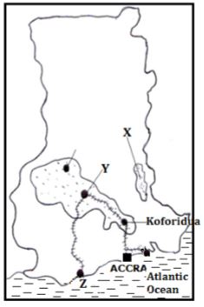
X
- i) Identify the cocoa growing areas marked X and Y. (2mks)

ii)Name the Port City marked Z. (1mk)
(b) State two economic problems facing cocoa farming in Ghana. (2mks)
4(a) Name two agricultural non-food processing industries in Kenya. (2mks)
(b) State three ways in which Kenya has benefited from motor-vehicle assembly industry.
(3mks)

5. a) Identify two traditional methods of fishing used by fishermen in Western Kenya. (2mks)
b) State three factors that have favoured fishing in the South West Africa fishing ground. (3mks)

SECTION B.

6. The data below represents the number of Dairy breeds in Kenya in1960 in ‘000’.
Breeds | Number of Kenya’s Dairy Breeds
Jersey | 50
Sahiwal | 100
Ayrshire | 200
Guernsey | 250
Friesian | 400
Total | 1000

- i) Draw a divided rectangle 15cm long to represent the data above. (8mks)

ii) Calculate the percentage of the Kenya’s Dairy Breeds in 1960. (2mks)

iii) Give two areas where commercial dairy farming is done along the Kenyan Coast.
(2mks)
- i) State five characteristics of Nomadic herding. (5mks)
ii) Explain four steps the Kenyan Government is taking to improve livestock farming in Semi-Arid areas. (8mks)

7. a) i) Give two methods of Land reclamation. (2mks)
ii) Apart from Mwea-Tebere, identify two major irrigation schemes in Kenya. (2mks)
b) i) Name two rivers that supply water to Mwea-Tebere irrigation scheme. (2mks)
ii) Explain how the following factors influenced the location of Mwea-Tebere irrigation scheme.
    - Government policy. (2mks)
    - Strategic location. (2mks)
    - Soils. (2mks)
    - Presence of rivers. (2mks)
c) i) Name three polders under the Zuider-zee project. (3mks)
ii) Explain four differences between land reclamation in Kenya and the Netherlands. (8mks)
8.(a) Identify three sources of renewable energy. (3mks)
(b) Use the map of Africa below to answer question (b)(i).

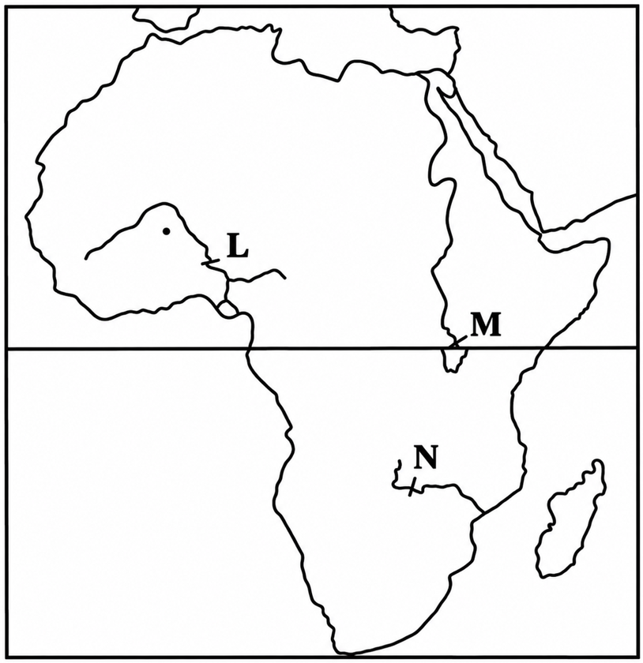
(i) Name the dams marked L, M and N. (3mks)
(iii) State four effects that the increase of oil prices has had on the economies of oil-importing countries of Africa. (4mks)
(c)(i) Explain two measures the Government of Kenya has taken to conserve energy. (4mks)
(ii) Give four reasons hindering the expansion of rural electrification programme in Kenya
(5mks)

(d) Some students carried out a field study on sources of energy by sampling the households around their school.
(i) State two objectives for their study. (3mks)
(ii) State four after-study activities that the students are likely to engage in. (3mks)

9. The population pyramids below represent the population structure of country Y and Z.
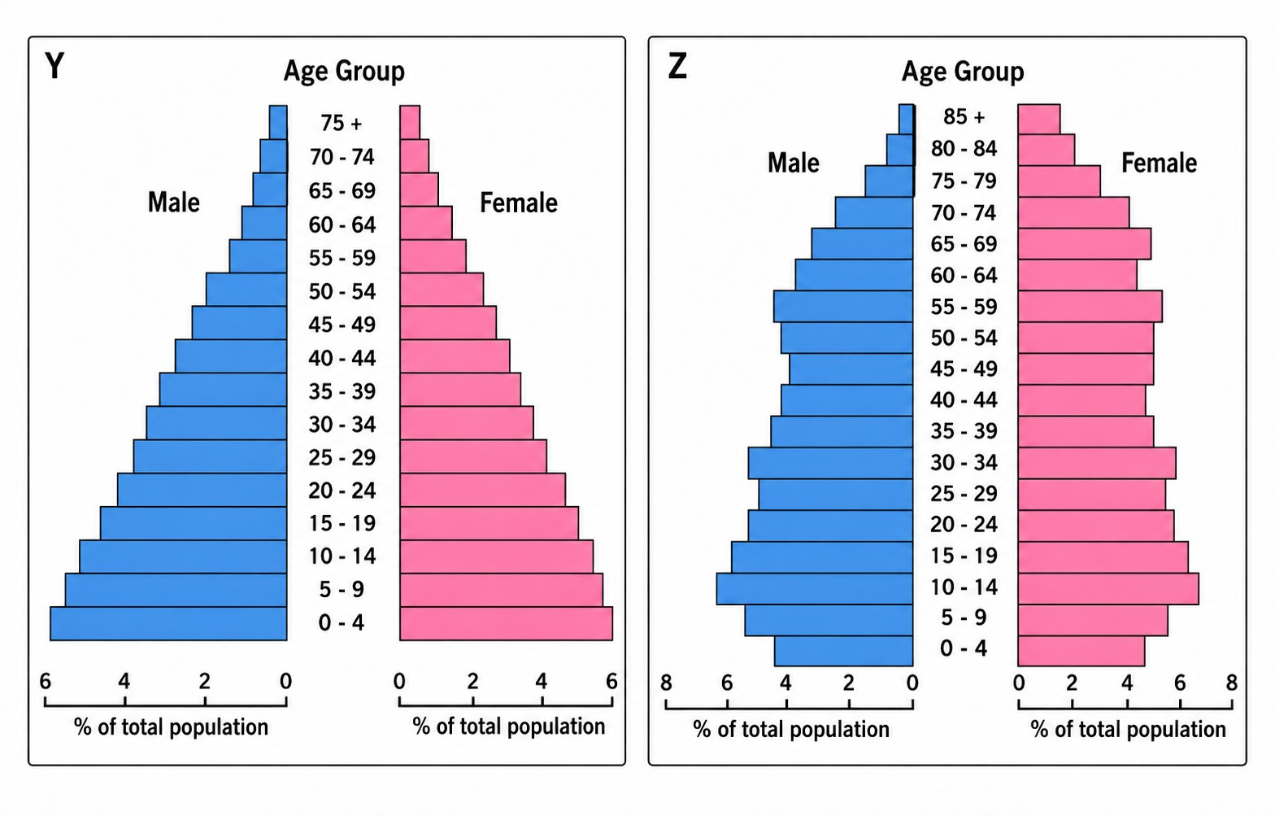
a.(i) Describe the characteristics of population represented by country Y. (4mks)
(ii) Which of the pyramids represents a developed country. (1mk)
b.(i) What is infant mortality rate? (2mks)
(ii) Identify four information you are likely to collect using a well-designed population census questionnaire. (4mks)
(iii) Give four reasons why it is necessary for a country to carry out population census. (4mks)
c.(i) State four measures the government of Kenya can undertake to reduce rural-urban migration. (4mks)
(ii) Explain three effects of migration on an individual. (6mks)

10.(a) What is environmental management? (2mks)
(b)(i) Name two rivers in the lake region of Kenya which cause large scale flooding. (2mks)
(ii)Explain three human activities that contribute to occurrence of floods in Kenya. (6mks)
(iii)State two measures being taken to control lightning. (2mks)
(c) Explain four significance of conserving the environment. (8mks)
(d) Your Geography class carried out a field work on floods along a river.
(i) Name two types of fieldwork they could have used. (2mks)
(ii) Give three advantages of studying floods through field work. (3mks)
...........................................................................................................................................................
............................................................................................................................................................
............................................................................................................................................................
............................................................................................................................................................
............................................................................................................................................................
............................................................................................................................................................
............................................................................................................................................................
............................................................................................................................................................
............................................................................................................................................................
............................................................................................................................................................
............................................................................................................................................................
............................................................................................................................................................
............................................................................................................................................................
............................................................................................................................................................
………………………………………………………………………………………………………
………………………………………………………………………………………………………
………………………………………………………………………………………………………
............................................................................................................................................................
............................................................................................................................................................
............................................................................................................................................................
............................................................................................................................................................
............................................................................................................................................................
............................................................................................................................................................
............................................................................................................................................................
............................................................................................................................................................
............................................................................................................................................................
............................................................................................................................................................
............................................................................................................................................................
............................................................................................................................................................
............................................................................................................................................................
............................................................................................................................................................
………………………………………………………………………………………………………
………………………………………………………………………………………………………
………………………………………………………………………………………………………
............................................................................................................................................................
............................................................................................................................................................
............................................................................................................................................................
............................................................................................................................................................
............................................................................................................................................................
............................................................................................................................................................
............................................................................................................................................................
............................................................................................................................................................
............................................................................................................................................................
............................................................................................................................................................
............................................................................................................................................................
............................................................................................................................................................
............................................................................................................................................................
............................................................................................................................................................
………………………………………………………………………………………………………
………………………………………………………………………………………………………
………………………………………………………………………………………………………
............................................................................................................................................................
............................................................................................................................................................
............................................................................................................................................................
............................................................................................................................................................
............................................................................................................................................................
............................................................................................................................................................
............................................................................................................................................................
............................................................................................................................................................
............................................................................................................................................................
............................................................................................................................................................
............................................................................................................................................................
............................................................................................................................................................
............................................................................................................................................................
............................................................................................................................................................
………………………………………………………………………………………………………
………………………………………………………………………………………………………
………………………………………………………………………………………………………
............................................................................................................................................................
............................................................................................................................................................
............................................................................................................................................................
............................................................................................................................................................
............................................................................................................................................................
............................................................................................................................................................
............................................................................................................................................................
............................................................................................................................................................
............................................................................................................................................................
............................................................................................................................................................
............................................................................................................................................................
............................................................................................................................................................
............................................................................................................................................................
............................................................................................................................................................
………………………………………………………………………………………………………
………………………………………………………………………………………………………
………………………………………………………………………………………………………
............................................................................................................................................................
............................................................................................................................................................
............................................................................................................................................................
............................................................................................................................................................
............................................................................................................................................................
............................................................................................................................................................
............................................................................................................................................................
............................................................................................................................................................
............................................................................................................................................................
............................................................................................................................................................
............................................................................................................................................................
............................................................................................................................................................
............................................................................................................................................................
............................................................................................................................................................
………………………………………………………………………………………………………
………………………………………………………………………………………………………
………………………………………………………………………………………………………
............................................................................................................................................................
............................................................................................................................................................
............................................................................................................................................................
............................................................................................................................................................
............................................................................................................................................................
............................................................................................................................................................
............................................................................................................................................................
............................................................................................................................................................
............................................................................................................................................................
............................................................................................................................................................
............................................................................................................................................................
............................................................................................................................................................
............................................................................................................................................................
............................................................................................................................................................
………………………………………………………………………………………………………
………………………………………………………………………………………………………
………………………………………………………………………………………………………
............................................................................................................................................................
............................................................................................................................................................
............................................................................................................................................................
............................................................................................................................................................
............................................................................................................................................................
............................................................................................................................................................
............................................................................................................................................................
............................................................................................................................................................
............................................................................................................................................................
............................................................................................................................................................
............................................................................................................................................................
............................................................................................................................................................
............................................................................................................................................................
............................................................................................................................................................
………………………………………………………………………………………………………
………………………………………………………………………………………………………
………………………………………………………………………………………………………
............................................................................................................................................................
............................................................................................................................................................
............................................................................................................................................................
............................................................................................................................................................
............................................................................................................................................................
............................................................................................................................................................
............................................................................................................................................................
............................................................................................................................................................
............................................................................................................................................................
............................................................................................................................................................
............................................................................................................................................................
............................................................................................................................................................
............................................................................................................................................................
............................................................................................................................................................
………………………………………………………………………………………………………
………………………………………………………………………………………………………
………………………………………………………………………………………………………
............................................................................................................................................................
............................................................................................................................................................
............................................................................................................................................................
............................................................................................................................................................
............................................................................................................................................................
............................................................................................................................................................
............................................................................................................................................................
............................................................................................................................................................
............................................................................................................................................................
............................................................................................................................................................
............................................................................................................................................................
............................................................................................................................................................
............................................................................................................................................................
............................................................................................................................................................
………………………………………………………………………………………………………
………………………………………………………………………………………………………
………………………………………………………………………………………………………

