KALA TRIAL EXAMINATION-2026
MARKING SCHEME

Kenya Certificate of Secondary Education

312/2 GEOGRAPHY Paper 2

JULY, 2026
2hrs 45min



Name: …………………………………...........................Admission………..….Class……Date……......

Signature……………… School……………………….......

Instructions to Candidates:
- This paper has two Sections, A and B.
- Answer all the questions in Section A.
- In Section B, answer question 6 and any other two questions.
- All answers must be written in the foolscaps provided.

For Examiner’s Use Only

SECTION | Questions | Maximum Score | Candidate’s score
A | 1-5 | 25
B | 6 | 25
 |  | 25
 |  | 25
 | Total Score | 100%
- a) Give two main Branches of Geography.
- Human Branch
- Physical Branch Any 1x2=2mks
b) State three ways in which Geography is related to agriculture.
- It studies soil that is an important factor in crop and animal production.
- It studies distribution of agricultural activities on the earth surface.
- It studies weather which determines growth of various crops and survival of
- animals.
- It studies relief which is important in agriculture. Any 3x1=3mks

- a) Define forestry
- A forest is a continuous growth of trees and undergrowth covering a large tract of land. Any 1x2=2mks
b) State three characteristics of coniferous forests
- Coniferous forests are conical in shape to combat the snow fall during winter.
- Trees have needle-like leaves to reduce transpiration.
- Trees are found in uniform/ pure stands.
- The major tree species are spruce, fir, pine and larch.
- They have a thick carpet of mosses.
- Some trees like pine have flexible branches to withstand snow fall.
- Most trees are evergreen to allow maximum use of sunlight during short summers.
- Trees have flexible trunks to allow swaying in order to withstand strong winter winds.
- Trees have wide spread root system for maximum utilization of moisture from top soil since sub-soil is permanently frozen.
- Tree leaves have a tough waxy skin to protect them from winter cold/ prevent snow from damaging plant cells.
- Most trees are softwoods. Any 3x1=3mks
3. The map below shows cocoa growing areas in Ghana. Use it and answer question (a)
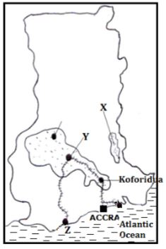
- i) Identify the cocoa growing areas marked X and Y.
- Y- Kumasi and X -
ii)Name the Port City marked Z.
- Takoradi
- State three economic problems facing cocoa farmers in Ghana.
- Fluctuations of cocoa prices in the world market leads to uncertainty earnings making it difficult for farmers to plan ahead.
- Inaccessible roads lead to delays in delivery of cocoa to the factories resulting into wastage/losses to farmers.
- High cost of farm inputs makes them unaffordable to the farmers leading to low yields/low profit margins.
- Inadequate capital from cooperatives to purchase inputs lower production.
- Delayed payment to the farmers by cooperatives lowers their morale.
- Poor marketing strategies leads to low earnings.
- Mismanagement of cooperatives leads to low payment to farmers which lowers their morale.
- Low labour supply during harvesting season increases cost of production.
- Competition for land from other crops leads to low production.
- Competition from other beverages lowers the market/demand for cocoa.
Any 3x1=3mks
4. a) Name two agricultural non-food processing industries in Kenya.
- Tobacco processing/ cigarette making.
- Cotton /textile processing/cloth fabrication.
- Leather tanning /footwear making.
- Bees wax processing.
- Pyrethrum processing.
- Aloe Vera processing.
- Wood processing /lumbering/pulp and paper manufacturing.
- Sisal/ fibre making.
- Soap making.
- Glue making. Any 2x1=2mks
b) State three ways in which Kenya has benefited from motor-vehicle assembly industry.
- Saves Kenya foreign exchange since importation of parts is cheaper.
- Kenya earns foreign exchange through motor vehicle export
- Has created employment opportunities to Kenyans earning them income raising their standards of living
- Has promoted transport sector by availing buses, lorries and vans improving accessibility.
- The industry has promoted trade links with the neighboring countries bringing development.
- The industry has attracted foreign investors improving the standard of living of Kenyans.
- It has led to the development of skills among Kenyans making the sector develop.
- It is source of government revenue through taxation. Any 3x1=3mks

5. a) Identify two traditional methods of fishing used by fishermen in Western Kenya.
- Harpooning/use of arrows and spears
- Use of herbs/chemicals
- Use of fish barrier traps.
- Hook and line/handlines
- Use of gill nets
- Use lamp and net /lampara
- Basket method.
Any 2x1=2mks

b) State three factors that have favoured fishing in the South West Africa fishing ground.
- Convergence of cold Benguela current and warm Agulhas current moderate the sea water.
- Namib desert discourages Agriculture hence fishing is an alternative economic activity.
- The meeting of cold Benguela and Agulhas cause upwelling of the ocean water which increases oxygen/bring minerals and plankton to the surface for fish to feed on hence plenty of fish species. Any 3x1=3mks

6. The data below represents the number of Dairy breeds in Kenya during in1960 in ‘000’.
- i) Draw a divided rectangle 15cm long to represent the data above. (8mks)

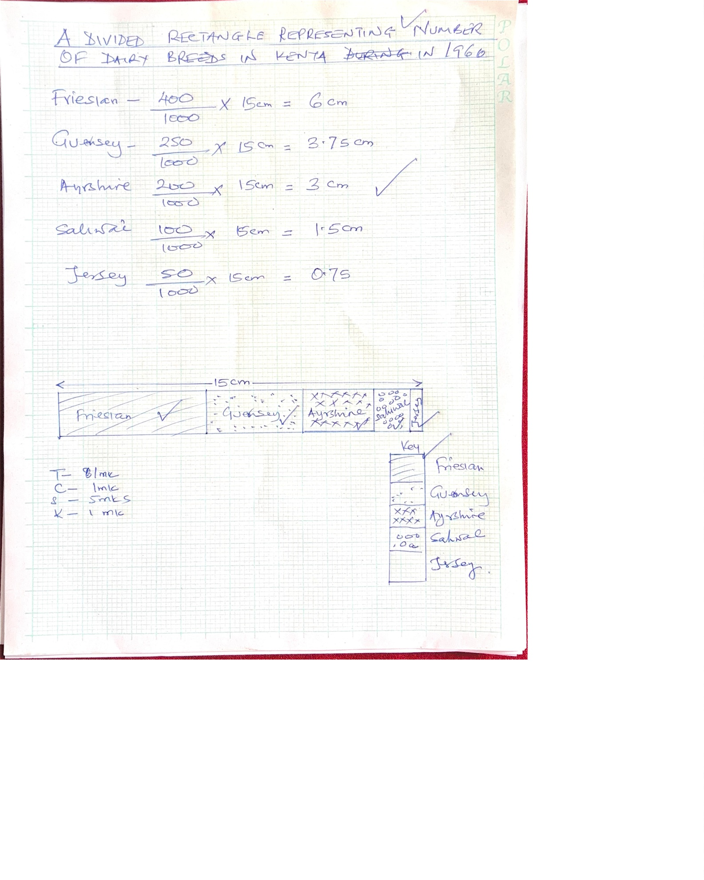

ii) Calculate the percentage of the Kenya’s Friesian Dairy Breed in 1960.
400 x 100% = 40%. (2mks)
1000

iii) Give two areas where commercial dairy farming is done along the Kenyan Coast.
- Matuga in Kwale
- Kikambala in Kilifi
- Mariakani in Kilifi
- Lamu
- Taita-Taveta. (2mks)
- i) State five characteristics of Nomadic herding.
- They keep large numbers of animals.
- There is uncontrolled breeding of animals.
- Many kinds of animals are kept e.g. cattle, sheep, goats and camels.
- They keep animals as a sign of wealth/prestige.
- Land in which animals are kept is communally owned.
- The animals are weakened by pests and diseases/have low value/unhealthy.
- The animals are moved seasonally in search for pasture and water.
- There is inefficient marketing system/walking for long distances to the market.
- Animals are exposed to cattle rustling/frequent raids.
- Animals are reared for subsistence not for commercial purposes.
- They keep indigenous cattle which are hardy such as Zebu and Boran. (5mks)

ii) Explain four steps the Kenyan Government is taking to improve livestock
farming in Semi-Arid areas.
- Establishment of demonstration ranches to sensitize pastoralists on better methods of animal husbandry.
- The government is encouraging cross breeding of indigenous breeds with hybrid to improve the quality of cattle.
- Provision of extension sources to offer advice, drugs and treatment to animals.
- Boreholes have been sunk dams constructed to provide water for the cattle.
- Encourage bee keeping along racer valleys to provide an alternative to cattle.
(8mks)

7 a) i) Two methods of Land reclamation.
- Irrigation
- Control of pests/Tsetse fly control
- Planting of trees / afforestation
- Draining of Swamps/Flood control
- Filling open pits/ landscaping.
- Planting trees/ afforestation.
- Filling open quarries with water to practice aquaculture.
- Controlling soil erosion.
- Introducing drought resistant crops.
- Use of manure/ fertilizers.
- Draining a portion of the lake.
Any 2x1=2mks

ii) Apart from Mwea-Tebere identify two major irrigation schemes in Kenya.
- Perkera irrigation scheme
- Bura- Galole irrigation scheme
- Ahero irrigation scheme

b) i) Two rivers that supply water to Mwea.
- Thiba River
- Nyamindi river
- Murubara river.
ii)Explain how the following factors influenced the location of Mwea-Tebere irrigation scheme.
Government Policy
- There was need to keep detainees busy.
- For people to provide free labour.
- There was need to settle landless people.
- The need to control flood of rivers that pass through the area.
- To increase food production. (2mks)

Strategic Location
- Strategic location near major urban centres like Nyeri, Nairobi and Embu that provide large internal market for rice. (2mks)
Soils
- Presence of black cotton/ clay soils which retains water for a long time hence suitable for rice cultivation. (2mks)
Presence of Rivers
- Presence of permanent rivers Nyamindi and Thiba which provide constant water for irrigation throughout the year. (2mks)

c) i) Three polders of Zuider zee project.
- Marker Waad
- Wieringer Meer
- South Flevoland
- East Flevoland
- North- Eastern Flevoland. Any 3x1=3mks
ii) Four differences between land reclamation in Kenya and Netherlands.
- In Kenya, the area that is reclaimed is relatively small while the areas reclaimed in the Netherlands are large.
- In Kenya, land is mainly reclaimed from swamps/ marginal areas while in the Netherlands, reclamation is from sea.
- In Kenya, the methods used for draining water from marshy areas is digging of canals/ ditches while in Netherlands, methods are advanced/ use of wind pumps to drain sea water from the polders.
- In Kenya, irrigation is used in reclaiming dry areas while in the Netherlands, irrigation is used to lower salinity of the soil in reclaimed lands.
- In Kenya, the methods of land reclamation are simple like digging canals/ ditches to drain water from land while in the Netherlands, method used are highly advanced like creation of polders.
- Furrow/ ridges in Kenya are used to control river floods while in the Netherlands, dykes protect the reclaimed land from invasion by the sea.
- In the Netherlands, the methods employed are more capital intensive while in Kenya, the methods are less capital intensive.
- In the Netherlands, the main method of land reclamation is the draining of the seas while in Kenya a variety of methods are used e.g. irrigation/ Tse-Tse fly control.
- In the Netherlands, advanced technology is employed in reclaiming land e.g. use of underground pipes/ pumping stations while in Kenya, low technology that uses only canals and dykes. (8mks)

7.(a) Identify three sources of renewable energy.
- Water
- Wind
- Solar/ sun
- Waves/ tides
- Geothermal steam/ underground steam
- Biomass
- Wood / trees
- Drought animals. Any 2x1=2mks

b) Use the map of Africa below to answer question (b)(i).
(i) Name the dams marked L, M and N.
L-Kainji dam
M-Owen Falls/Nalu Baale
N-Kariba dam
ii) Give four effects that the increase of oil prices has had on the economies of oil-importing countries of Africa.
- Spending more of their foreign exchange on oil importation thus negatively affecting other sectors of their economy.
- Increasing cost of transport causing rise in cost of movement of people,goods and services.
- Production cost has increased leasing to an increase in prices of commodities reducing their demand.
- Collapse of some industries relying on petroleum by-products leading to redundancy and unemployment.\
- The countries have experienced low economic growth leading to poverty among its citizens.
- Has led to need to establish/look for cheaper sources of energy to supplement/replace oil.
c)i) Explain two measures the Government of Kenya has taken to conserve energy.
- Encouraging people to use renewable sources of energy in order to reduce the overreliance of fossil fuels.
- Developing energy saving technologies in order to reduce the high consumption of energy.
- Enforcing the legislation against indiscriminate cutting down of trees for fuel thus conserving existing resources.
- Educating the public on the careful use of energy in order to save it.
- Progress taxation on energy consumption in order to discourage the misuse of energy.
- Proper planning of road networks in urban areas to reduce traffic jam hence saving on fuel consumption.
- Encouraging the use of public transport/ walking/ cycling/ railway in order to reduce the number of vehicles on the roads/ reducing energy consumption.
- Discouraging importation of high fuel consumption vehicles to reduce amount of fuel used.
- Encouraging afforestation/ reafforestation for continuous supply of wood fuel.
d) Give four reasons hindering the expansion of rural electrification programme in Kenya
- Inadequate capital to develop and maintain HEP projects.
- Remoteness of some potential areas limits their exploitation.
- Low industrial development hence low demand for electricity limiting HEP production.
- Fluctuation of river regime affecting power production.
- Limited research is carried out slowing the development of HEP projects.
- Foreign aid sought by many countries to put up the projects carries higher interest rates thereby over-burdening countries with HEP potential.
- High expenses involved in transmission make it difficult to be met by the rural communities very many people in rural areas less afford electricity
- Those few who are able are unwilling to meet the high cost of having homes connected to main power supply
- Poor housing in rural areas. Most houses are still grass thatched
- The rural population is dispersed over wide areas and some areas are far from power station

(d) Some students carried out a field study on sources of energy by sampling the households around their school.
i) State two objectives for their study
- To find out the sources of energy in the households.
- To count how households use the same source of energy. (mark any relevant objective)
(2mks)
ii) Identify four after study activities that the students are likely to engage in.
- Asking/answering question.
- Assessing the information collected against the hypothesis.
- Consulting geography teachers.
- Data analysis/Data presentation.
- Discussion about findings/discussing the findings.
- Displaying of photographs taken/items collected.
- Drawing conclusions.
- Drawing diagrams
- Reading more on the topic.
- Report writing.
- Sketching the features. (4mks)
9. The population pyramids below represent the population structure of country Y and Z.
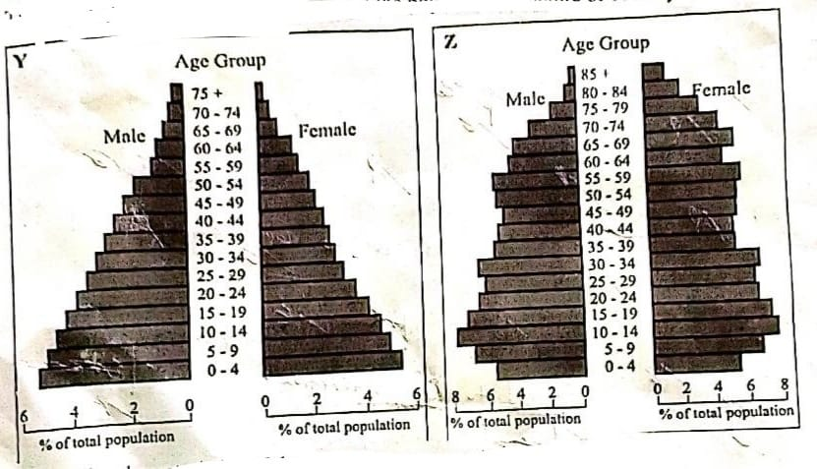
a.(i) Describe the characteristics of population represented by country Y. (4mks)
- High fertility rate/High birth rate.
- High dependency ratio.
- High death rate/ mortality.
- Low life expectancy/ aging population is low.
- Low working population.
- Number of male and female is almost equal at all ages.
- Number of infants from age 0 to 4 years is high.
- Number of youthful populations is high.
(ii) Which of the pyramids represents a developed country.
Pyramid - Z. (1mk)
b) i) What is infant mortality rate?
- The number of death of babies below the age of one year per 1000 people of the population. (2mks)

(ii) Identify four information you are likely to collect using a well-designed population census questionnaire.
- It reveals trends of fertility and mortality which helps to calculate population growth rate. It is also necessary for planning of social services.
- It reveals the place of birth of an individual. This may help to know the migration trends.
- It reveals the marital status which may help to know the marriage age.
- It reveals the prevailing trends of population changing demands by regions.
- The age-sex composition of the population helps to reveal regional imbalances in working and dependence population.
- It reveals the occupation of people which is useful in the estimation of the level of taxation and employment.
- It reveals the ethnicity/ nationality which may be useful in planning for the distribution of political responsibilities.
- It reveals the level of literacy for purposes of educational planning.
- It helps in calculating dependency ratio used in determining tax relief.
- It reveals the size of families which is used in determining rural-urban ratio.
(iii) Give four reasons why it is necessary for a country to carry out population census.
- To help in the distribution of resources.
- For planning purposes/ policy making.
- To help in creating administrative units/ boundaries.
- To identify the rates of birth/ death.
- To help in estimating population growth.
- To determine total number of people.
c) i) State four measures the government of Kenya can undertake to reduce rural-urban migration.
- Improving agriculture to create employment in rural areas
- Decentralizing industries to create jobs in rural areas
- Establishing settlement schemes in rural areas /Reclaiming/Rehabilitating land to settle the landless.
- Increasing social amenities/infrastructure for better services in the rural areas
- Undertaking rural electrification
- Encourage establishment of jua kali industry in rural areas
- Setting up technical colleges/institution of higher learning in rural areas
- Encourage development of more service industries in Rural areas to create employment.

(ii) Explain three effects of migration on an individual.
- Separation of spouses for long seasons may lead to marriage break-ups
- Individuals may gain more skills and change their attitude towards life because of the exposure
- Some people who have migrated to urban areas to work may take longer time to get married as they try to achieve various goals in their lives eg accumulation of wealth and education
- Some urban immigrants may lose touch with their cultural values leading to immorality
- Savings made from income gained after working can help improve the standards of living of workers.
- Leads to decrease in fertility as a result of long separation of spouses.
10.a) What is environmental management?
- It is effective planning and control of the processes and activities that could cause the deterioration of the environment.
b) i) Name two rivers in the lake region of Kenya which cause large scale flooding (2mks)
- River Nyando
- River Nzoia
- River Yala
- River Kuja
- River Sondu

ii) Explain three human activities that contribute to the occurrence of flooding in Kenya.
- Indiscriminate falling of trees exposed the land leading to increase in run-off thereby causing flash floods
- Further deforestation exposes the soil to the agent of erosion and at the same time reduces water percolation rate resulting in surface run-off which carries the silt to river channels thus making them too shallow to accommodate its water resulting in spilling water over bank
- Poor urban planning like constructing buildings too close makes drainage system either poor or non-existent leading to floods
- Cultivation along river banks exposes the soil to water erosion hence when it rains heavily the soil is carried and deposited in river channel making it too shallow to accommodate its water which then spills over banks
- When dams collapse, excess water enters into lower river channel resulting into floods
(3x2=6mks)

ii)State two measures being taken to control lightning.
- Installing lightning arrestors on buildings.
- Creating public awareness on dangers of lightning.
- Educating people to avoid sheltering under or near trees during rainstorms.
- Proper earthing of electrical installations.
- Switching off electrical appliances during thunderstorms.
- Use of aircrafts to spray carbon dioxide/ silver iodide to disperse clouds reducing formation of lightning clouds.
- Use of early warning systems e.g. radars that detect lightning before it strikes.
(c) Explain four significances of conserving the environment.
- To ensure effective utilization of the available resources/ avoid wastage/ depletion.
- To reduce pollution which causes diseases to animals/ plants resulting into good health/ prolonged life/ reduce global warming.
- To protect the endangered plant/ animal species/ preserving them for posterity.
- To preserve the aesthetic value/ beauty of landscape/ wildlife to promote tourism.
- To protect the water catchment areas/ wetlands in order to preserve water sources/ maintain water cycle.
- To increase/ maintain source of food/ to maintain soil fertility because soil is the source of food.
- For economic value. Some natural resources like forests and minerals are extracted/ processed and sold earning income.
- To sustain sources of raw materials for industries e.g. forests and mineral reserves need to be managed well.

(d) Your Geography class carried out a field work on floods along a river.
(i) Name two types of fieldwork they could have used.
- Field study.
- Field excursion.
(ii) Give three advantages of studying floods through field work.
- It enables students to collect first-hand information.
- It helps students to relate what is learnt in the classroom to what is in the field.
- Students are able to apply the knowledge learnt in the classroom and from books, in the field.
- It enables students to acquire appropriate attitudes towards the environment.
- It breaks the monotony for the students and the teachers.

