KALA TRIAL EXAMINATION-2026
Kenya Certificate of Secondary Education

312/1 - GEOGRAPHY - Paper 1
JULY 2026 2hrs 45min



Name: …………………………………...........................Admission………..….Class……Date…….

Signature……………………… School……………………….......

Instructions to Candidates
- This paper has two Sections A and B.
- Answer all the questions in Section A.
- In Section B, answer question 6 and any other two questions from Section B.
- All answers must be written in the foolscaps provided.
For Examiner’s Use Only

SECTION | Questions | Maximum Score | CANDIDATE’S SCORE
A | 1-5 | 25
B | 6 | 25
 |  | 25
 |  | 25
 | Total Score | 100%

SECTION A (25 MARKS)

Answer all the questions in this section.
1.a) Differentiate between weather and climate (2mks)
b) State three factors that may determine the amount of solar radiation reaching the
Earth’s surface. (3mks)
2. (a) Draw a well labelled diagram of a conservative boundary. (2mks)
(b) The diagram below shows intrusive volcanic features.
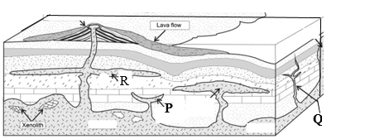
Identify the features marked P, Q and R. (3mks)
3. a) Outline two agents of Weathering. (2mks)
b) State how relief influences Weathering of rocks. (3mks)
4. a) State the factors that influence river deposition. (3mks)
b) Describe radial drainage pattern. (2mks)
5. a) What is Glaciation? (2mks)
b) State three factors that influence glacial erosion. (3mks)

SECTION B (75MARKS)

Answer Question 6 and Any Other two Questions in this Section.

6. Study the map of Kipkabus (1:50,000) (sheet 104/1) and answer the following questions;
a). i). What information can be derived from the map title? (2mks)
ii). Name two districts in the area covered by the map. (2mks)
ii) What was the magnetic variation as at 1985? (2mks)
b) i) Draw a rectangle measuring 8cm by 6cm to represent the area enclosed by eastings 87 and 95 and northing 35 and 41. (1mk)
On it mark and label the following,
    - Main track (1mk)
    - Dry weather road (1mk)
    - Thicket (1mk)
ii) What is the new scale? (2mks)
c). i). Identify three natural features found in grid 9132. (3mks)
ii). Citing evidence from the map, explain three ways in which drainage has influenced the distribution of settlements in the area covered by the map. (6mks)
d). Describe the relief of the area covered by the map. (4mks)
7. a) i. Give three ways in which rocks are classified. (3mks)
ii. Explain how igneous rocks are formed (5mks)
b) i State four characteristics of sedimentary rocks (4mks)
ii Describe how Dynamic metamorphism leads to formation of metamorphic rocks
(2mks)
c) Explain the following characteristics of rocks
- Cleavage (2mks)
- Lustre (2mks)
(iii) Tenacity (2mks)
d) State reasons why coral rocks are widespread at the coast (5mks)

8. (a) Differentiate between derived and cultivated vegetation. (2mks)
(b) Explain how the following factors influence vegetation distribution in Kenya:
(i) Living organisms (2mks)
(ii) Precipitation (2mks)
(c) The map below shows World vegetation distribution. Use it to answer the questions that follow.
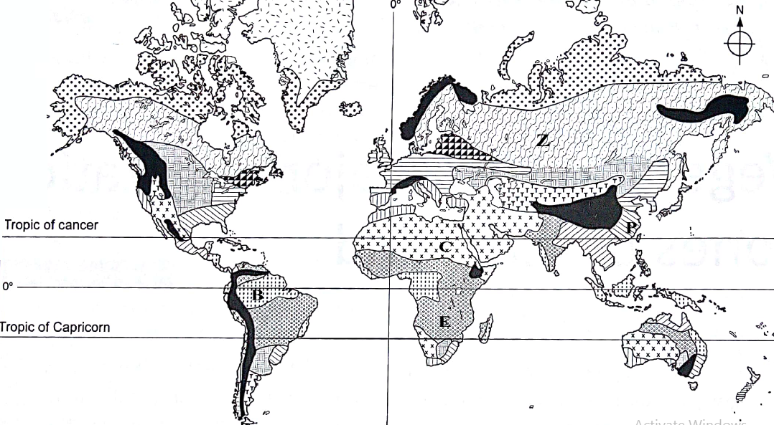
- Identify the vegetation labelled B, C and Z. (3mks)
- Describe the adaptive characteristics of the vegetation labeled Z. (6mks)
(d) Your class is to planning to undertake a field study on vegetation in Ngong forest;
(i) State three preparations you would carry out. (3mks)
(ii) Give three sampling techniques you would use. (3mks)
(iii) Identify four problems you are likely to face during the actual field study. (4mks)

9. a) i) Differentiate between Aridity and Desertification. (2mks)
ii) Explain the following processes of wind erosion.
- Abrasion (2mks)
- Deflation. (2mks)

b) Describe the formation of the following features;
- Zeugen (5mks)
- An oasis (4mks)

c) i) State three factors which influence wind transport. (3mks)
ii) Give three characteristics of a Barchan. (3mks)
d) Explain two significance of the resultant features of action of wind and water in arid areas
(4mks)
10 a) i) Name two types of tides. (2mks)
ii) State two causes of vertical movement of ocean water (2mks)
b).Describe the formation of the following features;
- A bay bar (4mks)
- Fringing reef (4mks)
c) i) Name three types of submerged lowland coasts (3mks)
ii) State characteristics of submerged lowland coasts (4mks)
d) You are planning to carry out a field study on coastal features along the Kenyan coast.
i) State two methods you will use to collect data. (2mks)
ii) Explain two economic benefits of coral rocks (4mks)

------------------------------------------------------------------------------------------------------------------------------------------------------------------------------------------------------------------------------------------------------------------------------------------------------------------------------------------------------------------------------------------------------------------------------------------------------------------------------------------------------------------------------------------------------------------------------------------------------------------------------------------------------------------------------------------------------------------------------------------------------------------------------------------------------------------------------------------------------------------------------------------------------------------------------------------------------------------------------------------------------------------------------------------------------------------------------------------------------------------------------------------------------------------------------------------------------------------------------------------------------------------------------------------------------------------------------------------------------------------------------------------------------------------------------------------------------------------------------------------------------------------------------------------------------------------------------------------------------------------------------------------------------------------------------------------------------------------------------------------------------------------------------------------------------------------------------------------------------------------------------------------------------------------------------------------------------------------------------------------------------------------------------------------------------------------------------------------------------------------------------------------------------------------------------------------------------------------------------------------------------------------------------------------------------------------------------------------------------------------------------------------------------------------------------------------------------------------------------------------------------------------------------------------------------------------------------------------------------------------------------------------------------------------------------------------------------------------------------------------------------------------------------------------------------------------------------------------------------------------------------------------------------------------------------------------------------------------------------------------------------------------------------------------------------------------------------------------------------------------------------------------------------------------------------------------------------------------------------------------------------------------------------------------------------------------------------------------------------------------------------------------------------------------------------------------------------------------------------------------------------------------------------------------------------------------------------------------------------------------------------------------------------------------------------------------------------------------------------------------------------------------------------------------------------------------------------------------------------------------------------------------------------------------------------------------------------------------------------------------------------------------------------------------------------------------------------------------------------------------------------------------------------------------------------------------------------------------------------------------------------------------------------------------------------------------------------------------------------------------------------------------------------------------------------------------------------------------------------------------------------------------------------------------------------------------------------------------------------------------------------------------------------------------------------------------------------------------------------------------------------------------------------------------------------------------------------------------------------------------------------------------------------------------------------------------------------------------------------------------------------------------------------------------------------------------------------------------------------------------------------------------------------------------------------------------------------------------------------------------------------------------------------------------------------------------------------------------------------------------------------------------------------------------------------------------------------------------------------------------------------------------------------------------------------------------------------------------------------------------------------------------------------------------------------------------------------------------------------------------------------------------------------------------------------------------------------------------------------------------------------------------------------------------------------------------------------------------------------------------------------------------------------------------------------------------------------------------------------------------------------------------------------------------------------------------------------------------------------------------------------------------------------------------------------------------------------------------------------------------------------------------------------------------------------------------------------------------------------------------------------------------------------------------------------------------------------------------------------------------------------------------------------------------------------------------------------------------------------------------------------------------------------------------------------------------------------------------------------------------------------------------------------------------------------------------------------------------------------------------------------------------------------------------------------------------------------------------------------------------------------------------------------------------------------------------------------------------------------------------------------------------------------------------------------------------------------------------------------------------------------------------------------------------------------------------------------------------------------------------------------------------------------------------------------------------------------------------------------------------------------------------------------------------------------------------------------------------------------------------------------------------------------------------------------------------------------------------------------------------------------------------------------------------------------------------------------------------------------------------------------------------------------------------------------------------------------------------------------------------------------------------------------------------------------------------------------------------------------------------------------------------------------------------------------------------------------------------------------------------------------------------------------------------------------------------------------------------------------------------------------------------------------------------------------------------------------------------------------------------------------------------------------------------------------------------------------------------------------------------------------------------------------------------------------------------------------------------------------------------------------------------------------------------------------------------------------------------------------------------------------------------------------------------------------------------------------------------------------------------------------------------------------------------------------------------------------------------------------------------------------------------------------------------------------------------------------------------------------------------------------------------------------------------------------------------------------------------------------------------------------------------------------------------------------------------------------------------------------------------------------------------------------------------------------------------------------------------------------------------------------------------------------------------------------------------------------------------------------------------------------------------------------------------------------------------------------------------------------------------------------------------------------------------------------------------------------------------------------------------------------------------------------------------------------------------------------------------------------------------------------------------------------------------------------------------------------------------------------------------------------------------------------------------------------------------------------------------------------------------------------------------------------------------------------------------------------------------------------------------------------------------------------------------------------------------------------------------------------------------------------------------------------------------------------------------------------------------------------------------------------------------------------------------------------------------------------------------------------------------------------------------------------------------------------------------------------------------------------------------------------------------------------------------------------------------------------------------------------------------------------------------------------------------------------------------------------------------------------------------------------------------------------------------------------------------------------------------------------------------------------------------------------------------------------------------------------------------------------------------------------------------------------------------------------------------------------------------------------------------------------------------------------------------------------------------------------------------------------------------------------------------------------------------------------------------------------------------------------------------------------------------------------------------------------------------------------------------------------------------------------------------------------------------------------------------------------------------------------------------------------------------------------------------------------------------------------------------------------------------------------------------------------------------------------------------------------------------------------------------------------------------------------------------------------------------------------------------------------------------------------------------------------------------------------------------------------------------------------------------------------------------------------------------------------------------------------------------------------------------------------------------------------------------------------------------------------------------------------------------------------------------------------------------------------------------------------------------------------------------------------------------------------------------------------------------------------------------------------------------------------------------------------------------------------------------------------------------------------------------------------------------------------------------------------------------------------------------------------------------------------------------------------------------------------------------------------------------------------------------------------------------------------------------------------------------------------------------------------------------------------------------------------------------------------------------------------------------------------------------------------------------------------------------------------------------------------------------------------------------------------------------------------------------------------------------------------------------------------------------------------------------------------------------------------------------------------------------------------------------------------------------------------------------------------------------------------------------------------------------------------------------------------------------------------------------------------------------------------------------------------------------------------------------------------------------------------------------------------------------------------------------------------------------------------------------------------------------------------------------------------------------------------------------------------------------------------------------------------------------------------------------------------------------------------------------------------------------------------------------------------------------------------------------------------------------------------------------------------------------------------------------------------------------------------------------------------------------------------------------------------------------------------------------------------------------------------------------------------------------------------------------------------------------------------------------------------------------------------------------------------------------------------------------------------------------------------------------------------------------------------------------------------------------------------------------------------------------------------------------------------------------------------------------------------------------------------------------------------------------------------------------------------------------------------------------------------------------------------------------------------------------------------------------------------------------------------------------------------------------------------------------------------------------------------------------------------------------------------------------------------------------------------------------------------------------------------------------------------------------------------------------------------------------------------------------------------------------------------------------------------------------------------------------------------------------------------------------------------------------------------------------------------------------------------------------------------------------------------------------------------------------------------------------------------------------------------------------------------------------------------------------------------------------------------------------------------------------------------------------------------------------------------------------------------------------------------------------------------------------------------------------------------------------------------------------------------------------------------------------------------------------------------------------------------------------------------------------------------------------------------------------------------------------------------------------------------------------------------------------------------------------------------------------------------------------------------------------------------------------------------------------------------------------------------------------------------------------------------------------------------------------------------------------------------------------------------------------------------------------------------------------------------------------------------------------------------------------------------------------------------------------------------------------------------------------------------------------------------------------------------------------------------------------------------------------------------------------------------------------------------------------------------------------------------------------------------------------------------------------------------------------------------------------------------------------------------------------------------------------------------------------------------------------------------------------------------------------------------------------------------------------------------------------------------------------------------------------------------------------------------------------------------------------------------------------------------------------------------------------------------------------------------------------------------------------------------------------------------------------------------------------------------------------------------------------------------------------------------------------------------------------------------------------------------------------------------------------------------------------------------------------------------------------------------------------------------------------------------------------------------------------------------------------------------------------------------------------------------------------------------------------------------------------------------------------------------------------------------------------------------------------------------------------------------------------------------------------------------------------------------------------------------------------------------------------------------------------------------------------------------------------------------------------------------------------------------------------------------------------------------------------------------------------------------------------------------------------------------------------------------------------------------------------------------------------------------------------------------------------------------------------------------------------------------------------------------------------------------------------------------------------------------------------------------------------------------------------------------------------------------------------------------------------------------------------------------------------------------------------------------------------------------------------------------------------------------------------------------------------------------------------------------------------------------------------------------------------------------------------------------------------------------------------------------------------------------------------------------------------------------------------------------------------------------------------------------------------------------------------------------------------------------------------------------------------------------------------------------------------------------------------------------------------------------------------------------------------------------------------------------------------------------------------------------------------------------------------------------------------------------------------------------------------------------------------------------------------------------------------------------------------------------------------------------------------------------------------------------------------------------------------------------------------------------------------------------------------------------------------------------------------------------------------------------------------------------------------------------------------------------------------------------------------------------------------------------------------------------------------------------------------------------------------------------------------------------------------------------------------------------------------------------------------------------------------------------------------------------------------------------------------------------------------------------------------------------------------------------------------------------------------------------------------------------------------------------------------------------------------------------------------------------------------------------------------------------------------------------------------------------------------------------------------------------------------------------------------------------------------------------------------------------------------------------------------------------------------------------------------------------------------------------------------------------------------------------------------------------------------------------------------------------------------------------------------------------------------------------------------------------------------------------------------------------------------------------------------------------------------------------------------------------------------------------------------------------------------------------------------------------------------------------------------------------------------------------------------------------------------------------------------------------------------------------------------------------------------------------------------------------------------------------------------------------------------------------------------------------------------------------------------------------------------------------------------------------------------------------------------------------------------------------------------------------------------------------------------------------------------------------------------------------------------------------------------------------------------------------------------------------------------------------------------------------------------------------------------------------------------------------------------------------------------------------------------------------------------------------------------------------------------------------------------------------------------------------------------------------------------------------------------------------------------------------------------------------------------------------------------------------------------------------------------------------------------------------------------------------------------------------------------------------------------------------------------------------------------------------------------------------------------------------------------------------------------------------------------------------------------------------------------------------------------------------------------------------------------------------------------------------------------------------------------------------------------------------------------------------------------------------------------------------------------------------------------------------------------------------------------------------------------------------------------------------------------------------------------------------------------------------------------------------------------------------------------------------------------------------------------------------------------------------------------------------------------------------------------------------------------------------------------------------------------------------------------------------------------------------------------------------------------------------------------------------------------------------------------------------------------------------------------------------------------------------------------------------------------------------------------------------------------------------------------------------------------------------------------------------------------------------------------------------------------------------------------------------------------------------------------------------------------------------------------------------------------------------------------------------------------------------------------------------------------------------------------------------------------------------------------------------------------------------------------------------------------------------------------------------------------------------------------------------------------------------------------------------------------------------------------------------------------------------------------------------------------------------------------------------------------------------------------------------------------------------------------------------------------------------------------------------------------------------------------------------------------------------------------------------------------------------------------------------------------------------------------------------------------------------------------------------------------------------------------------------------------------------------------------------------------------------------------------------------------------------------------------------------------------------------------------------------------------------------------------------------------------------------------------------------------------------------------------------------------------------------------------------------------------------------------------------------------------------------------------------------------------------------------------------------------------------------------------------------------------------------------------------------------------------------------------------------------------------------------------------------------------------------------------------------------------------------------------------------------------------------------------------------------------------------------------------------------------------------------------------------------------------------------------------------------------------------------------------------------------------------------------------------------------------------------------------------------------------------------------------------------------------------------------------------------------------------------------------------------------------------------------------------------------------------------------------------------------------------------------------------------------------------------------------------------------------------------------------------------------------------------------------------------------------------------------------------------------------------------------------------------------------------------------------------------------------------------------------------------------------------------------------------------------------------------------------------------------------------------------------------------------------------------------------------------------------------------------------------------------------------------------------------------------------------------------------------------------------------------------------------------------------------------------------------------------------------------------------------------------------------------------------------------------------------------------------------------------------------------------------------------------------------------------------------------------------------------------------------------------------------------------------------------------------------------------------------------------------------------------------------------------------------------------------------------------------------------------------------------------------------------------------------------------------------------------------------------------------------------------------------------------------------------------------------------------------------------------------------------------------------------------------------------------------------------------------------------------------------------------------------------------------------------------------------------------------------------------------------------------------------------------------------------------------------------------------------------------------------------------------------------------------------------------------------------------------------------------------------------------------------------------------------------------------------------------------------------------------------------------------------------------------------------------------------------------------------------------------------------------------------------------------------------------------------------------------------------------------------------------------------------------------------------------------------------------------------------------------------------------------------------------------------------------------------------------------------------------------------------------------------------------------------------------------------------------------------------------------------------------------------------------------------------------------------------------------------------------------------------------------------------------------------------------------------------------------------------------------------------------------------------------------------------------------------------------------------------------------------------------------------------------------------------------------------------------------------------------------------------------------------------------------------------------------------------------------------------------------------------------------------------------------------------------------------------------------------------------------------------------------------------------------------------------------------------------------------------------------------------------------------------------------------------------------------------------------------------------------------------------------------------------------------------------------------------------------------------------------------------------------------------------------------------------------------------------------------------------------------------------------------------------------------------------------------------------------------------------------------------------------------------------------------------------------------------------------------------------------------------------------------------------------------------------------------------------------------------------------------------------------------------------------------------------------------------------------------------------------------------------------------------------------------------------------------------------------------------------------------------------------------------------------------------------------------------------------------------------------------------------------------------------------------------------------------------------------------------------------------------------------------------------------------------------------------------------------------------------------------------------------------------------------------------------------------------------------------------------------------------------------------------------------------

