KENYA JUNIOR SCHOOL EDUCATION ASSESSMENT
GRADE 8 – 2026
SOCIAL STUDIES
TIME: 1 Hour 30 Minutes
Learner's Name | ________________________ | Assessment Number | ________________
School Name | ________________________ | School Code | ________________
Learner's Signature | ________________________ | Date | ________________

INSTRUCTIONS TO LEARNERS
- Write your name and assessment number in the spaces provided above.
- Write the name and code of your school in the spaces provided above.
- Sign and write the date of the assessment in the spaces provided above.
- This paper consists of two sections: A and B.
- Answer ALL questions in Section A on the separate ANSWER SHEET provided.
- Answer ALL questions in Section B in the spaces provided in this question paper.
- Use an ordinary HB pencil for Section A.
- For each question in Section A, choose only ONE correct answer.
- Do NOT remove any page from this question paper.

FOR OFFICIAL USE ONLY
SECTION | A | B | TOTAL
Maximum Score | 20 | 30 | 50
Learner's Score

SECTION A: MULTIPLE CHOICE QUESTIONS (20 MARKS)
Answer ALL questions. Choose the correct answer from A, B, C and D.

1. A community health worker notices that a family has poor access to clean water. Which community resource would most directly help address this problem?
A. A football field
B. A protected water source
C. A cultural dance
D. A market stall
2. Which activity best demonstrates responsible use of natural resources?
A. Cutting all trees near a river
B. Planting trees after harvesting
C. Dumping waste in wetlands
D. Hunting wildlife during breeding season
3. Which of the following is an example of a push factor that may cause people to migrate?
A. Availability of employment
B. Political instability
C. Better schools
D. Fertile farmland
4. Which early human activity is most closely associated with the use of stone tools?
A. Industrial manufacturing
B. Hunting and gathering
C. Commercial banking
D. Modern transport
5. Which feature is most useful for identifying the relief of an area on a topographical map?
A. Contour lines
B. Road signs
C. School symbols
D. Settlement names
6. A map scale of 1:50,000 means that 1 cm on the map represents:
A. 50 m on the ground
B. 500 m on the ground
C. 5 km on the ground
D. 50 km on the ground
7. Identify the physical feature shown below:
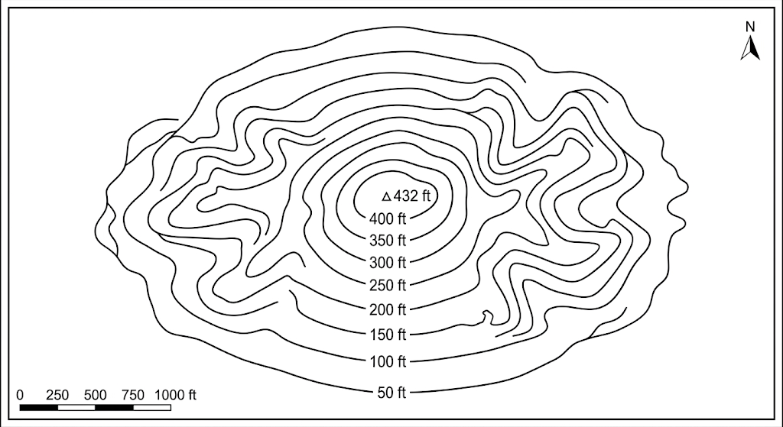
A. A depression
B. A hill
C. A valley
D. A flat plain
8. Which arm of government is mainly responsible for interpreting laws in Kenya?
A. Legislature
B. Executive
C. Judiciary
D. County assembly
9. Which of the following is a civic responsibility of a citizen?
A. Destroying public property
B. Obeying the law
C. Avoiding all community activities
D. Refusing to pay lawful taxes
10. Which factor can contribute to rapid population growth in an area?
A. High death rate
B. Low birth rate
C. High birth rate
D. Large outward migration
11. Which method can be used to resolve conflict peacefully in a family or community?
A. Negotiation
B. Revenge
C. Violence
D. Intimidation
12. Which statement best describes a cultural practice?
A. A habit or activity shared and transmitted within a community
B. A weather event
C. A type of mineral
D. A form of physical relief
13.
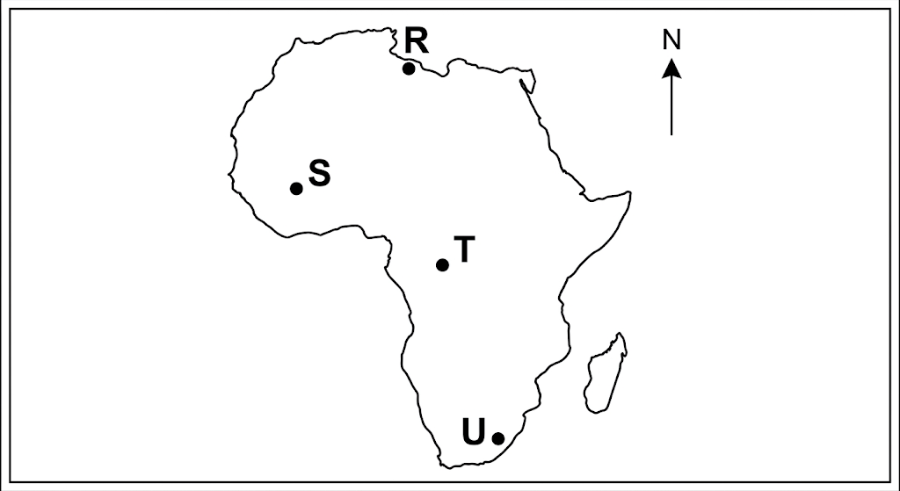
A. R
B. S
C. T
D. U
14. Which factor is most likely to influence the location of a settlement?
A. Availability of water
B. Distance from all roads
C. Absence of fertile land
D. Lack of economic activity
15. Which of the following is an example of a climatic element?
A. Altitude
B. Rainfall
C. Soil type
D. Relief
16. Which instrument is used to measure atmospheric pressure?
A. Thermometer
B. Rain gauge
C. Barometer
D. Wind vane
17. Which economic activity is most associated with areas having extensive grasslands suitable for livestock?
A. Pastoralism
B. Deep-sea fishing
C. Mining only
D. Ship building
18. Which type of migration occurs when people move from one country to another?
A. Internal migration
B. International migration
C. Seasonal movement only
D. Local commuting
19. Which action promotes good governance in a community?
A. Transparency in decision-making
B. Corruption
C. Discrimination
D. Concealing public information
20. Which source would provide first-hand information about an event witnessed by a person?
A. A primary source
B. A fictional story
C. A secondary summary
D. An unrelated textbook

SECTION B: STRUCTURED QUESTIONS (30 MARKS)
Answer ALL questions in the spaces provided.
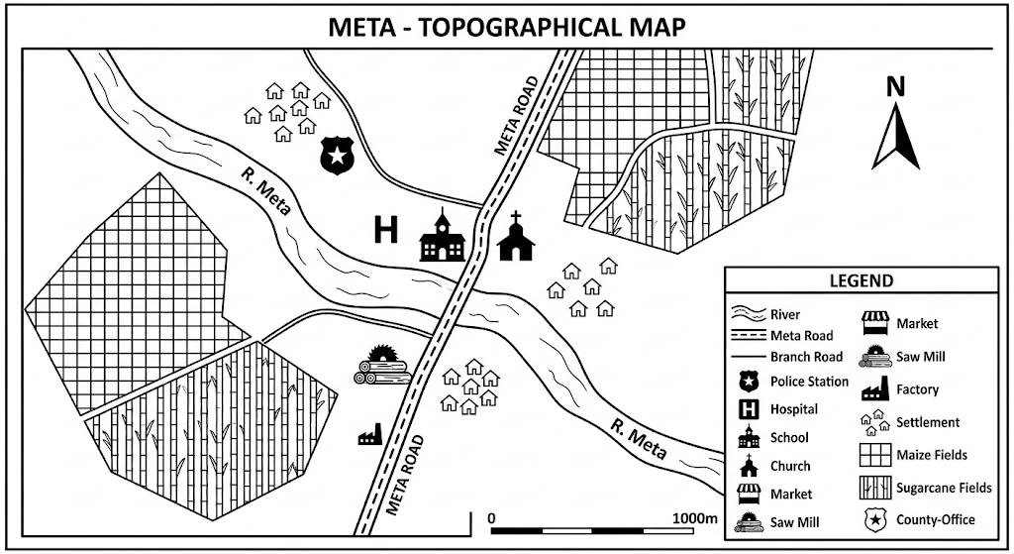
Study the map of Meta area above and answer Questions 21–24.
21. (a) State the direction of the flow of River Meta from its source area. (1 mark)
__________________________________________________________________________________________________________________________________________________________________________________________________________________
(b) What is the direction of the school from the market? (1 mark)
__________________________________________________________________________________________________________________________________________________________________________________________________________________
(c) State one settlement pattern represented on the map. (1 mark)
__________________________________________________________________________________________________________________________________________________________________________________________________________________
(d) Give one factor that may have influenced the location of settlements in Meta area. (1 mark)
__________________________________________________________________________________________________________________________________________________________________________________________________________________
22. State four reasons why the East African coast attracted early visitors from other regions. (4 marks)
______________________________________________________________________________________________________________________________________________________________________________________________________________________________________________________________________________________________________________________________________________________________________________________________________________________________________________________________________________________________________________________________________________________________________________________________________________________________________________________
23. Explain four factors that may lead to population increase in Africa. (4 marks)
______________________________________________________________________________________________________________________________________________________________________________________________________________________________________________________________________________________________________________________________________________________________________________________________________________________________________________________________________________________________________________________________________________________________________________________________________________________________________________________
24. Identify four types of information that can be obtained from a topographical map. (4 marks)
______________________________________________________________________________________________________________________________________________________________________________________________________________________________________________________________________________________________________________________________________________________________________________________________________________________________________________________________________________________________________________________________________________________________________________________________________________________________________________________
25. Explain four methods that can be used to resolve conflicts peacefully in a family or community. (4 marks)
______________________________________________________________________________________________________________________________________________________________________________________________________________________________________________________________________________________________________________________________________________________________________________________________________________________________________________________________________________________________________________________________________________________________________________________________________________________________________________________
26. State four factors that contributed to the partition of Africa by European powers. (4 marks)
______________________________________________________________________________________________________________________________________________________________________________________________________________________________________________________________________________________________________________________________________________________________________________________________________________________________________________________________________________________________________________________________________________________________________________________________________________________________________________________
27. Name the three arms of government in Kenya and state one specific role of each. (3 marks)
______________________________________________________________________________________________________________________________________________________________________________________________________________________________________________________________________________________________________________________________________________________________________________________________________________________________________________________________________________________________________________________________________________________________________________________________________________________________________________________
28. State three methods that can be used to identify a problem in a community before planning a community-service project. (3 marks)
_____________________________________________________________________________________________________________________________________________________________________________________________________________________________________________________________________________________________________________________________________________________________________________________________________________________________________________________________________________________________________________________________________________
END OF QUESTION PAPER

