GRADE 8 – 2026
PRE-TECHNICAL STUDIES THEORY
Time: 1 hour 40 minutes | Total: 50 marks
Learner’s Name | Assessment Number | School | School Code

Instructions to Learners
- Write your name and assessment number in the spaces provided.
- Write the name and code of your school in the spaces provided.
- This paper consists of two sections: A and B.
- Section A comprises Multiple Choice Questions.
- Section B comprises Short Structured Questions.
- Answer all questions in Section A by choosing the correct option.
- Answer all questions in Section B in the spaces provided.
- Answer all questions in English.
- Do not remove any page from this question paper.

SECTION A – MULTIPLE CHOICE QUESTIONS (20 marks)
Choose the correct answer from the four options. Each question carries one mark.

1. A learner notices a small fire in a workshop and first removes the material that is feeding the flames. Which fire-fighting method is being used?
A. Cooling
B. Smothering
C. Starvation
D. Evacuation
2. Which practice is most likely to cause an electrical fire in a workshop?
A. Inspecting electrical cables regularly
B. Using one extension cable to power many machines
C. Keeping fire extinguishers accessible
D. Switching off machines after use
3. The drawing instrument shown below is used to draw accurate circles and arcs. What is its name?
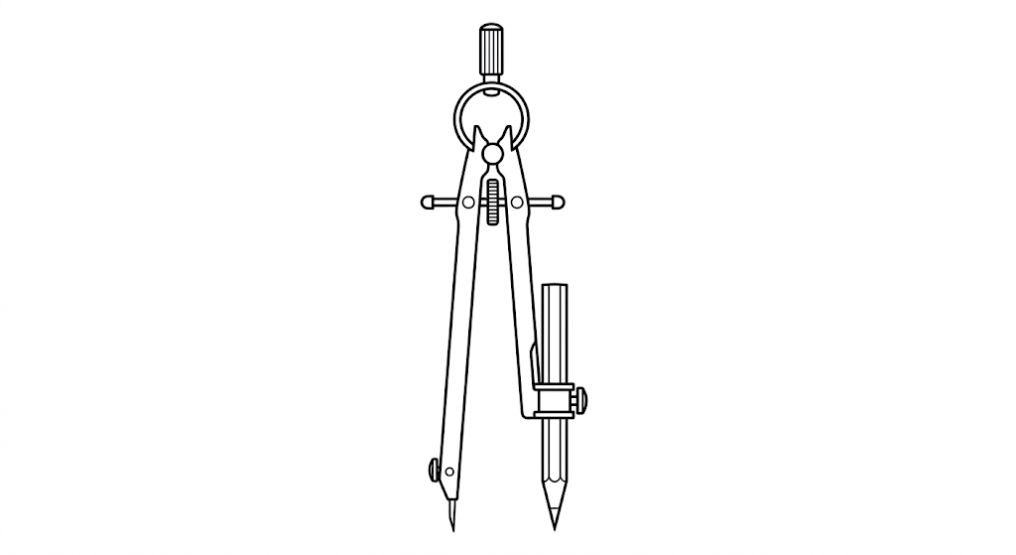
A. Pair of compasses
B. Dividers
C. Set square
D. Protractor
4. The stepped shape below has several measurements taken from the same datum line. What type of dimensioning is illustrated?
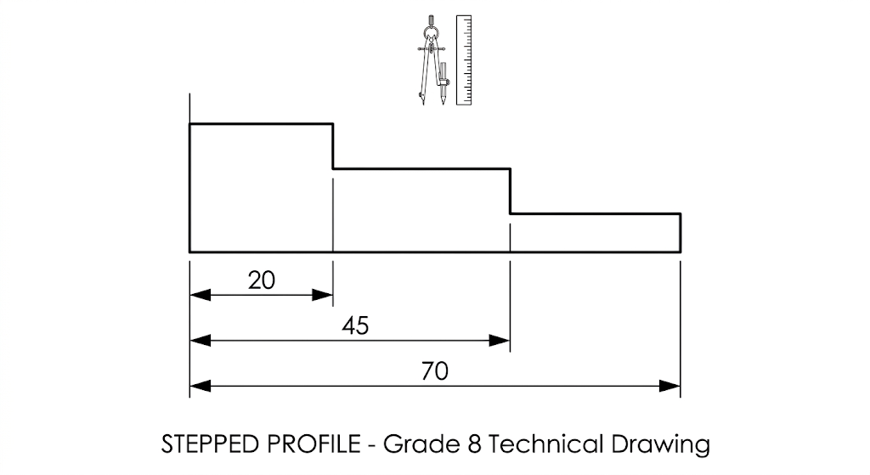
A. Baseline dimensioning
B. Chain dimensioning
C. Radial dimensioning
D. Angular dimensioning
5. On a drawing, 2 cm represents 3 m on the actual ground. What is the representative fraction (RF)?
A. 1/50
B. 1/100
C. 1/150
D. 1/200
6. Which one of the following is a composite material made by combining cement, sand, water and gravel?
A. Manufactured board
B. Stone
C. Brick
D. Concrete
7. A learner uses the instrument shown below to measure the outside diameter of a metal rod. What is the name of the instrument?
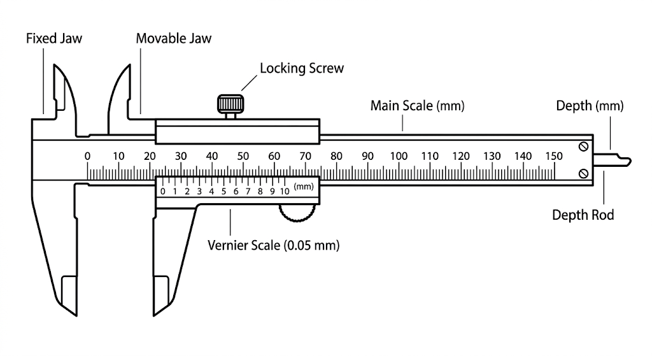
A. Vernier calipers
B. Micrometer screw gauge
C. G-clamp
D. Bench vice
8. Which one of the following is NOT a physical property associated with ceramics?
A. Hardness
B. Brittleness
C. Conductivity
D. Resistance to high temperatures
9. A learner makes the repeated lines shown below during a freehand drawing exercise. What type of lines are they?
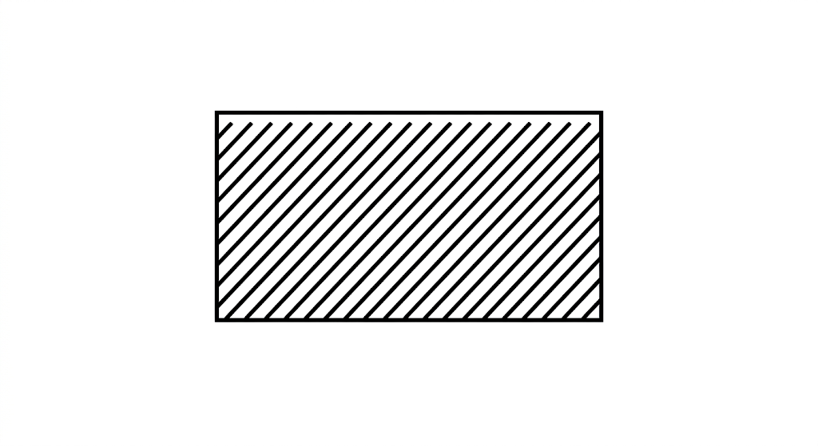
A. Oblique lines
B. Curved lines
C. Horizontal lines
D. Vertical lines
10. Rubber is suitable for making gumboots mainly because it
A. is flexible
B. is a poor conductor of electricity
C. does not absorb water easily
D. is resistant to wear and tear
11. A school wants to prevent unauthorised people from viewing confidential computer records. Which technique is most appropriate?
A. Installing and updating antivirus software
B. Creating backups regularly
C. Setting user access levels
D. Using an easy-to-remember password
12. A computer user notices the symbol shown on a system icon. What does the symbol most directly indicate?

A. The computer battery is low
B. A security threat has been detected
C. System updates are ready to be installed
D. The computer is connected to the internet
13. Which one of the following is NOT an application of visual programming?
A. Education
B. Web development
C. Multimedia production
D. Data cable installation
14. In Scratch, which block enables a program to choose between two actions depending on whether a condition is true or false?
A. Repeat block
B. If then...else block
C. Forever block
D. Wait block
15. The computer icon shown below is commonly used in word-processing applications. What is the name of the icon?

A. Save
B. Copy
C. Paste
D. Print
16. Which one of the following is NOT a basic term used in bookkeeping?
A. Assets
B. Liabilities
C. Capital
D. Salary
17. Which quality is most useful to an entrepreneur starting a small business?
A. Ability to take calculated risks
B. Avoiding challenges
C. Depending on others to make decisions
D. Inability to learn new skills
18. Which one of the following is NOT a useful source of business ideas?
A. Trade fairs and exhibitions
B. Newspapers
C. Hobbies
D. Office furniture
19. Which factor can be used to determine the size of a production unit?
A. Number of customers and selling locations
B. Methods used to advertise products
C. Number of employees and amount of output produced
D. Name of the business and ownership structure
20. Which one of the following is a financial goal of a business?
A. Increasing profits and reducing unnecessary expenses
B. Improving products and attracting more customers
C. Choosing locations and expanding branches
D. Creating adverts and promoting products

SECTION B – SHORT STRUCTURED QUESTIONS (30 marks)
21. State three likely causes of fire in a school. (3 marks)
________________________________________________________________________________
________________________________________________________________________________
________________________________________________________________________________
22. A plain scale is used in maps and drawings to represent distances in reduced form. State three features of a plain scale. (3 marks)
________________________________________________________________________________
________________________________________________________________________________
________________________________________________________________________________
23. Non-metallic materials are commonly used in making different products.
(a) State three examples of non-metallic materials used in production. (3 marks)
________________________________________________________________________________
________________________________________________________________________________
________________________________________________________________________________
(b) State one use of each material named in (a). (3 marks)
________________________________________________________________________________
________________________________________________________________________________
________________________________________________________________________________
24. Use the stippling technique to complete the given freehand drawing below. (4 marks)
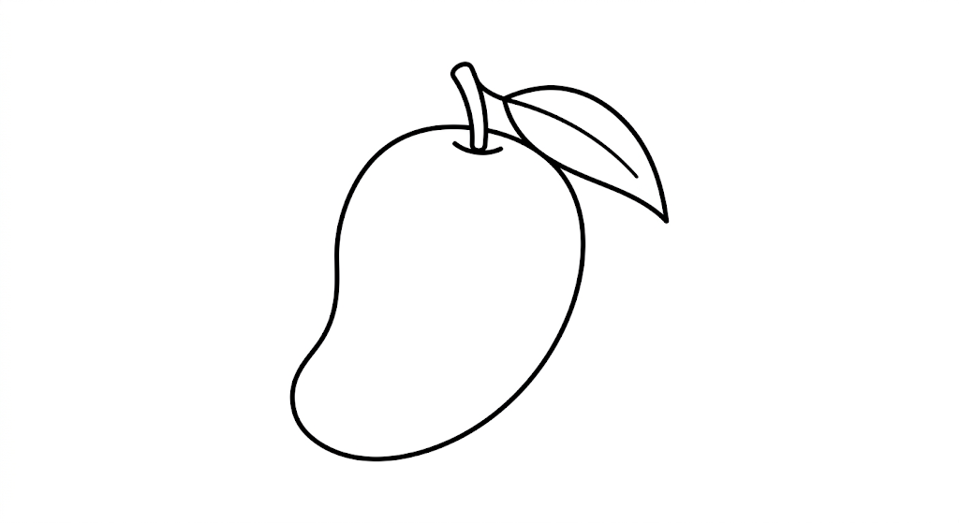
________________________________________________________________________________
25. A learner wants to start a small bakery near a shopping centre. State three factors that should be considered before starting the business. (3 marks)
________________________________________________________________________________
________________________________________________________________________________
________________________________________________________________________________
26. A learner is typing a document on a computer. State one use of each of the following keyboard keys: (3 marks)
a) Caps Lock
________________________________________________________________________________
b) Backspace
________________________________________________________________________________
c) Enter
________________________________________________________________________________
27. Online threats are dangers that users may encounter when using the internet and digital services. Explain the meaning of the following online threats. (4 marks)
(a) Phishing
________________________________________________________________________________
(b) Cyberbullying
________________________________________________________________________________
(c) Hacking
________________________________________________________________________________
(d) Impersonation
________________________________________________________________________________
28. Name each of the following computer storage devices shown below. (3 marks)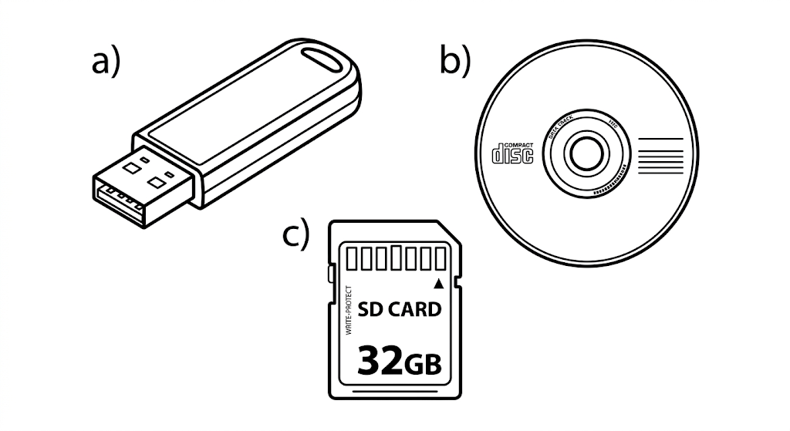
________________________________________________________________________________
________________________________________________________________________________
________________________________________________________________________________
29. Name one application software used to create and display information in the form of slides during a presentation. (1 mark)
________________________________________________________________________________

