GRADE 8 – 2026
MATHEMATICS
Time: 1 hour 40 minutes | Total: 50 marks
Learner’s Name | Assessment Number | School Name | School Code

INSTRUCTIONS TO LEARNERS
- Write your name and assessment number in the spaces provided.
- Write the name and code of your school in the spaces provided.
- Sign and write the date of the assessment in the spaces provided.
- This question paper consists of TWO sections: A and B.
- Answer ALL questions in Section A on the separate answer sheet provided.
- Answer ALL questions in Section B in the spaces provided in this question paper.
- Show all your workings in Section B.
- Non-programmable calculators may be used except where a question requires otherwise.
- Give non-exact numerical answers correct to 3 significant figures and angles to 1 decimal place unless another accuracy is specified.
- Use π = 3.142 or the calculator value where required.
- Do not remove any page from this question paper.
- Answer all questions in English.

SECTION A – MULTIPLE CHOICE QUESTIONS (20 marks)
For each question, choose the one correct answer.

1. A game gives a learner 60 points. She earns 18 bonus points, loses 9 points, and then loses another 12 points. What is her final score?
A. 57
B. 69
C. 87
D. 51
2. A mass of 0.007846 kg is recorded correct to 3 significant figures. What is the recorded mass?
A. 0.00784 kg
B. 0.00785 kg
C. 0.00780 kg
D. 0.0785 kg
3. The temperature of a cold room changes from 18°C to 6°C. What is the change in temperature?
A. 12 K decrease
B. 12 K increase
C. 267 K decrease
D. 279 K increase
4. Round off 27.43856 to the nearest ten-thousandth.
A. 27.4385
B. 27.4386
C. 27.439
D. 27.4000
5. Evaluate: 5/6 ÷ 10/9 − 1/3.
A. 5/12
B. 1/6
C. 1/3
D. 7/12
6. Which fraction gives a recurring decimal when converted to decimal form?
A. 3/8
B. 5/16
C. 2/7
D. 9/20
7. The volume of a tank is 4,506,000 m³. Which is its standard form?
A. 4.506 × 10⁶ m³
B. 45.06 × 10⁵ m³
C. 4.506 × 10⁵ m³
D. 0.4506 × 10⁷ m³
8. A shopkeeper bought 7 3/5 kg of rice. What is this mass as a decimal?
A. 7.35 kg
B. 7.5 kg
C. 7.6 kg
D. 7.75 kg
9. A dress requires 2.4 m of cloth. How many complete dresses can be made from 19.2 m of cloth?
A. 7
B. 8
C. 9
D. 10
10. The perimeter of a square field is 36 m. What is its area?
A. 72 m²
B. 81 m²
C. 108 m²
D. 144 m²
11. The L-shaped flowerbed shown below has an area of
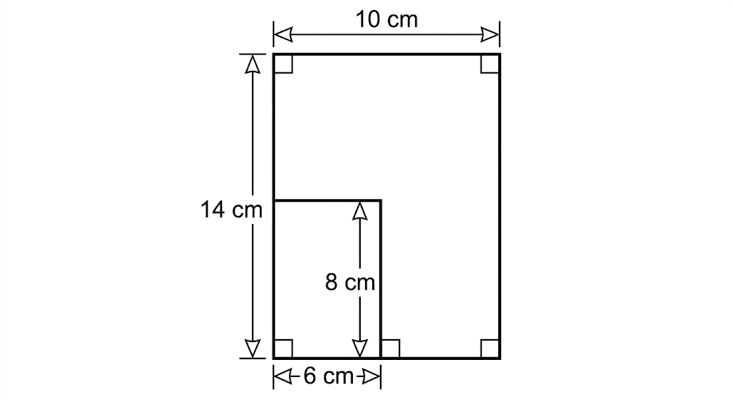
A. 84 cm²
B. 92 cm²
C. 104 cm²
D. 112 cm²
12. Solve the equation: 7x + 5 = 3x + 29.
A. x = 4
B. x = 5
C. x = 6
D. x = 8
13. A sector has radius 14 cm and central angle 90°. What is its area? Use π = 22/7.
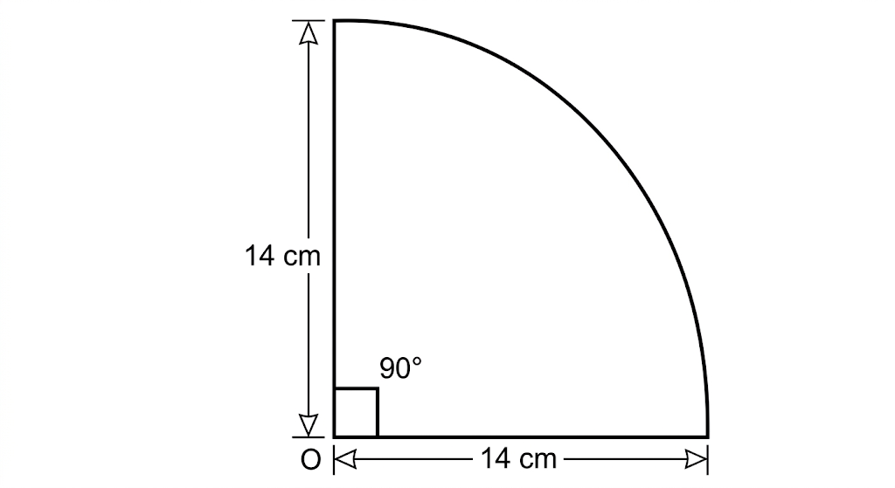
A. 154 cm²
B. 308 cm²
C. 616 cm²
D. 77 cm²
14. A learner deposits Ksh 36,000 at 10% simple interest per annum. How much interest is earned after 2 years?
A. Ksh 3,600
B. Ksh 7,200
C. Ksh 43,200
D. Ksh 72,000
15. What is the next number in the sequence? 2, 6, 18, 54, …
A. 108
B. 162
C. 216
D. 324
16. A rectangular tank is 7 m long and 5 m wide. Water fills it to a depth of 2 m. How many litres of water does it contain?
A. 7,000 L
B. 35,000 L
C. 70,000 L
D. 140,000 L
17. A jacket marked Ksh 3,000 is sold for Ksh 2,400. Which expression gives the percentage discount?
A. (600/3000) × 100%
B. (2400/3000) × 100%
C. (600/2400) × 100%
D. (3000/2400) × 100%
18. Given a = 3, b = a + 2, c = 2b and d = c − a, find the value of (a + b + c + d)/5.
A. 4
B. 5
C. 6
D. 7
19. A vehicle travels 180 km in 3 hours. What is its speed in metres per second?
A. 16.7 m/s
B. 20 m/s
C. 50 m/s
D. 60 m/s
20. Each interior angle of a regular polygon is 150°. How many sides does the polygon have?
A. 8
B. 10
C. 12
D. 15

SECTION B – STRUCTURED QUESTIONS (30 marks)
21. The population of a county is 583,742,916. (3 marks)
a) Write the population in words.
______________________________________________________________________________________________
b) Round off the population to the nearest ten million.
______________________________________________________________________________________________
c) State the place value of the digit 7.
______________________________________________________________________________________________
22. A diver is 15 m below sea level. He rises 8 m and then dives down 6 m. (4 marks)
a) Draw a number line to represent the movements.
______________________________________________________________________________________________
______________________________________________________________________________________________
b) State the diver’s final position relative to sea level.
______________________________________________________________________________________________
c) How far is the final position below sea level?
______________________________________________________________________________________________
23. Three partners shared a profit. One received 1/4 of the profit, another received 3/8, and the third received the remainder. (4 marks)
a) Find the fraction of the profit received by the third partner.
______________________________________________________________________________________________
b) If the third partner received Ksh 27,000, find the amount received by each of the other two partners.
______________________________________________________________________________________________
______________________________________________________________________________________________
______________________________________________________________________________________________
24. The figure below represents an L-shaped flower garden. Find its perimeter. (3 marks)
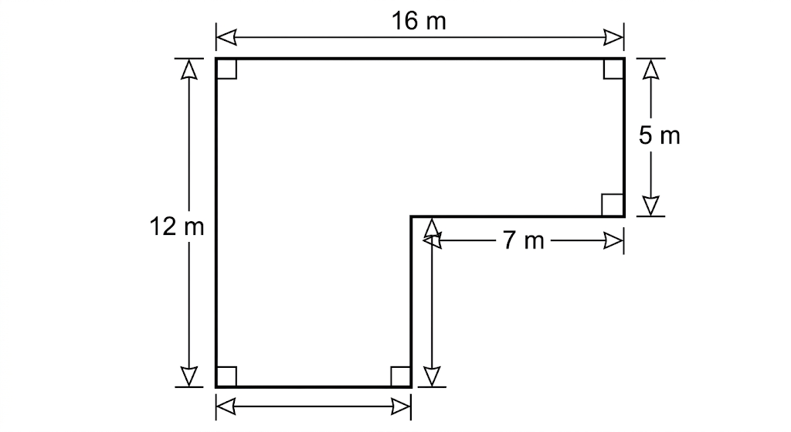
______________________________________________________________________________________________
______________________________________________________________________________________________
25. A closed cube has side length 5 cm and is opened to form a net. (4 marks)
a) Draw an accurate net of the cube.
______________________________________________________________________________________________
______________________________________________________________________________________________
______________________________________________________________________________________________
b) Use the net to find the total surface area of the cube.
______________________________________________________________________________________________
______________________________________________________________________________________________
26. A plot valued at Ksh 400,000 appreciates at 6% per year. Find its value after three years, assuming annual compound appreciation. (3 marks)
______________________________________________________________________________________________
______________________________________________________________________________________________
______________________________________________________________________________________________
27. Construct parallelogram ABCD such that AB = 7 cm, AD = 5 cm and angle DAB = 60°. (5 marks)
a) Complete the construction using a ruler, pencil and compass. (3 marks)
______________________________________________________________________________________________
______________________________________________________________________________________________
b) Measure angle ABC. (1 mark)
______________________________________________________________________________________________
c) State the length of diagonal BD to the nearest 0.1 cm. (1 mark)
______________________________________________________________________________________________
28. Three bottles of water and two packets of biscuits cost Ksh 250. Five bottles of water and four packets of biscuits cost Ksh 430. Using simultaneous equations, determine the cost of one bottle of water and one packet of biscuits. (4 marks)
______________________________________________________________________________________________
______________________________________________________________________________________________
______________________________________________________________________________________________
______________________________________________________________________________________________

