KENYA JUNIOR SCHOOL EDUCATION ASSESSMENT
GRADE 8 – 2026
INTEGRATED SCIENCE
TIME: 1 Hour 40 Minutes
Learner's Name | ________________________ | Assessment Number | ________________
School Name | ________________________ | School Code | ________________
Learner's Signature | ________________________ | Date | ________________

INSTRUCTIONS TO LEARNERS
- Write your name and assessment number in the spaces provided above.
- Write the name and code of your school in the spaces provided above.
- Sign and write the date of the assessment in the spaces provided above.
- This paper consists of two sections: A and B.
- Answer ALL questions in Section A on the separate ANSWER SHEET provided.
- Answer ALL questions in Section B in the spaces provided in this question paper.
- Use an ordinary HB pencil for Section A.
- Choose only ONE correct option for each question in Section A.
- Do NOT remove any page from this question paper.

FOR OFFICIAL USE ONLY
SECTION | A | B | TOTAL
Maximum Score | 20 | 30 | 50
Learner's Score

SECTION A: MULTIPLE CHOICE QUESTIONS (20 MARKS)
Answer ALL questions. Choose the correct answer from A, B, C and D.

1. During a practical lesson, a learner wants to test whether a liquid is acidic. Which observation would give the strongest evidence?
A. Blue litmus turns red.
B. Red litmus turns blue.
C. Universal indicator remains green.
D. The liquid becomes colourless.
2. Which of the following is a waste product excreted by the human body?
A. Oxygen
B. Urea
C. Starch
D. Glucose
3. The instrument shown below is most suitable for measuring:
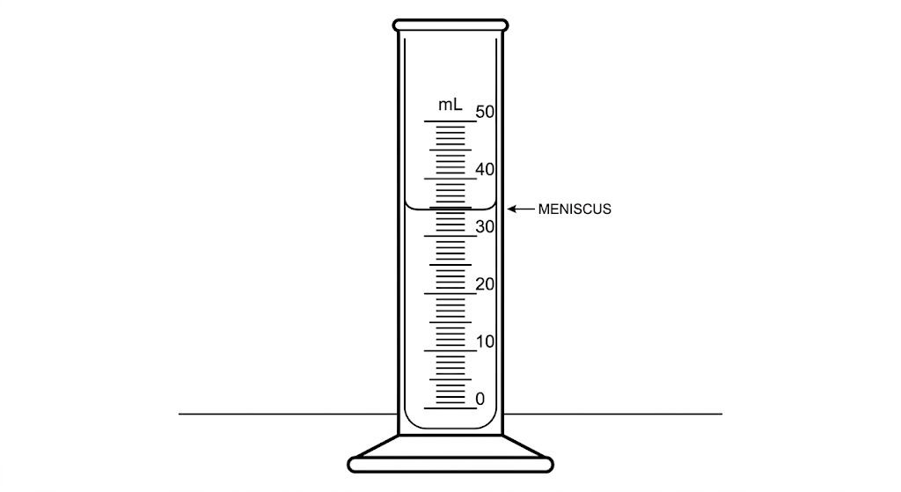
A. Mass of a solid.
B. Volume of a liquid.
C. Temperature of a liquid.
D. Length of a solid.
4. Which process is represented by the apparatus shown below?
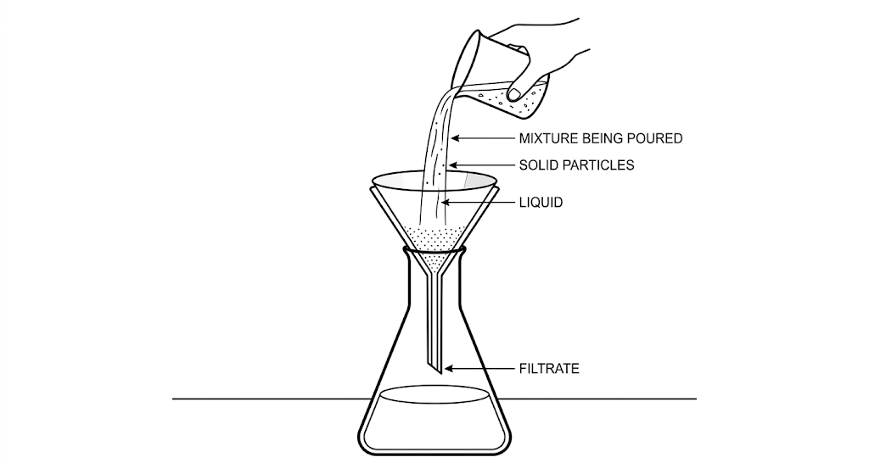
A. Filtration
B. Distillation
C. Evaporation
D. Sublimation
5. A learner mixes sand and water. Which method would separate the two substances most directly?
A. Filtration
B. Chromatography
C. Crystallisation
D. Distillation
6. Which group contains only renewable sources of energy?
A. Coal and petroleum
B. Solar and wind
C. Natural gas and coal
D. Petroleum and uranium
7. Which symbol should be displayed where a substance presents a danger of poisoning or acute toxicity?
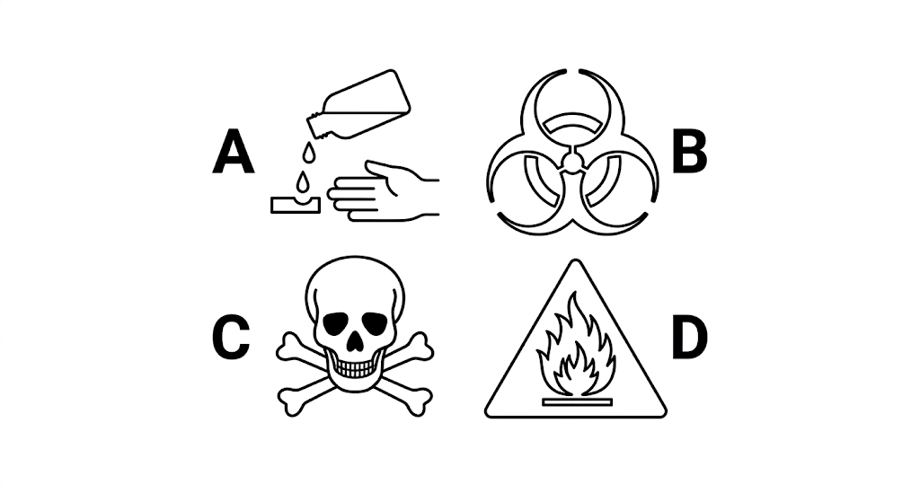
A. Corrosive
B. Biohazard
C. Toxic
D. Flammable
8. A learner tears a sheet of paper into smaller pieces. Which statement is correct?
A. A new substance has formed.
B. The change is physical.
C. The paper has undergone combustion.
D. The paper has changed into ash.
9. A liquid has a fixed volume but takes the shape of its container. Which state of matter is it?
A. Solid
B. Liquid
C. Gas
D. Plasma
10. Which process in plants involves loss of water vapour mainly through leaves?
A. Respiration
B. Transpiration
C. Photosynthesis
D. Germination
11. Which extinguisher is most appropriate for an electrical fire?
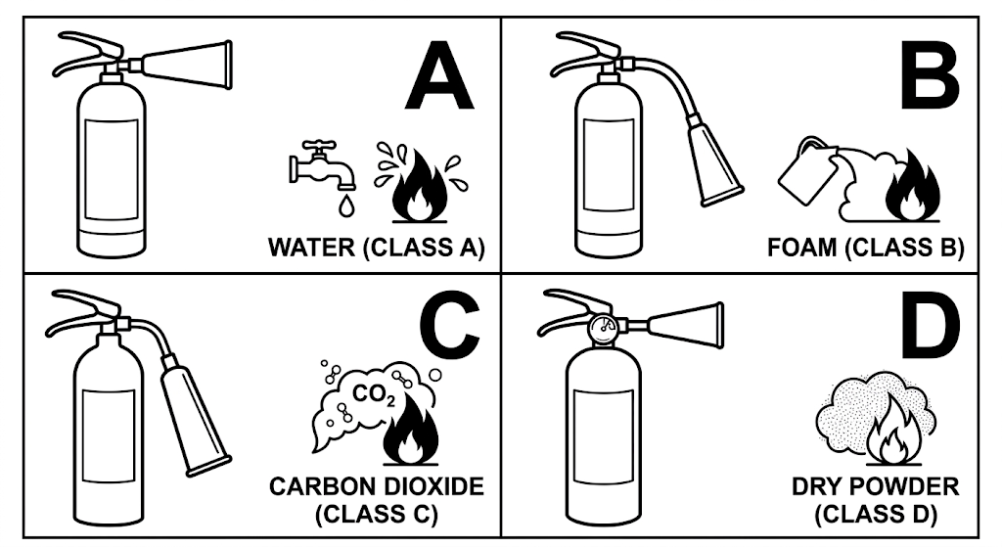
A. Water
B. Carbon dioxide
C. Foam only
D. Wet cloth
12. In the animal cell shown below, Y points to the central control structure and Z points to the surrounding jelly-like material. Which pair is correct?
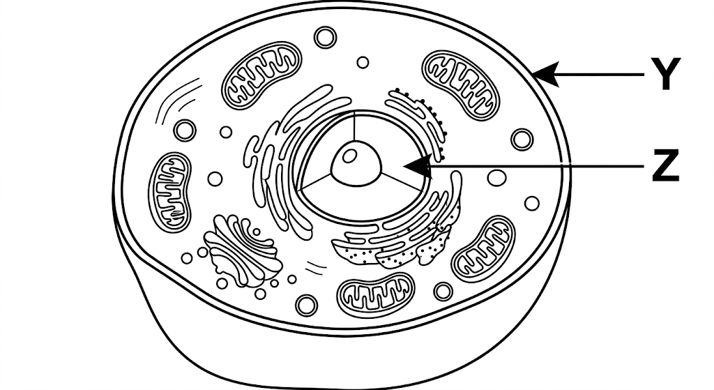
A. Y – nucleus; Z – cytoplasm
B. Y – cell wall; Z – nucleus
C. Y – cytoplasm; Z – cell membrane
D. Y – chloroplast; Z – nucleus
13. Which process demonstrates homeostasis in living organisms?
A. Movement of food through the intestine
B. Regulation of body temperature
C. Germination of a seed
D. Growth of a root
14. Which is a common symptom of a sexually transmitted infection?
A. Unusual discharge from reproductive organs
B. Increased appetite only
C. Improved eyesight
D. Stronger bones
15. Movement of particles from a region of higher concentration to a region of lower concentration is called:
A. Osmosis
B. Diffusion
C. Transpiration
D. Active transport
16. When sodium reacts with chlorine, the product formed is classified as:
A. An element
B. A compound
C. A homogeneous mixture
D. A heterogeneous mixture
17. When a simple electric circuit is switched on, electrical energy is mainly transformed into:
A. Light, heat or other useful forms depending on the appliance
B. Chemical energy only
C. Sound energy only
D. Nuclear energy
18. The process shown below is:
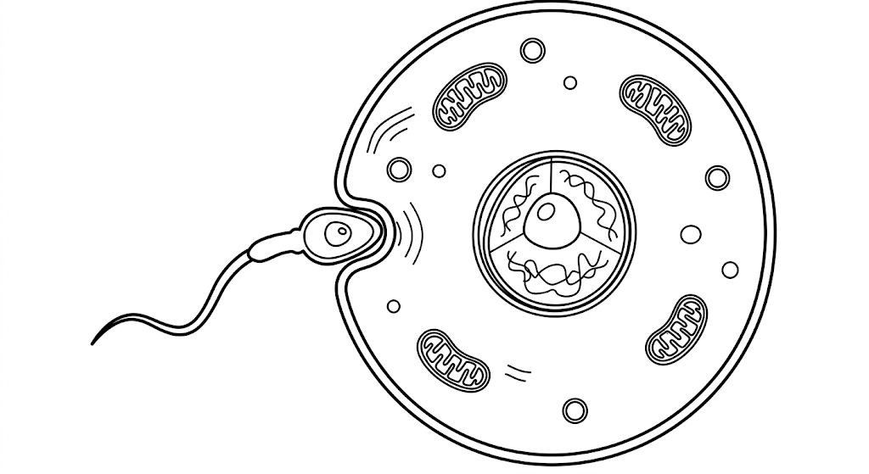
A. Fertilisation
B. Implantation
C. Menstruation
D. Ovulation
19. Which safety practice should be followed when handling electrical appliances?
A. Touch switches with wet hands.
B. Overload electrical sockets.
C. Unplug appliances when not in use.
D. Use damaged cords.
20. A specimen observed under a microscope has a cell wall and chloroplasts. The specimen is most likely from:
A. An animal cell
B. A plant cell
C. A red blood cell
D. A nerve cell

SECTION B: STRUCTURED QUESTIONS (30 MARKS)
21. The diagram below shows changes of state of matter.
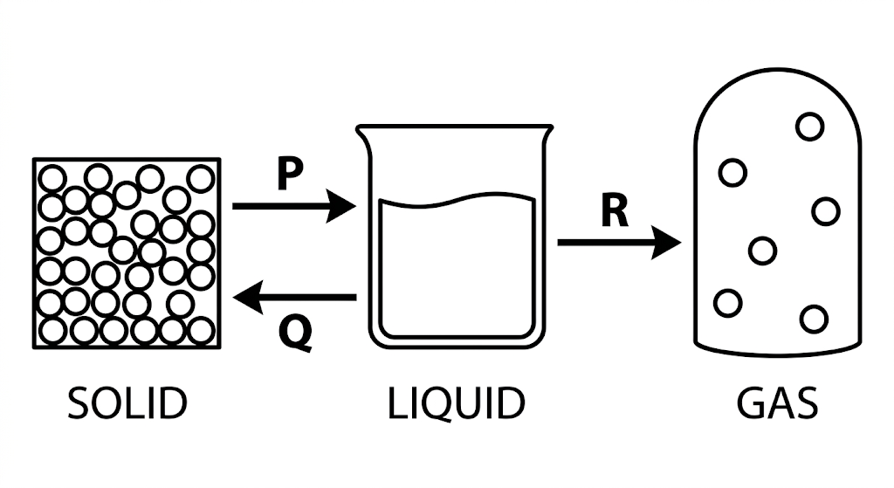
(a) Identify the processes represented by P and R. (2 marks)
___________________________________________________________________________________________________________________________________________________________________________________________________________________________________________________________________________________________________________________________
(b) State whether heat is gained or lost during Q. (1 mark)
__________________________________________________________________________________________________________________________________________________________________________________________________________________
22. (a) State the law describing the behaviour of magnetic poles. (1 mark)
__________________________________________________________________________________________________________________________________________________________________________________________________________________
(b) Give three applications of magnets in everyday life. (3 marks)
____________________________________________________________________________________________________________________________________________________________________________________________________________________________________________________________________________________________________________________________________________________________________________________________________________________________________
23. (a) Name the two elements in water. (2 marks)
___________________________________________________________________________________________________________________________________________________________________________________________________________________________________________________________________________________________________________________________
(b) Write the complete word equation for formation of water. (1 mark)
__________________________________________________________________________________________________________________________________________________________________________________________________________________
24. List two challenges that may be associated with the menstrual cycle. (2 marks)
___________________________________________________________________________________________________________________________________________________________________________________________________________________________________________________________________________________________________________________________
25. Describe how you would demonstrate diffusion using perfume and osmosis using plant tissue. (2 marks)
____________________________________________________________________________________________________________________________________________________________________________________________________________________________________________________________________________________________________________________________________________________________________________________________________________________________________
26. Apart from gonorrhoea, name three other sexually transmitted infections. (3 marks)
____________________________________________________________________________________________________________________________________________________________________________________________________________________________________________________________________________________________________________________________________________________________________________________________________________________________________
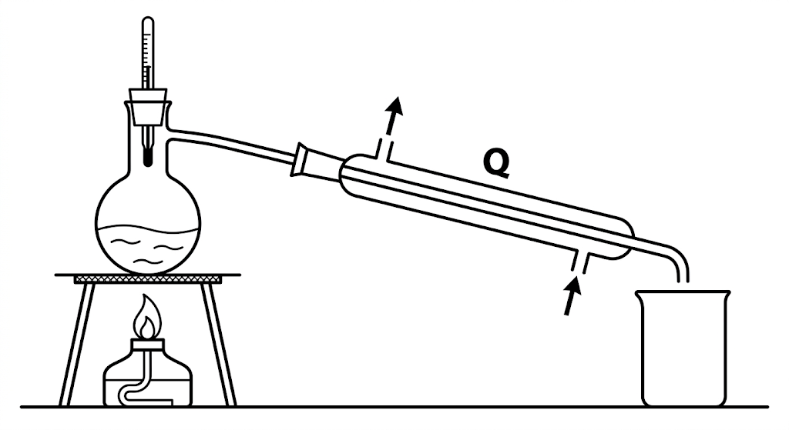
27. (a) Name the method of separation shown above. (1 mark)
__________________________________________________________________________________________________________________________________________________________________________________________________________________
(b) State the function of apparatus Q. (1 mark)
__________________________________________________________________________________________________________________________________________________________________________________________________________________
(c) Identify the water inlet and outlet and explain why water is circulated through the condenser. (2 marks)
____________________________________________________________________________________________________________________________________________________________________________________________________________________________________________________________________________________________________________________________________________________________________________________________________________________________________
28. (a) State one reason for adding a drop of water to a specimen on a microscope slide. (1 mark)
__________________________________________________________________________________________________________________________________________________________________________________________________________________
(b) State one reason for staining the specimen with iodine. (1 mark)
__________________________________________________________________________________________________________________________________________________________________________________________________________________
(c) State one function of the cell membrane and one function of the nucleus. (2 marks)
____________________________________________________________________________________________________________________________________________________________________________________________________________________________________________________________________________________________________________________________________________________________________________________________________________________________________
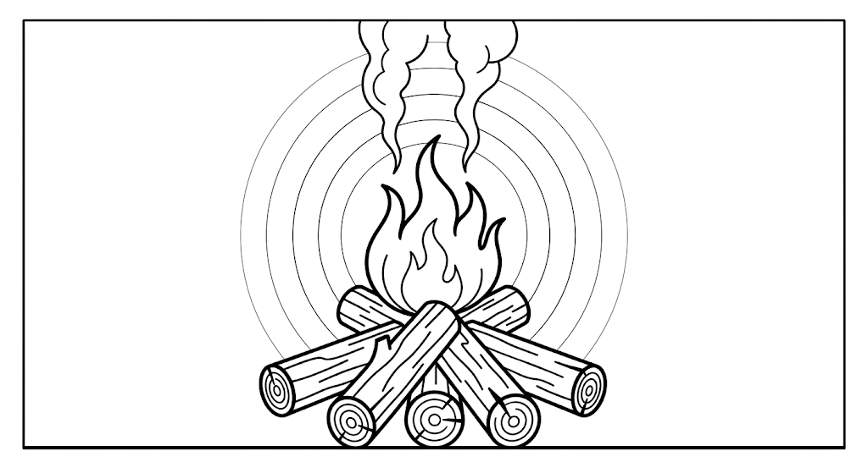
29. (a) Identify the main energy transformation shown above. (1 mark)
__________________________________________________________________________________________________________________________________________________________________________________________________________________
(b) Give two safety measures when dealing with fire or heat. (2 marks)
___________________________________________________________________________________________________________________________________________________________________________________________________________________________________________________________________________________________________________________________
30. Give two examples of applications of pressure in liquids in everyday life. (2 marks)
_________________________________________________________________________________________________________________________________________________________________________________________________________________________________________________________________________________________________________________________
END OF QUESTION PAPER

