KENYA JUNIOR SCHOOL EDUCATION ASSESSMENT
GRADE 8 – 2026
CREATIVE ARTS AND SPORTS
TIME: 1 Hour 40 Minutes
Learner's Name | ________________________ | Assessment Number | ________________
School Name | ________________________ | School Code | ________________
Learner's Signature | ________________________ | Date | ________________

INSTRUCTIONS TO LEARNERS
- Write your name and assessment number in the spaces provided above.
- Write the name and code of your school in the spaces provided above.
- Sign and write the date of the assessment in the spaces provided above.
- This paper consists of two sections: A and B.
- Section A consists of Multiple Choice Questions.
- Section B consists of structured questions.
- Answer ALL questions in Section A on the separate ANSWER SHEET provided.
- Answer all questions in Section B except where an optional choice is expressly given.
- For the optional part, answer EITHER Question 25 OR Question 26.
- Answer all questions in English.
- Do NOT remove any page from this question paper.

FOR OFFICIAL USE ONLY
SECTION | A | B | TOTAL
Maximum Score | 20 | 30 | 50
Learner's Score
Note: Section B contains an optional choice between Question 25 and Question 26.

SECTION A: MULTIPLE CHOICE QUESTIONS (20 MARKS)
Answer ALL questions by choosing the correct answer.

1. Grade 8 learners were asked to create a rhythmic pattern in monotone. Which activity best demonstrates this?
A. Singing a melody using several pitches.
B. Clapping and chanting a rhythm on one repeated pitch.
C. Singing a song that moves between high and low notes.
D. Changing the key during the rhythm.
2. Which element is specifically associated with narrative story structure rather than a poem or verse as an organising feature?
A. Theme
B. Character
C. Plot
D. Rhyme
3.
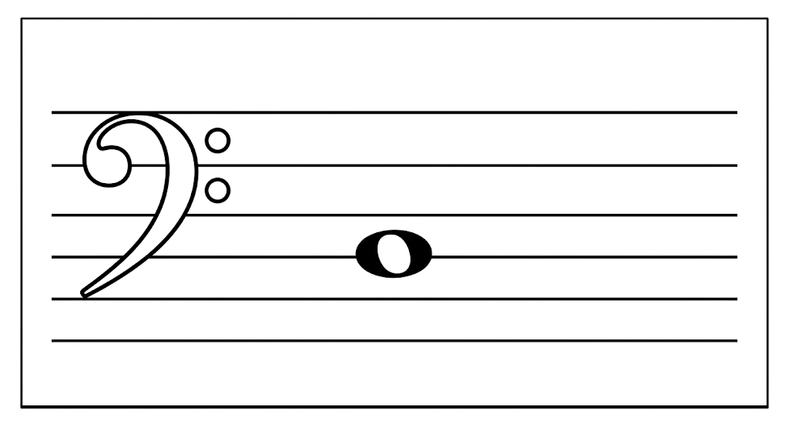
A. G
B. A
C. C
D. F
4. Which note value is most suitable for giving a longer ending sound to an answer phrase in a simple melody?
A. Crotchet
B. Quaver
C. Pair of quavers
D. Minim
5. When playing a descant recorder, Amani partly closes the thumb hole at the back to produce a higher register note. Which technique is being used?
A. Slurring
B. Fingering
C. Pinching
D. Posture
6. Which recorder technique involves partly covering the thumb hole to produce higher notes?
A. Slurring
B. Fingering
C. Pinching
D. Posture
7. Identify the part labelled X.
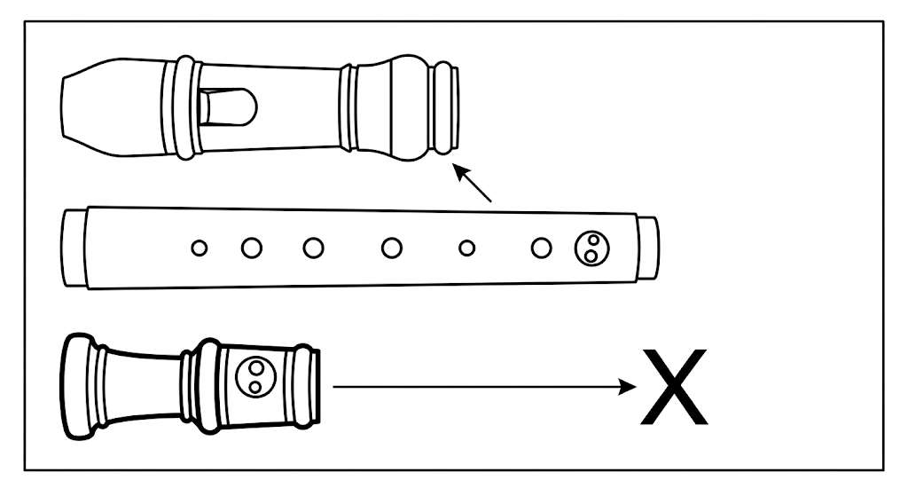
A. Foot joint
B. Head joint
C. Body
D. Mouthpiece
8. Which of the following is classified as a middle-distance athletics race?
A. 100 m
B. 200 m
C. 800 m
D. 50 m
9. Which activity most directly develops reaction time?
A. Responding quickly to a starting signal in a sprint.
B. Holding a static balance for one minute.
C. Walking slowly around a field.
D. Stretching the arms before exercise.
10. Identify the technique shown below:
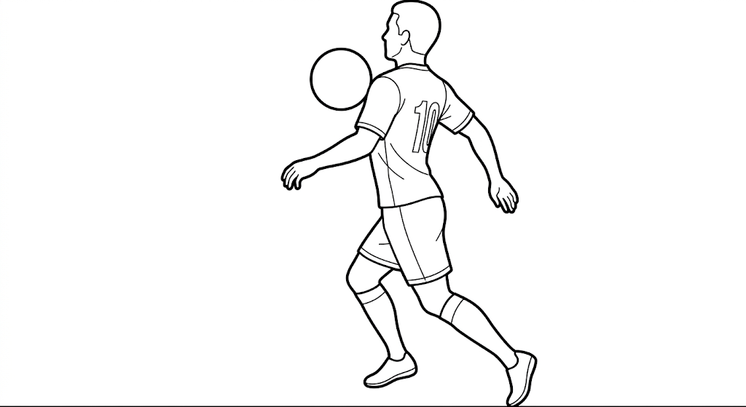
A. Shooting
B. Chest trap
C. Thigh trap
D. High dribble
11. Which type of start is commonly used for middle-distance races?
A. Elongated start
B. Medium start
C. Standing start
D. Crouch start
12. Which one is NOT a phase of the long jump?
A. Approach run
B. Take-off
C. Flight
D. Release
13. Which statement best demonstrates teamwork as a value gained through sporting activities?
A. Completing tasks without consulting teammates.
B. Working together to achieve a common goal.
C. Ignoring teammates' suggestions.
D. Blaming others when the team loses.
14. A learner wants to make a painting colour darker without changing its basic hue. Which colour should be added?
A. White
B. Black
C. Yellow
D. Blue
15. In a composition, the area occupied by the main object is called:
A. Theme
B. Negative space
C. Positive space
D. Background
16. Identify the technique illustrated below:
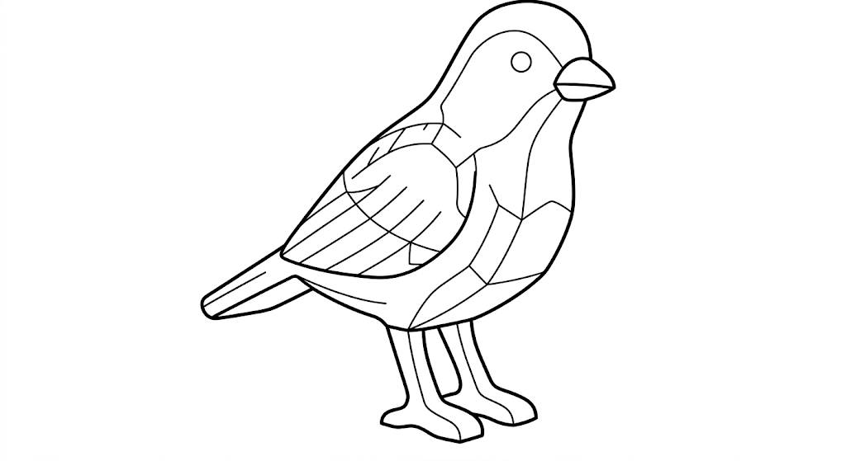
A. Casting
B. Sculpture
C. Improvising
D. Printing
17. Which item is NOT normally required when making a montage pictorial composition from cut-out images?
A. Pieces of coloured paper
B. Canvas paper
C. Cut-out photographs
D. Adhesive
18. Identify the approach shown below:
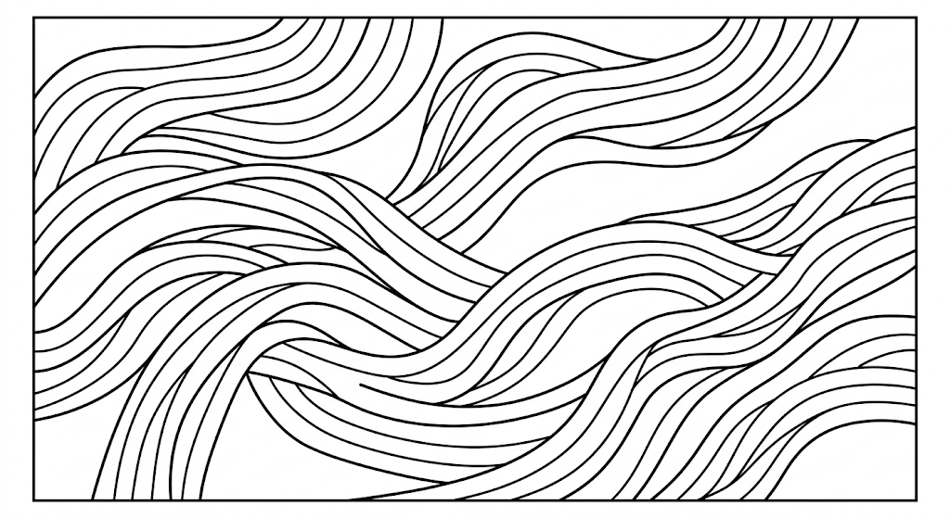
A. Balance
B. Rhythm
C. Proportion
D. Overlapping
19. Which item would NOT normally be required for a crayon etching composition?
A. Toothpick
B. Paint brush
C. Pencil
D. Wax crayons
20. Artworks made by folding and shaping paper from exercise books or newspapers are generally known as:
A. Papercraft
B. Photomontage
C. Collage
D. Flipbook

SECTION B: STRUCTURED QUESTIONS (30 MARKS)

PART I: PERFORMING ARTS
21. You have been asked to compose and write a verse addressing a pertinent issue in society.
(a) Identify the theme you would address in your verse. (1 mark)
__________________________________________________________________________________________________________________________________________________________________________________________________________________
(b) Name two sound patterns you would adhere to in your verse. (2 marks)
___________________________________________________________________________________________________________________________________________________________________________________________________________________________________________________________________________________________________________________________
(c) Write one stanza of verse with five lines on the theme you selected. (5 marks)
________________________________________________________________________________________________________________________________________________________________________________________________________________________________________________________________________________________________________________________________________________________________________________________________________________________________________________________________________________________________________________________________________________________________________________________________________________________________________________________________________________________________________________________________________________________________________________________________________________________________________________________________________
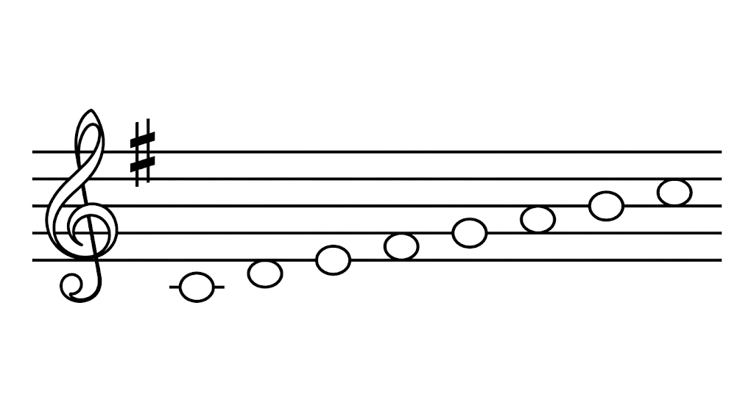
22. The staff above represents the G major key. Fill in and name the notes of the G major scale in ascending order. (4 marks)
____________________________________________________________________________________________________________________________________________________________________________________________________________________________________________________________________________________________________________________________________________________________________________________________________________________________________

PART II: SPORTS
23. You are playing volleyball. List four steps you would apply when executing the volleying skill. (4 marks)
______________________________________________________________________________________________________________________________________________________________________________________________________________________________________________________________________________________________________________________________________________________________________________________________________________________________________________________________________________________________________________________________________________________________________________________________________________________________________________________
24. Name the two kicking skills applied in a game of football. (2 marks)
___________________________________________________________________________________________________________________________________________________________________________________________________________________________________________________________________________________________________________________________
- OPTIONAL SECTION: ANSWER EITHER QUESTION 25 OR QUESTION 26
25. SWIMMING
(a) List four steps executed when engaging in a pencil dive in swimming. (4 marks)
______________________________________________________________________________________________________________________________________________________________________________________________________________________________________________________________________________________________________________________________________________________________________________________________________________________________________________________________________________________________________________________________________________________________________________________________________________________________________________________
(b) Name one safety precaution observed to avoid drowning when diving. (1 mark)
__________________________________________________________________________________________________________________________________________________________________________________________________________________
26. INDIGENOUS GAMES
(a) How are indigenous games learned? (2 marks)
___________________________________________________________________________________________________________________________________________________________________________________________________________________________________________________________________________________________________________________________
(b) Name two rope-skipping strategies performed in indigenous rope games. (2 marks)
___________________________________________________________________________________________________________________________________________________________________________________________________________________________________________________________________________________________________________________________
(c) Name one role played by rope games in promoting the health of an individual. (1 mark)
__________________________________________________________________________________________________________________________________________________________________________________________________________________

PART III: VISUAL ARTS
27. Name four items that may be used when drawing a still-life composition. (2 marks)
____________________________________________________________________________________________________________________________________________________________________________________________________________________________________________________________________________________________________________________________________________________________________________________________________________________________________
28. On the space below, draw a simple landscape outline suitable for a painting. (4 marks)
________________________________________________________________________________________________
________________________________________________________________________________________________
________________________________________________________________________________________________
________________________________________________________________________________________________
________________________________________________________________________________________________
________________________________________________________________________________________________
________________________________________________________________________________________________
________________________________________________________________________________________________
________________________________________________________________________________________________
________________________________________________________________________________________________
29. Your classmate has displayed a drawing for appreciation and peer feedback. Write one constructive comment you would give. (1 mark)
___________________________________________________________________________________________________________________________________________________________________________________________________________________________________________________________________________________________________________________________
END OF QUESTION PAPER

