MWALIMUFOCUS ASSESSMENT
GRADE 8 AGRICULTURE • TERM 3, 2026
Candidate's Name: ________________________________________________
Assessment Number: _______________________ Signature/Date: _______________________

INSTRUCTIONS TO CANDIDATES
- This paper consists of TWO sections: A and B.
- Answer ALL questions.
- For Section A, write the letter of the correct answer in the space provided.
- For Section B, show all working for calculations and answer diagram-based questions as instructed.
- The marks for each question or sub-question are shown in brackets.

SECTION A: MULTIPLE CHOICE QUESTIONS
(30 MARKS)

1. Which practice is most likely to prevent pollution of soil on a farm?
A. Burning plastic containers in the field
B. Disposing of farm waste responsibly
C. Pouring used chemicals onto the soil
D. Leaving chemical containers near a water source
Answer: ______
2. Which structure is constructed across a slope along contour lines to slow down surface run-off?
A. Contour bund
B. Poultry house
C. Granary
D. Feeding trough
Answer: ______
3. Which of the following is a suitable way of harvesting water for agricultural use?
A. Roof catchment
B. Burning vegetation
C. Overgrazing a pasture
D. Leaving bare soil exposed
Answer: ______
4. Which practice best helps to conserve nutrients when preparing vegetables for a meal?
A. Cooking them for a very long time
B. Using an appropriate cooking method and limited water
C. Throwing away all cooking water
D. Soaking them for several hours before cooking
Answer: ______
5. Which planting material is most suitable for establishing a healthy crop?
A. A diseased cutting
B. A healthy mature seed
C. A rotten tuber
D. A damaged root
Answer: ______
6. Why are seedlings thinned after germination?
A. To reduce competition for resources
B. To increase overcrowding
C. To encourage weed growth
D. To destroy strong seedlings
Answer: ______
7. What is the practice of replacing seedlings that failed to establish in the field called?
A. Gapping
B. Pruning
C. Staking
D. Hardening
Answer: ______
8. Which crop benefits particularly from earthing-up?
A. Potato
B. Cabbage
C. Spinach
D. Onion
Answer: ______
9. Which is a physical method of controlling weeds?
A. Hand pulling
B. Spraying a herbicide
C. Applying a fungicide
D. Applying an insecticide
Answer: ______
10. Which is the most appropriate way of handling a healthy farm animal?
A. Handling it calmly and carefully
B. Shouting at it continuously
C. Twisting its limbs
D. Striking it to make it move
Answer: ______
11. Which factor should be considered when selecting a suitable pet?
A. Its suitability to the owner's environment
B. The owner's favourite colour
C. The price of the owner's clothes
D. The height of the owner only
Answer: ______
12. Eggs are commonly graded using characteristics such as:
A. size and quality
B. colour of the storage basket
C. shape of the poultry house
D. age of the farmer
Answer: ______
13. Which practice would help preserve honey safely?
A. Storing it in a clean, dry, covered container
B. Leaving it exposed to dust
C. Mixing it with soil
D. Keeping it in a dirty container
Answer: ______
14. Which method can be used to preserve meat?
A. Drying
B. Watering
C. Germinating
D. Weeding
Answer: ______
15. The length of time a food product remains suitable for use is called its:
A. shelf life
B. field capacity
C. germination period
D. soil tilth
Answer: ______
16. Square foot gardening involves:
A. dividing a garden into small measured sections
B. planting crops without any spacing
C. flooding the entire garden
D. growing only one crop throughout the garden
Answer: ______
17. One important advantage of square foot gardening is:
A. efficient use of limited space
B. increased soil erosion
C. elimination of all management practices
D. deliberate wastage of water
Answer: ______
18. Which organism is a common pest of vegetable crops?
A. Aphid
B. Honey bee
C. Earthworm
D. Earthworm cast
Answer: ______
19. Which observation may indicate that a vegetable crop is diseased?
A. Unusual spots or wilting
B. Uniform healthy green leaves
C. Normal growth
D. Strong roots with no abnormality
Answer: ______
20. What is an appropriate first response when a plant is severely diseased and may spread infection?
A. Remove and dispose of it safely
B. Move it next to healthy plants
C. Water it excessively
D. Use it as mulch around healthy plants
Answer: ______
21. Repairing a leaking water pipe mainly conserves:
A. water
B. seed
C. manure
D. soil
Answer: ______
22. The main purpose of an innovative animal waterer should be to:
A. provide drinking water while reducing wastage
B. make water difficult for animals to access
C. increase contamination
D. release water continuously onto the ground
Answer: ______
23. How can ICT directly support a farmer?
A. By providing useful agricultural information
B. By preventing all farm activities
C. By replacing all crops
D. By stopping communication
Answer: ______
24. Value addition refers to:
A. processing produce to increase its usefulness or value
B. reducing the quality of produce
C. discarding harvested produce
D. mixing food produce with waste
Answer: ______
25. Which practice can reduce post-harvest losses in vegetables?
A. Sorting and storing produce properly
B. Leaving vegetables in strong sun for long periods
C. Handling vegetables roughly
D. Storing damaged produce together with healthy produce
Answer: ______
26. Which is a major benefit of compost manure?
A. It improves soil fertility
B. It increases plastic waste
C. It destroys all useful soil organisms
D. It prevents crop growth
Answer: ______
27. Which condition is important in a compost heap?
A. Adequate moisture and air
B. Complete dryness
C. Only plastic materials
D. Absence of organic material
Answer: ______
28. Which is a benefit of trees on a farm?
A. Protection of soil
B. Increased erosion
C. Reduced biodiversity
D. Reduced infiltration of water
Answer: ______
29. A farmer's yield calculation relates the produce harvested to:
A. the relevant production area or input
B. the colour of farm tools
C. the number of workers only
D. the number of farm buildings
Answer: ______
30. The main aim of sustainable agriculture is to:
A. meet present needs while conserving resources for the future
B. use up resources as quickly as possible
C. avoid all forms of technology
D. maximize farm waste
Answer: ______

SECTION B: STRUCTURED QUESTIONS
(70 MARKS)
Answer ALL questions.
31.
a) State three causes of soil pollution on farms. (3 marks)
________________________________________________________________________________
________________________________________________________________________________
________________________________________________________________________________
b) Give two ways of controlling soil pollution. (2 marks)
________________________________________________________________________________
________________________________________________________________________________
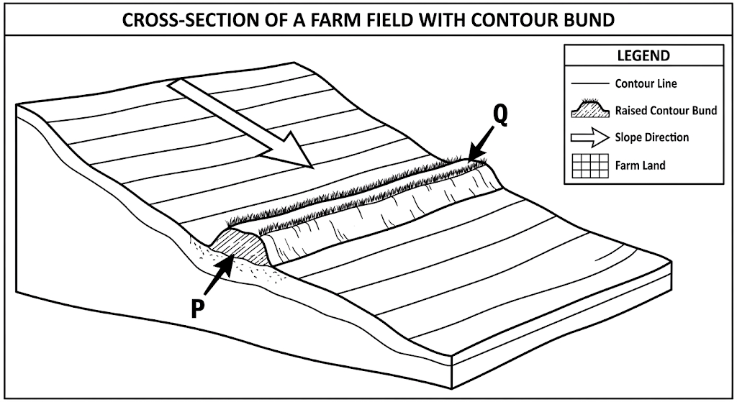
c) Study the diagram above. Name the soil-conservation structure shown. (1 mark)
________________________________________________________________________________
d) State two ways the structure in (c) helps conserve soil. (2 marks)
________________________________________________________________________________
________________________________________________________________________________
32.
a) State three factors considered when selecting a planting site. (3 marks)
________________________________________________________________________________
________________________________________________________________________________
________________________________________________________________________________
b) Distinguish between thinning and gapping. (2 marks)
________________________________________________________________________________
________________________________________________________________________________
c) State one reason for weeding crops. (1 mark)
________________________________________________________________________________
33.
a) State three principles of humane animal handling. (3 marks)
________________________________________________________________________________
________________________________________________________________________________
________________________________________________________________________________
b) Give three factors considered when selecting a pet. (3 marks)
________________________________________________________________________________
________________________________________________________________________________
________________________________________________________________________________
34.
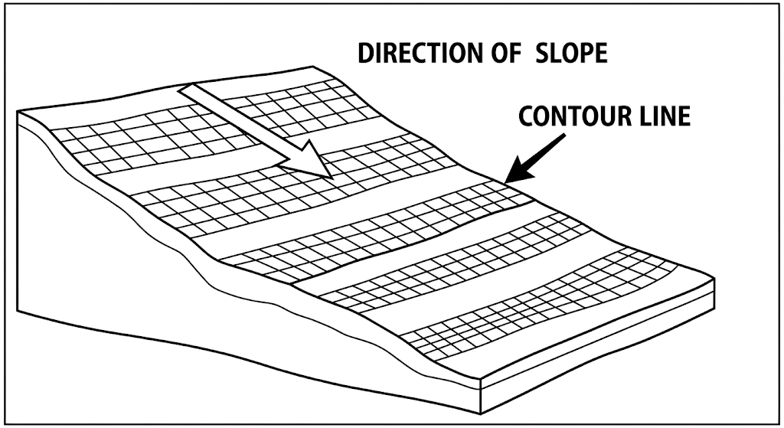
a) Study the diagram above. Identify two features that show how the structure follows the contour. (2 marks)
________________________________________________________________________________
________________________________________________________________________________
b) State three methods of harvesting water for agricultural use. (3 marks)
________________________________________________________________________________
________________________________________________________________________________
________________________________________________________________________________
c) A water tank contains 2,400 litres of harvested water. If 600 litres are used, calculate the percentage of water remaining. (3 marks)
________________________________________________________________________________
________________________________________________________________________________
________________________________________________________________________________
35.
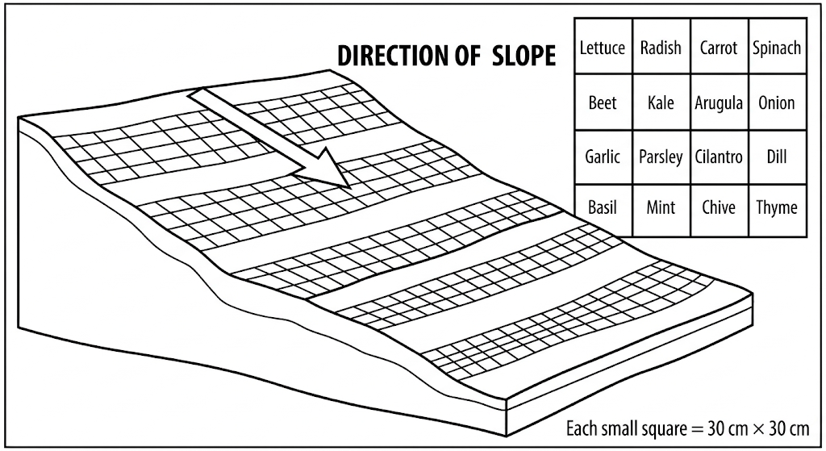
a) Study the diagram above. State the dimensions of one small square shown in the diagram. (2 marks)
________________________________________________________________________________
________________________________________________________________________________
b) Give three advantages of square foot gardening. (3 marks)
________________________________________________________________________________
________________________________________________________________________________
________________________________________________________________________________
c) If a square foot garden has 20 equal squares and a learner plants 3 crop positions in each square, calculate the total number of crop positions. (2 marks)
________________________________________________________________________________
________________________________________________________________________________
36.
a) Name three common pests that attack vegetable crops. (3 marks)
________________________________________________________________________________
________________________________________________________________________________
________________________________________________________________________________
b) State one sign that a vegetable crop may be diseased. (1 mark)
________________________________________________________________________________
c) Give two methods of controlling vegetable crop pests without relying on synthetic pesticides. (2 marks)
________________________________________________________________________________
________________________________________________________________________________
37.
a) Define the term post-harvest practice. (1 mark)
________________________________________________________________________________
b) State three post-harvest practices that reduce losses in vegetables. (3 marks)
________________________________________________________________________________
________________________________________________________________________________
________________________________________________________________________________
c) Give two methods of preserving meat. (2 marks)
________________________________________________________________________________
________________________________________________________________________________
d) State two reasons for preparing animal products such as meat, eggs or honey for storage/use. (2 marks)
________________________________________________________________________________
________________________________________________________________________________
38.
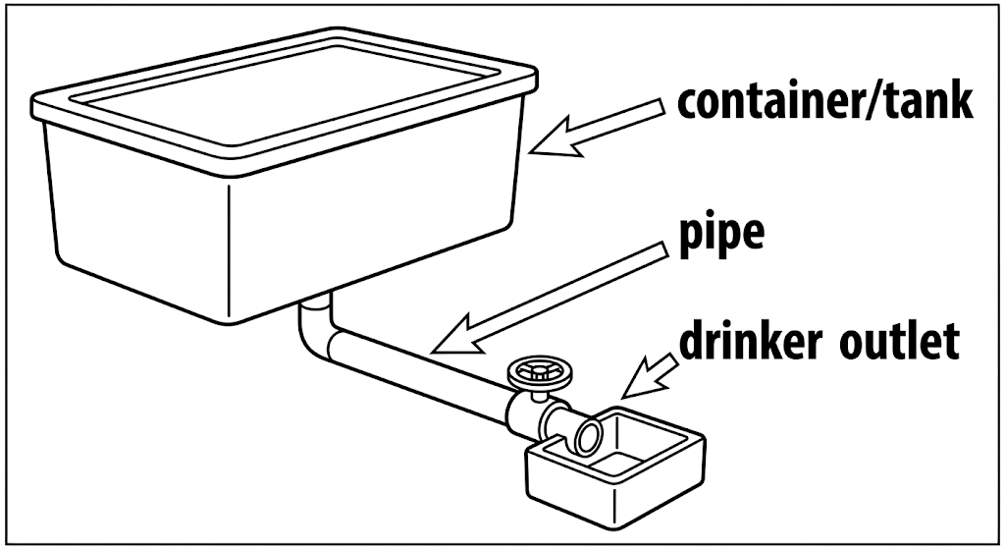
a) Study the diagram above. Identify the main purpose of the innovative waterer. (2 marks)
________________________________________________________________________________
________________________________________________________________________________
b) State three features that would make the waterer conserve water. (3 marks)
________________________________________________________________________________
________________________________________________________________________________
________________________________________________________________________________
c) Give two ways ICT can support agricultural activities. (2 marks)
________________________________________________________________________________
________________________________________________________________________________
39.
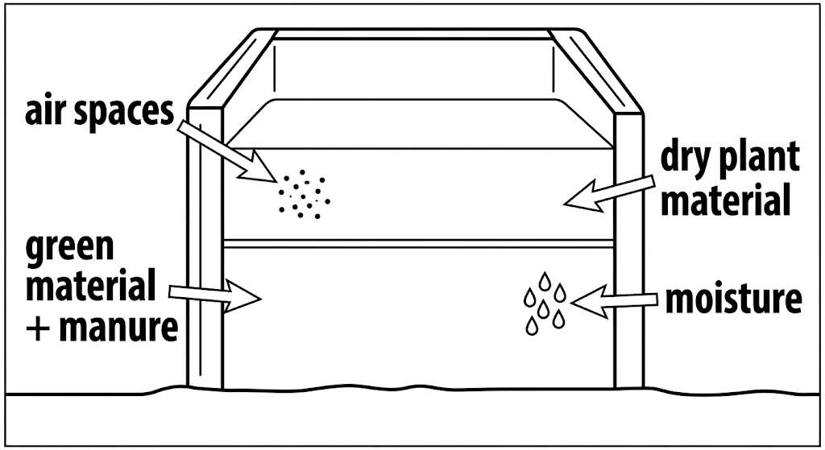
a) Study the diagram above. Name the agricultural process represented. (1 mark)
________________________________________________________________________________
b) State three materials that can be placed in a compost heap. (3 marks)
________________________________________________________________________________
________________________________________________________________________________
________________________________________________________________________________
c) Give two conditions necessary for effective composting. (2 marks)
________________________________________________________________________________
________________________________________________________________________________
40.
a) A learner has KSh 2,000. She spends KSh 750 on seed, KSh 400 on manure and KSh 300 on pest-control materials. Calculate the amount remaining. (2 marks)
________________________________________________________________________________
________________________________________________________________________________
b) State three sustainable practices the learner should use in the garden. (3 marks)
________________________________________________________________________________
________________________________________________________________________________
________________________________________________________________________________
c) Explain one way value addition can increase income from farm produce. (2 marks)
________________________________________________________________________________
________________________________________________________________________________
d) Give one reason why accurate farm records are important. (1 mark)
________________________________________________________________________________

