KENYA JUNIOR SCHOOL EDUCATION ASSESSMENT
GRADE 7 - 2026
SOCIAL STUDIES
TIME: 1 HOUR 30 MINUTES
Learner's Name | ____________________________ | Assessment Number | ____________________________
School Name | ____________________________ | School Code | ____________________________
Learner's Signature | ____________________________ | Date | ____________________________
INSTRUCTIONS TO LEARNERS
1. Write your name and assessment number correctly.
2. Write the name and code of your school in the spaces provided above.
3. Write the date of the assessment.
4. This paper consists of two sections: A and B.
5. Section A comprises Multiple Choice Questions.
6. Section B comprises structured questions.
7. Answer ALL the questions in Section A on the separate ANSWER SHEET provided.
8. Answer ALL the questions in Section B in the spaces provided in this question paper.
9. Do NOT remove any page from this question paper.
10. Answer the questions in English.
FOR OFFICIAL USE ONLY — SECTION B
Question | 21 | 22 | 23 | 24 | 25 | 26 | 27 | TOTAL
Maximum Score | 5 | 4 | 4 | 4 | 4 | 5 | 4 | 30
Candidate's Score

SECTION A: MULTIPLE CHOICE QUESTIONS
Answer ALL questions in this section on the separate ANSWER SHEET provided.

1. Grade 7 learners were discussing qualities of a person with a steady personality. Which one is NOT a quality of a steady personality?
A. Consistency
B. Reliability
C. Calmness
D. Impulsiveness
2. Which water body lies to the north-east of Africa?
A. Atlantic Ocean
B. Mediterranean Sea
C. Indian Ocean
D. Pacific Ocean
3. Which professional provides a link between agricultural research institutions and farmers by sharing improved farming knowledge?
A. Extension officer
B. Horticulturist
C. Agricultural engineer
D. Surveyor
4. Which action is NOT likely to promote peaceful coexistence in a society?
A. Respecting human rights
B. Respecting other people's property
C. Spreading false information about other people
D. Cooperating with members of the community
5. A group of traders from Asia travelled to the East African coast mainly for trade. Which goods were commonly exchanged by such visitors?
A. Spices and cloth
B. Motor vehicles and computers
C. Petroleum and cement
D. Steel and tractors
6. Traditional and religious stories may explain human origins in different ways. Which statement represents an evolutionary explanation?
A. Human beings were created instantly by a supernatural being.
B. Human beings have changed gradually over a long period of time.
C. Human beings appeared at the same time as all modern machines.
D. Human beings were created only after written history began.
7. A learner is trying to control anger. Which action is NOT an appropriate way of managing anger?
A. Taking slow, deep breaths
B. Talking calmly to a trusted person
C. Engaging in physical violence against another person
D. Taking time away from a situation to calm down
8. A Grade 7 group started a small school enterprise. Which is a possible benefit of the project?
A. It can provide income for the learners.
B. It prevents learners from learning new skills.
C. It makes the community dependent on the school.
D. It stops learners from working together.
9. Which action does NOT contribute to development of a steady and responsible personality?
A. Setting clear goals
B. Practising empathy
C. Maintaining integrity
D. Frequently changing decisions without considering consequences
10. Which statement best describes servitude?
A. A condition in which a person is forced to work or serve another person without freedom.
B. A voluntary agreement between equal business partners.
C. A system in which everyone receives equal wages.
D. A community celebration held after a harvest.
11. A teacher described trade as involving an exchange of goods and services without using money. Which type of trade was being described?
A. Currency trade
B. Barter trade
C. Wholesale trade
D. Retail trade
12. Which of the following is NOT an aspect of human diversity?
A. Age
B. Gender
C. Race
D. Weather
13. Which item was NOT commonly obtained from the East African coast through the Indian Ocean trade?
A. Ivory
B. Gold
C. Salt
D. Television sets
14. Learners were discussing skills needed for healthy interaction in a multicultural society. Which action demonstrates conflict-resolution skills?
A. Ignoring every disagreement
B. Listening to different views and seeking a peaceful solution
C. Insulting people who disagree with you
D. Refusing to communicate with others
15. Which personality attribute is generally desirable?
A. Optimism
B. Defeatism
C. Dishonesty
D. Aggressiveness
16. Which river was important to the development of ancient Egyptian civilization?
A. River Niger
B. River Nile
C. River Congo
D. River Volta
17. Which of the following is NOT a right of a child?
A. Access to education
B. Access to basic needs
C. Medical attention
D. The right to deny other children their rights
18. Which pair correctly gives a latitude and longitude location?
A. 37°N and 35°E
B. 25°S and 58°E
C. 35°N and 37°E
D. 15°W and 51°S
19. Which country is the largest in Africa by area?
A. Democratic Republic of the Congo
B. Algeria
C. Sudan
D. Morocco
20. Which statement best describes community service learning?
A. A learning experience that combines classroom learning with service to the community.
B. A school activity carried out without any connection to community needs.
C. A method of avoiding practical work.
D. A private activity that benefits only one learner.

SECTION B: STRUCTURED QUESTIONS
Answer ALL questions in the spaces provided.
21. Study the map of Kichu area below and use it to answer the questions that follow.
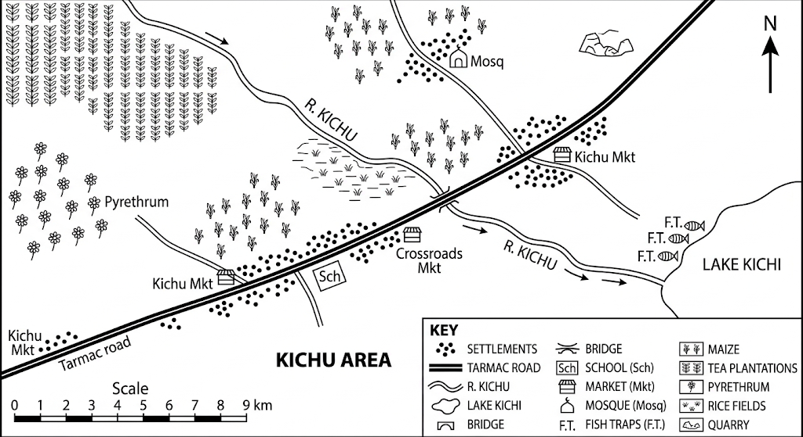
a) Using the map, state the general direction in which River Kichu flows. (1 mark)
________________________________________________________________________________
b) Name one economic activity practised in the southern part of Kichu area. (1 mark)
________________________________________________________________________________
c) Which religion is represented by the place of worship shown on the map? (1 mark)
________________________________________________________________________________
d) Which type of settlement pattern is suggested by the settlement symbols on the map? (1 mark)
________________________________________________________________________________
e) What type of climate would most likely be associated with the north-western part of the area shown? (1 mark)
________________________________________________________________________________
22. Grade 7 learners planned to carry out a community service learning project. List four problems they are likely to encounter during the project. (4 marks)
________________________________________________________________________________
________________________________________________________________________________
________________________________________________________________________________
________________________________________________________________________________
________________________________________________________________________________
23. Joy and her classmates researched contributions of early civilizations to the modern world. Highlight four contributions they researched. (4 marks)
________________________________________________________________________________
________________________________________________________________________________
________________________________________________________________________________
________________________________________________________________________________
________________________________________________________________________________
24. A group of learners discussed factors that led to the introduction of money as a medium of exchange in Africa. Outline four factors they discussed. (4 marks)
________________________________________________________________________________
________________________________________________________________________________
________________________________________________________________________________
________________________________________________________________________________
________________________________________________________________________________
25. Grade 7 learners were divided into groups and asked to discuss various forms of slavery and servitude in traditional African and contemporary society. List four points they noted. (4 marks)
________________________________________________________________________________
________________________________________________________________________________
________________________________________________________________________________
________________________________________________________________________________
________________________________________________________________________________
26. Grade 7 learners were studying map reading. Their Social Studies teacher asked them to answer the following questions.
(a) Define the term map. (2 marks)
________________________________________________________________________________
________________________________________________________________________________
________________________________________________________________________________
(b) Identify three types of maps used in Social Studies. (3 marks)
________________________________________________________________________________
________________________________________________________________________________
________________________________________________________________________________
27. A group of learners explored sources of historical information. Identify four primary sources of information. (4 marks)
________________________________________________________________________________
________________________________________________________________________________
________________________________________________________________________________
________________________________________________________________________________
________________________________________________________________________________

