KENYA JUNIOR SCHOOL EDUCATION ASSESSMENT
JUNIOR SCHOOL ASSESSMENT
GRADE 7 - 2026
PRE-TECHNICAL STUDIES
TIME: 1 hour 40 minutes
Learner's Name | ____________________________________________
School | ____________________________________________
Assessment Number | ________________________
School Code / Date | ________________________ / __________________
PRE-TECHNICAL STUDIES THEORY — INSTRUCTIONS TO LEARNERS
1. Write your name and assessment number in the spaces provided above.
2. Write the name and code of your school in the spaces provided above.
3. Sign and write the date of the assessment in the spaces provided above.
4. This paper consists of two sections: A and B.
5. Section A comprises Multiple Choice Questions.
6. Section B comprises Structured Questions.
7. Answer ALL the questions in Section A on the separate ANSWER SHEET provided.
8. Answer ALL the questions in Section B in the spaces provided in this question paper.
9. Do NOT remove any page from this question paper.
10. Answer all questions in English.
HOW TO USE THE ANSWER SHEET
• Use an ordinary HB pencil.
• Confirm that the answer sheet contains your Assessment Number, Name, School Name and Subject.
• Choose only ONE correct option (A, B, C or D) for each question.
• Mark your choice by drawing a DARK LINE inside the corresponding box.
• Do not write more than one letter for any question.
FOR OFFICIAL USE ONLY — SECTION B (30 MARKS)
Question | 21 | 22 | 23 | 24 | 25 | 26 | 27 | TOTAL
Maximum Score | 6 | 3 | 6 | 3 | 3 | 5 | 4 | 30
Learner's Score per Question

SECTION A: MULTIPLE CHOICE QUESTIONS
Answer ALL questions on the separate ANSWER SHEET provided.

1. During a school project, learners design a simple phone stand, make a digital record of the process, and sell finished stands. Which combination of pre-technical areas is most directly demonstrated?
A. Technical Studies, Computer Studies and Business Studies
B. Business Studies, Agriculture and Music
C. Computer Studies, Geography and Art
D. Technical Studies, History and Biology
2. Which career is least directly associated with pre-technical studies?
A. Mason
B. Software developer
C. Surveyor
D. Pharmacist
3. Which situation is a physical hazard in a workshop?
A. A clearly labelled toolbox
B. A wet floor near the workbench
C. A learner wearing goggles
D. A tool stored safely
4. Which statement best describes artistic drawing?
A. It must always follow exact dimensions.
B. It is mainly used to communicate construction measurements.
C. It allows ideas and creativity to be expressed through freehand work.
D. It uses only standard engineering symbols.
5. Which line is normally used to represent hidden edges in a technical drawing?
A. Continuous thick line
B. Dashed line
C. Dimension line
D. Extension line
6. A learner is injured when a hammer slips from another learner's hand. Which action would most directly reduce the likelihood of such an accident?
A. Working without supervision
B. Checking that tools are suitable and in good condition
C. Placing tools on the floor
D. Increasing the number of learners around the workbench
7. In technical drawing, the abbreviation O.D. commonly refers to:
A. Object Direction
B. Outside Diameter
C. Original Drawing
D. Overall Dimension
8. A learner sketches a group of straight lines slanting upward from left to right. What type of lines are these?
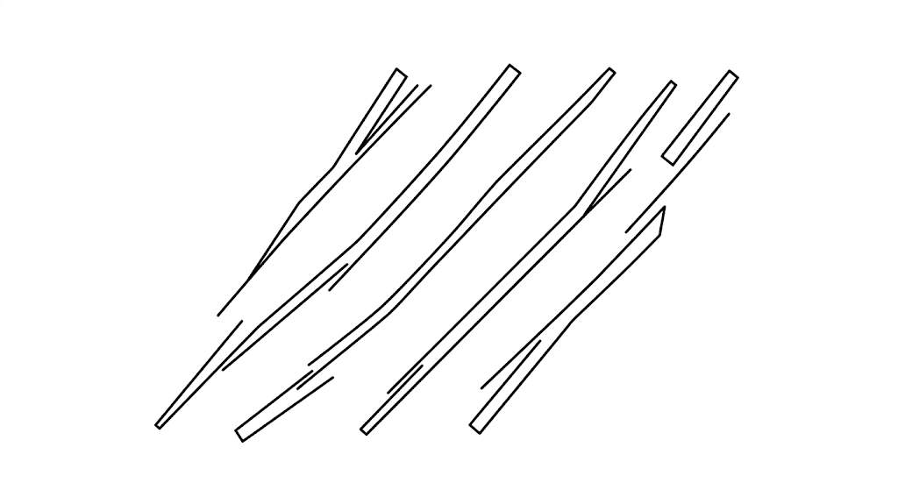
A. Horizontal lines
B. Vertical lines
C. Oblique lines
D. Curved lines
9. Which of the following is NOT a recognized style of lettering used in technical drawing?
A. Uppercase vertical lettering
B. Uppercase inclined lettering
C. Lowercase vertical lettering
D. Lowercase curved lettering
10. Which object is NOT commonly made from rubber?
A. Eraser
B. Bicycle tyre
C. Rubber ball
D. PVC pipe
11. The tool shown below is used for transferring or comparing measurements. What is its name?
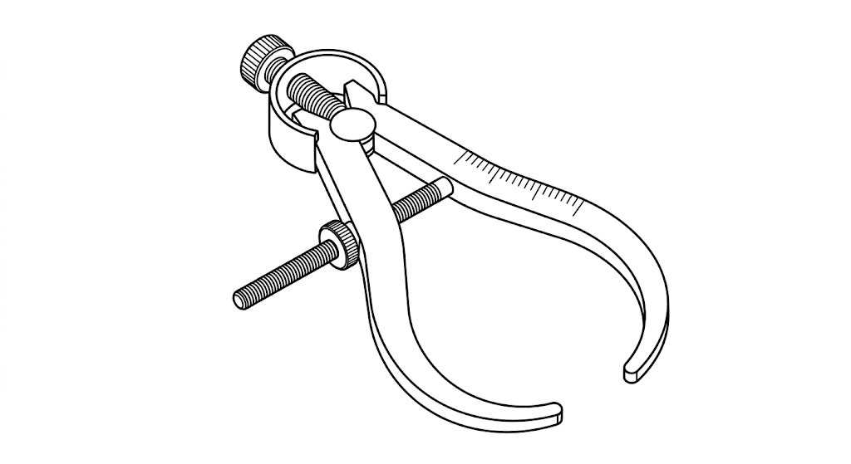
A. Divider
B. Outside caliper
C. Inside caliper
D. Micrometer screw gauge
12. Which of the following is NOT a physical threat to a digital device?
A. Dust entering the system
B. Liquid spillage
C. Electrical surge
D. Identity theft
13. Which devices are used to present processed information to a computer user?
A. Output devices
B. Input devices
C. Processing devices
D. Storage devices
14. Which is a classification of computers according to functionality?
A. Mainframe
B. Thermometer
C. Keyboard
D. Printer
15. Which statement is NOT an advantage of ICT tools in communication?
A. They make communication faster.
B. They allow communication over long distances.
C. They can make sharing information easier.
D. They always increase the cost of communication.
16. The symbol shown below represents which communication tool?

A. Voice call
B. Video call
C. Text message
D. Email
17. Which one of the following is NOT a computer output device?
A. Monitor
B. Speaker
C. Projector
D. Microphone
18. A learner is editing a document and presses Ctrl + A. What does the shortcut do?
A. Saves the document
B. Selects all the text
C. Copies selected text
D. Prints the document
19. A computer can perform repeated operations without becoming tired. Which characteristic does this demonstrate?
A. Consistency
B. Portability
C. Creativity
D. Emotions
20. Which term describes the physical, tangible parts of a computer system?
A. Software
B. Hardware
C. Firmware
D. Application

SECTION B: STRUCTURED QUESTIONS
Answer ALL questions in this section.
21. Symbols are used in technical drawing to communicate important information.
a) State three symbols used in technical/drawing work. (3 marks)
________________________________________________________________________________
________________________________________________________________________________
________________________________________________________________________________
b) Draw each type of symbol named above. (3 marks)
________________________________________________________________________________
________________________________________________________________________________
________________________________________________________________________________
________________________________________________________________________________
________________________________________________________________________________
22. State three differences between artistic drawing and technical drawing. (3 marks)
Artistic drawing | Technical drawing
23. Observing safety in a work or school environment reduces chances of accidents.
a) List three safety threats in a work or school environment. (3 marks)
________________________________________________________________________________
________________________________________________________________________________
________________________________________________________________________________
________________________________________________________________________________
b) Suggest one way of preventing each safety threat mentioned in (a). (3 marks)
________________________________________________________________________________
________________________________________________________________________________
________________________________________________________________________________
________________________________________________________________________________
________________________________________________________________________________
24. Materials are physical substances used for making different items. State one use of each of the following materials. (3 marks)
a) Cement:
________________________________________________________________________________
b) Glass:
________________________________________________________________________________
c) Wood:
________________________________________________________________________________
25. Fill the blanks with the correct computer concept being described. (3 marks)
a) Raw facts such as numbers, text, images or symbols that have not been processed: __________________________
________________________________________________________________________________
b) Processed data that is meaningful and useful to the user: __________________________
________________________________________________________________________________
c) An electronic device that accepts data, processes it, stores it and produces information: __________________________
________________________________________________________________________________
26. A group of Grade 7 learners were investigating the ability of a metal to transfer heat. They performed the experiment below.
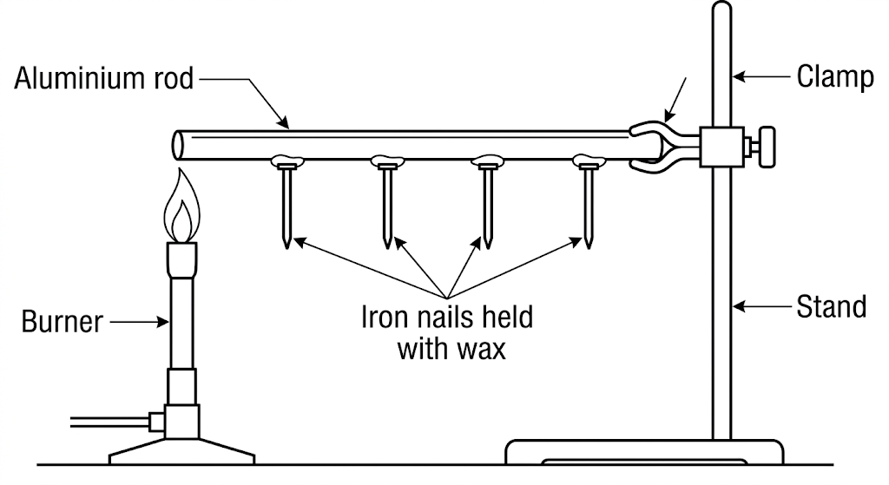
a) Which physical property of metals is being investigated? (1 mark)
________________________________________________________________________________
________________________________________________________________________________
b) Name four other physical properties of metals. (4 marks)
________________________________________________________________________________
________________________________________________________________________________
________________________________________________________________________________
________________________________________________________________________________
________________________________________________________________________________
27. A learner has completed a drawing of the Kenyan flag on a computer.
a) Name one computer program that can be used to create or edit the drawing. (1 mark)
________________________________________________________________________________
________________________________________________________________________________
b) List three steps the learner should follow to save the work after drawing. (3 marks)
________________________________________________________________________________
________________________________________________________________________________
________________________________________________________________________________
________________________________________________________________________________

