KENYA JUNIOR SCHOOL EDUCATION ASSESSMENT
GRADE 7 - 2026
MATHEMATICS
TIME: 1 HOUR 40 MINUTES
Learner's Name |  | Assessment Number
School Name |  | School Code
Learner's Signature |  | Date
INSTRUCTIONS TO LEARNERS
1. Write your name and assessment number in the spaces provided above.
2. Write the name and code of your school in the spaces provided above.
3. Sign and write the date of the assessment in the spaces provided above.
4. This question paper consists of TWO sections: A and B.
5. Answer ALL the questions in Section A on the separate ANSWER SHEET provided.
6. Answer ALL the questions in Section B in the spaces provided in this question paper.
7. Show all the workings in Section B in the spaces provided.
8. Non-programmable calculators may be used, except where stated otherwise.
9. Give non-exact numerical answers correct to 3 significant figures and angles to the nearest degree unless otherwise specified.
10. For π, use either the calculator value or 3.142.
11. Do NOT remove any page from this question paper.
12. Answer ALL the questions in English.
SECTION A: ANSWER SHEET INSTRUCTIONS
• Use an ordinary HB pencil.
• Confirm that your answer sheet contains your Assessment Number, Name, School Name and Subject.
• For each question, four alternatives are given and only ONE is correct.
• Mark your choice by drawing a DARK LINE inside the corresponding box.
• Keep the answer sheet clean, dry and do not fold it.
Worked example: If the correct answer is C, mark only the box labelled C on the answer sheet.
FOR OFFICIAL USE ONLY
Question | 21 | 22 | 23 | 24 | 25 | 26 | 27 | 28 | 29 | 30 | 31 | TOTAL
Maximum Score | 3 | 3 | 2 | 2 | 3 | 3 | 2 | 1 | 3 | 4 | 4 | 30
Learner's Score
SECTION A (20 MARKS)
Answer all the questions in this section.

1. A shopkeeper received eight million two hundred and forty-six thousand and thirty-five shillings. Which is the correct numeral?
A. Ksh. 8,246,035
B. Ksh. 8,264,035
C. Ksh. 8,246,350
D. Ksh. 8,204,635
2. A county recorded 5,738,214 seedlings planted. Round this number to the nearest million.
A. 5,000,000
B. 5,700,000
C. 6,000,000
D. 7,000,000
3. Find the next number in the sequence: 1,024, 512, 256, 128, …
A. 16
B. 32
C. 64
D. 96
4. What is the smallest number that can be added to 63,475 to make it divisible by 9?
A. 1
B. 2
C. 3
D. 4
5. Three bells ring at intervals of 12 seconds, 18 seconds and 30 seconds. If they ring together at 9:00:00 a.m., after how long will they ring together again?
A. 1 minute
B. 2 minutes
C. 3 minutes
D. 6 minutes
6. The area of a square garden is 20 1/4 m². Find its perimeter.
A. 18 m
B. 20 m
C. 22 m
D. 24 m
7. Solve: 3/5 × x + 4 = 16.
A. 15
B. 20
C. 24
D. 30
8. A trader received Ksh. 1,305,000 from selling rice. He sold the rice in 75 kg bags at Ksh. 2,900 per bag. How many kilograms of rice were sold?
A. 30,000 kg
B. 33,750 kg
C. 36,000 kg
D. 45,000 kg
9. A farmer has 96 m of wire, exactly enough to fence a square plot once. What is the area of the plot?
A. 576 m²
B. 625 m²
C. 729 m²
D. 9216 m²
10. Mary and Asha share 18 kg of maize flour. Mary receives 4 kg more than Asha. How much does each receive?
A. Mary 7 kg, Asha 11 kg
B. Mary 9 kg, Asha 9 kg
C. Mary 11 kg, Asha 7 kg
D. Mary 12 kg, Asha 6 kg
11. A hall can accommodate at most 320 learners. If x represents the number of learners in the hall, which inequality is correct?
A. x < 320
B. x ≤ 320
C. x > 320
D. x ≥ 320
12. A cylindrical tank has radius 4 cm and height 6 cm. What is its volume? Take π = 3.142.
A. 301.6 cm³
B. 150.8 cm³
C. 75.4 cm³
D. 603.3 cm³
13. A 13 m ladder rests against a vertical wall. Its foot is 5 m from the wall. How high up the wall does it reach?
A. 8 m
B. 10 m
C. 12 m
D. 13 m
14. A rectangular garden is 18 m long and 11 m wide. What is its area?
A. 58 m²
B. 198 m²
C. 208 m²
D. 396 m²
15. Calculate the area of a parallelogram whose base is 15 cm and perpendicular height is 8 cm.
A. 60 cm²
B. 100 cm²
C. 120 cm²
D. 240 cm²
16. A cubical tank has a side of 4 m and is full of water. How much water does it contain in litres?
A. 16,000 litres
B. 32,000 litres
C. 64,000 litres
D. 128,000 litres
17. A laboratory thermometer records 315 K. Convert this temperature to degrees Celsius.
A. 42°C
B. 52°C
C. 588°C
D. 315°C
18. A trader buys 12 baskets of oranges at Ksh. 150 per basket. He sells all the baskets at Ksh. 180 each. What profit does he make?
A. Ksh. 180
B. Ksh. 240
C. Ksh. 360
D. Ksh. 396
19. A meeting starts at the time shown in the clock below. If it lasts 2 1/2 hours, at what time does it end?
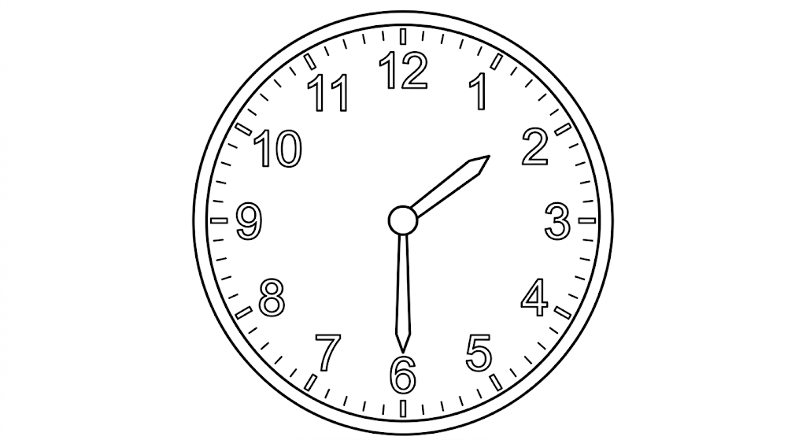
A. 4:15 p.m.
B. 4:00 p.m.
C. 4:45 p.m.
D. 5:00 p.m.
20. A cyclist travels at 72 km/h. What is this speed in m/s?
A. 12 m/s
B. 18 m/s
C. 20 m/s
D. 24 m/s

SECTION B (30 MARKS)
Answer all the questions in the spaces provided. Show all your workings.
21. A farmer received a cheque worth Ksh. 625,804,120 after selling farm produce.
(a) Write the amount on the cheque in words. (1 mark)
________________________________________________________________________________
(b) Round off the amount to the nearest million. (1 mark)
________________________________________________________________________________
(c) Find the total place value of the digit 8 in the amount. (1 mark)
________________________________________________________________________________
22. The area of a circular pond is 554.176 cm². Taking π = 3.142, find the diameter of the pond. (3 marks)
Working: ________________________________________________________________________
________________________________________________________________________________
23. A number is increased by 8 and then multiplied by 4. The result is 52. Find the number. (2 marks)
Working: ________________________________________________________________________
24. The temperature of a classroom is more than 16°C but less than or equal to 24°C. Form a compound inequality to represent the possible temperatures. (2 marks)
________________________________________________________________________________
25. Simplify the following combined operation: 24 ÷ 3 × 5 + 7 − 9. (3 marks)
Working: ________________________________________________________________________
________________________________________________________________________________
26. A farmer harvested 36.75 tonnes of maize. He sold 14.25 tonnes and later used 7.50 tonnes to feed livestock. The remaining maize was packed equally into 5 stores. How many tonnes of maize were stored in each store? (3 marks)
Working: ________________________________________________________________________
________________________________________________________________________________
27. Arrange the following fractions in descending order: 3/4, 5/8, 7/10, 2/5. (2 marks)
________________________________________________________________________________
28. Use a protractor to measure the size of angle ABC in the figure below. (1 mark)
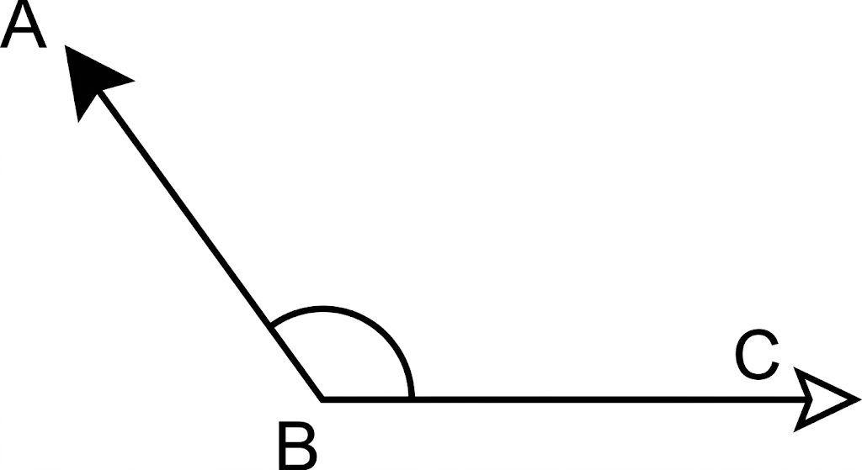
Answer: __________________°
29. Work out the value of line x in the right-angled triangle above. (3 marks)
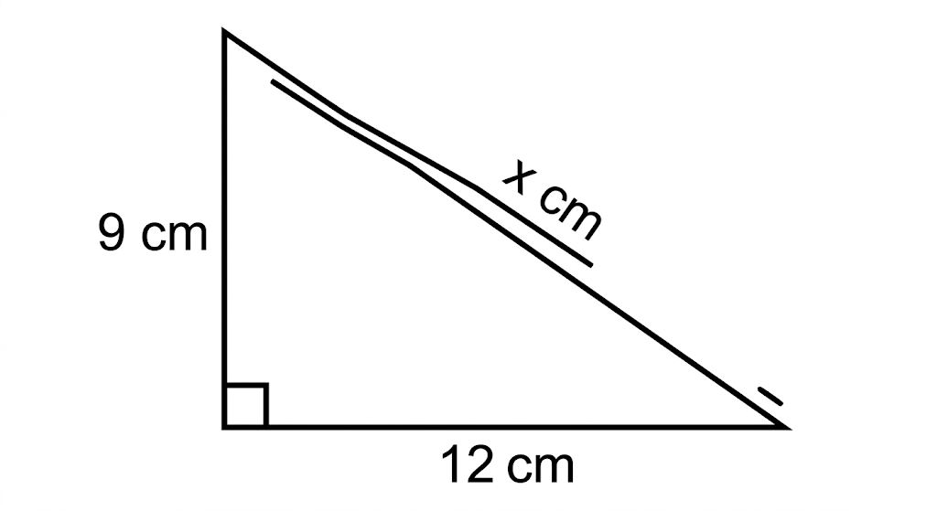
Working: ________________________________________________________________________
________________________________________________________________________________
30. A rectangular container of length 9 m, width 5 m and height 4 m is full of water.
(a) What is the volume of water in m³? (2 marks)
Working: ________________________________________________________________________
(b) How much water does the tank contain in litres? (2 marks)
Working: ________________________________________________________________________
31. Learners recorded the number of vehicles that passed a road junction in 30 minutes. They found that there were 21 cars, 10 buses, 14 motorcycles, 8 lorries and 7 bicycles. Complete the tally table below. (4 marks)
Type of Vehicle | Tally Marks | Frequency
Cars
Buses
Motorcycles
Lorries
Bicycles
Total
END OF QUESTION PAPER

