KENYA JUNIOR SCHOOL EDUCATION ASSESSMENT
GRADE 7 - 2026
INTEGRATED SCIENCE
TIME: 1 Hour 40 Minutes
Learner's Name |  | Assessment Number
School Name |  | School Code
Learner's Signature |  | Date
INSTRUCTIONS TO LEARNERS
1. Write your name and assessment number in the spaces provided above.
2. Write the name and code of your school in the spaces provided above.
3. Sign and write the date of the assessment in the spaces provided above.
4. This paper consists of two sections: A and B.
5. Section A comprises Multiple Choice Questions numbered 1 to 20.
6. Section B comprises short, structured questions numbered 21 to 30.
7. Answer ALL the questions in Section A on the separate ANSWER SHEET provided.
8. Answer ALL the questions in Section B in the spaces provided in this QUESTION PAPER.
9. Do NOT remove any page from this question paper.
10. Answer ALL the questions in English.
FOR OFFICIAL USE ONLY
Question | 21 | 22 | 23 | 24 | 25 | 26 | 27 | 28 | 29 | 30
Maximum Score | 3 | 4 | 2 | 3 | 3 | 2 | 3 | 4 | 4 | 2
Learner's Score per question
SECTION A: (20 Marks)
Answer all the questions in this section.

1. A learner was asked to measure exactly 25 ml of a liquid. Which apparatus is most suitable?
A. Beaker
B. Graduated pipette
C. Conical flask
D. Evaporating dish
2. The hazard symbol shown on a container has a skull and crossbones. What does it indicate?

A. Flammable substance
B. Corrosive substance
C. Poisonous substance
D. Radioactive substance
3. A learner tested four household liquids with blue litmus paper. Which liquid would most likely leave the blue litmus unchanged?
A. Lemon juice
B. Vinegar
C. Distilled water
D. Orange juice
4. Which apparatus is used to measure temperature in the laboratory?
A. Thermometer
B. Measuring cylinder
C. Stopwatch
D. Balance
5. A metal block has a mass of 180 g and a volume of 60 cm³. What is its density?
A. 0.3 g/cm³
B. 3 g/cm³
C. 30 g/cm³
D. 240 g/cm³
6. A learner accidentally spills a small amount of dilute acid on the hand. What should the learner do first?
A. Wash the affected area immediately with plenty of running water.
B. Rub the area with a strong base.
C. Cover the area with soil.
D. Leave the acid on the skin until the lesson ends.
7. Which of the following is a physical change that occurs only in girls during adolescence?
A. Growth of pubic hair
B. Development of breasts
C. Growth of body hair
D. Development of pimples
8. A mixture contains muddy water. Which method is most suitable for obtaining clearer water by removing the insoluble soil particles?
A. Filtration
B. Evaporation
C. Distillation
D. Magnetic separation
9. Three liquids have the following pH values: Liquid P — pH 3; Liquid Q — pH 7; Liquid R — pH 10. Which classification is correct?
A. P is a base, Q is neutral, R is an acid
B. P is an acid, Q is neutral, R is a base
C. P is neutral, Q is an acid, R is a base
D. P is a base, Q is an acid, R is neutral
10. In the heating arrangement shown, what is the main function of the wire gauze placed between the container and the tripod?
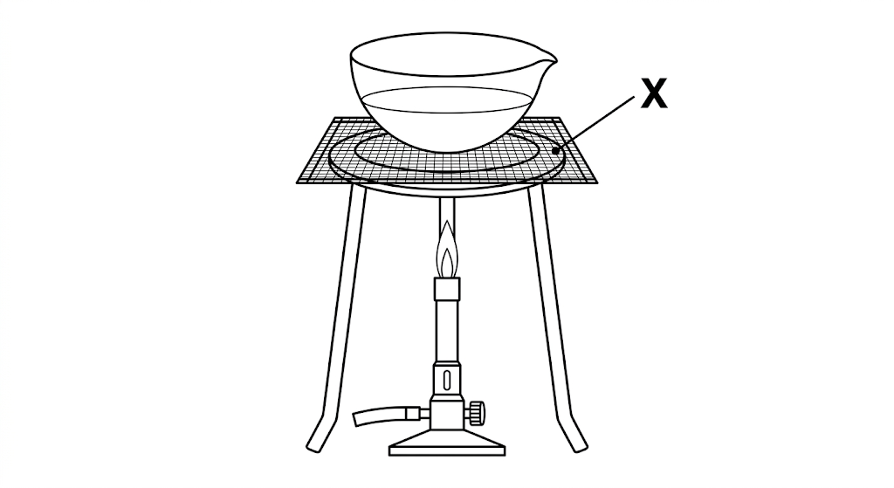
A. To spread heat evenly and support the container
B. To produce the flame
C. To increase the amount of water
D. To prevent the burner from receiving gas
11. Which structure in the human urinary system carries urine from a kidney to the urinary bladder?
A. Urethra
B. Ureter
C. Oviduct
D. Penis
12. Which practice can increase the risk of kidney problems?
A. Drinking adequate water
B. Eating a balanced diet
C. Excessive intake of alcohol
D. Taking regular physical exercise
13. A learner needs a hot Bunsen burner flame for an experiment. Which setting is appropriate?
A. Close the air hole completely.
B. Open the air hole to allow air to mix with the gas.
C. Cover the air hole with tape.
D. Remove the burner collar.
14. Which of the following is NOT an organ of the human excretory system?
A. Kidney
B. Skin
C. Lungs
D. Heart
15. Which pair forms a heterogeneous mixture?
A. Salt and water
B. Sugar and water
C. Cooking oil and water
D. Glucose and water
16. Learners grouped laboratory objects according to their observable features and placed similar objects together. Which science skill did they mainly use?
A. Observation and classification
B. Communication and measurement
C. Prediction and experimentation
D. Hypothesis and conclusion
17. The Bunsen burner shown has a part labelled X. What is the function of this part?
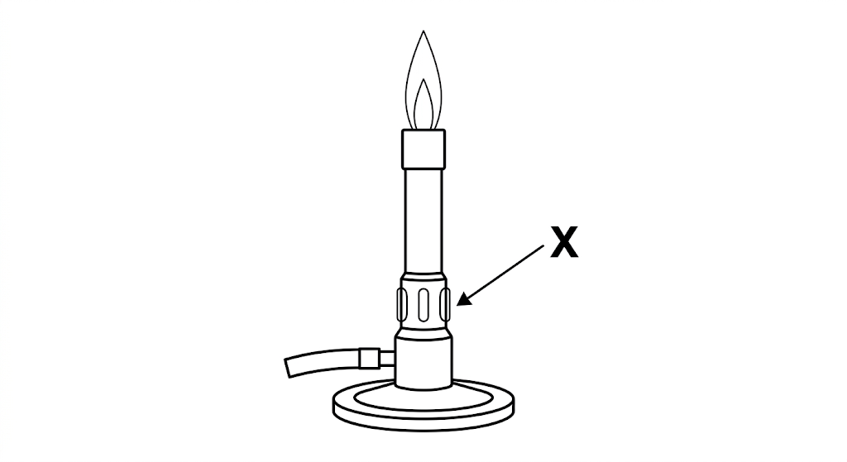
A. Allows air to enter and mix with the gas
B. Supports the burner on the table
C. Stores the gas supply
D. Produces electricity
18. After vigorous exercise, sweat appears on the skin. Through which structure does sweat leave the body?
A. Sweat pore
B. Dermis
C. Epidermis
D. Hair follicle
19. Which of the following is a natural source of electrical energy?
A. Solar energy
B. Electric iron
C. Electric kettle
D. Blender
20. When using a light microscope, which part is adjusted to bring a specimen into sharp, clear focus after coarse focusing?
A. Fine adjustment knob
B. Revolving nosepiece
C. Diaphragm
D. Stage clips

SECTION B: (30 Marks)
Answer all the questions in the spaces provided.
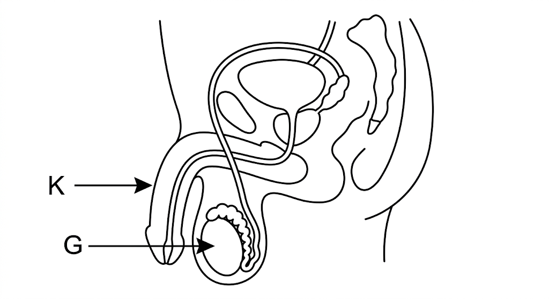
21(a). Identify the part labelled G in the diagram. (1 mark)
________________________________________________________________________________
________________________________________________________________________________
21(b). State two functions of the part labelled K. (2 marks)
________________________________________________________________________________
________________________________________________________________________________
________________________________________________________________________________
________________________________________________________________________________
22(a)(i). State one physical property of an acid. (1 mark)
________________________________________________________________________________
________________________________________________________________________________
22(a)(ii). State one physical property of a base. (1 mark)
________________________________________________________________________________
________________________________________________________________________________
22(b)(i). Give one use of an acid in everyday life. (1 mark)
________________________________________________________________________________
________________________________________________________________________________
22(b)(ii). Give one use of a base in everyday life. (1 mark)
________________________________________________________________________________
________________________________________________________________________________
23(a). Name the apparatus most appropriate for separating a mixture of water and cooking oil. (1 mark)
________________________________________________________________________________
________________________________________________________________________________
23(b). What term describes a mixture in which a solute dissolves completely in a liquid? (1 mark)
________________________________________________________________________________
________________________________________________________________________________
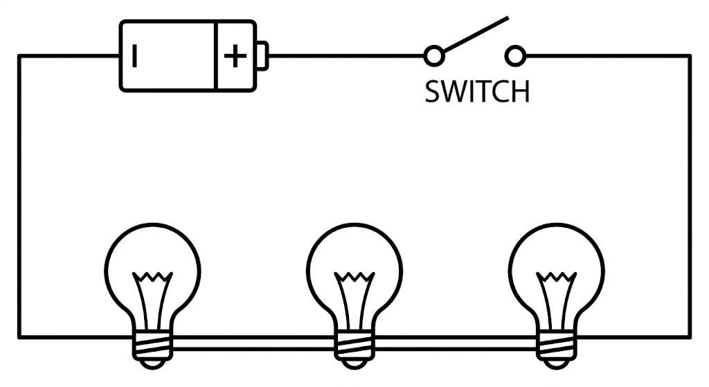
24(a). Which type of simple electrical circuit arrangement is represented by the diagram? (1 mark)
________________________________________________________________________________
________________________________________________________________________________
24(b). List two common electrical appliances used in day-to-day life. (2 marks)
________________________________________________________________________________
________________________________________________________________________________
________________________________________________________________________________
25. State three reasons why it is important to maintain a healthy excretory system. (3 marks)
________________________________________________________________________________
________________________________________________________________________________
________________________________________________________________________________
________________________________________________________________________________
________________________________________________________________________________
26. State two career opportunities related to the study of Integrated Science. (2 marks)
________________________________________________________________________________
________________________________________________________________________________
________________________________________________________________________________
27(a). State the meaning of the term fertilization. (1 mark)
________________________________________________________________________________
________________________________________________________________________________
27(b). In which part of the female reproductive system does fertilization take place? (1 mark)
________________________________________________________________________________
________________________________________________________________________________
27(c). State one function of the ovaries. (1 mark)
________________________________________________________________________________
________________________________________________________________________________
28(a)(i). Name the outermost layer of the skin that contains the sweat pores through which sweat leaves the body. (1 mark)
________________________________________________________________________________
________________________________________________________________________________
28(a)(ii). Name the inner layer of the skin that contains blood capillaries and sweat glands. (1 mark)
________________________________________________________________________________
________________________________________________________________________________
28(a)(iii). Name the part of the skin through which sweat reaches the surface. (1 mark)
________________________________________________________________________________
________________________________________________________________________________
28(b). State the main waste product excreted by the skin. (1 mark)
________________________________________________________________________________
________________________________________________________________________________
29. A learner prepared an acid-base indicator from hibiscus flowers and tested three household substances. The results were recorded below.
Substance | Colour change of hibiscus indicator
Lime juice | Turns red
Soap solution | Turns green
Distilled water | No colour change
29(i). What was the colour of the hibiscus indicator before testing? (1 mark)
________________________________________________________________________________
________________________________________________________________________________
29(ii). State whether each substance is an acid, a base or neutral. (3 marks)
________________________________________________________________________________
________________________________________________________________________________
________________________________________________________________________________
________________________________________________________________________________
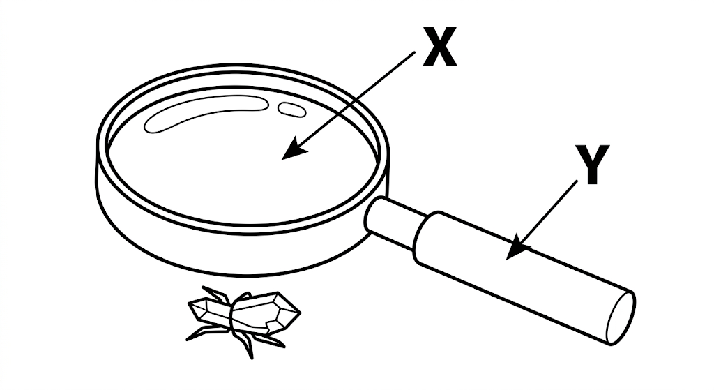
30. Name the parts labelled X and Y. (2 marks)
________________________________________________________________________________
________________________________________________________________________________
________________________________________________________________________________
END OF QUESTION PAPER

