KENYA JUNIOR SCHOOL EDUCATION ASSESSMENT
GRADE 7 - 2026
CREATIVE ARTS AND SPORTS (THEORY)
TIME: 1 Hour 40 Minutes
Learner’s Name: | ________________________ | Assessment Number: | __________________
School Name: | ________________________ | School Code: | __________________
Learner’s Signature: | ________________________ | Date: | __________________
INSTRUCTIONS TO LEARNERS
1. Write your name and assessment number in the spaces provided above.
2. Write the name and code of your school in the spaces provided above.
3. Sign and write the date of the assessment in the spaces provided above.
4. This paper consists of two sections: A and B.
5. Section A comprises 20 Multiple Choice Questions numbered 1 to 20.
6. Section B comprises structured and analysis questions numbered 21 to 29.
7. Answer ALL the questions in Section A on the separate ANSWER SHEET provided.
8. Answer ALL the questions in Section B in the spaces provided on this QUESTION PAPER.
9. Do NOT remove any page from this question paper.
10. Answer all questions in English.
11. For Part I, Part II and Part III of Section A, answer all questions as instructed.
FOR OFFICIAL USE ONLY
Question Number | 21 | 22 | 23 | 24 | 25 | 26 | 27 | 28 | 29
Maximum Score | 7 | 6 | 1 | 2 | 2 | 4 | 4 | 2 | 2
Learner's Score
SECTION A: MULTIPLE CHOICE QUESTIONS (20 Marks)
Read the instructions carefully.
1. You have been given this question paper and a separate answer sheet.
2. Answer ALL questions on the answer sheet provided, NOT on the question paper.
3. Do all the necessary rough work on this question paper.
HOW TO USE THE ANSWER SHEET
4. Use an ordinary HB pencil.
5. Confirm that your answer sheet has your Assessment Number, Name, Name of your School and Name of the Learning Area.
6. Keep the answer sheet clean and dry. DO NOT fold it.
7. For each question, four answers are given. The answers are lettered A, B, C and D. In each case, only ONE of the four answers is correct. Choose the correct answer.
8. On the answer sheet, show the correct answer by drawing a DARK LINE inside the box in which the letter you have chosen is printed.
PART I: PERFORMING ARTS

1. Which statement correctly describes the xylophone as used in Kenyan music?
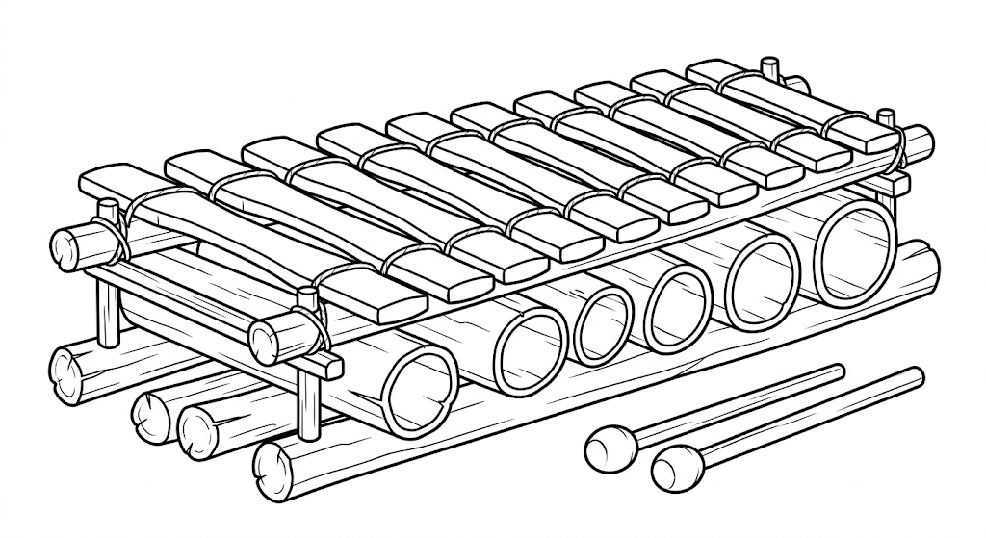
A. It is a wind instrument played by blowing
B. It is a percussion instrument played by striking
C. It is a string instrument played by plucking
D. It is an electronic instrument played with switches
2. A traditional song from a community is being prepared for performance. Which element should the performers maintain to preserve the character of the song?
A. The appropriate rhythm and style
B. Random changes of tempo
C. Silence throughout the performance
D. A different language for every line
3. When composing a simple melody in solfa notation, which syllable comes immediately after Mi in the ascending scale?
A. Do
B. Re
C. Fa
D. So
4. Which group contains parts commonly found on a violin?
A. Sound box, strings, bridge and tuning pegs
B. Mouthpiece, keys, bell and slide
C. Membrane, beads, bow and rotor
D. Keyboard, pedals, reeds and valves
5. A learner is positioning the hands on a recorder before playing. Which finger provides the main support for the instrument?
A. The left-hand thumb
B. The right-hand thumb
C. The left-hand little finger
D. The right-hand little finger
6. Before presenting a story to an audience, which practice is most likely to improve the learner's delivery?
A. Rehearsing the story several times
B. Avoiding the story until the performance begins
C. Changing the plot during every rehearsal
D. Reading without considering expression

PART II: SPORTS

7. During a football match, a learner wants to send the ball into the opponent's goal. Which skill should the learner apply?
A. Shooting
B. Trapping
C. Dribbling
D. Marking
8. Arrange the following phases of a javelin throw in the correct order: i. Release; ii. Approach run; iii. Follow-through; iv. Withdrawal of javelin into throwing position.
A. ii, iv, i, iii
B. iv, ii, i, iii
C. ii, i, iv, iii
D. iii, ii, iv, i
9. The handball player shown is controlling the ball close to the ground with one hand. Which skill is being demonstrated?
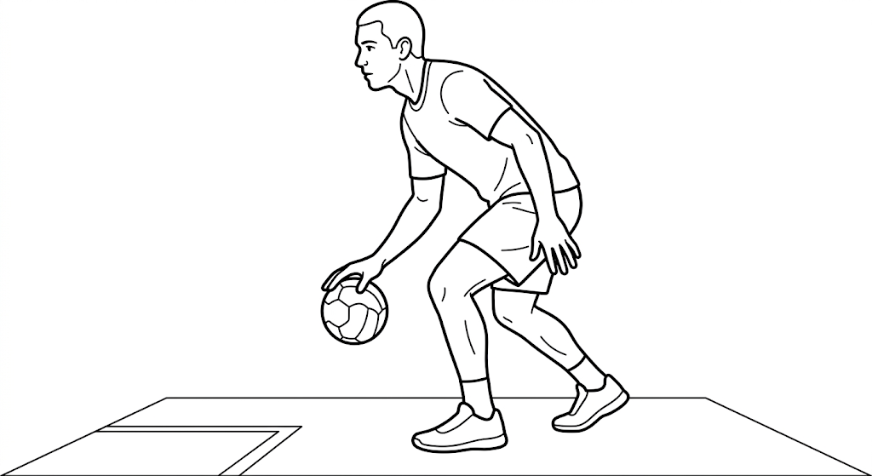
A. Catching
B. Low dribbling
C. Chest passing
D. Jump shooting
10. What is the main purpose of the handball skill shown in the previous question?
A. To move with the ball while maintaining possession
B. To stop an opponent from scoring directly
C. To signal the end of the match
D. To replace the goalkeeper
11. At an athletics meeting, which event is best described as a middle-distance race?
A. 100 m
B. 400 m
C. 800 m
D. 5000 m
12. Which action is a safe practice when participating in football?
A. Wearing suitable sports shoes
B. Tackling an opponent from behind
C. Continuing to play when seriously injured
D. Playing without warming up
PART III: VISUAL ARTS
13. A circular palette is divided into coloured segments for a learner working with paint. What is its main purpose?
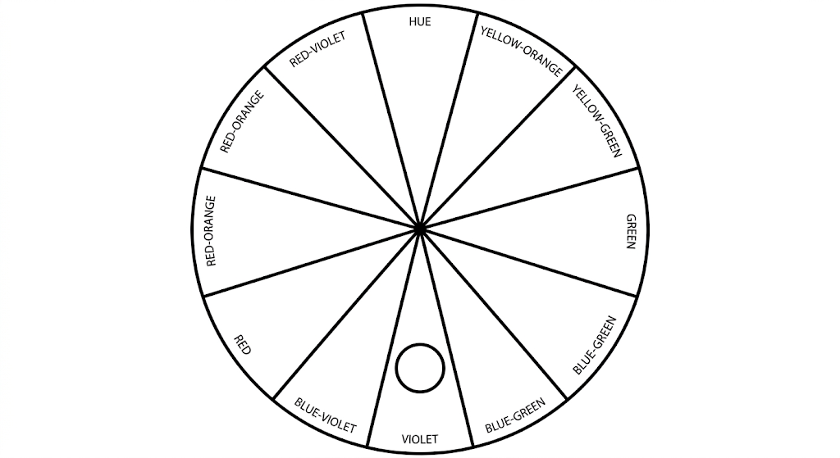
A. To measure the mass of paint
B. To help mix and compare colours
C. To sharpen drawing tools
D. To store finished paintings
14. A learner is designing a poster intended to create a cheerful and energetic mood. Which colour would be most appropriate?
A. Yellow
B. Black
C. Grey
D. Violet
15. A learner is improvising crayons and completes these steps: i. Mix pigment with melted wax; ii. Cool the mixture; iii. Cut the crayons to size; iv. Pour the mixture into moulds. Which sequence is correct?
A. i, ii, iv, iii
B. i, iv, ii, iii
C. iv, i, iii, ii
D. ii, i, iv, iii
16. Why should learners discuss and comment constructively on artworks after completing a practical activity?
A. To appreciate, evaluate and learn from artworks
B. To prove that one learner is always better
C. To prevent learners from improving their work
D. To avoid using art vocabulary
17. A learner has produced a bracelet by arranging small beads in a repeated pattern. Which technique is most clearly shown?
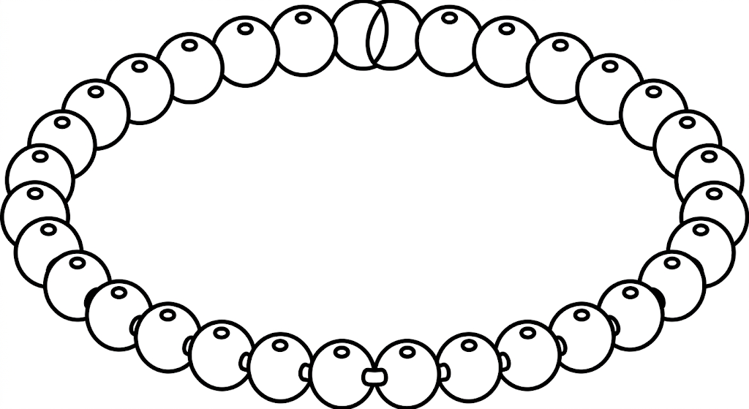
A. Beading technique
B. Weaving technique
C. Coiling technique
D. Casting technique
18. A learner is making a collage from dried leaves, fabric pieces and coloured paper. Which base would provide the most suitable firm surface?
A. A piece of carton board
B. A thin sheet of tissue paper
C. A piece of cotton wool
D. A plastic ruler
19. Wooden javelin-like implements are smoked during improvisation mainly to:
A. Protect the wood from pests and moisture
B. Make the implement softer
C. Increase the weight with water
D. Cover the wood with paint
20. Which material would be most useful when assembling a simple flipbook animation?
A. Small sheets of paper
B. A cooking pan
C. A football net
D. A metal bucket

SECTION B: STRUCTURED AND ANALYSIS QUESTIONS
PART I: PERFORMING ARTS
21. Grade 7 learners were discussing plot as an element of a story.
(a) Define the term plot as used in a story. (2 marks)
________________________________________________________________________________
________________________________________________________________________________
________________________________________________________________________________
________________________________________________________________________________
21. (b) Draw and label the main stages in the structure of plot in a story in the space provided below. (5 marks)
________________________________________________________________________________
________________________________________________________________________________
22. On the space provided below compose a 2-bar melody in 3/4 time on a treble staff using C major notes. (6 marks)
________________________________________________________________________________
________________________________________________________________________________
PART II: SPORTS
23. You have been asked to create a flipbook animation. Mention one theme that you would address. (1 mark)
________________________________________________________________________________
________________________________________________________________________________
24. Name two trapping skills applied in a game of football. (2 marks)
________________________________________________________________________________
________________________________________________________________________________
25. You have been asked to create a team to play a football game. Identify two playing positions you would consider. (2 marks)
________________________________________________________________________________
________________________________________________________________________________
26. (a) What is coordination as applied in physical fitness? (2 marks)
________________________________________________________________________________
________________________________________________________________________________
26. (b) List down three components of coordination. (2 marks)
________________________________________________________________________________
________________________________________________________________________________
PART III: VISUAL ARTS
27. On the space provided below, draw a still-life composition and ensure you have achieved symmetrical balance in your drawing. (4 marks)
________________________________________________________________________________
________________________________________________________________________________
28. Name two tools used when improvising a javelin implement. (2 marks)
________________________________________________________________________________
________________________________________________________________________________
29. List down two reasons why candle wax is used when improvising crayons. (2 marks)
________________________________________________________________________________
________________________________________________________________________________

