KENYA JUNIOR SCHOOL EDUCATION ASSESSMENT
GRADE 7 - 2026
AGRICULTURE AND NUTRITION
TIME: 1 hour 40 minutes
Learner's Name |  | Assessment Number
School Name |  | School Code
Learner's Signature |  | Date
INSTRUCTIONS TO LEARNERS:
1. Write your name and assessment number in the spaces provided above.
2. Write the name and code of your school in the spaces provided above.
3. Sign and write the date of the assessment in the spaces provided above.
4. This paper consists of two sections: A and B.
5. Section A comprises Multiple Choice Questions numbered 1 to 20.
6. Section B comprises short, structured questions numbered 21 to 30.
7. Answer ALL the questions in Section A on the separate ANSWER SHEET provided.
8. Answer ALL the questions in Section B in the spaces provided in this QUESTION PAPER.
9. Do NOT remove any page from this question paper.
10. Answer ALL the questions in English.
FOR OFFICIAL USE ONLY
Question | 21 | 22 | 23 | 24 | 25 | 26 | 27 | 28 | 29 | 30 | TOTAL
Maximum Score | 3 | 3 | 2 | 3 | 2 | 4 | 4 | 3 | 4 | 2 | 30
Learner's Score
SECTION A
20 Marks
Read all the instructions carefully.
1. You have been given this question paper and a separate answer sheet. This section consists of 20 multiple choice questions.
2. Answer ALL the questions on the ANSWER SHEET provided, NOT on the question paper.
3. Do all the necessary rough work on the question paper.
HOW TO USE THE ANSWER SHEET
4. Use an ordinary HB pencil.
5. Confirm that your answer sheet has your Assessment Number, Name, School Name and Subject.
6. Keep the answer sheet clean and dry. DO NOT fold it.
7. For each question, four options are given: A, B, C and D. In each case, only ONE option is correct.
8. On the answer sheet, show the correct answer by drawing a DARK LINE inside the box with the letter you have chosen.
Example: If the correct answer to a question is B, darken the box containing B.
9. Your dark line MUST be within the box. Do not make marks outside the boxes.
10. For each question, ONLY one box is to be marked.

1. A learner has washed a mixture of white and coloured school clothes. Which action should be taken before soaking them together?
A. Separate coloured clothes from white clothes.
B. Add bleach to all the clothes.
C. Scrub all clothes with a hard brush.
D. Dry all clothes before washing.
2. Identify the activity shown below.
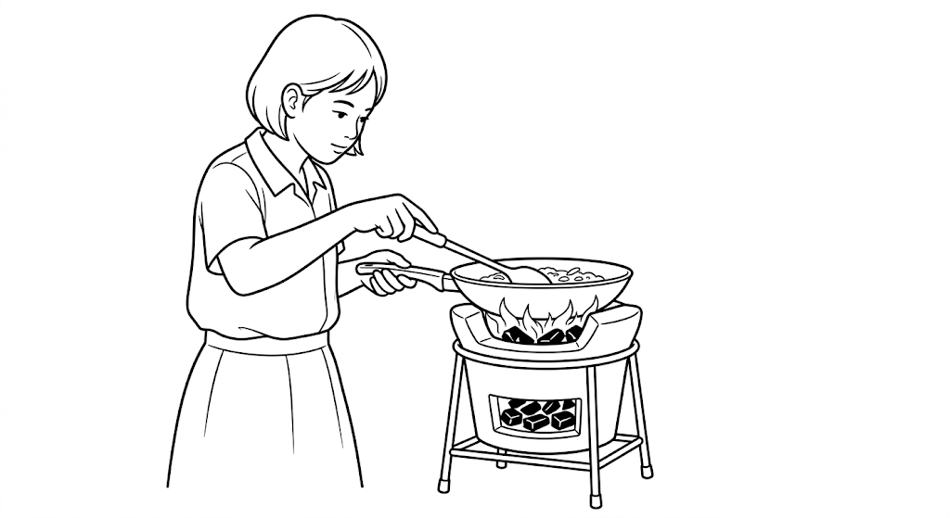
A. Roasting
B. Frying
C. Boiling
D. Steaming
3. A farmer wants to reduce the loss of fertile topsoil carried away by rainwater from a sloping field. Which structure would be most suitable?
A. Compost pit
B. Water retention ditch
C. Seedbed
D. Footpath
4. A poultry farmer is preparing eggs for sale. Which practice would best help maintain their quality?
A. Break each egg before selling.
B. Mix all eggs in one deep container.
C. Grade the eggs according to size and shell quality.
D. Soak all eggs in detergent.
5. A farmer clears bushes, removes stones and levels a plot before planting millet. Which farm practice is being carried out?
A. Irrigation
B. Land preparation
C. Harvesting
D. Crop storage
6. Learners visit a beekeeper and observe honey being prepared for storage. Which set contains materials used in processing raw honey?
A. Muslin cloth, wooden spoon and storage container
B. Knapsack sprayer, watering can and secateurs
C. Milk can, churn and teat cup
D. Rake, jembe and wheelbarrow
7. A mother chooses to steam green vegetables instead of boiling them in a lot of water. What is the main advantage of this method?
A. It uses more cooking oil.
B. It helps retain more nutrients.
C. It removes all vitamins.
D. It makes the vegetables much harder.
8. A farmer is using pruning shears on a fruit tree. Which action should NOT be part of proper pruning?
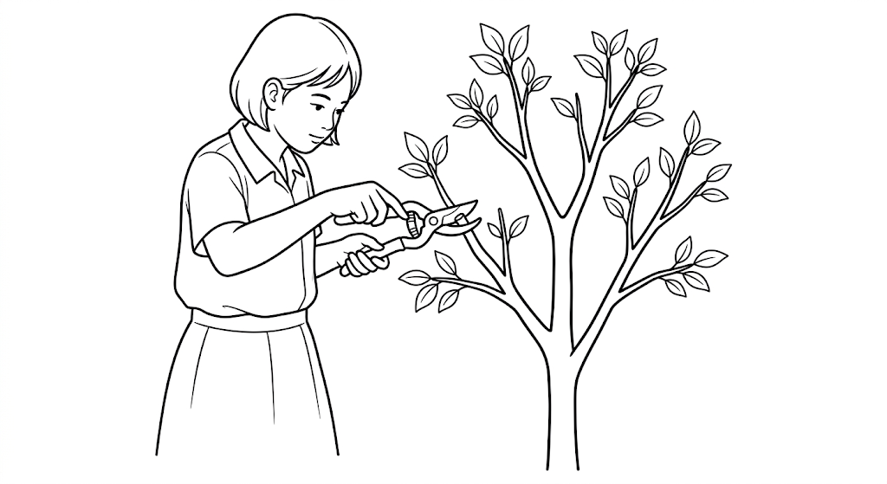
A. Removing dead branches
B. Removing damaged branches
C. Cutting the main stem unnecessarily
D. Improving light penetration into the canopy
9. Weeds are growing between maize plants and competing for water and nutrients. Which management practice should be used?
A. Mulching
B. Thinning
C. Weeding
D. Pruning
10. Which practice promotes good hygiene when keeping small domestic animals?
A. Cleaning the animal house regularly
B. Giving animals stagnant water
C. Mixing sick animals with healthy ones
D. Feeding animals spoiled food
11. Which food preservation method is suitable for both milk and meat?
A. Drying only
B. Boiling only
C. Salting
D. Fermenting only
12. After transplanting tree seedlings, a learner waters them immediately. Why is this important?
A. It helps the soil settle firmly around the roots.
B. It removes nutrients from the soil.
C. It encourages weeds to grow.
D. It prevents the roots from taking up water.
13. Farmers are advised to minimise excessive use of chemical fertilisers and pesticides because it may
A. improve soil structure in every case.
B. pollute the soil and water.
C. stop all soil organisms from working.
D. increase soil fertility permanently.
14. The rabbit house shown needs better hygiene. Which practice should be carried out?
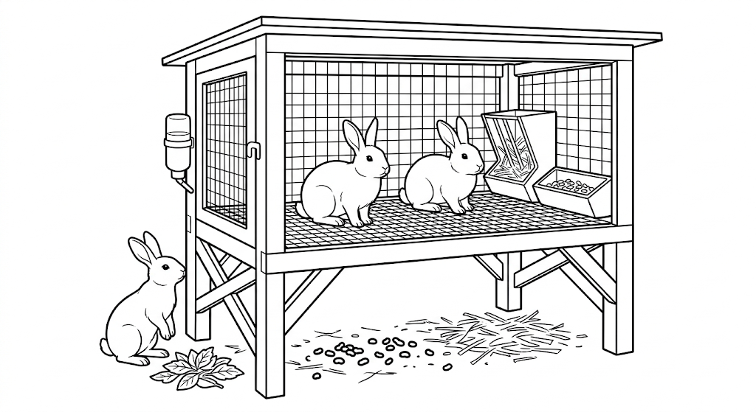
A. Leave droppings until the end of the month.
B. Feed rabbits on the dirty floor.
C. Clean the house and feeding equipment regularly.
D. Keep the structure in a damp place.
15. Trees are planted along a riverbank by a community group. What is the main environmental benefit of this practice?
A. Reducing erosion and protecting water sources
B. Increasing soil pollution
C. Encouraging flooding
D. Reducing air movement
16. Learners are preparing to construct a water retention pit. Which sequence is correct?
A. Dig the pit, mark the site, remove unwanted materials, test effectiveness.
B. Mark the site, remove stones and roots, dig the pit, firm the soil and test effectiveness.
C. Remove stones and roots, test effectiveness, mark the site, dig the pit.
D. Firm the soil, dig the pit, mark the site, remove unwanted materials.
17. Before moving tomato seedlings to the main field, a farmer gradually reduces watering and increases sunlight exposure. What is the purpose of this practice?
A. To make the seedlings flower immediately
B. To prevent weeds from germinating
C. To help seedlings adapt to field conditions
D. To increase the number of leaves permanently
18. Which practice is least effective in reducing the spread of diseases among poultry?
A. Isolating sick birds
B. Cleaning and disinfecting the poultry house
C. Mixing newly purchased birds with the flock immediately
D. Vaccinating birds against common diseases
19. A learner cooks vegetables quickly with little water and keeps the cooking pot covered. Which nutrient-conservation practice is being used?
A. Long cooking
B. Steaming or controlled cooking with little water
C. Peeling thick layers before cooking
D. Adding baking soda
20. A teacher has brought carrot seeds for planting. Which soil tilth is most suitable for establishing these small seeds?
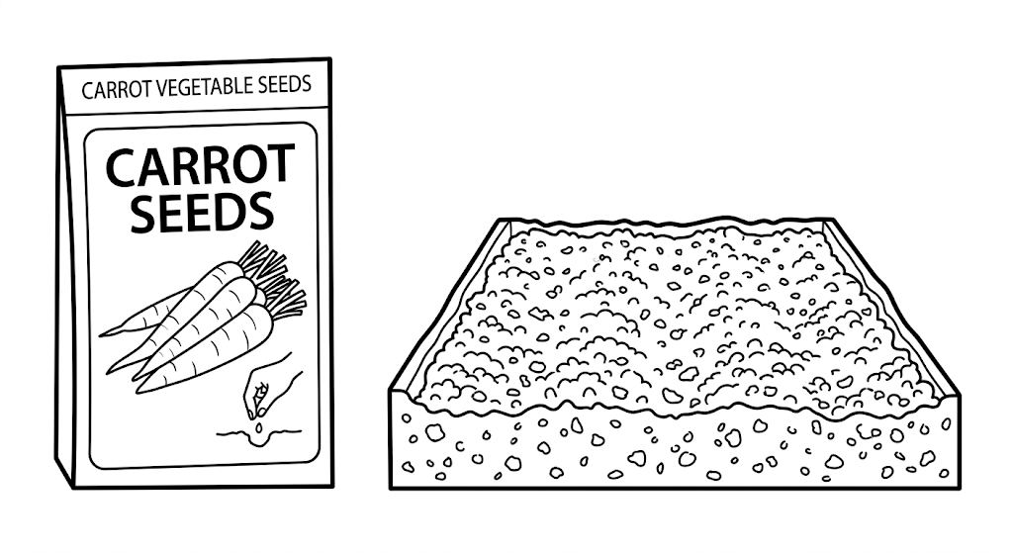
A. Fine tilth
B. Coarse tilth
C. Rough cloddy tilth
D. Stony tilth

SECTION B: 30 Marks
Answer all the questions in this section in the spaces provided.
21. Members of the Agriculture Club notice solid waste has been thrown in the school garden.
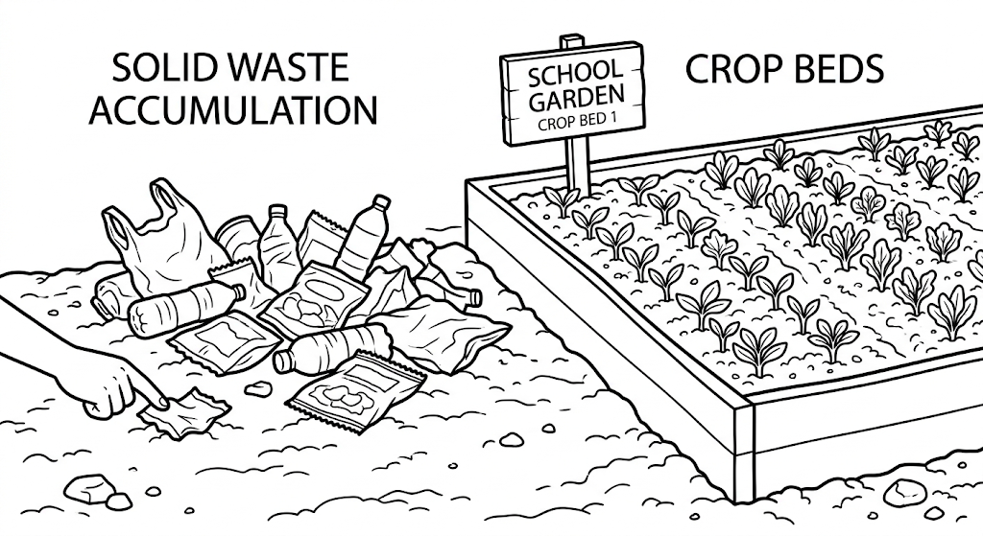
(a) State two ways the solid waste materials can pollute the soil garden. (2 marks)
i) ______________________________________________________________
ii) _____________________________________________________________
(b) Suggest one responsible action that learners should take to prevent further soil pollution. (1 mark)
________________________________________________________________
22. Grade 7 learners plan to improve the fertility of their school garden using a sustainable method.
(a) Suggest one organic method of improving soil fertility. (1 mark)
________________________________________________________________
(b) State two benefits of using the method suggested in (a). (2 marks)
i) ______________________________________________________________
ii) _____________________________________________________________
23. A learner is practising knitting to make a household article. Identify the two basic knitting stitches. (2 marks)
i) ______________________________________________________________
ii) _____________________________________________________________
24. A learner planted bean seeds but some planting holes had no seedlings after two weeks.
(a) What is the name of the practice of replacing the missing seedlings? (1 mark)
________________________________________________________________
(b) State two importance of carrying out crop management practices. (2 marks)
i) ______________________________________________________________
ii) _____________________________________________________________
25. The structure shown is a type of garden constructed where space is limited.
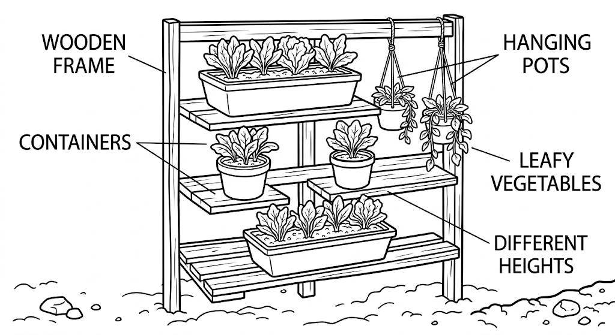
(i) Identify the type of garden shown above. (1 mark)
________________________________________________________________
(ii) Give one example of a crop that can be planted on the garden shown above. (1 mark)
________________________________________________________________
26. Grade 7 learners planted tree seedlings around the school compound.
(a) Name two types of planting materials the learners may have used. (2 marks)
i) ______________________________________________________________
ii) _____________________________________________________________
(b) State two practices that will help the seedlings grow well after planting. (2 marks)
i) ______________________________________________________________
ii) _____________________________________________________________
27. The picture shows a structure used for rearing farm animals.
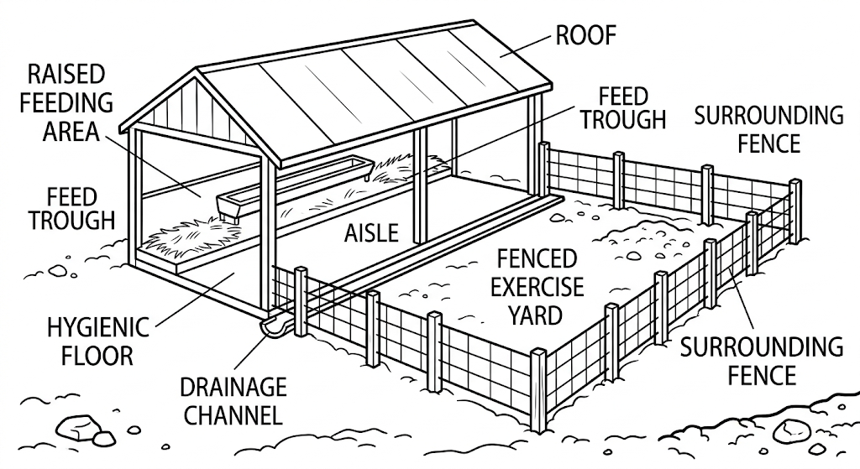
(a) Give two reasons why it is important to keep the structure clean at all times. (2 marks)
i) ______________________________________________________________
ii) _____________________________________________________________
(b) Apart from cleaning the structure, state two other hygiene practices carried out in the structure. (2 marks)
i) ______________________________________________________________
ii) _____________________________________________________________
28. A family prepares cabbages and spinach for supper. State three ways they can reduce nutrient loss during preparation and cooking. (3 marks)
i) ______________________________________________________________
ii) _____________________________________________________________
iii) ____________________________________________________________
29. During a practical lesson, Grade 7 learners wash loose-coloured clothes. Outline four correct procedures to prevent fading and colour transfer to other clothes. (4 marks)
i) ______________________________________________________________
ii) _____________________________________________________________
iii) ____________________________________________________________
iv) ____________________________________________________________
30. Grade 7 learners roast sweet potatoes using a charcoal grill. State two safety precautions they should observe while roasting the food. (2 marks)
i) ______________________________________________________________
ii) _____________________________________________________________

