JULY/AUGUST 2026
PHYSICS

PAPER 2

MARKING SCHEME

1. A - microwave ✓1
B - for vision✓1

2.
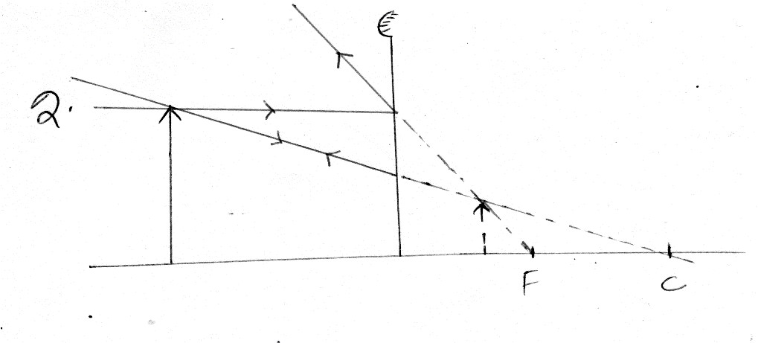
Correct image; correct rays
3. (a)
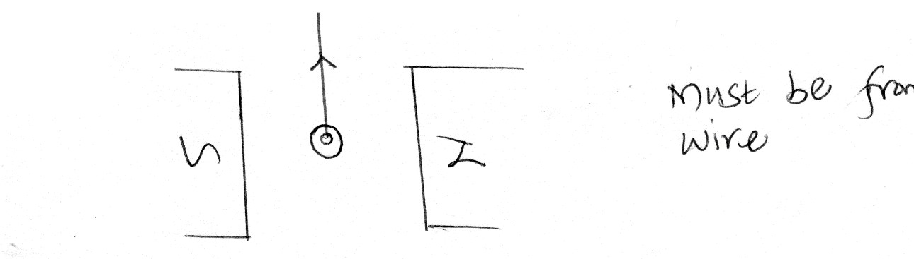
(b) moves on the opposite side. ✓1

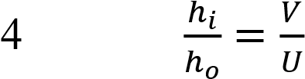✓
h_{o} 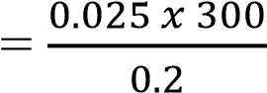✓
= 37.5 m✓

5. 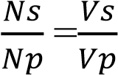
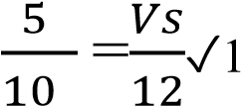
Vs=6V✓1

6 i) like poles repel, unlike poles attract✓1

ii) Magnetic keepers become magnetized by induction; ✓1 keep dipoles aligned in a continuous loop of N-S poles pair✓1

7.the ratio of sine of angle of incidence to the sine of the angle of refraction is the same/constant for a given pair of media. ✓1

λ
- no. of cycles = 2.75 or 2
Frequency=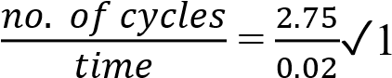
= 137.5 𝐻𝑧✓1
- f =V/ λ and f1= f2 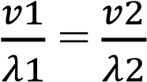
2/1=V₂/0.4✓1
V₂=0.8m/s✓1
- 90-35=55º ✓1
11.White light is made up of seven colours; ✓1 which travel at different speed/ wavelength in the glass prism and hence dispersion✓1

- 2d= speed x time✓1
2d= 1600 x 2.4✓1
d= 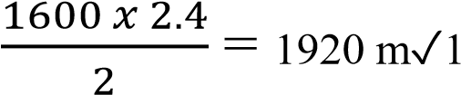

- positive charges ✓1

14.(a) (i) Argon – to initiate the discharge. ✓1
(ii) Quenching agent. Absorb energy of positive ions before they cause secondary
electron emission. ✓1
iii). Using an amplifier✓1

iv) a = 226✓1
b=88✓1

15. (a) (i) to provide heat for thermionic emission✓1

(ii) to create high pd for the anode which acts as accelerating voltage for ejected Electrons ✓1
- Increasing heater current to produce more electrons✓1

- air undergoes ionization due collision with cathode rays ; ✓1 or and resulting electrons have less kinetic energy✓1

- posses kinetic energy✓1 travel in straight lines
- X-rays-formed have no charge while cathode rays are negatively charged✓1

Any 1correct answer
X rays are faster than cathode rays
X-rays are waves while cathode rays are particulate/ particles X-rays are more energetic than cathode rays

(f) can measure both ac and dc voltages✓1 (any 1correct answer) can measure larger voltages (g) (i) T=5x4=20ms f=1/T=1/0.02✓1
f=50Hz✓1

(ii) V=10x4✓1 =40V✓1
- (a) (i) electron emitted are repelled by the negative charges, so the leaf of
electroscope fall✓1
    - electron emitted are attracted by the positive charged✓1
    - its energy is lower than the energy need to dislodge an electron from a metal surface/Work function✓1

  - (i). increase in the number of emitted electrons✓1
    - speed /KE of electrons increases✓1
  - (i) E=hf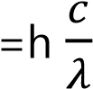
(6.63x10⁻³⁴x3.0x10⁸)/(4.3x10⁻⁷) ✓1
=4.6256x10⁻¹⁹J✓1
    - Potassium, lower work function an also less energy than energy of radiation

    - KE =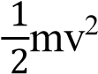
v²= (2x 0.9456x10⁻¹⁹)/(9.1X10⁻³¹) v=4.559X10⁵m/s

- a)
- A circuit which is not delivering current; ✓1
- A circuit which is delivering current; ✓1 b(i) Total resistance=
0.5 0.3 36 
^{ 6  3}
0.30.52 2.8;✓1

V 6.6 2.357A;
I   
^{R  2.8} ✓1

I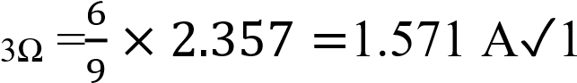
ii)
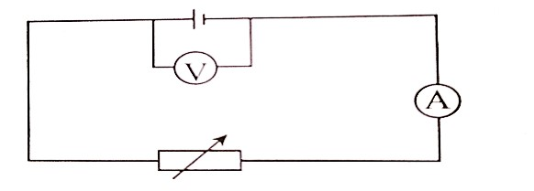
iii) E.m.f=voltage intercept =9.6V; ✓ iv) Internal resistance = slope;
-r = slope✓1
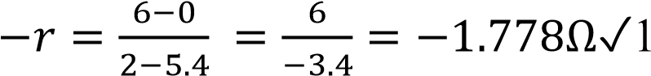
𝑟 = 1.778Ω ✓1

18 a) correct rays✓1 correct image✓1

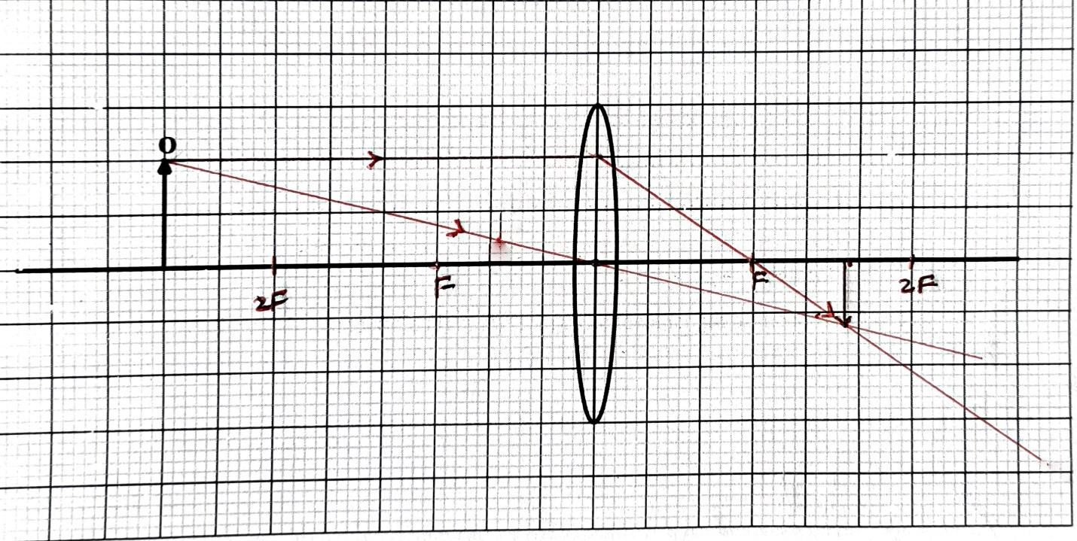 b) u = 8 cm v= 4.7± 0.1 cm
m = 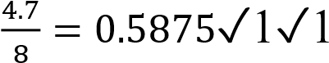 OR
m=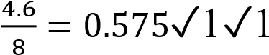
OR m= 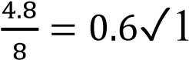✓ m = 0.5875 to 0.6

c)
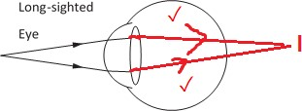
19. a) i) Step - down transformer; the power is to be stepped-down for domestic
use✓ 
ii)𝑾𝒂𝒕𝒆𝒓 𝒉𝒆𝒂𝒕𝒆𝒓 = 𝟐𝒌𝑾 × 𝟐 × 𝟑𝟎 × 𝟗. 𝟓𝟎
= 𝟏𝟏𝟒𝟎 ✓ 
𝑬𝒍𝒆𝒄𝒕𝒓𝒊𝒄 𝒃𝒖𝒍𝒃 = 𝟎. 𝟎𝟕𝟓 × 𝟏𝟎 × 𝟑𝟎 × 𝟗. 𝟓
= 𝟐𝟏𝟑. 𝟕𝟓
𝑰𝒓𝒐𝒏 𝒃𝒐𝒙 = 𝟏. 𝟓 × 𝟏 × 𝟑𝟎 × 𝟗. 𝟓
= 𝟒𝟐𝟕. 𝟓 ✓ 
𝑻𝒐𝒕𝒂𝒍 𝒄𝒐𝒔𝒕 = 1140+213.75+427.5 = 𝑲𝒔𝒉𝒔. 𝟏𝟕𝟖𝟏. 𝟐𝟓✓ 
 
- i) B-live wire /plug✓ 
 
ii) To open both the neutral and the live hole✓  or
 
To earth the appliance before the user uses it just in case there is a current leak ✓ 

- ) i) The ring mains circuit✓¹ ii) X – Neutral ✓¹ Y – Live ✓¹ iii) Disconnecting the circuit✓¹ or breaking the circuit✓¹ or opening the circuit✓¹
(any one)

END

