- Evaluate
$\frac{3}{4}$ +$\frac{2}{5}$ $÷\frac{3}{5}$ of $\frac{5}{3}$

$\frac{7 }{4}$ - $\frac{2}{8}$ $X \frac{2}{9}$

$\frac{ 3}{4}$ +$\frac{2}{5}$ $X$ 1

$\frac{7-5}{8}$ - $X \frac{2}{9}$

$\frac{3}{4}$ +$\frac{2}{5}$

$\frac{9}{8}$ $X \frac{2}{9}$

$\frac{15+8}{20}$ =$\frac{23}{20}$………………………………….M1
$\frac{1}{4}$ ………………………………………M1

$\frac{23}{20}$ ÷$\frac{1 }{4}$

$\frac{23}{20}$ X $\frac{4}{1}$

$\frac{23}{5}$

4$\frac{ 3}{5}$ or 4.6……………………………………….A1

 | B1  M1  M1  A1 For both answers.
  3yrs ago new 2 yrs to come
  Mary 3x 3x+3 3x + 5
  Oloo x x+3 $\frac{x+5}{sum 62}$ )......
  3x + 5+x+5=62……………………………………………………………………
  4x = 52
  X= 13
  Mary 3x+3=3(13)+3 =42 Yrs …………..
  Oloo x+3 =13 +3 = 16 yrs………………………..
3.  3 rec 0.6735 + 13 rec 0.156  3 rec (6.375 x $\frac{1}{10}$) + 13 rec (1.56 X $\frac{1}{10}$)……………..  (3 rec 6.375 x $\frac{1}{10}$) + (13 rec 1.56 X $\frac{1}{10}$)  (3 x 0.1485 x 10) + (13 x 0.6410 x 10)……………  4.455 + 83.33  87.785……………………………………………………………….. | M1  M1  A1 to 3d.p
4.
A.S.F = $\frac{108}{192}$

L.S.F = $\frac{3}{4}$……………………………… M1

V.S.F = $\frac{27}{64}$
$\frac{27}{64}$ = $\frac{X}{572}$

X= $\frac{27}{64}$ X 512 …………………………………………………M1

= 216CM3 A1

5.
Cost of mixture of 5kg 2 x 140 + 3 x 160…M1
280 + 480 = 760
Cost of 1kg = $\frac{760}{5}$ = Shs.152
Selling price = Shs 240
Profit per Kg = 240 – 152
= Shs. 88 …………………………………..B1
% profit =$\frac{88}{152}$ x 100 = 57.8947 ………………A1

6.
$\frac{Δy}{Δx}$ = $\frac{6-5}{-1- -4}$ = $\frac{1}{4-1}$ = $\frac{1}{3}$

$\frac{y- - 4}{x-5}$ = $\frac{1}{3}$ ………………………………M1

$\frac{y+4}{x-5}$ = $\frac{1}{3}$

$\frac{y- 6}{x+1}$ = -3 ………………………………………M1

$y$ – 6 = -3(x +1)
$y$−6 = -3x – 3
$y=$−3x – 3 + 6
$y=$−3x + 3 …………………………………A1
7.  X +y = 13, y=13- x  10y + x – 10x –y = 9 …………… . M1  9y-9x = 9……….(ii)  9(13-x)-9x=9  117-9x-9x=9  117-18x=9…………………………………………..M1  117-9=18x  $\frac{108}{18}$ = $\frac{18x}{18}$  X=6  Y=13-x  Y=13-6  Y=7  Xy=67 A1 | Formation of equation  Attempting to solve for x
8.  9550 x 165.57  Kshs.1,581,193.5 …………………………M1  $\frac{95.5}{100}$ x 1,581,193.5  1,510,039.79  0.75 x 1510039.78  Ksh 1,132,529.84 ……………………..m1  Remaining ksh 377,509.84  $\frac{ 377509.95}{141.95}$  US $ 2659.46  ~_ US $ 2659 …………………. A1 | Conversion to kshs  Getting $\frac{3}{4}$ of total amount
9.
i) 8cosx²+2cosx-5=0
8(1-cos²x)+2cosx-5=0
8-8cos²x+2cosx-5=0
-8cos²x+2cosx+3=0
8cos²x-2cosx-3=0…………………………………..m1
8cos²x-6cosx+4cosx-3=0
2cosx(4cosx-3)+1(4cosx-3)=0
(2cosx+1)(4cosx-3)=0…………………………..M1
2cosx=-1 or 4cosx=3
Cosx= -$\frac{1}{2}$ or cosx =$\frac{3}{4}$
COSX ≠-$\frac{1}{2}$ cosx=$\frac{3}{4}$……………………….B1

^{√7 4}

^{x}
³
Tan x =$\frac{√7}{3}$ A1

10.
3X-8$≺2x-3$  3x-2x≺-3+8  x≺5 ……………………………..M1  3x-8≥x-5  3x-x≥3  2x≥3  x≥1.5  $\frac{3}{2}$ ≤x≺5 …………………………….M1  0 1 1.5 2 3 4 5  11.  $\frac{D}{75}$ and $\frac{D}{95}$  $\frac{d}{75}$ - $\frac{d}{95}$ =$\frac{20}{60}$……………………………………..M1  1140( $\frac{d}{75}$ ) - $(1140)\frac{d}{95}$ =$\frac{20}{60}$X1140………….M1  15.2d-12d=380  d=$\frac{380}{3.2}$  118.75km ……………………………………………… A1 | for compound statement  B1 For drawing the number line correctly
12.  OB-OA=(4i+j-3k) –(3i-2j+k)  4i-3i+j+2j-3k-k  i+3j-4k ………………………………………………….M1  |AB|=√1²+3²+(-4)² ……………………………...M1  |AB|=$\sqrt{26}$ =5.O99  5.10 …………………………………………….A1 | answer given to 2.d.p
^{13.}

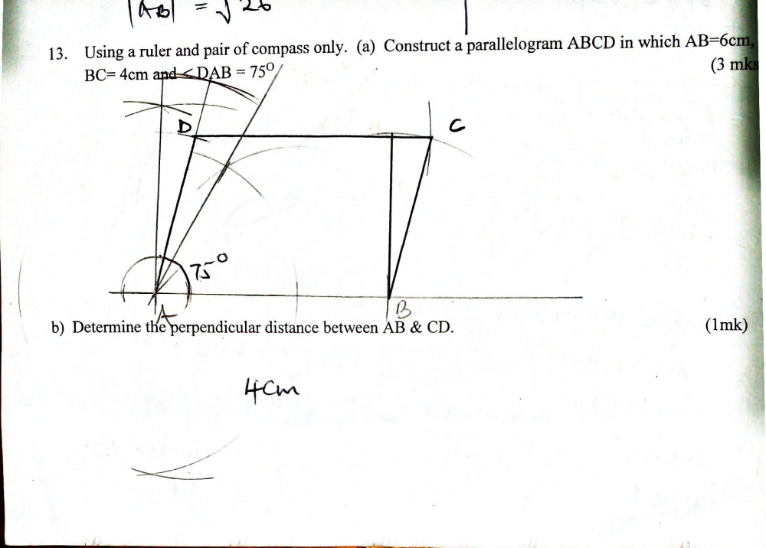

14. B  66  60M  C A | Tan 45⁰ =$\frac{60}{bc}$  BC=$\frac{60}{\tan{450}}$ =60m………………….B1  $≺$x=tan⁻¹0.25 ………………………..M1  =14.04………………………………………..A1
15.  X²+5X+P=0  3²+5(3)+P=0  9+15+P=0  24+P=0  P=-24……………………………………….B1  X²+5X-24=0  X²+8X-3X-24=0  X(X+8)-3(X+8)=0  (X-3)(X+8)=0 …………………….M1  X=3 OR X=-8 …………………………..A1 | Obtaining the value of P  Obtaining the factors
16.

A=$\frac{144}{360}$X 2X$\frac{22}{7}$XR²

385=$\frac{144}{360}$X 2X$\frac{22}{7}$XR² ……………………………….M1

R²=306.25
R=17.5cm. ………………………………………….B1
L=$\frac{144}{ 360}$x2x$\frac{22}{7}$x17.5
L=44cm
Perimeter=17.5cm+17.5cm+44cm=79cm………………….A1
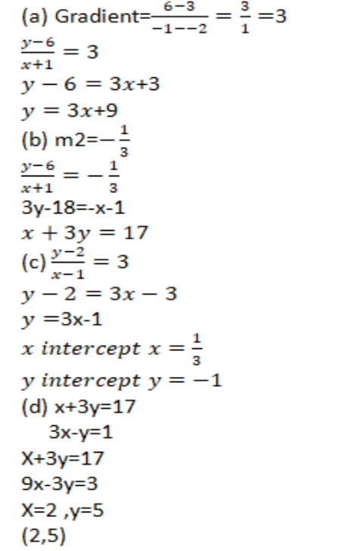  18.)  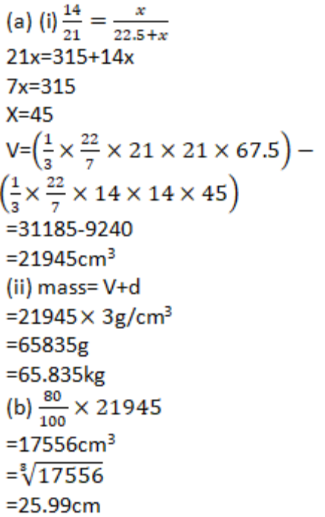  19.  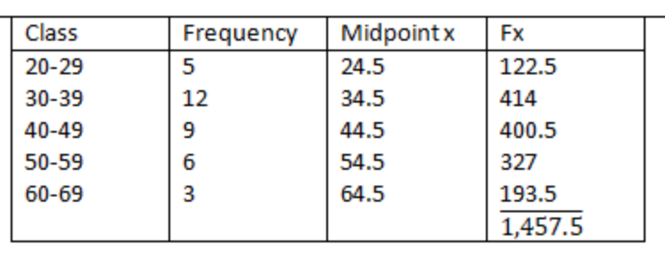  b)  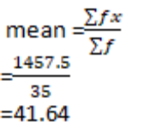  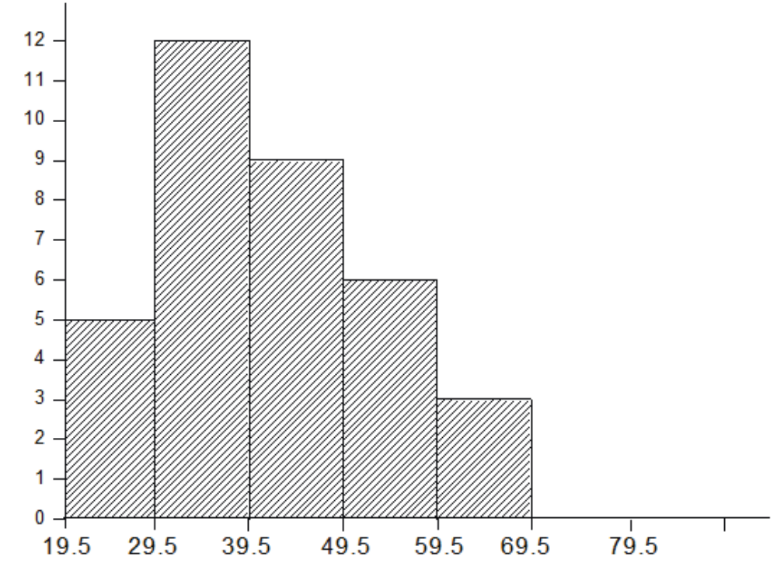  20. $P ∝\frac{Q^{3}}{R^{2}}$……………………………..B1  $p=\frac{{KQ}^{3}}{R^{2}}$  $16= \frac{{K2}^{3}}{3^{2 }}$ ……………………………..M1  $16= \frac{8K}{9}$  $k=18$ …………………………………A1  $288= \frac{18 ×4^{3}}{R^{2}}$  $R^{2}=\frac{18 X 64}{288}$ ……………………………………M1  $R^{2}=4$  $R=2$ ……………………………………………………………..A1  b)  $P= {\frac{KQ}{122}}^{3}$  $P_{1}=\frac{K{\left(0.7\right)}^{3} Q^{3}}{R^{2{\left(1.4\right)}^{2} R^{2}}}$ ………………………………..M1  $P1= \frac{{0.343KQ}^{3}}{{1.96R}^{2}}$ ……………………………………….B1  $\left(P_{1}-P\right)= {0.343K\frac{1}{1.96}Q}^{3}- \frac{{KQ}^{3}}{R^{2}}$ …………….M1  $\left(P_{1}-P\right)= {\frac{-29.106Q}{{1.96R}^{2}}}^{3}$  $\frac{{-29.106Q}^{3 }}{{1.96R}^{2}} ×{\frac{R}{{18Q}^{3}}}^{2}$ X 100 ………………………………………….M1  = - 82.5%  P decreases by 82.5% …………………………………………………A1  21  Det=10-12=-2…………………………………………………………………………B1  (a) $m^{-1}$ = $\frac{-1}{2}\left[\begin{matrix}5 & -3 \\ -4 & 2\end{matrix}\right]$ …………………………………………………..M1  $m^{-1}= \left[\begin{matrix}\frac{-5}{2} & \frac{3}{2} \\ 2 & -1\end{matrix}\right]$ ………………………………………………………A1  (i) $4x+6y=1280$ …………………………………………B1  $8x+10y=2360$………………………………………….B1  Or  $2x+3y=640$  $4x+5y=1180$  (ii) $-\frac{1}{2}\left[\begin{matrix}5 & -3 \\ -4 & 2\end{matrix}\right] \left[\begin{matrix}2 & 3 \\ 4 & 5\end{matrix}\right] \left[\frac{x}{y} \right]= -\frac{-1}{2} \left[\begin{matrix}5 & -3 \\ -4 & 2\end{matrix}\right] \left[\begin{matrix}640 \\ 1180\end{matrix}\right]$  $\left(\begin{matrix}1 & 0 \\ 0 & 1\end{matrix}\right) \left(\frac{x}{y}\right)=-\frac{1}{2} \left(\begin{aligned}32000-3540 \\ -2560+2360\end{aligned}\right)$……………Pre-multiplication by inverse M1  $\left[\frac{x}{y}\right]$=-$\frac{1}{2 } \left[\begin{matrix}-340 \\ -200\end{matrix}\right]$………………………………………………………B1  X = shs 170  Y= shs. 100 ……………………………………………………………...A1 For both answers  22  23  24. v= $\frac{1}{2}t^{2} -3t +7$  $v=\frac{8^{2} }{2}$ -3$\left(8\right)+7$ ……………………………………………….M1  $32-24+7$  $15m/s$ …………………………………………………………….A1  b) $a=\frac{dy}{dt}= \left(t-3\right) {m/s}^{2}$ ………………………………….M1  a=-3m/s²………………………………………….A1  c) $t-3=0$  $t=3 sec$  $v=\frac{1}{2}t^{2}-3t+7$  = $\frac{9}{2}-9+7$ ………………………………………………..M1  4.5-9+7=2.5M/S……………………………………………………..A1  d) $s= \frac{1}{6}t^{3}- \frac{{3t}^{2} }{2}+7t+c$  $\left[\frac{t^{3} }{6}- \frac{{3t}^{2 }}{2}+7t+c\right]²$…………………………………………..M1  $$\left\{\frac{8}{6}-6+14+c\right\}- \left\{0+c\right\}$$  1$\frac{1}{3}+8+c-c$  $9\frac{1}{3}$m………………………………………………………………A1  e) $\left(\frac{1^{t3}}{6}- \frac{3^{t2}}{2}+7t+c \right)²$  $\left\{\frac{27}{6} \frac{27}{2}+21+c\right\}- \left\{\frac{8}{6}-6+14+c\right\}$ ………………………………………………….M1  $$12+c-9\frac{1}{3} c$$  $12-9\frac{1}{3}=2\frac{2}{3}$ ……………………………………………………………………………….A1 | M1  A1  M1  A1  M1  M1  A1  M1  M1  A1  10mks  M1  A1  M1  M1  A1  M1  A1  M1  M1  A1  10mks  B1  B1  M1  M1  B1  B1  M1  M1  A1  M1  B1  B1  M1 B1  B1  B1  B1  M1  M1 | Classes  Frequency  Midpoints  Fx column

