FORM 4
312/2
GEOGRAPHY
PAPER 2 MARKING SCHEME
SECTION A
- a) Name two exotic breeds of commercial beef cattle reared in Kenya.(2marks)
- Aberdeen Angus
- Red Angus
- Hereford
- Sahiwal
- Galloway
- Sauta –Gertrodus
- Charolais
- Shorthorn

b) State three physical factors that favour commercial beef farming in Nyika plateau. (3marks)
- Gently sloping or undulating landscape for easy movement of animals.
- Adequate water supply from water points and rivers for animals to drink.
- Large tracts of land or extensive land for beef ranching.
- Adequate natural features to feed animals
- The hot semi-arid conditions or moderate rainfall conditions in the areas favour beef cattle farming /keeping
- The ranching schemes which control grazing and spreading of diseases and pests.
- Tsetse fly free conditions favour keeping of livestock.

- a) Define the term fisheries.(2marks)
They are water bodies where aquatic animals or fish are found or reared and exploited for food and commercial purposes.

b) State three ways in which marine fisheries in Kenya can be conserved. (3marks)
- Restocking the overfished areas by breeding fingerling in fish farms.
- Standardizing the mesh size of nets used to stop indiscriminate fishing and ensure only mature fish are caught.
- Licensing commercial fishermen to control their numbers and prevent illegal fishing and overfishing.
- Restricting fishing to specific seasons to allow breeding and maturing of fish.
- Legislation to restrict disposal of untreated or solid waste into the sea/ lakes in order and ensure to control water pollution and ensure survival of fish.
- Monitoring and discouraging the entry of foreign fishermen in the Indian Ocean water to an extent of the 320km Exclusive Economic Zone or Territorial waters.
- Enforcing the international conventions to protect the endangered fish species.
- Encouraging fish farming to ensure sufficient supply of fish from other sources other than the natural fisheries.

- a) Apart from coniferous forests, name two other types of natural forests. (2marks)
- Tropical hardwoods/Equatorial forests.
- Temperate hardwoods or temperate deciduous forests.
- Tropical monsoon forests.
- Mangrove forests.
- Mediterranean forests.
- Warm temperate evergreen forests or warm temperate forests.
- Mixed forests
- Montane forests / Bamboo forests.

b) State three characteristics of coniferous forests which favour their exploitation.(3marks)
- The trees are light in weight thus easy to transport.
- The trees are softwood thus easy to cut.
- Forests have pure tree stands thus easy to select desired tree species.
- There is little or no undergrowth hence easy cutting.
- Moderate the density thus easy to cut the mature trees.
- The trees have straight and tall trunks.
- Planting trees in the catchment areas.

- a) Identify two types of road surfaces.(2marks)
- All weather road-bound surface.
- All weather road- loose surface.
- Dry weather roads.
- Motorable tracks and footpaths.
b) Name three Great Lakes on the St. Lawrence sea way. (3marks)
- Lake superior
- Lake Michigan
- Lake Huron.
- Lake Erie
- Lake Ontario
- a) Name two rivers in the low lands of western Rift valley causing seasonal flooding.(2marks)
- River Nyando
- River Nzoia.
- River Yala.
- River Kuja/Gucha.

b) State three methods used to control foods in Kenya.(3marks)
- Construction of check/ earth dams across Rivers.
- Construction of dykes /artificial levees along river banks.
- Construction of diversion channels / canal.
- Construction of drainage channels / ditches / forrow.
- Dredging to deepen / widen River channel.

SECTION B
- Study the photograph below and answer the question that follows.
a i)Identify the type of photograph shown above.(1mark)
Ground General View photograph.

ii) Give three factors that could have favored establishment of irrigation project shown on the photograph. (3marks)
- Gently sloping and that allows water to flow by gravity.
- Clay soils / black cotton soils which hold water for long to be used by crops.
- Large and regular supply of fresh water from rivers, lakes or reservoirs to irrigate throughout the year.
- Extensive op[en land for starting and expanding the irrigation project.
- Sparsely populated land to reduce the cost of resettlement and provide land for large scale farming.
- Availability of capital to run the project activities
- Availability of skills and technology for undertaking the irrigation project.
- Availability of market for crops to make the project viable and profitable.
- Absence of pests and diseases that can lead to law yield or lower the quality of products.

iii) Draw a rectangle measuring 15 $×$ 10 cm to represent the area shown on photograph. (1marks)
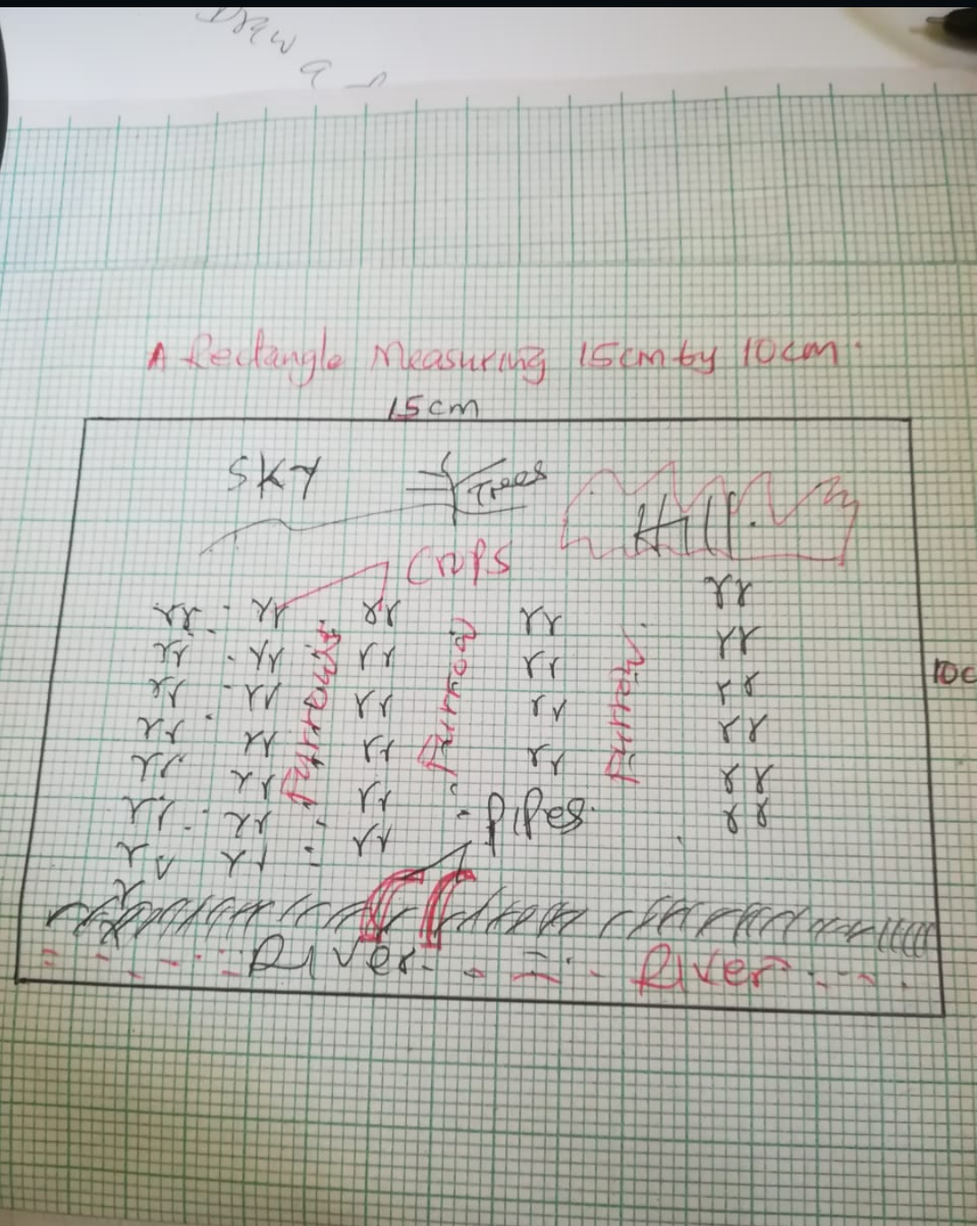

iv) On the rectangle sketch label four main features represented on photograph. (4marks)
- Crop
- Furrow
- Pipes
- Rivers
- Sky

b) i)Apart from forrow name four irrigation methods used in Kenya.(4marks)
a)Lifting devices
b)Basin irrigation or flood irrigation.
c) Overhead sprinkling.
D Trickle irrigation.
ii) State four physical problems experienced by farmers at Mwea Tebere Irrigation Scheme.
- Incidences of water borne diseases like Malaria and Bilharzia affect farmers or even kill them.
- Pests infest rice which lowers production e.g Quelea Birds.
- Water weeds which compete with rice for nutrients e.g Rhizome weeds.
- Sitting in the canals reduces the amount of water flowing into the fields.
- Low or fluctuating water levels in the rivers during the dry season reduce water flowing into the fields.
c i)State two ways in which Salinity of the polder is reduced in the Netherlands. (2marks)
- Planting reeds to use up excess salts.
- Treating soil with chemicals to reduce salty in the soil.
- Flushing soil with fresh water to remove or dilute excess salt.
- Continuous pumping of water out of the polder to the sea.

ii) Give three differences between land reclamation in Kenya and the Netherlands. (6marks)
- In Kenya reclaimed land is relatively small while in Netherlands reclaimed land is large.
- In Kenya land is mainly reclaimed from swamps and marginal areas while in Netherland reclamation is from the sea.
- In Kenya digging of canals or ditches is used to drain water from marshy areas while in the Netherlands there is use of advanced methods like wind pumps to drain sea water from polder.
- In Kenya irrigation is used to reclaim dry areas while in Netherlands Irrigation is used to lower the salinity of the soil in the reclaimed lands.
- In Kenya dykes are used to control river flood while in Netherlands dykes protect the reclaimed land from invasion by the sea.
- In Kenya land reclamation was prompted by drought and food shortage while in Netherland it was promoted by large scale flooding at the coast.

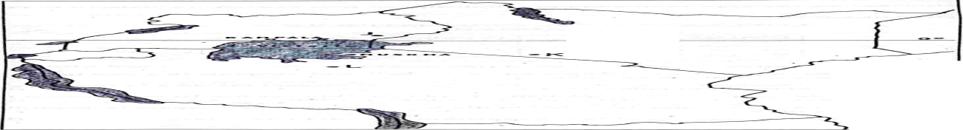
- The Map below shows the location some minerals in East Africa.
- Name the minerals mined in the areas marked J, k, and L.(3marks)
J Gold
K Salt
L Diamond

b) Explain how the following factors influence the exploitation of minerals.
- Mode of occurrence of minerals.(4mrks)
- It determines the method of mining and the cost of extraction.
- Minerals at shallow depths or near the surface or alluvial deposits are easier and cheaper to extract while deep seated minerals are expensive to mine
- Minerals close to the surface in layers .beds and seams are extracted by open cast or alluvial mining while minerals found deep in the ground in veins and lodes underground mining is used

- Transport.(2marks)
- Mineral Ores that are heavy and bulky require cheaper railway or water transport system to reduce the total cost of production
- Mineral deposits in remote areas with poorly developed transport systems are less likely to be exploited.
c i) Identify three factors that influence occurrence of minerals.(3marks)
- Vulcanicity
- Rock Metamorphism
- Denudation-weathering and erosion
- Earth Movement like folding
- Evaporation
- Deposition or sedimentation.

ii) State three conditions necessary for the formation of petroleum.(3marks)
- Presence of sedimentary rock structure or rock layers over the fossils
- Presence or deposition of organic remains or fossils over a long period of time.
- Presence of a porous rock sandwiched between two non-porous rock layers.
- Presence to compress the organic remains due to folding.

d) Describe the opencast method of mining.(4marks)
- Used to exploit minerals at shallow depths.
- The unwanted materials or over burden or top soil covering the minerals are removed using bulldozers.
- If the mineral Ore is soft, it is removed by digging or quarrying or stripping.
- If the mineral Ore is found within hard rocks the rocks are broken up by blasting using explosives
- The mineral deposits are then dug out using huge and powerful mechanical shovels
- The minerals Ore is loaded into trucks or railway wagons to the processing plant.

e) Explain three benefits of petroleum mining to the economies of Middle East countries. (6marks)
- The countries export petroleum which earns foreign exchange that helps to develop other sectors of the economy.
- Petroleum is used as a raw material for petrochemical products leading to the growth of petroleum industries and promoting industrialization
- The government earns revenue on royalties that enable Middle East countries to invest heavily in overseas countries.
- Petroleum mining has led to the creation of employment opportunities for the local population raising their living standards.
- The proceeds or income from petroleum mining have been used to

8.The table below shows the total number of horticultural crops exported from Kenya in 2008 to 2009 use it to answer the questions that follow
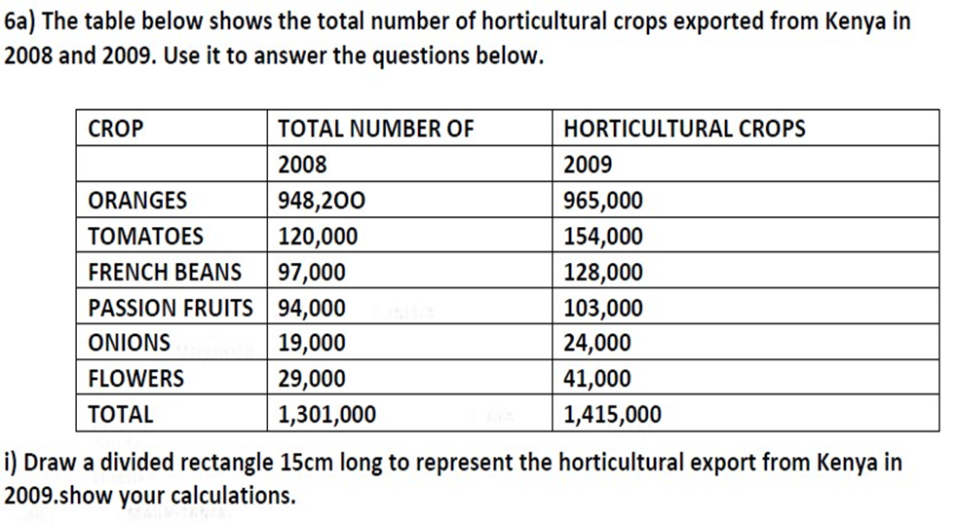

(8marks)
A DIVIDED RECTANGLE REPRESENTING THE HORTICULTURAL EXPORT FROM KENYA IN 2009

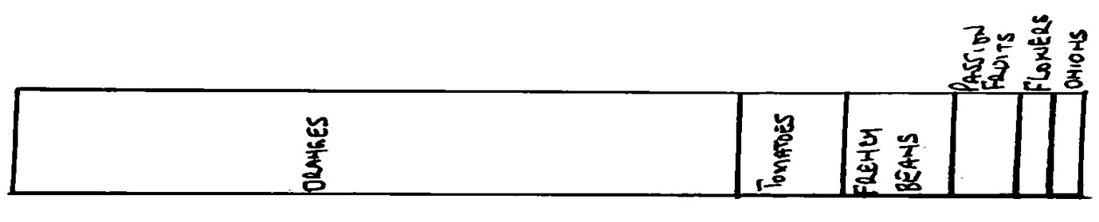

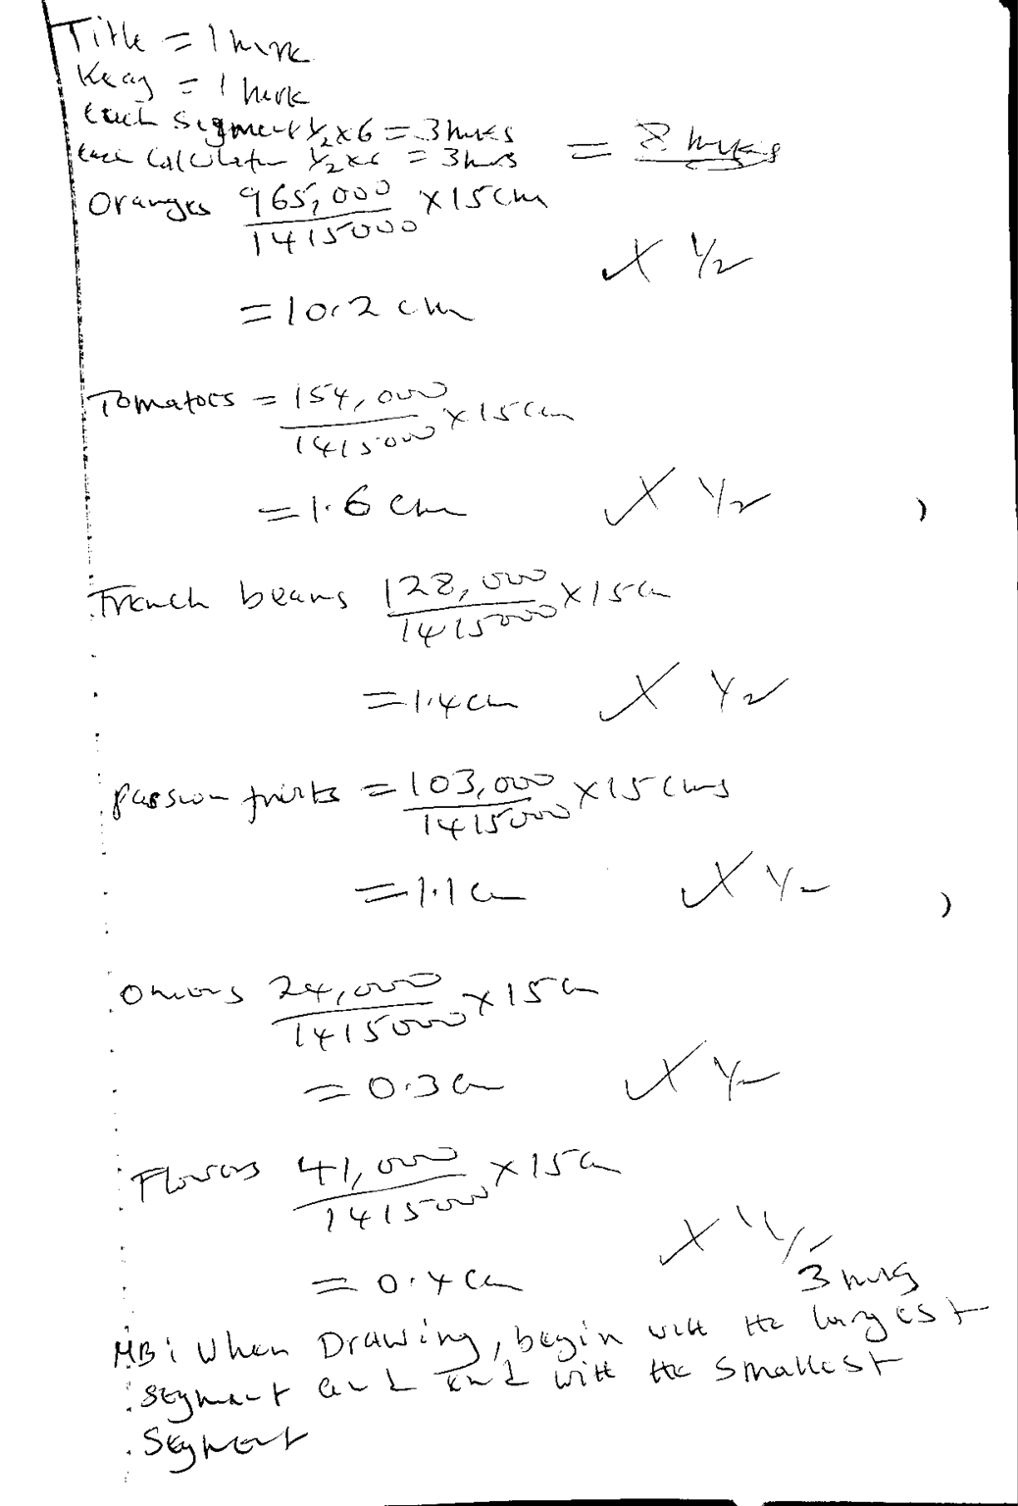

b) i)Name any two counties in Kenya where tea is grown on large scale (2marks)

Kericho
Kissi
Nyamira
Nandi
Vihiga
Bomet
Kiambu
Muranga
Meru
Nyeri
Kirinyaga
Embu
Kakamega
Trans Nzoia
Nakuru

ii) State three physical conditions required for growing of tea in Kenya (3marks)

Cool/ warm climate/ moderate to high temperature
High rainfall which is well distributed throughpout the year
Deep well drained volcanic soils
High altitude above sea level
Frost free areas
Gently sloping/ undiluating landscape
- Describe the stages involved involved processing of sugarcane at the factory. (6marks)
- At the factory the cane is weighed.
- The cane is washed to remove soil or mud
- The cane is cut into small pieces by rotating knives.
- The cane pieces are crushed or pressed by heavy rollers to produce juice.
- The juice is filtered to remove impurities.
- Addition of lime is done to reduce acidity in the juice.
- The juice is boiled to evaporate water forming thick brown syrup.
- The syrup is stirred for crystal to form.
- The crystals a are separated from the molasses
- The crystals are refined by bleaching to form white sugar.
- The crystals are heated dried and cooled.
- Grading, weighing and packing ready for sale.

- Explain three challenges facing sugar farming in Kenya.(6marks)
- Fire outbreak destroying the cane causing losses to the farmers.
- High cost of farm inputs lowering the farmers.
- Pest such as termites, white scales destroying the quality and lowering the yields of cane.
- Diseases such as rationing stunting, smut, mosaic and yellow wilt destroying the quality and lowering the yields.
- Mismanagement of sugar factories lead to delayed payments to the farmers discouraging farmers.
- Competition from cheap imported sugar lowering the prices hence low profits to the farmers.
- Poor feeder roads delaying delivery of cane to the factory lowing the quality of the cane.
- Drought delaying maturing of sugar cane which lower the quality and production.
- Poor seeds lead to poor harvest which lowers. Profits.

9a i)Differentiate between internal and regional trade.(2marks)
Internal trade or domestic trade is the buying and selling of goods and services within a country’s borders while Regional trade is the buying and selling of goods and services between countries that are found within the same geographical region.

ii) Name three major imports from the Europe to Kenya. (3marks)
- Machinery.
- Capital equipment or parts of assembled machinery.
- Textiles.
- Pharmaceutical products or medicine.
- Fertilizers.
- Automobiles or vehicles.
- Aircraft.

b) Explain three factors influencing trade in Kenya. (6marks)
- Population size: This determines demand or market of goods produced leading to expansion of trade.
- Cultural differences: This lead to specialization in production of goods for exchange.
- Production of similar goods for trade by different regions; this limits market potential while production of different goods enhances trade between communities in the country
- Level of income or purchasing Power: Low purchasing power by most Kenyans limits the markets for goods and services.
- Level of production of transport and network: A well-developed transport network enhances trade as goods can be transported to far markets while a poor transport network limits trade as market potential is restricted.
- Security: This encourages expansion of trading
Activities while insecurity discourages trade I stone regions

c i)Give two reasons why the Common Market for Eastern and Southern African (COMESA) was formed.(2marks)
- To encourage member countries to reduce duties charged on goods entering their countries from COMESA member countries
- To promote trade among member countries or states.
- To acquire greater economic strength or higher bargaining power with other world trading blocs.
- To establish a large market for the goods produced in the region.
- To remove trade barriers among member’s states and create similar trade laws.
- To create regional specialization in order to improve the quality of goods produced.
- To create political cooperation among member states.
- To create monetary or financial cooperation among member state or create a common currency for trade.
ii)Apart from COMESA,give any other two trading blocs in Africa.(2marks)
- EAC:East Africa cooperation
- ECOWAS: Ecomomic Community Of West African States
- EU:European Union
- SADC
(Student must write in full to score)

- State four reasons why Kenya experience unfavorable balance of trade.(4marks)
- Kenyan’s exports are mainly agricultural raw materials with low value and earn less revenue while imputs are manufactured goods of high value causing a trade deficit.
- Agricultural goods from Kenya face stiff competition from imposed quota markets which lead to reduced sales and less earnings.
- Some of the goods exported are of low quality hence generates little earnings.
- Semi processed goods exported earns less income compared to imports.

- Explain the future of international trade in Kenya can be improved. (6marks)
- Kenya is exploring for new markets in the Far East countries eg China to avoid over reliance on the European markets.
- Kenya has signed trade agreements with various countries in Africa and in America which will help improve trade
- Kenya has joined trading blocs like COMESA AND each in order to improve trade with other African countries.
- Some Kenyan entrepreneurs are setting up branches of their industries in the neighboring countries so as to expand trading activities.
- Kenya is undertaking partial processing of some of the agricultural products before export thus adding value to increase earnings.
- Implementation of vision 2023 will lead to increased production hence increased trade.
- Kenya should diversity her export products and ensure quality through HEBS so as to reach wider markets for her goods Kenya should improve her international transport and communication links for efficient trade transactions in world trade.
- Kenya should improve her inter- regional transport and communication links for efficient trade transactions in regional trade and remove trade barriers by opening border points to create free movement people and goods within the region.

10a) Name three national parks in Uganda. (3marks)
- Ruwenzori National Park.
- Murchison Falls National Park
- Kabalega National Park.
- Kipedo Valley National Park
- Lake mburo National Park.
b i) Give four benefits of game reserves to local communities. (4marks)
- Offers employment to nearly communities raising their living standards.
- The management of game reserves provides social amenities like schools to local communities.
- Income from game reserves to local authorities is used to provide services to the communities.
- Sometimes the community members are given animals meat when they are culled.
- Education institutions located near game reserves have easy access for educational tours and learning.
- Tourists to game reserves increase the market for local products like handicraft.

ii) Name three tourist attractions found in the Rift Valley province of Kenya.(3marks)
- Varied relief features like crates and volcanic mountains
- Gorges eg Njorowa,gorge at Hell’s gate.
- Geysers and hotsprings.
- Wild animals or wildlife in National Parks and Game Reserve.
- Lakes .
- Birds like flamingoes.
- Vegetation
- Diverse culture or handicraft.
- Pre-historic sites archaeological sites or Museums.
- Sport fishing and game ranching.

c i) State three physical conditions that influences that influence distribution of wildlife in East Africa. (3marks)
- Climate or Temperature and rainfall variations
-Hot and warm lowland areas support many plants and animal species.
-Cold Mountains areas have fewer plant and animal species.
-High rainfall areas have thick forest that supports many animal species.
- Relief/Terrain / Attitude and aspect
Some plants grow in lowlands e.g grasslands while most forest trees grow in highlands.
Windward slopes of mountain have more rainfall and are forested with more animals unlike the leeward side which have grassland.
- Soil type: Different soils support different types of plants some animals depend directly on such plants for their food and shelter.
- Vegetation variation and distribution: Vegetation provide habitat for different animal species and birds found in an area
Grassland support grazing herbivores
Most carnivores live in grassland.
- Drainage: Presence or absence of water will determine the kind of plant and animals in an area
Well drained areas support a wide variety of plants and animals.
ii) List four problems experienced by the Kenya Government in its effort to conserve wildlife. (4marks)
- Illegal hunting or poaching of wild game threatens conservation and many lead to extinction of some wildlife.
- Overstocking of some wild animals leads to overgrazing and destruction of the environment reducing food for the animals.
- Human animal conflict when some wild animal’s stray into settlement and destroy crops or kill domestic animals resulting in high compensation
- Inadequate capital limits conservation efforts as the government depends largely on donors.
- Rapid population growth makes people encroach into the game parks and game reserves.
- Pollution of the environment leads to death of wildlife.
- Fire outbreaks destroy wildlife habitats for wildlife.
- Pests and disease threatens some animal species.
- Frequent drought in some national parks leads to loss of plants and animals through starvation.
d) Explain four physical factors which have made Switzerland a major tourist centre.(8marks)
- Favourable / varied Climate
Warm summers allow swimming, sunbathing and viewing the show capped mountains while cold winters encourage winter sporting like skiing and ice skating.
- Magnificent scenery
The show capped mountains, cascading waterfall and glaciated landscape on the AIPS
- Glacial lakes
These have clean, fresh blue water ideal for sports, fishing, boating and swimming and has few beaches for sunbathing in summer
Central location of Switzerland in Europe.

- Health spas or health resorts
The many glacial lakes and wells with medicinal water

