MARKING SCHEME
312/1
GEOGRAPHY PAPER 1
SECTION A
ANSWER ALL THE QUESTIONS IN THIS SECTION
1a, Identify two areas studied in practical geography (2mks)
- Map work
- Field work
- Photograph work
(any 2)
b, state three reasons for studying geography (3mks)
- Geography is a career subject and a requirement for admission to particular courses.
- One acquires knowledge which contribute to local, regional and international development.
- Creates awareness in the people of the significance of management and conservation of the environment
- Geography teaches on how to manage time properly by drawing working schedule
- It is a tool for a better citizenship
- Help learners to develop skills of observing, reading, analyzing and interpreting map , photographs, charts and diagrams and statistical data
- Provide knowledge on formation and evolution of land forms
- Encourages teamwork through field work
( Max of 3mrks)

2a. What is a line of longitude? (2mks)
- It is an imaginary line which is drawn on a map from North Pole to South Pole.

B what is longitude of a point x whose local time is 12:40 pm, when the local time at point A 20°E is 4:00PM. (3MKS)
12:40PM – 4:00PM =3hrs 20mins
- 3hrs 20min
- 30°W 20°E 200mins =50° = 4:00PM
- 30°W

3, The diagram below represents an instrument found in a weather station, use it to answer question 3 (a(i) and (a(ii)

a (i) Identify the instrument
- Wind vane (1mk)
(ii) How is the direction of wind determined from the diagram above? (1mk)
- By checking where the points
b, State 3 characteristics of wind (3mks)
- Winds originates from areas with high pressure to low pressure zone
- Wind carry weather conditions of place of origin
- Wind influences weather conditions to place of destinations.
4a, Name two tectonic plates
- Eurasian -Australian-African -North American
- South American -pacific –Antarctic –Nazian –Juan –Somali - caribian -cocos
[max 2 (2mks)
b, Identify 3ways in which the earth’s crust is affected by earthquake (3mks)
- Causes landslides –Leads to volcanic eruption –Cause lowering/ rising of land
- Cause lateral/ vertical displacement of land
- Cause faulting of the crust/breaking of rocks
- Lead to distortion of crustal rocks

5. The diagram below shows a desert land form .use it to answer the question that follows.

- M-Yardang
II) Describe how the feature marked M is formed (4mks)
- -Formed in desert where alternating verticai layers of hard and soft rocks
- -Rocks lie parallel to the winds
- -Wind abrasion erodes on soft rocks leading to formation of farrows
- -Ridges are left standing between the farrows thse ridges are yardangs

SECTION B
ANSWER QUESTION 6 (SIX) AND ANY OTHER TWO QUESTIONS IN THIS SECTION
Study the map of Kisumu East sheet and answer the questions that follow
6a, (i) Give six figure grid difference of Mow camp located along all-weathered road bound surface in the North Western part of the area covered by the map (2mks)
- 964958 (2X1)=2
ii) Measure the length of a regional boundary in the North Western part of the area covered by the map. Give your answer in KM. (2mks)
- 6.9+ OR – 0.2 (6.7-7.1)KM
iii) What is the bearing of the trigonometrical station at grid square 0898 from the air photo principle point at grid square 0294
- 048°
b, Using a scale of 1cm rep 100m draw a cross-section along northing 99 from grid reference 0409902 to grid reference 100990
i) On the cross-section mark and name
* A rock out crop at grid square 0599 (1mk)
* Other tracks and footpaths (1mk)
* A river at grid square 0899 (1mk)
- (Draw the cross-section and mark the features)
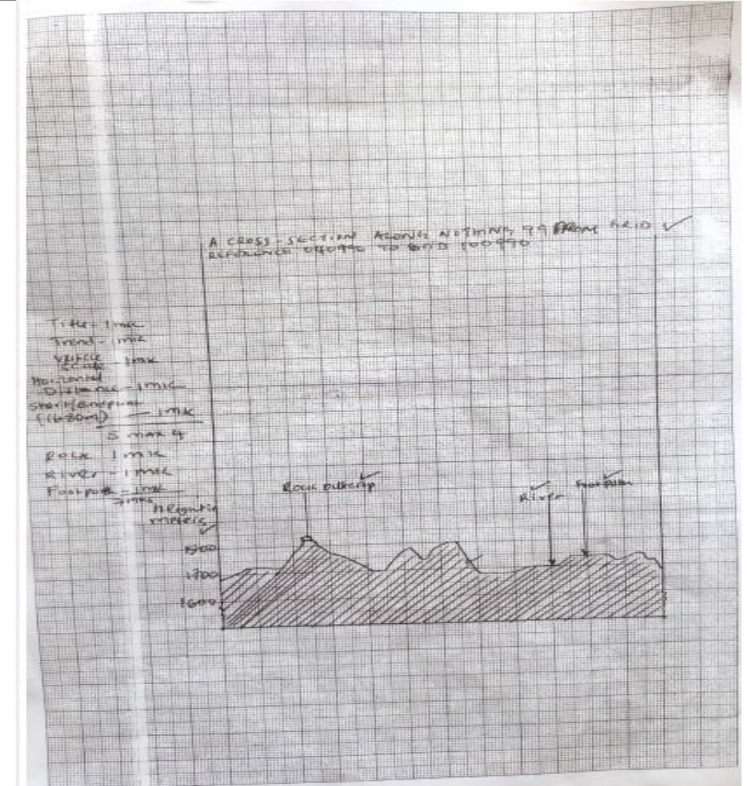
ii) Calculate the vertical exaggeration of your cross-section (2mks)
- 1cm rep 100/1 : 50000
- 1cm rep 100m
1/100000x 50000/1=5times

c. Citing evidence from the area covered by the map, explain 3 factors that influenced the location of Kisumu town (6mks)
- Gentle slopes as evidenced by spaced contours for easy construction
- Availability of water from the lake (winum gulf) for domestic and industrial use
- Availability of building materials from quarrey at grid reference 9691
d. Describe the characteristic of the long profile of Mayenga/Luando (4mks)
- Has meanders
- It is a permanent river
- Flows from NW to SW
- flows on flood plain
- has many tributaries and ditches
- forms dendritic drainage pattern
- at the mouth has distributaries
- drains into a lake in the south west

7a, i) State 3 factors that influence rock metamorphism (3mks)
- rock resistance /hardness/stability of the minerals
- rock texture and structure
- solubility of rock minerals
- rock porosity
- chemical properties of rock mineral
ii) Explain three ways in which brocks may become metamorphic (6mks)
- Localized trees/compressional forces causes modification of the previous rocks/resulting to folding of existing rocks changing their structure and mineralogical alignment
- Great heat caused by intrusion of hot magma on previous rocks changes rock leads to recrystallization forming new minerals
- Pressure caused by the weight of overlying rock may alter the structure and appearance of bottom layers of rocks
- Great heat by hot gases an d liquids on previous rock leading to re-crystalline forming new minerals
b, i) Give an example of each of the following categories of sedimentary rocks
  - I) Carbonaceous rocks -coal
  - ii) Sulphates -Gypsum
  - iii) Arenaceous -sandstone/mad stone/clay stone/silt stone
c, Explain how coral rocks are formed (4mks)
- Tiny marine organism called coral polyps lives in colonies in the sea
- The polyps extracts calcium from sea water to make shells
- When the polyps die and their hard skeletons accumulate sea bed in shallow waters
- Weight caused by successive colonies compress the shells into a coral rock

d, i) Give reasons why coal and petroleum are not referred as minerals (2mks)
- They are products of plants and animals/flora and fauna and therefore are organic substance but minerals are inorganic substances
ii) Give 3 characteristics of minerals (3mks)
- Have different degrees of hardness
- Minerals differs in texture
- Have different degree of tenacity
- Minerals has luster
- Have different colors
- Have different solubility
- Have different cleavage
iii) Explain the significance of rocks under the following fields
- Industry (2mks)
  - limestone rocks are used as raw materials in constructing industries
  - coral rocks are harnessed into coal fuel that is used in industry

Agriculture (2mks)
- Igneous rocks weather into fertile soils which are used in agricultural production

8. a ) What is folding? (2mks)
- Folding is the bending of the rocks crust due to tectonic forces.
b) Name the continents in which the following fold mountains are found. (3mks)
i) Andes mountains
- SOUTH AMERICA
ii) Himalayas
- ASIA
iii) Cape ranges
- AFRICA
c) Draw a well labelled diagram to show a simple symmetrical fold. (3mks)
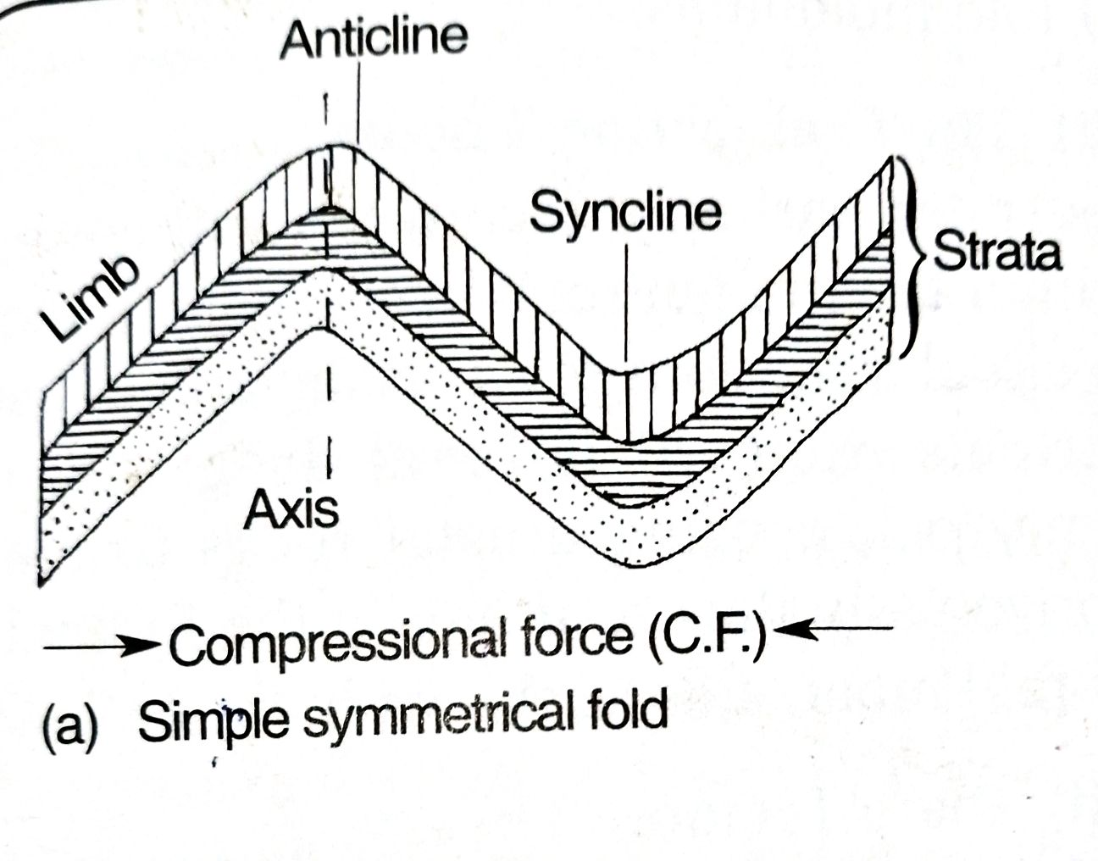

d) Apart from fold mountains, name any other three features that are formed through folding. (3mks)
- INTER MONTANE BASINS
- INTER MONTANE PLATEAUS
- DEPRESSIONS

e) Explain four positive effects of fold mountains. (8mks)
Foldind leads to formation of beautiful scenery which attracts tourist
Making mining sassier by exposing minerals to the surface
Fold moutains provides barrier during attacks
Leads to formation of minerals through metamorphism
Fold moutains receives rainfall leading to growth of forest which provides home for wild animals and promote agriculture
f) Form four students in your school are planning to study folded landforms through fieldwork.
i) Give three methods of recording data that can be applied by the students. (3mks)
- Taking photographs
- Note taking
- mapping
ii) What are some of the problems they are likely to face during the fieldwork? (3mks)
- Accidents due to steep slopes
- Attack by wild animals
- Harsh weather conditions
9. (a) Differentiate between river rejuvenation and river capture.
- River rejuvenation is the renewal of the river’s erosive activity while river capture is the diversion of the head waters of one river
into the system of a more powerful river.

(b) Give three features resulting from:
(i) river rejuvenation
  - Knick point / waterfall
  - River terraces
  - Incised meanders / entrenched / ingrown
  - Rejuvenatinated gorges
  - Valley within a valley
  - Abandoned meander
(ii) River capture
  - elbow of capture / knick point
  - pirate stream
  - beheaded stream / misfit / captured river
(c). Explain the four ways through which a river transports its load.
- The fine particles such as silt are carried in suspension because they are light and can be maintained within the turbulence of the water.
- Fairly heavy particles / pebbles are lifted and bounce over short distances by the turbulence of the water i.e. saltation / hydraulic lift.
- The large and heavy particles are slided along the river bed i.e. traction
- Soluble materials are dissolved in water and carried in form of solution.
(d) (i) Importance of a route map.
- To help identify the direction to follow
- To help prepare a working schedule
- To help identify location of features for study
- To help estimate distances to be covered
- To help estimate the time the field study is likely to take.

(ii) Characteristics of a river in its old stage.
- Low speed
- Brown water
- River brands
- Meanders
- Distributaries
- Differed tributaries
(iii) Follow-up activities

- Reading more on the topic
- Displaying photographs / items collected
- Asking /answering question
- Writing reports
- Discussing with the rest of the class
- Analyzing / assessing the information collected against the hypothesis.
any 2 ×1=2
10. a, i) What is an ocean current ? (2mks)
- The horizontal movement of sea water
ii) Explain how the following influences the occurrence of ocean currents.
- Shape of land masses (2mks)
- When an ocean current moves towards the land, it changes direction and follows the outline of coast line
- An ocean current might split into two on meeting an island
- The velocity increases on passing a constricted area eg btn an island
- Wind (2mks)
- Wind direction influences the direction and speed of an ocean current
b, The diagram below shows some coastal features

- Name the features marked P,Q,R (3mks)
- P- headland
- Q- spit/bar
- R- stack
- Describe how a bay is formed (3mks)
- A coast with alternating hard and soft rock is attacked by breaking wave
- The soft rock is eroded by abrasion and solution
- This leads to formation of sea inlets known as base
- The hard rock project into sea head lands

c, Using a well labeled diagram, describe the process through which a Geo is formed (7mks)

Geo ✔

- Geo is formed when waves attach the waves of the cliff through abrasion, solution and hydraulic action
- A notch develop at the base of the cliff
- Continues wave action enlarges the notch in to a cave
- Both wave and chemical weathering causes the joints on the roof of the cave to enlarge
- A hole slowly develops at the back of the cave forming a blow hole.
- During high tide water is forced through the blow hole causing it to widen further eventually, part of the roof cave between the blow hole and the mouth of the roof collapse forming a long narrow inlet known as geo.
d, Explain 3 significances of oceans to human activities (6mks)
- Ocean provide water transport for bulky goods
- Ocean attracts tourists since they provide reaction activities such as surfing and fishing
- The rias/fiords provide sheltered water that are ideal for development of harbors
- The shallow continental shelves are ideal fishing grounds
- Provides fresh water for domestic and industrial use
- Ocean water contains valuable minerals and mined
- Tides/waves are harnessed to produce power energy
- Ocean influences coastal climate which influence agriculture

