BUSINESS STUDIES PAPER 2
MARKING SCHEME
END OF TERM 2 2026
TIME 2$1/2$HRS
1. (a) Explain five factors to consider when evaluating a business opportunity (10mks)
• Potential for growth/ possibility of expansion
An opportunity is said to be viable, when it has the ability to grow and expand.

• Infrastructure:
Easy access to infrastructure such as roads, water, electricity, telephone and postal services among others enables business enterprises easily make orders for goods and deliver them hence reducing operating expenses. With low operating expenses, profits can be maximized.

• Market for the goods and services:
An entrepreneur has to access potential and actual market for the goods and services he would like to sell. There must be a clearly defined market if the opportunity is to be considered.

• Rewarding to the investor/profitability
The opportunity should be rewarding to the investor (cost-benefit consideration). He should consider the expected returns against the expected cost to ensure that the benefits outweigh the cost.
Capital required
This is the money required to start the business and expand

• Competition and Competitive advantage:
Competition is regarded as a threat to business of similar kinds operating in a similar location.
Competition should be fair.
Availability of raw materials
Raw materials should be available both in quality and quantity

• Legal Consideration/government policy
The new idea should be in line with the legal regulatory framework e.g. an idea to sell drugs may not be viable because it is illegal.

• Profitability:
There should be reasonable profit from the investment/ in order to cover all the operational expenses.

• Personnel, Training and Management/skills
Before starting a business, it is necessary to make an assessment of the required personnel training and management. Look at the ability, cost of hiring and training human resource. Management efficiency will enable the business to succeed.

(b) Explain five circumstances under which the nature of goods would influence the choice of the means of transport (10mks)
- When goods are perishable in nature- this will therefore demand a faster means
- When goods are fragile –a smooth mean will therefore have to be selected.
- When goods are of high value- this will call for a very secure mean
- When goods are bulky – this will demand the appropriate mean such as water transport
- If goods are irregular in shape- an appropriate mean have to be selected
- When goods are liquid or gas – this will call for pipeline transport
2 (a) Explain five importance of insurance to the economy of a country (10 mks)
- The government collects revenue through the taxes collected/ this revenue provides public services.
- Creation of employment for those who work in the insurance industry such as brokers/agents.
- The industry creates confidence by encouraging businessmen to take risks of investing/work efficiently without worriers.
- Insurance ensures business continuity/through compensating business owners for losses/this enables the economy to continue developing.
- Insurance companies invest the profits realized in ventures that promote economic development e.g. real estate.
- The industry promotes a saving culture through life insurance/the savings become a source of investment funds.
- Insurance firms extend credit facilities/loans to businesses that can be used for investment.
- Life assurance policy may be used a security to obtain loans for investment

2b

MUGOYA TRADERS
TRADING PROFIT AND LOSS ACCOUNT
FOR THE YEAR ENDED 30th JUNE 2014.
Shsh
Opening stock 45000 | Sales 320 000
Add purchases 140, 000 | Less S.R 15 000
Less P.R 19,000 | 305 000
Add carriage 5,400 126,400
C.G.A.F.S 171,400
Less closing stock 22,000
C.G.S 149,400
Gross profit c/d 155,600
305,000 | 305,000
Discounts 6,000 | Gross profit b/.d 155,600
Salaries 50,000 | Discount 2,000
Power lighting 12,000 | Commission 8,000
Carriage outward 2,300
Net profit 95,300
165,600 | 165, 600
 | 20 ticks @$\frac{1}{2}$
3 (a) Explain five types of wholesalers (10mks)
  - General merchandise- stock wide variety of goods
  - General line- stock wide variety of goods but within one line
- Specialized - stock only one type of product in a particular line
  - Mobile- use vehicles to supply their goods at different places
  - Regional - operate within a certain geographical area
- Nationwide - Operate all over the country
- Cash and carry – operate on self-service and cash basis
- Rack jobbers - sells special goods to other wholesalers 5x2=10mks

(b) Explain five principles that should be considered when designing a good tax system. (10 marks)
- Equitable - fairness in payment of tax
- Certain -clear in terms of amount, time and manner of payment
- Convenient - (to payer and payee) in terms of when, how and where
- Economical - cost should be less than revenue collected
- Flexible - reality adoptable to changing circumstances
- Ability to pay – not too high for one not to be able to pay
- Diversified – Variety of taxes/broad based
- Simplicity – Easily understood by the tax payer
Mention 1mk otherwise 2 marks x 5 = 10mks

4. (a) Explain five negative implication of overpopulation (10mks)
- Shortage of land for settlement and farming leading to land fragmentation.
- Shortage of /strain on social services e.g. schools and hospitals.
- High government expenditure provide social services for the people.
- High dependency ratio since much of the population is made up of children hence reducing investments and future savings.
- High rates of unemployment because of the less available jobs.
- Unemployment leads to high rates of crime and social unrest especially among the youths.
- Exhaustion of resources due to over exploitation./ environmental degradation
- Decrease in parcapita income - as per production is fixed
b)
Required:
A THREE COLUMN CASH BOOK. (10marks)
Maralal traders
Cash book for the month of May 2014
Date | Details | L.F | D. Al | Cash | Bank | Date | Details | L.F | D.Rc | Cash | Bank
2014  May 1 | Balance | b/d |  | 180,000 |  | 2014  May1 | Balance | b/d |  |  | 450,000
,, 3 | Mpasha |  |  |  | 1,500,000 | ,, 11 | Jolloimat |  |  | 200,000 | 400,000
,, 7 | Sales |  |  | 280,000 |  | ,,19 | Rent |  |  |  | 75,000
,,14 | Commission |  |  | 150,000 |  | ,,19 | Electricity |  |  |  | 32,000
,,17 | Leteipa |  | 3776 |  | 185,000 | ,,19 | Water |  |  |  | 25,000
 |  |  |  |  |  | ,,21 | Drawings |  |  |  | 100,000
 |  |  |  |  |  | ,,24 | Kinai |  | 2,720 | 133,280
,,25 | Kiyapi |  |  |  | 200,000 | ,,28 | Salaries |  |  |  | 120,000
,,31 | Cash | c |  |  | 226,720 | ,,31 | Bank | c |  | 226,720
 |  |  |  |  |  | ,,31 | Balance | c/d |  | 50,000 | 909,720
 |  |  |  | 610,000 | 2,111,720 |  |  |  |  | 610,000 | 2,111,720
Jun.1 | Balance b/d |  |  | 50,000 | 909,720
- Details should score independently
- 40 x ¼ (10mks)

5. (a) Explain five differences between private limited company and partnership forms of business units. (10marks)
 | Private limited company |  | Partnership
 | Have a minimum of 2 shareholders to 50 members. |  | Have a minimum of two and a maximum of twenty partners for ordinary partnership./fifty for professionals
 | The business can be managed by one or two directors |  | The business is managed by active partners jointly.
 | Formed through company’s act |  | Formed through partnership act.
 | All members have limited liabilities. |  | One partner must have unlimited liability
 | The business a separate legal entity |  | Doesn’t have a separate legal entity
 | Main source of capital is share capital |  | Main source of capital is partners contribution

(b) Explain five benefits of indirect production to the society (10mks)
- Access to enough quantity of goods due to surplus production.(can be used interchangeably)
- Improved living standards due to income/profit generated
- They have access to many choices due to a variety of goods produced in the economy. (can be used interchangeably)
- Encourage competition leading to fair prices/high quality goods/accept
- Availability of employment opportunities since many people are engaged in various stages of production. (accept advantages of employment as expansion)
- The society enjoys improved infrastructure/roads which may be put up to support business activities| facilitate movement production (accept advantages as of infrastructure as an expansion.
- Improves the societal cohesion/peace/harmony due to interaction since many people are brought together from different areas to trade.
- Maximum/optimum utilization of available resources since production is meant for sales/leading to increased production.
- High Quality goods produced due to use (better (advanced technology/specialization
- It encourages specialization/division of labor which leads to efficiency in product/ better quality good. (accept advantages of specialization/division of labor as expansion.
- The society enjoys improved social amenities/which may be put up to support business activities. (accept advantages of social amenities as expansion.
- The society enjoys improved auxiliary services which are put up to support business activities(accept advantages of auxiliary services).
- Encourages trade/ exchange many people to get what they cannot produce/leading to generation of income to owners/government through taxes.
- Can lead to steady supply of goods since there are many producers who may engage in similar production activities
- Promotes creativity/innovation which leads to new ideas/product/technology
- Encourages use of machines which makes production more.
6(a.) Effect of a shift in demand curve to the right ,while supply remains constant

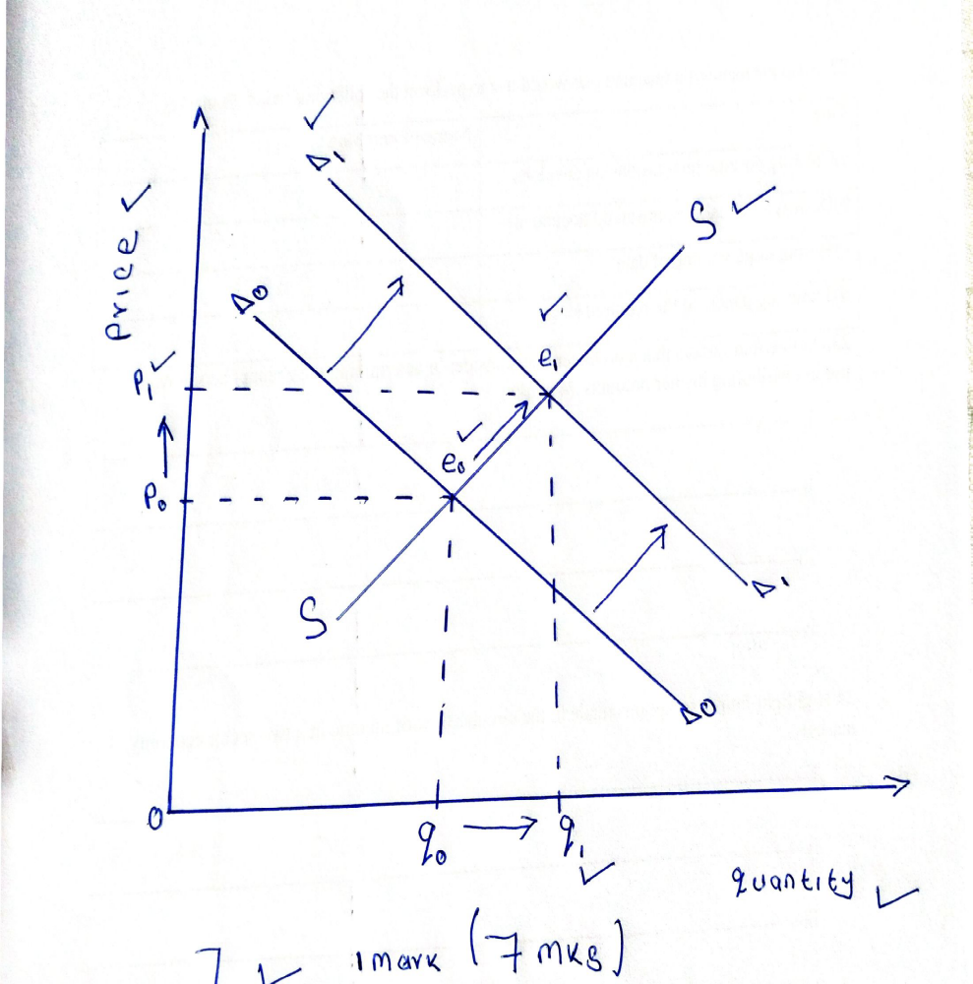

EXPLANATION
- Quantity demanded increases from Q 0 to Q1 creating shortage of goods /excess demand
- Due to the shortage /excess demand price increases from P0 to P1
- A new equilibrium point is established from E0 to E1 (3mks)

(b) Describe five features of good money. (10 marks)
- Acceptability: Must be acceptable to everyone for it to be used as a medium of exchange.
- Divisibility: Should be divisible into smaller units without loss of value.
- Scarcity: Should be relatively limited in supply so as to maintain value.
- Cognisability: Should be easy to recognize genuine from fake money.
- Malleability: Should be easy to print or mint but difficult to forge.
- Homogeneity: Money of the same denomination should be uniform in quality and identical.
- Stability in value: Should be able to last for a long time without changing in value so that it maintains credibility and acceptability. If it fluctuates in value, people prefer holding wealth in form of goods.
- Portability: Should be easy and convenient to carry around.
- Durability: Should be able to last for along time without getting torn, defaced or losing shape and texture.

