231/1
BIOLOGY
PAPER 1
Time: 2 HOURS

MARKING SCHEME
1. How does growth as a characteristic of living organisms differ in plants and animals?

(2marks
In plants growth occurs at meristematic tissues only ;while in animals growth occurs all over the body ;
2.a) State the role of active transport in animal nutrition (1mark)
Reabsorbtion of sugars and some salts in the kidney
Absorption of digested food from the alimentary canal into the blood stream.
Excretion of waste products from body cells.
b) Cyanide lowers the rate of active transport. Explain? (2marks)
cyanide is an enzyme inhibitor, it affects the rate of active transport
3.The figure below is a diagram of a vertical section of a mammalian tooth.
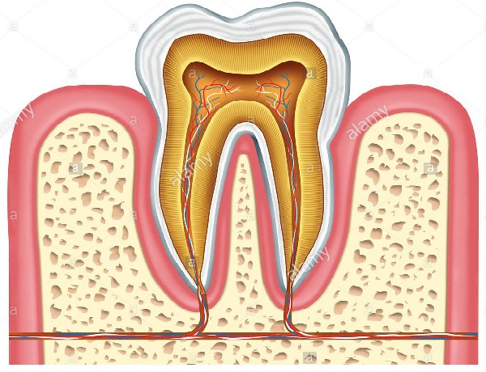
A
B
D
(i) Name the part labelled A and B. (2 marks)
A Enamel
B Gum
(ii) State two ways in which structure D is adapted to its functions. (2 marks)
- Contains blood vessels which supplies food nutrients and oxygen and remove carbon IV oxide and nitrogenous waste products;
- Contains nerve endings for sensitivity;
(iii) List two ways of preventing gingivitis. (2 marks)
- Regular brushing of teeth;
-Proper exercise of the teeth by eating tough fibrous food;
-Eating foods that are rich in vitamin C
4.The figure below shows % saturation of oxygen in blood in fish as water passes along the gill plate.

% saturation of oxygen
Water
Blood

Distance along the gill plates

(a) (i) Name the type of blood flow shown in the gill plate. (1mark)
Counter current flow
(ii) Explain the advantage of the type of flow named in a (i) above (2marks)
Creates a steep diffusion gradient; that enhances the rate of gaseous exchange across the gill filaments/ increases rate of gaseous exchange; through diffusion (Rej increases rate of gaseous exchange/enhances gaseous exchange alone
(b) State two organs in humans which display the type of flow named in a (i) above Kidney; Placenta; Ileum (2marks)
(c) State two ways in which floating leaves of aquatic plants are adapted to gaseous exchange (2marks)
– Stomata found only on upper epidermis to allow efficient gaseous exchange;
- Presence of large air-spaces/aerechyma tissue to enable floating and storage of air;
- Lack cuticle to enhance gaseous exchange;
5.The equation below shows an oxidation reaction of food substances.
C₅₁H₉₈O₆ + 145O2 ------- 102CO2 + 98 H2O + energy
a) What do you understand by the term respiratory quotient? (1mark)
Volumetric relationship between Carbon (IV) oxide produced and oxygen consumed

b) Determine respiratory quotient of the oxidation of food substance. (2marks)
R.Q = CO₂ produced
O₂ used up
R.Q = ¹⁰²/₁₄₅
R.Q = 0.7

c) Identify the food substances. (1mark)
Fat/ Lipid
6 (a)When any one of the growth parameters such as growth in size or weight, increase in number of cells are plotted in a graph against time like below, a clear curve is obtained
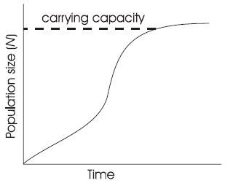
State its name sigmoid curve (1mark)
(b)The graph below represents the growth in a certain phylum.
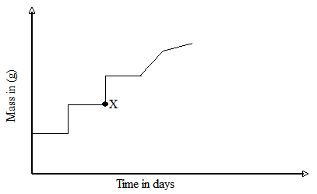

How does this differ from growth in humans? (1mark)

In humans it’s continuous from time of birth to maturity when it slightly tails off while for
this phylum it’s discontinuous /in intervals with shedding of exoskeleton
7.The diagram below represents an organism. Study it and answer the questions that follow.
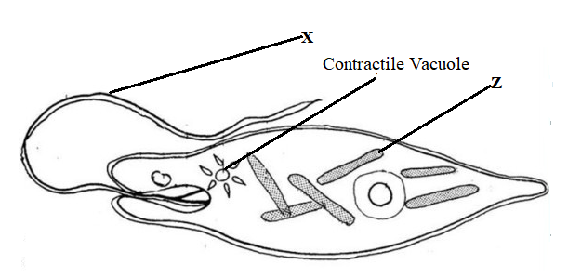
- Identify the kingdom to which the organism belongs (1 mk)
Protoctista/Protista;
b) Name the structure labeled X (1 mk)
Flagellum rej Flagella
c) Identify the type of nutrition carried out by the organism and give a reason (2 mks)
Type of Nutrition: Autotrophic
Reason: The organism has chloroplasts

8a) Cowpeas seeds were place in a vacuum flask and left for five days. What is the expected change in composition of gases in the flask on the sixth day? (1mark)
Decrease in oxygen and increase in carbon(1V)oxide
b) Give a reason for your answer in (a) above (1mark)
Germinating seeds respire using oxygen and release carbon(IV)oxide
9.Biotechnologist works day a night to curb food insecurity using the knowledge of polyploidy in genetics. Explain the economic importance of such practice? (2marks)
Increases yields in plants
Cause early maturity in plants
Enhance resistance to pest, disease and drought

b) Define a backcross? (1 mark)
A cross between an offspring with one of its parents
10. A student was found to have blood group B+
a) What type of antibody is present in his plasma? (1mark)
a
b) Which antigens are present in this blood group? (1mark)
B and Rhesus antigens
11.(a)Plants relatively have less waste to excrete than animals. Give two reasons to explain this observation (2marks)
Plants reuse some of their waste products;
Plants produce their waste products slowly compared to animals that produce slowly ;
(b)State two methods by which plants get rid of their waste products (2marks)
Diffusion
Transpiration
Guttation
Exudation
Deposition ( any two)
12.To estimate the population size of mosquitoes in Banji village that covers an area of 25km², visiting researchers caught 400 mosquitoes which they marked and released. After 24 hours, 200 mosquitoes were caught out of which 120 had not been marked.
(a) Suggest the sampling method described above. (1 mark)
Capture recapture method
(b) What are the disadvantages of this method? (2 marks)
-Some organism may die during the study period;
-The mark may come the out during the study period;owtt
13. The table below shows stomatal distribution on leaves A and B and their surface area. Use the information to answer the questions.
 | Leaf surface | A | B
Number of  stomata | Upper leaf  surface | 20 | 5
Number of  stomata | Lower leaf  surface | 0 | 15
Surface area |  | 25 cm² | 18cm²
Identify with reasons the habitats of the plant from which the leaves were obtained.
Leaf A: Habitat Fresh water; (1 mark)
Reason; Maximum number of stomata on the upper leaf surface for quick loss of excess water by transpiration; (1 mark)
Leaf B: Habitat: Savannah/ Rain forest; (1 mark)
Reason : More stomata on loer surface than on the upper to reduce the surface area exposed to excessive loss of water by transpiration
(1 mark)
14. Name the causative agent of the following diseases (2 marks)
(i) Trichomoniasis.
Trichomonas vaginalis
(ii) Gonorrhea
Neisseria gonorrhoea
15. Study the flow chart below which represents a physiological process in mammals
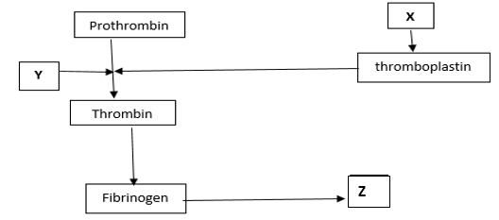
ai) Name blood components represented by X. (1mk) Platelets;
ii) What is the significance of product represented by Z. (2mks)
Forms a clot; that prevents excessive bleeding/prevents entry of pathogens;
b) Under what condition is thrombokinase released by the platelets? (1mk) When platelets are exposed to air/ When platelets clump together and adhere to the wall of damaged blood vessel;
16. (a) Define parthenogenesis? (1 mark)
A type of asexual reproduction in insects where eggs produced without being fertilized are able to hatch into adult insects;
(b) Name the plant hormone that induces fruit ripening. (1 mark) Ethylene;
17. . A section of nucleic strand contains the following sequence.
A — C — G — A — G — A — T — A— C
a) i) Write the complimentary DNA stand. (lmk)
T—G— C—T—C— T—A—T—G
ii) Write the mRNA strand of the strand in (a) above. (lmk)
U—G—C—U—C—U—A— U—G
b) Name the site for protein synthesis in a cell. (lmk)
Ribosomes
18 ( i) Give two structural features in aleaf that adapts it to absorb Carbon (IV) oxide (2mks)
Broad lamina
Many stomata
(ii) Name the cell Organelle in which Carbon (IV) oxide combines with water to form a complex organic compound takes place (1mk)
chloroplast
19. In an experiment to investigate a factor affecting photosynthesis; leaf of a potted plant, which had been kept in the dark overnight was covered with an aluminum foil as shown in the diagram below. The set up was kept in the sunlight for three hours after which a food test was carried out on the leaf.
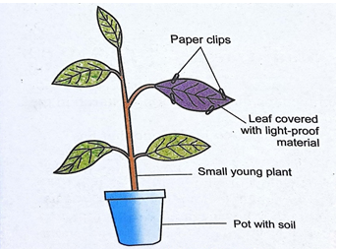
(a) Which factor was being investigated in the experiment? (1 mark)
Light;
(b) Which food test was carried out? (1 mark)
Starch test;
(c) State the results of the food test. (1 mark)
Starch absent/Iodine retains its brown colour/starch test negative;
20. Explain how the following plant adaptations minimizes rate of transpiration (2marks)
a) Sunken stomata
Water vapour accumulates in the pits reducing water vapour diffusion gradient hence reduced transpiration rate;
b) Thick cuticle
Reduces permeability of the leaf to water thus reducing water loss;
21. Explain how drooping of leaves on a hot sunny day is advantageous to a plant (2marks)
The leaves expose a smaller surface area to the sun thus reducing excessive water;
22. Name two tissues in plants which are thickened with lignin (2marks)
Parenchyma cells;
Xylem vessels;
23. State two functions of a microscope (1mk)
Resolution; Magnification;
24. Explain why the concentration of insecticides in fish eating birds may be hundreds of times greater than its concentration in the water where the fish live (3marks)
Aquatic plants in water absorb the pesticides that drain into water bodies and so accumulate ,fish consume small quantities every time the ingest the water this also accumulates in the fish with time, as the birds continue feeding the contaminated fish they pesticides increase in levels
25 .(a) What are analogous structures? (1mk)
Structures with different embryonic origin but have evolved to perform similar functions (due to exploitation of similar niche)
(b) Give two examples of analogous structures in animals (2mks)
Wings of birds and insects; Eyes of vertebrates and those of molluscs; Limbs of mammals and those of arthropods; 1st two
26. Name any two sites where gaseous exchange takes place in a leaf of a terrestrial plant (2mks)
Stomata
Cuticle
27. How do the following factors hinder self-pollination in flowering plants? (3marks)
a) Self-sterility
It is a condition where pollen grains from the anthers cannot grow on the stigma of the same flower of plant/ are incompatible to stigma of the same plant/flower;
b) Heterostyly
Is a condition of having different arrangements of style and stigma i.e. shorter stamen than pistil;
c)Protogyny
it’s a condition where the female matures an its ready to receive the pollen grains before the male parts mature;

