KALA TRIAL EXAMINATION-2026
Kenya Certificate of Secondary Education form 4
231/3 - BIOLOGY - Paper 3
JULY 2026 1hrs 45min


Name: …………………………………………..…… Admission No: ……………………
Class: …………………………………………..……..... Date: ………………………………
School: …………………………………………..…… Signature: …………………………

Instructions to Candidates
- Write your name, class, admission number, school, date and signature in spaces provided above.
- Answer all questions in the spaces provided below each question.
- You are required to take the first 15 minutes of the 1³/₄ hours allowed for this paper reading through the whole paper before commencing your work.
- The paper consists of 6 printed pages.
- Additional pages must not be inserted.
- Candidates should check the question paper and ascertain that all the pages are printed as indicated and that no questions are missing
- Candidates should answer all the questions in English.
FOR EXAMINER'S USE ONLY
QUESTION | MAXIMUM SCORE | CANDIDATES SCORE
1 | 13
2 | 13
3 | 14
Total Score | 40

- You are provided with specimen labelled Q and the following reagents:
- Dilute hydrogen peroxide
- Dilute hydrochloric acid
- Dilute sodium hydroxide
You have also been provided with the following apparatus:
- Four boiling tubes
- 10 ml measuring cylinder
- Scalpel
Procedure
- Peel specimen Q.
- Label the boiling tubes A, B, C and D.
- Cut four pieces of peeled specimen Q each measuring 20 mm × 10 mm ×10 mm.
- Put two of the pieces into boiling tube A.
- Macerate (chop into tiny pieces) two of the pieces. Place equal amounts of the macerated specimen in boiling tube labelled B and C.
- Cut one piece of specimen Q measuring 10 mm × 10 mm ×10 mm and place it into boiling tube labelled D.
- Add 3 cm³ of dilute sodium hydroxide solution in boiling tube A, C and D and add about 3 cm³ of dilute hydrochloric acid in boiling tube B.
- Add about 10 cm³ of hydrogen peroxide into each of the four boiling tubes.
- Observe the amount of effervescence in each of the boiling tubes and complete the table below. (7 marks)
Boiling tube | Amount of effervescence observed | Explanation
B

C

D

- Explain why the results of boiling tube A differed from that of boiling tube D. (4 marks)
………………………………………………………………………………………………………
………………………………………………………………………………………………………
………………………………………………………………………………………………………
………………………………………………………………………………………………………
………………………………………………………………………………………………………
- Suppose a piece similar to the one put in boiling tube D was initially boiled for 5 minutes and the cooled before being subjected to the same conditions as those in boiling tube D.
- Suggest the observation in terms of amount of effervescence that would have been made. (1 mark)
………………………………………………………………………………………………………
………………………………………………………………………………………………………
- Explain the observations made in (c) (i) above. (1 marks)
………………………………………………………………………………………………………
………………………………………………………………………………………………………
- The photographs below belong to specimens of organisms of the same class. Examine them and answer the questions that follow.

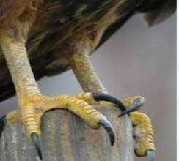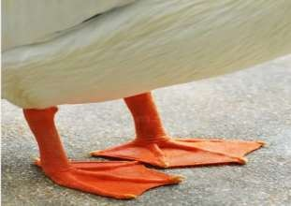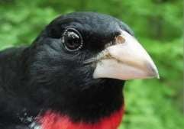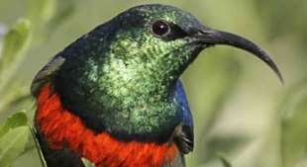

N

S

P

O

- Using observable feature(s) only, name the class of these specimens and give the reasons
for your answer. (3 marks)
Class……………………………………………………………………………………………

Reasons
………………………………………………………………………………………………………
………………………………………………………………………………………………………
- (i) Name the type of evolution exhibited by the organism. (1mark)
………………………………………………………………………………………………………
(ii) Name the type of structures indicated by the type of evolution named in b(i) above. (1 mark)
………………………………………………………………………………………………………
- From the observation suggest two features responsible for the different types of beaks in specimen N and S. (2 marks)
………………………………………………………………………………………………………
………………………………………………………………………………………………………
- With a reason, name the type of feed eaten by the organisms in photograph O and S. (4 marks)
(i) Photograph O…………………………………………………………………………………...
Reason ………………………………………………………………………………………………………
(ii) Photograph S……………………………………………………………………………………
Reason
………………………………………………………………………………………………………
- Using observable features only name two types of locomotion by specimen P above and
the structure involved. (2 marks)
………………………………………………………………………………………………………
………………………………………………………………………………………………………

- Study photograph below showing the cut surface of a type of fruit and specimen R and T.

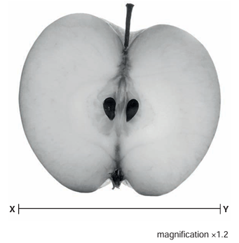

- Name the type of fruit shown in the photograph. (1 mark)
………………………………………………………………………………………………………
- Identify the type of carpel from which the type of fruit named in (a) above is formed. (1 marks)
………………………………………………………………………………………………………
- On the photograph, label any four parts. (4 marks)

- (i) Name the agent of dispersal of the fruit in the photograph. (1 mark)
………………………………………………………………………………………………………
(ii) Explain how the fruit is adapted to the agent of dispersal named in (d) (i) above. (2 marks)
………………………………………………………………………………………………………
………………………………………………………………………………………………………
- Calculate the actual width of the fruit from point X to Y. (Show your working). (3 marks)
………………………………………………………………………………………………………
………………………………………………………………………………………………………
………………………………………………………………………………………………………
- Identify two differences between specimen R and specimen T. (2 marks)
Specimen R | Specimen T

