KALA TRIAL EXAMINATION- JULY 2026
Kenya Certificate of Secondary Education form 4
231/3 - BIOLOGY PAPER 3 MARKING SCHEME -

- You are provided with specimen labelled Q and the following reagents:
- Dilute hydrogen peroxide
- Dilute hydrochloric acid
- Dilute sodium hydroxide
You have also been provided with the following apparatus:
- Four boiling tubes
- 10 ml measuring cylinder
- Scalpel
Procedure
- Peel specimen Q.
- Label the boiling tubes A, B, C and D.
- Cut four pieces of peeled specimen Q each measuring 20 mm × 10 mm ×10 mm.
- Put two of the pieces into boiling tube A.
- Macerate (chop into tiny pieces) two of the remaining pieces. Place equal amounts of the macerated specimen in boiling tube labelled B and C.
- Cut one piece of specimen Q measuring 10 mm × 10 mm ×10 mm and place it into boiling tube labelled D.
- Add 3 cm³ of dilute sodium hydroxide solution in boiling tube A, C and D and add about 3 cm³ of dilute hydrochloric acid in boiling tube B.
- Add about 10 cm³ of hydrogen peroxide into each of the four boiling tubes.
- Observe the amount of effervescence in each of the boiling tubes and complete the table below. (7 marks)

Boiling tube | Amount of effervescence observed | Explanation
B | No/little/low/small amounts of effervescence/foaming/frothing/bubbles/gas produced; | Acidic medium/ low pH did not favour the working/action/ activity of enzymes/ acid denatured enzyme/ catalase;
C | Vigorous/ rapid/ fast/ more effervescence; | -Alkaline/favourable/optimum pH for enzymatic action;  -Macerating increases surface area/ more surface area exposed by macerated potato increasing the enzymatic reaction;
D | Medium/moderate/average effervescence; | Surface area exposed is small reducing the rate of enzymatic reaction;

- Explain why the results of boiling tube A differed from that of boiling tube D. (4 marks)
- In A there are larger pieces of Q hence higher concentration of enzyme/ catalase; increasing the active sites hence faster rate of enzyme reaction;
- In D there is a smaller piece of specimen Q hence lower concentration of enzyme/catalase; leading to fewer active sites reducing the rate of enzyme action;
- Suppose a piece similar to the one put in boiling tube D was initially boiled for 5 minutes and the cooled before being subjected to the same conditions as those in boiling tube D.
- Suggest the observation in terms of amount of effervescence that would have been made. (1 mark)
- No/little/low/small amounts of effervescence/foaming/frothing/bubbles/gas produced;

- Explain the observations made in (c) (i) above. (1 marks)
- (Boiling) denatures/ destroys enzymes;

- The photographs below belong to specimens of organisms of the same class. Examine them and answer the questions that follow.

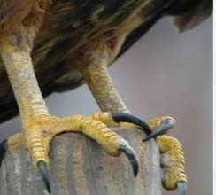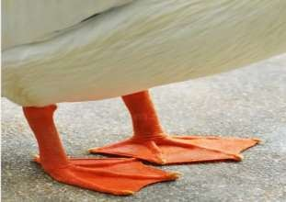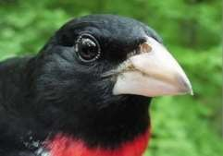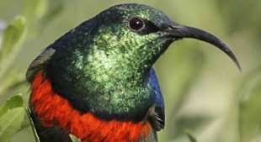

N

S

P

O

- Using observable feature(s) only, name the class of these specimens and give the reasons
for your answer. (3 marks)
Class – Aves;
Reasons
– Has feathers;
– Has beak;
– Has scales on the feet;
- (i) Name the type of evolution exhibited by the organism. (1mark)
– Divergent;
(ii) Name the type of structures indicated by the type of evolution named in b(i) above. (1 mark)
– Homologous;
- From the observation suggest two features responsible for the different types of beaks in specimen N and S. (2 marks)
– Length;
– Size;
– Shape;
- With a reason, name the type of feed eaten by the organisms in photograph O and S. (4 marks)
(i) Photograph O – Flesh;
Reason – Feet have talons for killing prey;
(ii) Photograph S – Nectar;
Reason – long and curved beak;
- Using observable features only name two types of locomotion by specimen P above and
the structure involved. (2 marks)
– Webbed feet; for swimming;
– Wings; for flying;
- Study photograph below showing the cut surface of a type of fruit and specimen R and T.
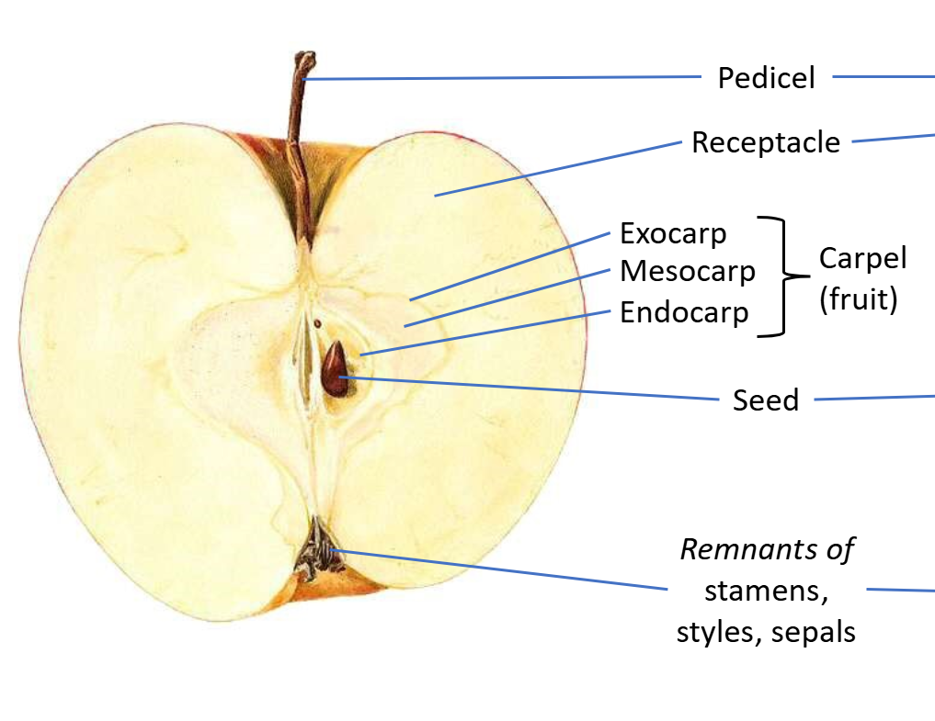
- Name the type of fruit shown in the photograph. (1 mark)
- Pome; Rej- Succulent fruit/Berry/False fruit
- Identify the type of carpel from which the type of fruit named in (a) above is formed. - Monocarpous; (1 marks)
- On the photograph, label any four parts. (4 marks)

- (i) Name the agent of dispersal of the fruit in the photograph. (1 mark)
- Animal; Rej- Animal dispersal
- Explain how the fruit is adapted to the agent of dispersal named in (c) (i) above. (2 marks)
- Fleshy; to attract the animal which eats the fruit and disperse away from parent plant;

- Calculate the actual width of the fruit from point X to Y. (Show your working). (3 marks)
(Linear) magnification = $\frac{Drawing length}{Actual length }$ ;
Actual length = $\frac{8 cm}{X1.2}$ ;
= 6.6667 cm;
- Identify two differences between specimen R and specimen T. (2 marks)
Specimen R | Specimen T
- Has two scars | - Has one scar
- Outer covering is the pericarp fused with testa; | - Outer covering is testa;

