

K.J.S.E.A

JUNIOR SCHOOL EDUCATION ASSESSMENT

TERM 2: ENDTERM ASSESSMENT 2026
GRADE 9 – SOCIAL STUDIES
Time: 1 Hour 30 Minutes
LEARNER’S DETAILS
Name: ________________________________________________. School: _____________________________________________________.
Assessment Number: _________________________________. Date: ______________________________________________________.
School Code: _______________________________________. Signature: _________________________________________________.

Instructions for Learners
- Write your name, school name, and assessment number in the spaces provided.
- This paper consists of five questions.
- Check the question paper carefully to ensure all pages are printed and no questions are missing.
- Answer all the questions in the spaces provided.

FOR EXAMINER’S USE
SECTION | SECTION A | SECTION B | % SCORE | EE1 | EE2 | ME1 | ME2 | AE1 | AE2 | BE1 | BE2
SCORE RANGE | 20 MARKS | 30 MARKS |  | 90-100 | 75-89 | 58-74 | 41-57 | 31-40 | 21-30 | 11-20 | 1-10
POINTS |  |  |  | 8 POINTS | 7 POINTS | 6 POINTS | 5 POINTS | 4 POINTS | 3 POINTS | 2 POINTS | 1 POINT
LEARNER’S TOTAL SCORE

SECTION A (20 MARKS)
Answer ALL questions in this section

- Which of the following pairs of countries represents a developing and a developed nation respectively?
A. Kenya and Germany
B. Germany and Kenya
C. South Africa and Kenya
D. Kenya and Uganda
- Which of the following African civilizations was known for its great stone buildings and trade in gold?
A. Kongo Kingdom B. Great Zimbabwe
C. Nubian Kingdom D. Egyptian Kingdom
- Which one of the following instruments is correctly matched with the element of weather it measures?

 | Instruments | Elements Of Weather
A | barometer | Rainfall amount
B | thermometer | Atmospheric pressure
C | anenometer | Wind speed
D | Rain gauge | temperature

- Kenya became a republic on
A. 1st June 1963
B. 20th October 1992
C. 12th June 1964
D. 12th December 1964
- Which one of the following latitudes measures 23 ½ South?
- Tropic of Capricorn
- Tropic of Cancer
- Antarctic
- Prime Meridian
- The arm of the government that interprets law is called the
- National Police Service
- Judiciary
C. Legislature
D. Executive

- The Best way of encouraging people in Kenya to obey the law is by
- Employing more police officers
B. rewarding people who obey law
C. educating people on the importance of observing the law.
D. keeping law breakers in prison.
- Which one of the following is not a responsibility of a Kenya citizen.
- being dishonest B. paying taxes
C. being patriotic D. obeying laws
- The highest court in Kenya is _____
- High court
- Principal magistrate
- Supreme court
- Court of appeal
- Which one of the following physical features is shared by many countries in Eastern Africa?
- Indian Ocean B. Lake Victoria
C. Mt. Elgon D. The Rift valley
- Which one of the following is not an arm of the government of Kenya?
- Judiciary
- Cabinet
- Executive
- legislature
Use the mountain vegetation below to answer the questions
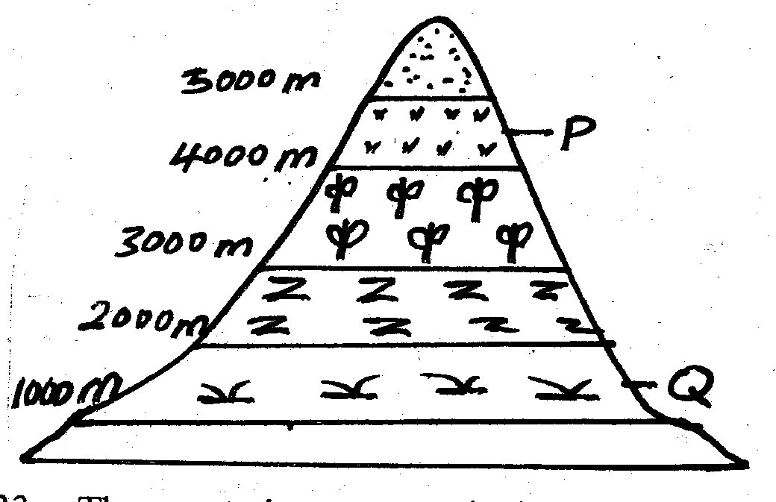

- The vegetation zone marked P is called ____.
- Health and moorland
- Bamboo
- Snow and bare rocks
- Savanna grasslands
Study the map below and use it to answer
questions 13-16.
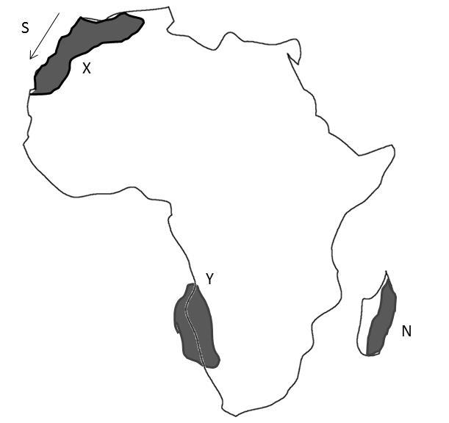

- The climatic zone marked N is called___
A. Desert climate
B. Tropical climate
C. Mediterenean climate
D. Mountain climate.
- Which of the following countries does not
experience desert climate?
- Congo B. Chad
C. Libya D. Egypt
- Name the vegetation zone marked X
A. Desert climate B. Mediterranean climate
C. Savannah climate D. Mountain climate
- The Ocean current marked S on the map is
called
- Warm Mozambique current
- Warm Guinea current
- Cold Canary Current
- Cold Benguela current
- Which one of the following least influences the population distribution in Africa.
- Modern forms of communication
- Climate
- Relief
- Soil
- Which chapter of the constitution talks about rights and freedom of individuals.
- Chapter four
- Chapter nine
- Chapter six
- Chapter fourteen
- Which one of the following is not a stage of development of early man.
- Middle stone age
- Late stone age
- Young stone age
- Early stone age

- Which of the following is not a cause of
conflict in the society.
- Discrimination
- Poverty
- Unequal distribution of resources
- Upholding the rule of law

SECTION B (80 MARKS)

PART 1: MAPWORK (10 MARKS)
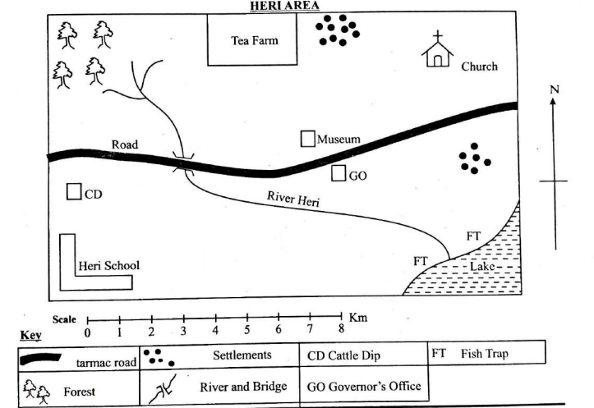
Study the map of Heri Area and answer the questions that follow.

- Use the map above to answer questions 21.
(a) River Heri flows from which direction? (1 mark)
_________________________________________________________
(b) Identify two human activities carried out in the area. (2 marks)
i) __________________________________.
ii) _________________________________.
(c) Calculate the straight-line distance between the school and the church in kilometres if the scale is 1:50,000. (3 marks)

(d) Name one physical feature found in the south eastern part of the map. (1 mark)
_________________________________________________________________________
(e) State two factors that may have influenced the location of the settlement shown on the map. (2 marks)
i) ______________________________________________________________________________________.
ii) _____________________________________________________________________________________.
(f) Calculate the area of the tea farm in kilometres if the scale is 1:50,000. (2 marks)

PART 2: GEOGRAPHY (35 MARKS)
- The residents of Baringo County have experienced deforestation leading to soil erosion and drying of rivers.
(a) Define environmental degradation.
__________________________________________________________________________________________________________________________________________________________________________

(b) State three causes of environmental degradation in the county.
- _______________________________________________________________________________
- _______________________________________________________________________________
- _______________________________________________________________________________
(c) Explain three effects of environmental degradation on the community.

- _______________________________________________________________________________
- _______________________________________________________________________________
- _______________________________________________________________________________

(d) Give three measures the residents can take to conserve the environment.
- _______________________________________________________________________________
- _______________________________________________________________________________
- _______________________________________________________________________________
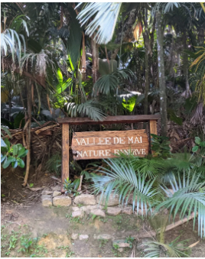
- A geography club is studying world heritage sites in Africa.
(a) Identify the following world heritage site
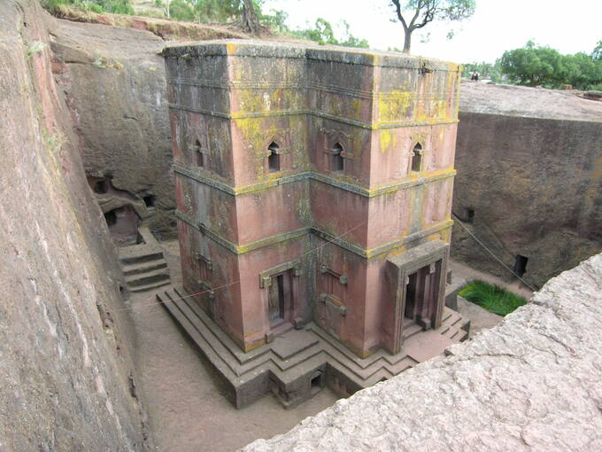

A B
A: _________________________________ B: _______________________________
(b) Apart from the above named heritage site, name two other world heritage sites in Africa.

- _______________________________________________________________________________
- _______________________________________________________________________________

(c) Explain two reasons why these sites are important.

- _______________________________________________________________________________
- _______________________________________________________________________________
(d) Suggest two ways of conserving these sites.
- _______________________________________________________________________________
- _______________________________________________________________________________
(e) State one challenge faced in conserving these sites.
_______________________________________________________________________________________
- The Aswan High Dam and River Tana Projects are examples of multipurpose river projects.
(a) Name the countries where each project is found.

Multipurpose river project | Country it is found
Aswan High Dam
Seven Fork Scheme

(b) Give two reasons why the Aswan High Dam project was established.
- _______________________________________________________________________________
- _______________________________________________________________________________

(c) Explain two economic benefits of such projects.
- _______________________________________________________________________________
- _______________________________________________________________________________
(d) State two challenges facing these projects and possible solutions.

Challenges facing multipurpose river projects | Solutions to the challenges facing multipurpose river projects

- During a science week, learners observed instruments in a weather station.
(a) Differentiate between weather and climate.

_____________________________________________________________________________________
_____________________________________________________________________________________

(b) Identify four characteristics of a Stevenson’s screen.
- _______________________________________________________________________________
- _______________________________________________________________________________
- _______________________________________________________________________________
- _______________________________________________________________________________
(c) State three instruments kept in a Stevenson’s screen.

- _______________________________________________________________________________
- _______________________________________________________________________________
- _______________________________________________________________________________
(d) Explain two effects of climate change on human activities.

- _______________________________________________________________________________
- _______________________________________________________________________________

- During a field trip to Mount Kenya, learners observed different vegetation zones.
(a) State four factors influencing vegetation distribution.

- _______________________________________________________________________________
- _______________________________________________________________________________
- _______________________________________________________________________________
- _______________________________________________________________________________
(b) Describe the characteristics of tropical vegetation regions in Africa.

- _______________________________________________________________________________
- _______________________________________________________________________________
- ______________________________________________________________________________
- _______________________________________________________________________________
(c) Explain two methods of conserving vegetation in the community.
- _______________________________________________________________________________
- _______________________________________________________________________________
- (a) Differentiate between folding and faulting.

_____________________________________________________________________________________
_____________________________________________________________________________________
_____________________________________________________________________________________
_____________________________________________________________________________________

(b) Name two resultant features due to faulting.
- _______________________________________________________________________________
- _______________________________________________________________________________

(c) Give two evidence supporting the continental drift theory.
- _______________________________________________________________________________
- _______________________________________________________________________________

(d) With the aid of a well-labelled diagram, describe the theory of plate tectonics.

PART 3: HISTORY (25 MARKS)
- (a) Outline two socio-economic practices of the early humans.

- _______________________________________________________________________________
- _______________________________________________________________________________

(b) Explain three reasons why Africa is referred to as the cradle of mankind.

- _______________________________________________________________________________
- _______________________________________________________________________________
(c) State three changes that took place during human evolution.
- _______________________________________________________________________________
- _______________________________________________________________________________
- _______________________________________________________________________________
(d) State two characteristics of microlithic tools used during the late Stone Age period. (2 mks)
- _______________________________________________________________________________
- _______________________________________________________________________________
- (a) Identify three factors that led to the growth of the Ancient Egypt Kingdom.

- _______________________________________________________________________________
- _______________________________________________________________________________

(b) Mention two contributions of early Egyptian civilizations to the modern world.
- _______________________________________________________________________________
- _______________________________________________________________________________
(c) Explain two social-economic practices of the Swahili civilization along the East African coast.
- _______________________________________________________________________________
- _______________________________________________________________________________
(d) State two ways early visitors influenced the Swahili culture.
- _______________________________________________________________________________
- _______________________________________________________________________________
- (a) Identify three ways in which slaves were acquired.
- _______________________________________________________________________________
- _______________________________________________________________________________
- _______________________________________________________________________________
(b) Identify two routes used in the Indian Ocean slave trade.
- _______________________________________________________________________________
- _______________________________________________________________________________
(c) State two factors that led to the growth of the Indian Ocean slave trade.
- _______________________________________________________________________________
- _______________________________________________________________________________
(d) Explain two social injustices committed against Africans during the trade.
- _______________________________________________________________________________
- _______________________________________________________________________________
(e) Give one way Africans resisted slavery.
_____________________________________________________________________________________
_____________________________________________________________________________________
- (a) Identify the political organization of the Asante community.

- _______________________________________________________________________________
- _______________________________________________________________________________
(b) Explain two roles of the Zulu kingdom in resisting colonial rule.
- _______________________________________________________________________________
- _______________________________________________________________________________

(c) State two similarities in the socio-economic organization of the Ogiek and Asante.
- _______________________________________________________________________________
- _______________________________________________________________________________
(d) Give two reasons why Liberia was not colonized.
- _______________________________________________________________________________
- _______________________________________________________________________________

PART 4: CITIZENSHIP (5 MARKS)
- (a) What is community service learning?
_____________________________________________________________________________________
_____________________________________________________________________________________

(b) Name two problems facing communities in Kenya today.
- _______________________________________________________________________________
- _______________________________________________________________________________
(c) State two solutions to the problems listed in (b) above.
- _______________________________________________________________________________
- _______________________________________________________________________________
(d) Explain one way citizens can help build the nation.
_____________________________________________________________________________________
_____________________________________________________________________________________

PART 5: LIFE SKILLS (5 MARKS)
- Healthy Relationships and Emotional Intelligence
(a) Define peer pressure?
_____________________________________________________________________________________
_____________________________________________________________________________________

(b) Identify two effects of peer pressure.
- _______________________________________________________________________________
- _______________________________________________________________________________
(c) State two ways of overcoming peer pressure.
- _______________________________________________________________________________
- _______________________________________________________________________________
(d) Explain one importance of emotional intelligence in resolving family conflicts.
_____________________________________________________________________________________
_____________________________________________________________________________________

This is the last printed page

ANSWERS

SECTION A
- A
- B
- C
- D
- A
- B
- C
- A
- C
- D
- B
- A
- C
- A
- B
- C
- A
- A
- C
- D

SECTION B

PART 1: MAPWORK

21.

(a)
River Heri flows from the north-west to the south-east.

(b)
i) Farming/tourism/transport
ii) Trading/administration

(c)
Straight line distance = approximately 14 cm
Scale = 1 : 50,000
1 cm represents 0.5 km
Distance = 14 × 0.5
= 7 km
Answer: 7 km

(d)
Hill / River / Forest

(e)
i) Availability of water/lake
ii) Presence of tea farm

(f)
Area of tea farm = Length × Width
Example: 3 cm × 2 cm = 6 cm²
1 cm² represents 0.25 km²
6 × 0.25 = 1 km²
Answer: 1.5 km²

PART 2: GEOGRAPHY

22.

(a)
Environmental degradation is the destruction or deterioration of the environment through human activities.

(b)
i) Deforestation
ii) Overgrazing
iii) Poor farming methods

(c)
i) Soil erosion reduces soil fertility
ii) Drying of rivers causes water shortage
iii) Loss of vegetation and wildlife

(d)
i) Planting trees
ii) Practicing controlled grazing
iii) Proper waste disposal

23.

(a)
A: Rock-Hewn Churches of Lallibela, Ethiopia
B: Vallée de Mai, Praslin, Seychelles

(b)
i) Table Mountain
ii) Serengeti National Park

(c)
i) They preserve history and culture
ii) They attract tourists and earn foreign exchange

(d)
i) Proper maintenance and restoration
ii) Educating people on their importance

(e)
Vandalism / Pollution / Lack of funds

24.

(a)
Multipurpose river project | Country
Aswan High Dam | Egypt
Seven Forks Scheme | Kenya

(b)
i) To control flooding
ii) To generate hydroelectric power

(c)
i) Creation of employment opportunities
ii) Promotion of irrigation farming

(d)
Challenges | Solutions
Siltation | Dredging rivers
Pollution | Proper waste management

25.

(a)
Weather is the condition of the atmosphere at a particular time while climate is the average weather condition of a place over a long period.

(b)
i) Painted white
ii) Raised above the ground
iii) Has louvered sides
iv) Roofed with double slanting roof

(c)
i) Thermometer
ii) Hygrometer
iii) Maximum and minimum thermometer

(d)
i) Drought affects farming activities
ii) Flooding destroys property and transport systems

26.

(a)
i) Climate
ii) Soil type
iii) Relief
iv) Human activities

(b)
i) Dense forests
ii) Tall trees
iii) Evergreen vegetation
iv) High rainfall throughout the year

(c)
i) Afforestation/reforestation
ii) Controlled grazing

27.

(a)
Folding is the bending of rock layers due to compression while faulting is the breaking of rock layers due to earth movements.

(b)
i) Rift valleys
ii) Block mountains

(c)
i) Coastlines of continents fit together
ii) Similar fossils found on different continents

(d)
Plate tectonics theory states that the earth’s crust is made up of moving plates floating on magma. Their movement causes earthquakes, folding, and faulting.

PART 3: HISTORY

28.

(a)
i) Hunting and gathering
ii) Fishing

(b)
i) Earliest human fossils were discovered in Africa
ii) Earliest stone tools were found in Africa
iii) Early man is believed to have originated from Africa

(c)
i) Development of upright posture
ii) Increase in brain size
iii) Use of tools

(d)
i) Small in size
ii) Sharp and well-shaped

29.

(a)
i) River Nile provided water
ii) Fertile soils supported farming

(b)
i) Writing system
ii) Calendar system

(c)
i) Trade along the coast
ii) Fishing activities

(d)
i) Introduction of Islam
ii) Intermarriage with foreigners

30.

(a)
i) Raiding
ii) Warfare
iii) Kidnapping

(b)
i) Trans-Saharan route
ii) East African coastal route

(c)
i) High demand for slave labour
ii) Existence of trade routes

(d)
i) Separation of families
ii) Harsh treatment and torture

(e)
Escaping / Revolting against slave traders

31.

(a)
i) King/Asantehene leadership
ii) Chiefdom system

(b)
i) Organized strong military resistance
ii) United communities against colonialists

(c)
i) Both practiced farming
ii) Both traded with neighbours

(d)
i) It was protected by the USA
ii) It was an independent state before partition

PART 4: CITIZENSHIP

32.

(a)
Community service learning is participating in activities that help improve the community while gaining skills and knowledge.

(b)
i) Poverty
ii) Unemployment

(c)
i) Creating job opportunities
ii) Promoting education and skills training

(d)
Citizens can help build the nation by obeying laws and participating in development activities.

PART 5: LIFE SKILLS

33.

(a)
Peer pressure is the influence from friends or age mates that affects a person’s behaviour or decisions.

(b)
i) Drug abuse
ii) Poor academic performance

(c)
i) Choosing good friends
ii) Being assertive and confident

(d)
Emotional intelligence helps people control emotions and solve family conflicts peacefully.

