

KENYA CERTIFICATE OF BASIC EDUCATION

JUNIOR SCHOOL EDUCATION ASSESSMENT

TERM 2: ENDTERM ASSESSMENT 2026
GRADE 9 – INTEGRATED SCIENCE PAPER 1
Time: 1 Hour 30 Minutes
LEARNER’S DETAILS
Name: ________________________________________________. School: _____________________________________________________.
Assessment Number: _________________________________. Date: ______________________________________________________.
School Code: _______________________________________. Signature: _________________________________________________.

Instructions for Learners
- Write your full name and assessment number in the spaces provided above.
- Indicate your school name and school code clearly.
- Sign and date this paper in the spaces provided.
- This paper consists of TWO sections: Section A and Section B.
- Answer ALL questions in BOTH sections.
- Write your answers in the spaces provided in this question paper.
- Do NOT remove any page from this paper.
- All responses must be written in English

FOR OFFICIAL USE ONLY -FOR EXAMINER’S USE
SECTION | SECTION A | SECTION B | % SCORE | EE1 | EE2 | ME1 | ME2 | AE1 | AE2 | BE1 | BE2
SCORE RANGE | 20 MARKS | 30 MARKS |  | 90-100 | 75-89 | 58-74 | 41-57 | 31-40 | 21-30 | 11-20 | 1-10
POINTS |  |  |  | 8 POINTS | 7 POINTS | 6 POINTS | 5 POINTS | 4 POINTS | 3 POINTS | 2 POINTS | 1 POINT
LEARNER’S TOTAL SCORE

SECTION A (20 MARKS)
Answer ALL questions in this section

1. A tailor is measuring the length of fabric to cut a dress. Which SI unit is appropriate for this measurement?
A. Kilogram B. Second C. Metre D. Litre
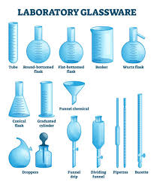
2. While working in the laboratory, a student handled an apparatus known as a conical flask. Which one of the following is a conical flask?

A B C D

3. A technician is troubleshooting a faulty electrical appliance. He finds that the circuit is incomplete, preventing the flow of current. This is referred to as:
A. A closed circuit
B. A short circuit
C. An open circuit
D. A parallel circuit
4. During a Science fair, a learner demonstrated that when purple cabbage juice is added to a solution, it turns green. This indicates that the solution is:
A. Acidic
B. Neutral
C. Basic
D. Solid
5. A gardener has a mixture of small stones and dry leaves in his compost pit. Which method would be the best to separate the stones from the leaves?
A. Evaporation B. Decantation
C. Winnowing D. Filtration
6. A child’s toy car uses small magnets to hold its parts together. This is an application of the property of magnets to:
A. Generate heat
B. Attract specific materials
C. Conduct electricity
D. Produce light
7. A chef prepares a salad by cutting vegetables into smaller pieces. This action changes the appearance of the vegetables but does not create new substances. This is an example of a:
A. Chemical change B. Irreversible change
C. Physical change D. Permanent change
8. A doctor explains that excessive sugar intake can draw water out of body cells, leading to dehydration. This movement of water across cell membranes is primarily due to:
A. Diffusion B. Active transport
C. Osmosis D. Phagocytosis
9. While observing a prepared slide, a student notices a cell containing a nucleus, cytoplasm, and a cell membrane, but no cell wall or chloroplasts. The cell is most likely to be:
A. An animal cell B. A plant cell
C. A fungal cell D. A bacterial cell
10. A small turbine installed in a nearby river to generate electricity is an example of which type of energy source?
A. Non-renewable
B. Fossil fuel
C. Geothermal
D. Hydroelectric
11. A jeweller uses a powerful magnifying glass to inspect intricate details on tiny gemstones. This tool works on the same principle as the lens in a:
A. Microscope
B. Telescope
C. Camera
D. Binoculars
12. During a fire safety lesson, learners learnt that removing one component helps to put out fire. Spraying carbon dioxide removes:
A. Fuel
B. Heat
C. Ignition source
D. Oxygen
13. The movement of water into plant cells against a concentration gradient is a vital process involving:
A. Evaporation
B. Photosynthesis
C. Diffusion
D. Osmosis
14. To obtain a luminous yellow flame suitable for gentle heating,
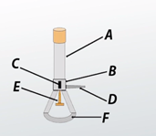
Which part of the Bunsen burner should be adjusted?
A. The gas tap
B. The air hole should be closed
C. The barrel should be shortened
D. The base should be rotated
15. During a Science trip, a learner accidentally gets a splinter in the finger. What should be the immediate first aid action?
A. Try to squeeze it out forcefully
B. Leave it to come out on its own
C. Wash the area gently and remove it with sterile tweezers
D. Cover it with a plaster

SECTION B (35 MARKS)
Answer all questions in this section.
16.(a) A farmer observes that the soil in his farm is too acidic, affecting plant growth. He decides to apply lime to the soil.
(i) What is the chemical nature of lime? (2 marks)
___________________________________________________________________________________________
(ii) Explain how applying lime helps improve the soil for plant growth. (2 marks)
___________________________________________________________________________________________ ___________________________________________________________________________________________ (b) During a titration experiment, a student uses phenolphthalein indicator. Describe the colour change observed when phenolphthalein is added to an acidic solution. (2 marks)
________________________________________________________________________________________________________________________________________________________________________________________
17.(a) State one major challenge faced by adolescents during puberty related to emotional changes. (1 mark)
________________________________________________________________________________________________________________________________________________________________________________________
(b) Explain two ways in which good personal hygiene can help manage challenges during adolescence. (2 marks)
(i) ______________________________________________________________________________________
(ii) _____________________________________________________________________________________
18. A patient experiences swelling in the ankles and feet, and the doctor suspects a kidney problem.
(a) Name the main excretory product filtered by the kidneys from the blood. (1 mark) ______________________________________________________________________________
(b) Besides swelling, state two other common symptoms of kidney disorders. (2 marks)
(i) __________________________
(ii) __________________________
(c) Explain the function of the glomerulus in the human kidney. (1 mark)
________________________________________________________________________________________________________________________________________________________________________________________
19. A student is setting up a circuit to light a bulb using a battery and wires.
(a) Name the form of energy stored in a battery. (1 mark) _______________________________________________________________________________________ __

(b) Draw a simple circuit diagram showing a battery, a switch, and a light bulb connected in series. (3 marks)

20. A child is playing with toy cars that have small magnets embedded in their wheels.
(a) Name two materials that are strongly attracted by a magnet. (2 marks)
(i) __________________________
(ii) __________________________
(b) State two common properties of magnets. (2 marks)
(i) __________________________
(ii) __________________________
(c) Describe two applications of magnets in everyday life other than toys and scrapyards. (2 marks)
________________________________________________________________________________________________________________________________________________________________________________________
(d) Explain the difference between a temporary magnet and a permanent magnet. (2 marks)
________________________________________________________________________________________________________________________________________________________________________________________________________________________________________________________________________________________________________________________________________________________________________________
21. Study the diagram of a plant leaf and answer the questions that follow.
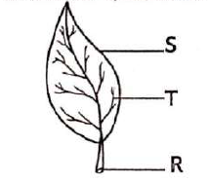
(a) Identify the parts marked R, S, and T respectively. (3 marks)
R: _____________________
S: _____________________
T: _____________________
(b) State the function of each vascular bundle:
(i) Phloem (1 mark)
________________________________________________________________________________________________________________________________________________________________________________________
(ii) Xylem (1 mark)
________________________________________________________________________________________________________________________________________________________________________________________
22. In an investigation to identify conditions necessary for rusting, Grade 9 learners set up the experiment below.
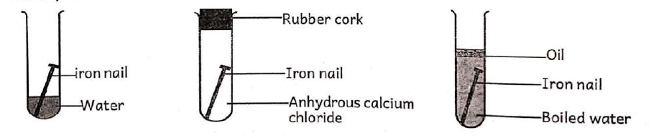
A B C
(a) In which test tube did rusting of the nail take place? (1 mark)
________________________________________________________________________________________________________________________________________________________________________________________
(b) State the reason for boiling water in test tube C. (1 mark)
________________________________________________________________________________________________________________________________________________________________________________________
(c) Which method of preventing rusting involves coating iron with a layer of zinc? (2 marks)
________________________________________________________________________________________________________________________________________________________________________________________
(d) State the physical property of metals that is useful in making jewellery and ornaments. (1 mark)
________________________________________________________________________________________________________________________________________________________________________________________

THIS IS THE LAST PRINTED PAGE
ANSWERS

SECTION A
- B
- B
- C
- C
- C
- B
- C
- C
- A
- D
- A
- D
- D
- B
- C

SECTION B

16.

(a)
(i)
- Lime is basic (alkaline) in nature.
(ii)
- Lime reduces soil acidity.
- It improves soil pH making nutrients available to plants.

(b)
- Phenolphthalein remains colourless in an acidic solution.

17.

(a)
- Mood swings / stress / anxiety / low self-esteem.

(b)
(i)
- Regular bathing prevents body odour.
(ii)
- Cleaning the skin helps reduce acne and infections.

18.

(a)
- Urea.

(b)
(i)
- Pain during urination.
(ii)
- Blood in urine / reduced urine output.

(c)
- The glomerulus filters waste products and excess water from the blood.

19.

(a)
- Chemical energy.

(b)
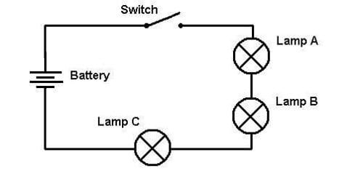

20.

(a)
(i) Iron
(ii) Nickel / Cobalt

(b)
(i) Magnets have two poles.
(ii) Like poles repel while unlike poles attract.

(c)
- Used in electric bells.
- Used in speakers/radios.
- Used in refrigerator doors.
- Used in compasses.

(d)
- A temporary magnet loses magnetism easily while a permanent magnet retains magnetism for a long time.

21.

(a)
R: Midrib
S: Vein
T: Petiole / leaf stalk

(b)
(i) Phloem
- Transports manufactured food.
(ii) Xylem
- Transports water and mineral salts.

22.

(a)
- Rusting occurred in test tube A.

(b)
- To remove dissolved oxygen from the water.

(c)
- Galvanization / galvanising.

(d)
- Lustre / shininess / malleability.

