

K.J.S.E.A

JUNIOR SCHOOL EDUCATION ASSESSMENT

TERM 2: ENDTERM ASSESSMENT 2026
GRADE 9 – CREATIVE ARTS AND SPORTS
Time: 1 Hour 30 Minutes
LEARNER’S DETAILS
Name: ________________________________________________. School: _____________________________________________________.
Assessment Number: _________________________________. Date: ______________________________________________________.
School Code: _______________________________________. Signature: _________________________________________________.

Instructions for Learners
- Write your full name and assessment number in the spaces provided above.
- Indicate your school name and school code clearly.
- Sign and date this paper in the spaces provided.
- This paper consists of TWO sections: Section A and Section B.
- Answer ALL questions in BOTH sections.
- Write your answers in the spaces provided in this question paper.
- Do NOT remove any page from this paper.
- All responses must be written in English

FOR EXAMINER’S USE
SECTION | SECTION A | SECTION B | % SCORE | EE1 | EE2 | ME1 | ME2 | AE1 | AE2 | BE1 | BE2
SCORE RANGE | 20 MARKS | 30 MARKS |  | 90-100 | 75-89 | 58-74 | 41-57 | 31-40 | 21-30 | 11-20 | 1-10
POINTS |  |  |  | 8 POINTS | 7 POINTS | 6 POINTS | 5 POINTS | 4 POINTS | 3 POINTS | 2 POINTS | 1 POINT
LEARNER’S TOTAL SCORE

SECTION A (20 MARKS)
Answer ALL questions in this section

Grade Nine learners were seen collecting the following items:
i. black ink
ii. toothpicks
iii. wax crayons
iv. pencil and rubber
Which pictorial composition were they going to make?
A. Painting B. Drawing
C. Crayon etching D. Cross-hatching

The following are techniques of creating tone in drawing. Which one is NOT?
A. Smudging B. Stippling
C. Cross-hatching D. Painting

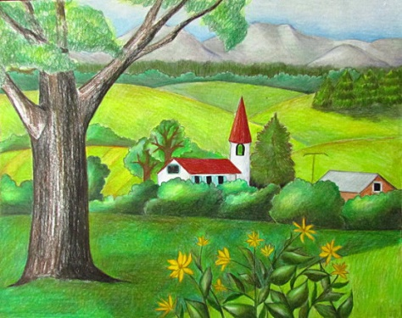
A Grade Nine learner made the following drawing:

This type of drawing is known as:
A. Seascape B. Landscape
C. Imaginative composition D. Good drawing

Grade Nine learners were asked to name dry media used in drawing. Who was WRONG?
A. Ashlee – ink B. Amos – pencil
C. Debby – chalk D. Valeria – charcoal sticks

Study the picture below.
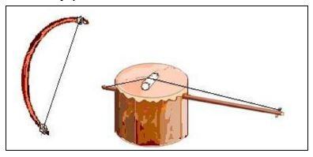
Identify the playing technique used on the instrument shown.
A. Pulling the strings B. Plucking the strings
C. Bowing D. Shaking

Grade Eight learners were asked to create a montage. Who did it correctly?
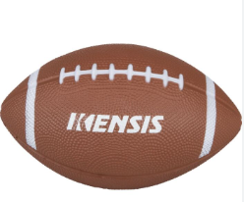
A. Angel – pasted coloured stones on a surface
B. Jayden – cut and pasted pictures to form a composition
C. Kilian – made a bird composition using coloured papers
D. Ginah – combined pictures, writing and fabric pieces

Study the ball below and identify the game:

A. Rugby B. Volleyball
C. Basketball D. Football

Study the melody below and identify the scale used:
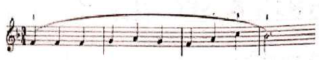
A. C major B. F major
C. G major D. Treble major

A learner mixed a primary colour and a secondary colour. The result is called:
A. Secondary colour B. Tertiary colour
C. Analogous colour D. Complementary colour

Which symbol shows that a pitch is raised by a half step?
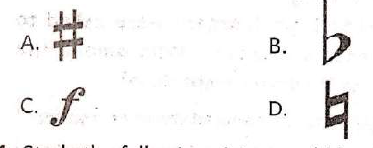

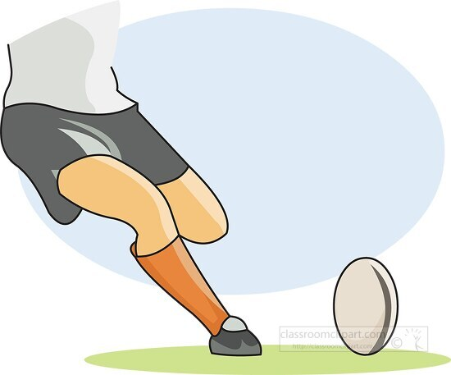
Study the picture and identify the rugby skill:

A. Placed kick B. Placed shot
C. Basic pass D. Pop pass

How many players are in a volleyball team?
A. 7 B. 9 C. 6 D. 11

Which netball skill enables scoring a point?
A. Overhead pass B. Chest pass
C. Shooting D. Dodging

Which of the following is a long-distance race?
A. 100m B. 400m C. Marathon D. 800m

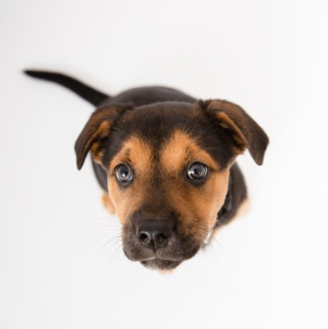
Study the photograph and identify camera position:

A. Front of the subject B. Above the subject
C. Below the subject D. Across the subject

The following are elements of photography. Which one is NOT?
A. Camera B. Light
C. Centre of interest D. View point

A written piece of literature meant to be acted on stage is called:
A. Verse B. Storyboard
C. Play D. Flipbook

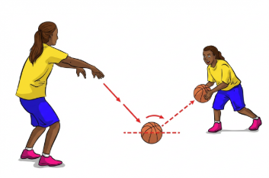
Study the picture and identify the basketball skill:

A. High dribbling B. Bounce pass
C. Chest pass D. Spin pass

Which part of a musical instrument produces sound?
A. Membrane
B. Resonator
C. Closed end
D. Tuning peg

Who is responsible for designing movement in dance?
A. Choreographer
B. Fine artist
C. Graphic designer
D. Referee

SECTION B (30 MARKS)

Name a folk dance performed in your community. (2mks)
__________________________________________________________________________________________________

Name the symbol used to connect treble and bass staff. (1mk)
____________________________________________________________________________

Define ledger lines in music. (2mks)
__________________________________________________________________________________________________________________________________________________________________________________________________________

Name two note extensions used in rhythm. (2mks)
(i) __________________________.
(ii) __________________________.

Write a rhythm in 4/4 time. (4mks)

List phases of triple jump in correct order. (4mks)
(i) _________________________
(ii) ________________________
(iii) _______________________
(iv) ________________________

Draw a still life composition on FOOD SECURITY theme. (4mks)

List three games that test reaction time. (3mks)

(i) _________________________
(ii) ________________________
(iii) _______________________

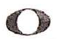
Identify the notes. (2mks)

(a) ____________________________ (b) ___________________________

OPTIONAL SECTION
(Answer EITHER 30 OR 31)

SWIMMING
(a) When a swimmer lies face down in water, this position is called: (1mk)
________________________________________________________________
(b) Name two water entry techniques. (2mks)
(i) ________________________________________________
(ii) _______________________________________________
(c) Define gliding in swimming. (2mks)
__________________________________________________________________________________________________________________________________________________________________________________________________________
(d) State one safety precaution in a swimming pool. (1mk)
___________________________________________________________________________________________________

31. INDIGENOUS GAMES
(a) What are indigenous tagging games? (2mks)
_________________________________________________________________________________________________________________________________________________________________________________________________________
(b) Name one indigenous tagging game in your community. (2mks)
__________________________________________________________________________________________________
(c) State two roles of indigenous tagging games. (2mks)
(i) ________________________
(ii) _______________________

THIS IS THE LAST PRINTED PAGE

ANSWERS

SECTION A (20 MARKS)
- B
- D
- B
- A
- C
- B
- A
- A
- B
- A
- A
- C
- C
- C
- B
- A
- C
- B
- B
- A

SECTION B

21. Folk dance
- Isukuti
- Gikuyu traditional dance
- Taarab dance (Coastal region)
- Adumu (Maasai jumping dance)

22. Symbol connecting treble and bass staff
- Brace
- Grand staff bracket

23. Ledger lines
- Short lines added above or below the staff
- Used to write notes that go beyond the normal staff range

24. Note extensions (any 2)
- Dot (dotted notes)
- Tie
- Triplet
- Fermata

25. Rhythm in 4/4 time (any correct pattern)
Examples:
♩ ♩ ♩ ♩ /♪♪ ♩ ♩ /♩ ♪♪ ♩ ♩ / ♩ ♩ ♪♪ ♩

26. Triple jump phases (correct order)
- Hop
- Step
- Jump
- Landing

27. Still life drawing (Food Security theme)
- Drawing of crops like maize, beans, vegetables, fruits
- Food storage items (granary, basket, sack)
- Kitchen items showing food preparation
(Any correct labeled drawing idea earns marks)

28. Reaction time games (any 3)
- Relay races
- Catching ball games
- Starting sprint races
- Dodge ball
- Whistle reaction games

29.
(a)
- semibreve
(b)
- crotchet

OPTIONAL SECTION

30. SWIMMING
(a)
- Prone position
(b) Water entry techniques:
- Diving
- Slide-in entry
(c) Gliding:
- Moving smoothly in water without strokes after pushing off
(d) Safety precaution:
- No running near the pool
- Swimming under supervision
- Use of life jacket

31. INDIGENOUS GAMES
(a)
- Games where players chase/tag each other using traditional rules
(b) Examples:
- Kati
- Hide and seek (traditional version)
- Ndondi ya mduara
(c) Roles:
- Promotes physical fitness
- Encourages teamwork
- Preserves culture

