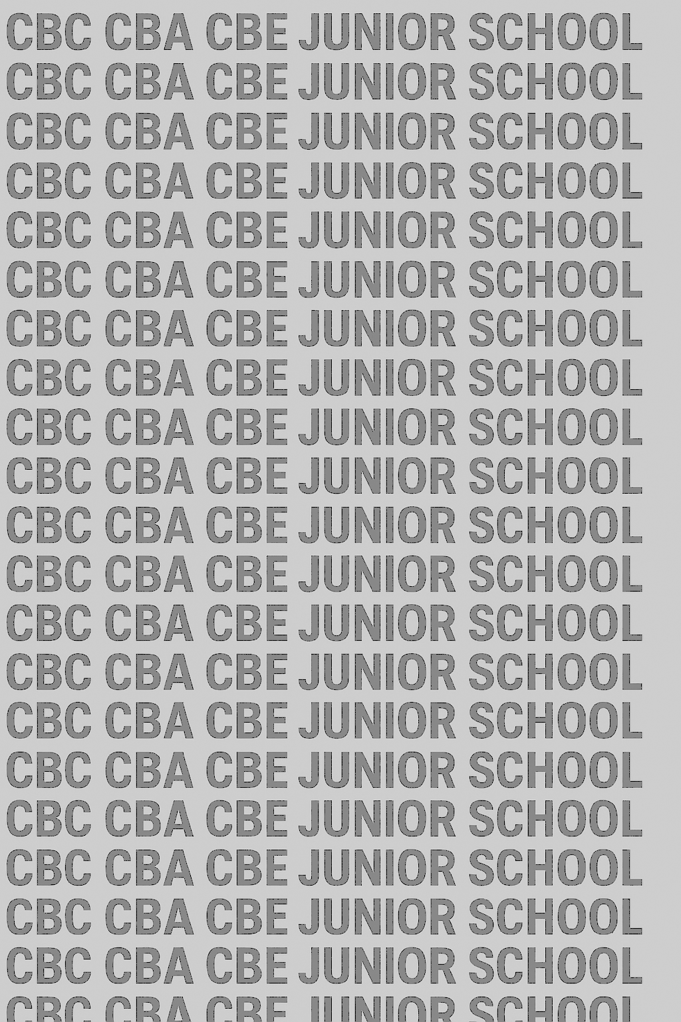
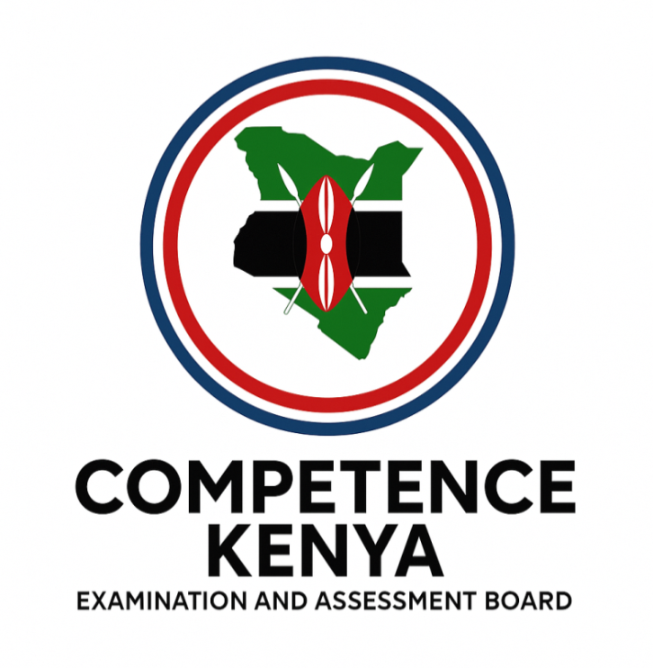
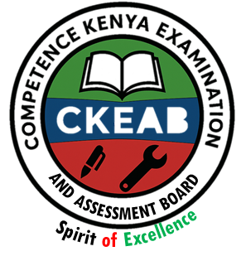
KENYA JUNIOR SCHOOL EDUCATION ASSESSMENT


GRADE 9 TERM 1 FEBRUARY 2026

ISLAMIC RELIGIOUS EDUCATION
CKEAB 002

Time - 1 hour 45 minutes

LEARNER’S DETAILS
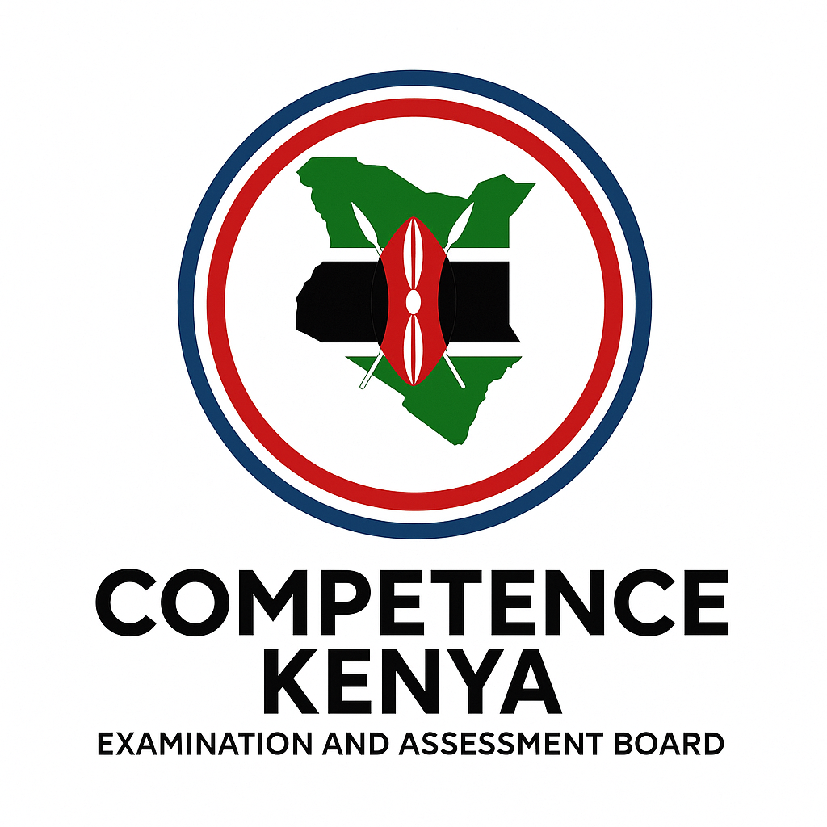
Name: ________________________________________________. School: _____________________________________
Assessment Number: _____________________________. Date: ______________________________.
School Code: ____________________________. Signature: ____________________________.
INSTRUCTIONS TO LEARNERS
- Write your name and assessment number in the spaces provided.
- Write the name and code of your school in the spaces provided.
- Write the date of the assessment and sign in the spaces provided.
- This question paper consists of two sections: A and B.
- Answer ALL questions in this paper.
- Write ALL the answers in the spaces provided in this question paper.
- Do NOT remove any page from this question paper.
- Answer the questions in English.
For official use only
SECTION A: MULTIPLE CHOICE QUESTIONS (20 Marks)
-IRE- -FORMATIVE ASSESSMENT- -001- - Paper Code 908-
Question No. | 1 | 2 | 3 | 4 | 5 | 6 | 7 | 8 | 9 | 10 | 11 | 12 | 13 | 14 | 15 | 16 | 17 | 18 | 19 | 20 | TOTAL
Max Score | 1 | 1 | 1 | 1 | 1 | 1 | 1 | 1 | 1 | 1 | 1 | 1 | 1 | 1 | 1 | 1 | 1 | 1 | 1 | 1 | 20
Candidate’s Score
SECTION B: STRUCTURED QUESTIONS (60 Marks)
Task | Qn Nos. | Max Marks | Candidate's Score  GRAND TOTAL
SECTION A | 20 | 20
SECTION B | 10 | 80
TOTAL | 50 | 100
This paper consists of 8 printed pages. Candidates should check the question paper to ascertain that all the pages are printed as indicated and that no questions are missing. This paper has 16 printed pages. Please check out to ensure all pages are printed
Turn over

SECTION A: (20 MARKS)
Answer all questions by choosing the correct answer

  - During a class discussion on faith, learners identify scriptures revealed by Allah to guide mankind. Which of the following is NOT a revealed scripture?
A. Injil
B. Zabur
C. Torah
D. Vedas
  - A learner explains that believing in revealed scriptures strengthens faith because they:
A. replace human laws
B. provide guidance from Allah
C. promote culture only
D. discourage reasoning
  - The Qur’an was revealed in portions mainly to:
A. test memorisation skills
B. allow easy implementation
C. delay its completion
D. favour certain companions
  - The first revelation of the Qur’an occurred:
A. in Madinah
B. during Hijrah
C. at Cave Hira
D. during Isra wal Mi’raj
  - Which quality of the Qur’an best shows Allah’s mercy to mankind?
A. Its length
B. Gradual revelation
C. Its Arabic language
D. Its compilation
- Surah Ad-Dhuha mainly teaches Muslims to:
A. avoid travel
B. honour orphans and the needy
C. engage in trade
D. fear poverty
- Surah Al-Balad emphasizes success through:
A. wealth accumulation
B. easy living
C. righteous struggle and charity
D. political power
- Hadith as a source of Sharia mainly explains:
A. scientific theories
B. Qur’anic verses
C. Sunnah of the Prophet (S.A.W.)
D. historical events only
- A Hadith that reports the actions, sayings, approval or appearance of the Prophet is classified as:
A. Qudsy
B. Nabawy
C. Dhaif
D. Hasan
- The Hadith “Actions are judged by intentions” teaches Muslims to:
A. work secretly
B. focus on outcomes
C. purify intentions
D. avoid migration
- A good friend according to the Hadith is compared to a:
A. farmer
B. teacher
C. musk seller
D. merchant
- Belief in Tawheed means:
A. worshipping angels
B. believing Allah has partners
C. believing in One Allah
D. worshipping prophets
- Which of the following is an example of major shirk?
A. Forgetfulness in prayer
B. Showing off
C. Worshipping idols
D. Seeking knowledge
- Congregational prayer is important because it:
A. reduces prayer units
B. earns more reward
C. replaces Sunnah prayers
D. shortens worship
- Zakatul Fitr is mainly paid to:
A. purify wealth
B. assist the poor before Eid
C. invest in business
D. build mosques
- One major objective of Saum is to:
A. promote hunger
B. increase wealth
C. attain taqwa
D. test health
- Islamic morality is best guided by:
A. culture only
B. personal opinions
C. Qur’an and Hadith
D. traditions
- Drug abuse is prohibited in Islam because it:
A. affects economy only
B. harms health and morals
C. wastes time only
D. causes poverty only
- A lawful (halal) source of earning must be:
A. profitable
B. popular
C. permissible in Islam
D. easy
- Respecting women’s rights in Islam reflects:
A. modern influence
B. western culture
C. Prophetic teachings
D. personal choice

SECTION B: (80 MARKS)
Answer all questions.

QUESTION 21: A Muslim youth attends an interfaith forum where scriptures are discussed respectfully.
a) Identify FOUR revealed scriptures sent by Allah. (4 marks)
i) _______________________________________________________________________________________________________.
ii) _______________________________________________________________________________________________________. iii) _______________________________________________________________________________________________________.
iv) _______________________________________________________________________________________________________.
b) Explain THREE reasons why Allah revealed scriptures to mankind. (6 marks)
i) _______________________________________________________________________________________________________.
ii) _______________________________________________________________________________________________________. iii) _______________________________________________________________________________________________________.
QUESTION 22: In a multicultural school, learners of different faiths interact daily.
a) State THREE importance of believing in revealed scriptures as a pillar of Iman. (3 marks)
i) _______________________________________________________________________________________________________.
ii) _______________________________________________________________________________________________________. iii) _______________________________________________________________________________________________________.
b) Identify THREE similarities found in revealed scriptures that promote religious tolerance. (3 marks)
i) _______________________________________________________________________________________________________.
ii) _______________________________________________________________________________________________________. iii) _______________________________________________________________________________________________________.
c) Describe TWO ways Muslims should show respect for revealed scriptures of other faiths. (4 marks) i) _______________________________________________________________________________________________________.
ii) _______________________________________________________________________________________________________.

QUESTION 23: A madrasa teacher explains how the Qur’an was revealed and preserved.
a) Describe the incident of the first revelation at Cave Hira. (4 marks)
i) _______________________________________________________________________________________________________.
ii) _______________________________________________________________________________________________________. iii) _______________________________________________________________________________________________________.
iv) _______________________________________________________________________________________________________.
b) Explain THREE reasons why the Qur’an was revealed in portions. (6 marks)
i) _______________________________________________________________________________________________________.
ii) _______________________________________________________________________________________________________. iii) _______________________________________________________________________________________________________.
QUESTION 24: Learners dramatize teachings from Surah Ad-Dhuha and Surah Al-Balad.
a) Explain the main message of Surah Ad-Dhuha (Q.93:1–11). (4 marks)
i) _______________________________________________________________________________________________________.
ii) _______________________________________________________________________________________________________. iii) _______________________________________________________________________________________________________.
iv) _______________________________________________________________________________________________________.
b) State THREE lessons derived from Surah Al-Balad (Q.90:1–20). (6 marks)
i) _______________________________________________________________________________________________________.
ii) _______________________________________________________________________________________________________. iii) _______________________________________________________________________________________________________.
QUESTION 25: During Islamic studies club, learners discuss Hadith.
a) Define the term Hadith. (2 marks)
________________________________________________________________________________________________________________________________________________________________________________________________

b) Describe the FOUR components of Hadith. (Qaul, Fiil, Taqrir, Sifat) (4 marks)
i) _______________________________________________________________________________________________________.
ii) _______________________________________________________________________________________________________. iii) _______________________________________________________________________________________________________.
iv) _______________________________________________________________________________________________________.
c) Differentiate between Hadith Nabawy and Hadith Qudsy. (4 marks)
________________________________________________________________________________________________________________________________________________________________________________________________________________________________________________________________________________________________________________________________________________________________________________________________

QUESTION 26: A learner reflects on personal choices and friendships.
a) Explain the lesson of the Hadith on intention. (4 marks)
i) _______________________________________________________________________________________________________.
ii) _______________________________________________________________________________________________________. iii) _______________________________________________________________________________________________________.
iv) _______________________________________________________________________________________________________.
b) Using the Hadith on choice of friends, explain THREE reasons why Muslims should choose good friends. (6 marks)
i) _______________________________________________________________________________________________________.
ii) _______________________________________________________________________________________________________. iii) _______________________________________________________________________________________________________.
iv) _______________________________________________________________________________________________________.

QUESTION 27: A Muslim is reminded to worship Allah sincerely.
a) Explain the significance of Tawheed in the life of a Muslim. (4 marks)
i) _______________________________________________________________________________________________________.
ii) _______________________________________________________________________________________________________. iii) _______________________________________________________________________________________________________.
iv) _______________________________________________________________________________________________________.
b) Identify THREE types of shirk and explain ONE effect of shirk on Iman. (6 marks)
i) _______________________________________________________________________________________________________.
ii) _______________________________________________________________________________________________________. iii) _______________________________________________________________________________________________________.
QUESTION 28: Islam links worship with good character.
a) Explain the importance of congregational and Sunnah prayers. (4 marks)
i) _______________________________________________________________________________________________________.
ii) _______________________________________________________________________________________________________. iii) _______________________________________________________________________________________________________.
iv) _______________________________________________________________________________________________________.
b) Describe THREE Islamic moral values that promote peaceful coexistence. (6 marks)

i) _______________________________________________________________________________________________________.
ii) _______________________________________________________________________________________________________. iii) _______________________________________________________________________________________________________.

©2026
All rights reserved
©COMPETENCE KENYA EXAMINATION AND ASSESSMENT BOARD
This is the last printed page

