
KENYA JUNIOR SCHOOL EDUCATION ASSESSMENT
GRADE 9 TERM 1 FEBRUARY 2026
INTEGRATED SCIENCE PRACTICAL CKEAB 002

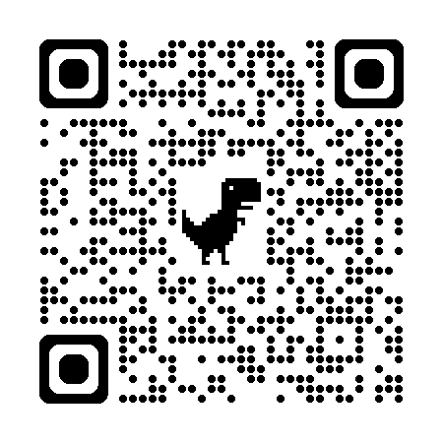
LEARNER’S DETAILS
Name: _______________________________________________________________________________________.
School: ______________________________________________________________________________________.
Assessment Number: ________________________________. Date: __________________________________.


School Code: _______________________________. Signature: ________________________________.

INSTRUCTIONS TO CANDIDATES
- Write your name and admission number in the spaces provided above.
- Answer all questions in the spaces provided.
- Read each question carefully and observe all safety instructions in the laboratory.
- Marks for each question are shown in brackets.

SECTION A: MULTIPLE CHOICE QUESTIONS (30 Marks)
-INTEGRATED SCIENCE- -002- - Paper Code 905/2-
Section | Maximum Marks | Learner’s Score | LEVEL
TASK 1 | 20
TASK 2 | 10
TOTAL | 30

Performance Levels Grid
Level | Level | % Range | Points | Learner’s score | Remarks
Exceeding (EE) | EE1 | 90–100% | 8 |  | Exceptional mastery; exceeds expectations
Exceeding (EE) | EE2 | 75–89% | 7 |  | Very strong performance
Meeting (ME) | ME1 | 58–74% | 6 |  | Solid understanding
Meeting (ME) | ME2 | 41–57% | 5 |  | Partial achievement
Approaching (AE) | AE1 | 31–40% | 4 |  | Limited achievement
Approaching (AE) | AE2 | 21–30% | 3 |  | Very limited
Below (BE) | BE1 | 11–20% | 2 |  | Poor performance
Below (BE) | BE2 | 1–10% | 1 |  | Extremely weak

This paper has 16 printed pages. Please check out to ensure all pages are printed
Turn over

TASK 1: (20 MARKS)
A local health centre has reported an increase in cases of skin infections and kidney-related illnesses among adolescents. The school health club has been asked to investigate how the human excretory system helps in removing wastes from the body and how good hygiene and lifestyle choices can prevent such conditions.
You are provided with:
- A labelled diagram of the human skin
- A labelled diagram of the urinary system
- A table showing daily activities of a learner

Questions
a) Draw and label four parts of the human skin. (4 marks)

b) State one function of each of the parts identified in (a). (4 marks)
 | Part | Function

c) Name the following parts of the urinary system as shown in the diagram: (4 marks)
i) The organ that filters blood: _________________________________________.
ii) The tube that carries urine from the kidney: _________________________________________.
iii) The organ that stores urine: _________________________________________.
iv) The tube through which urine leaves the body: _________________________________________.
d) Explain two ways in which the skin helps in the removal of wastes from the body. (4 marks)
i. _____________________________________________________________________________________________.
ii._____________________________________________________________________________________________.
e) A learner records the following daily activities:
- Drinking clean water
- Bathing daily
- Eating salty junk foods regularly
- Exercising three times a week
i) Identify two activities that promote kidney and skin health. (2 marks)
_____________________________________________________________________________________________.
_____________________________________________________________________________________________.
ii) Suggest two lifestyle changes the learner should make to reduce the risk of kidney disorders. (2 marks)
_____________________________________________________________________________________________.
_____________________________________________________________________________________________.

TASK 2: (10 MARKS)
During a power outage, learners are asked to assemble a simple lighting system using dry cells to light a bulb safely. Understanding how electric current flows in a circuit helps in using electricity efficiently and safely at home and in school.
You are provided with:
- Two dry cells
- A small bulb
- Connecting wires
- A switch

Questions
a) Draw a well-labelled diagram of a simple electric circuit using the materials provided to light the bulb. (4 marks)

b) State two observations you would make when the switch is closed. (2 marks)
i. _____________________________________________________________________________________________.
ii._____________________________________________________________________________________________.
c) Explain why the bulb does not light when the circuit is incomplete. (2 marks)
i. _____________________________________________________________________________________________.
ii._____________________________________________________________________________________________.
d) State two safety precautions that should be observed when using electricity at home or school. (2 marks)
i. _____________________________________________________________________________________________.
ii._____________________________________________________________________________________________.

©2026
All rights reserved
©COMPETENCE KENYA EXAMINATION AND ASSESSMENT BOARD
This is the last printed page

