
KENYA JUNIOR SCHOOL EDUCATION ASSESSMENT
GRADE 9 TERM 1 FEBRUARY 2026
INTEGRATED SCIENCE CKEAB 002


LEARNER’S DETAILS
Name: _______________________________________________________________________________________.
School: ______________________________________________________________________________________.
Assessment Number: ________________________________. Date: __________________________________.


School Code: _______________________________. Signature: ________________________________.

INSTRUCTIONS TO LEARNERS
- Write your name and class on the answer sheet provided.
- Answer ALL questions in Section A and Section B.
- For questions with pictures, study the pictures carefully before answering.
- Ensure your work is neat and clear.

SECTION A: MULTIPLE CHOICE QUESTIONS (30 Marks)
Question Number | 1 | 2 |  | 3 | 4 |  | 5 | 6 | 7 |  | 8 | 9 | 10 | 11 | 12 | 13 | 14 | 15
Maximum Score | 1 | 1 |  | 1 | 1 |  | 1 | 1 | 1 |  | 1 | 1 | 1 | 1 | 1 | 1 | 1 | 1
Candidate’s Score
Question Number | 16 |  | 17 |  |  | 18 |  | 19 |  | 20 |  | 21 | 22 | 23 | 24 | 25 | 26 | 27 | 28 | 29 | 30 | Total score
Maximum Score | 1 |  | 1 |  |  | 1 |  | 1 |  | 1 |  | 1 | 1 | 1 | 1 | 1 | 1 | 1 | 1 | 1 | 1 | 30
Candidate’s Score

SECTION B: STRUCTURED QUESTIONS. (50 Marks)
-INTEGRATED SCIENCE- -002- - Paper Code 905/1-
Section | Maximum Marks | Learner’s Score | Percentage (%)
A. Multiple Choice | 30
B. Structured Questions | 40
TOTAL | 80

Performance Levels Grid
Level | Level | % Range | Points | Learner’s score | Remarks
Exceeding (EE) | EE1 | 90–100% | 8 |  | Exceptional mastery; exceeds expectations
Exceeding (EE) | EE2 | 75–89% | 7 |  | Very strong performance
Meeting (ME) | ME1 | 58–74% | 6 |  | Solid understanding
Meeting (ME) | ME2 | 41–57% | 5 |  | Partial achievement
Approaching (AE) | AE1 | 31–40% | 4 |  | Limited achievement
Approaching (AE) | AE2 | 21–30% | 3 |  | Very limited
Below (BE) | BE1 | 11–20% | 2 |  | Poor performance
Below (BE) | BE2 | 1–10% | 1 |  | Extremely weak
This paper has 6 printed pages. Please check out to ensure all pages are printed
Turn over

SECTION A: MULTIPLE CHOICE QUESTIONS (30 MARKS)
Answer all the questions. Choose the correct answer for each.

- The kidney is a very important part of the excretory system. Its main function is to filter blood and remove waste materials. Urine is the main waste material excreted by the kidney.
Which one of the following is NOT a component of urine?
A. Urea
B. Salts
C. Sweat
D. Excess water
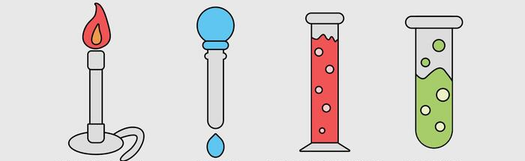
- While cleaning the laboratory, a Grade 7 learner came across the apparatus shown below.

A B C D
Which apparatus is called a dropper?
A. A B. B C. C D. D
- Every element has a unique symbol used for identification. Identify the element that has been correctly matched with its symbol.
A. Sodium – Na
B. Sulphur – Si
C. Silicon – S
D. Potassium – Po
- Study the table below and identify the physical change in adolescents that has been correctly matched with the gender.
Change | Occurs in
A. Hips broadening | Boys
B. Voice becomes softer | Girls
C. Menstruation begins | Boys
D. Experiences wet dreams | Girls
- When preparing a specimen for observation under a microscope, staining is important. What is the importance of staining the specimen?
A. To make the specimen more beautiful
B. To increase turgidity
C. To prevent distortion of cells
D. To increase visibility

- During a practical lesson, a Grade 8 learner used the circuit shown below to test the conductivity of a metal.
Identify the type of bulb arrangement used.
A. Parallel arrangement of cells
B. Series arrangement of bulbs
C. Series arrangement of cells
D. Parallel arrangement of bulbs
- A Grade 8 learner saw the symbols below on a fire extinguishers.
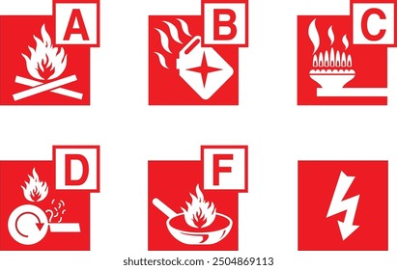

A B

C D
Which class of fire extinguisher is used to put out electrical fires?
A. A B. B
C. C
D. D
- Integrated Science has several components. Which one of the following is NOT a component of Integrated Science?
A. Agriculture
B. Biology
C. Physics
D. Chemistry
- Identify the danger that may cause loss of hearing and can be reduced by the use of earmuffs.
A. Bright light
B. Collisions
C. Road accidents
D. Loud noise
- Carbon is an element found in the periodic table. It has 6 protons and 6 electrons. What is the mass number of carbon?
A. 0
B. 12
C. 36
D. 6
- A Grade 8 learner listed the components of a fire triangle. Which arrangement is correct?
A. Hydrogen, fire and light
B. Oxygen, fuel and carbon (IV) oxide
C. Oxygen, hydrogen and heat
D. Oxygen, fuel and heat
- An atom has an electronic arrangement of 2.8.2. What is the name of the element?
A. Aluminium
B. Silicon
C. Magnesium
D. Barium
- The picture below shows a common source of electricity in homes. What is the name of the power source?
A. Wind power
B. Solar power
C. Hydroelectric power
D. Geothermal power
- After use, a microscope should be covered before storage. What is the importance of covering the microscope?
A. To prevent dust
B. To prevent moisture
C. To avoid falling
D. To keep away pests
- Measurements in science are standardised. Which of the following is NOT a derived quantity?
A. Area
B. Density
C. Temperature
D. Pressure
- Which part of the female reproductive system nourishes and supports the developing foetus?
A. Fallopian tube
B. Uterus
C. Ovary
D. Cervix
- The cell membrane selectively allows substances in and out of the cell. Which is NOT a property of the cell membrane?
A. Semi-permeable
B. Sensitive to pH and temperature
C. Polarised
D. Affected by surface area to volume ratio
- Electric motors and generators use magnets. Identify another device that uses magnets.
A. Washing machines
B. Iron sheets
C. Electrical cables
D. Bulbs
- Osmosis is important in plants. Which one is NOT an importance of osmosis?
A. Support in plants
B. Opening and closing of stomata
C. Osmoregulation
D. Feeding of insectivorous plants
- Which situation demonstrates high pressure?
A. A sharp knife cutting through meat
B. A wide paddle boat moving on water
C. A snowshoe on soft snow
D. A flat shoe on the ground
- Study the diagram below and identify the part marked X.
X
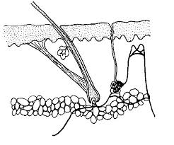

A. Hair follicle
B. Sweat duct
C. Blood vessels
D. Hair
- Which part of the microscope concentrates light onto the specimen?
A. Diaphragm
B. Aperture
C. Fine adjustment knob
D. Condenser
- A television uses a battery to display pictures and produce sound. Identify the correct energy transformation.
A. Potential → kinetic
B. Chemical → kinetic → electrical
C. Chemical → electrical → light and sound
D. Potential → kinetic → sound
- Where are sperms produced in the male reproductive system?
A. Prostate gland
B. Testes
C. Urethra
D. Epididymis
- The laboratory symbol shown represents:

A. Corrosive
B. Radioactive
C. Flammable
D. Carcinogenic
- A state of matter has no fixed shape and particles are far apart. Identify the state.
A. Liquid
B. Gas
C. Solid
D. Plastic
- Identify the part of the microscope that concentrates light from the mirror.
A. Diaphragm
B. Aperture
C. Fine adjustment knob
D. Condenser
- What is the name given to the part labelled Y and L respectively in the atom diagram?

Y

A. Electrons and Energy level
B. Protons and electrons
C. Energy levels and electrons
D. Electron configuration and protons
- Which material is attracted by a magnet?
A. Aluminium sufuria
B. Iron nails
C. Glass door
D. Copper coin
- Tomatoes in the school farm are performing poorly even after adding fertiliser. The soil pH is suspected. What should be done?
A. Check the soil pH
B. Add more fertiliser
C. Use organic manure
D. Add more water and lime

SECTION B: (40 MARKS)
Answer ALL questions in the spaces provided.
- a) Name two careers related to Integrated Science. (2 marks)
  - ____________________________________________________________________________.
  - ____________________________________________________________________________.
b) State two laboratory safety rules. (2 marks)
  - ____________________________________________________________________________.
  - ____________________________________________________________________________.

c) Using the microscope image provided:

i) Identify part c.
____________________________________________________________________
ii) State the function of part b. (2 marks)
____________________________________________________________________________________________________________________________________________________________________________________
- Complete the table below. (3 marks)
Common Laboratory Accident | Cause
Burns
Electric shock
Falls
- Identify the scientific skill demonstrated:
a) Measuring length and width to calculate area.____________________________________
b) Watering wilting crops.____________________________________________________ (2 marks)
- Identify the kidney parts labelled 2 and 3. (2 marks)

2: ____________________________________. 3: ____________________________________.
- State the function of the epidermis. (1 mark)
____________________________________________________________________________________________________________________________________________________________________________________
- a) State two functions of the female reproductive system. (2 marks)
  - ___________________________________________________________________________.
  - ___________________________________________________________________________.
b) State two challenges associated with menstruation. (2 marks)
  - ___________________________________________________________________________.
  - ___________________________________________________________________________.
- a) Identify the physiological process investigated. (1 mark)
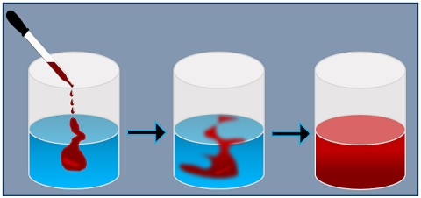
_________________________________________________________________
b) State two factors affecting the process. (2 marks)
  - ___________________________________________________________________________.
  - ___________________________________________________________________________.
- a) Define:
i) Conductor
____________________________________________________________________________________________________________________________________________________________________________________
ii) Non-conductor (2 marks)
____________________________________________________________________________________________________________________________________________________________________________________
b) State two electrical safety measures. (2 marks)
  - ___________________________________________________________________________.
  - ___________________________________________________________________________.
- Yusuf conducted the experiment shown below while separating a mixture
a) Name the separation technique shown. (1 mark)

____________________________________________________________.
b) What is the name of the solid that remained at part Y? (1 mark)
_____________________________________________________________________________.
- a) Define an atom. (1 mark)
____________________________________________________________________________________________________________________________________________________________________________________
b) Calculate the atomic number of an element with mass number 16 and 10 neutrons. (1 mark)

- a) Identify the substance shown by particle arrangement. (1 mark)

________________________________________________________.
b) State one characteristic. (1 mark)
_____________________________________________________________________________________.
- Explain the energy transformation when a car slows down. (1 mark)
____________________________________________________________________________________________________________________________________________________________________________________
- Explain how magnets can reduce environmental pollution. (1 mark)
____________________________________________________________________________________________________________________________________________________________________________________
- a) Identify parts X and Y. (2 marks)
X: ___________________________________________________.
Y: ___________________________________________________.
b) State the sub-atomic particles found in X. (1 mark)
______________________________________________________________________________

- State the uses of: (2 marks)
a) Sodium chloride
______________________________________________________________________________________.
b) Gold
_______________________________________________________________________________________.
- An element P has atomic number 7. Write its electronic configuration. (1 mark)
______________________________________________________________________________________.
- a) Identify the process investigated. (1 mark)
_______________________________________________________________________________.
b) Define pressure. (1 mark)
____________________________________________________________________________________________________________________________________________________________________________________
- What observation is expected when two magnets are brought close? (1 mark)

__________________________________________________________________________________________
__________________________________________________________________________________________
- Explain why pointed shoes exert higher pressure than flat shoes. (1 mark)
____________________________________________________________________________________________________________________________________________________________________________________
- Complete the table showing results of an acid-base test. (2 marks)
Indicator | Base | Acid
Litmus | Blue | ___
Methyl orange | ___ | Pink

©2026
All rights reserved
©COMPETENCE KENYA EXAMINATION AND ASSESSMENT BOARD
This is the last printed page

