


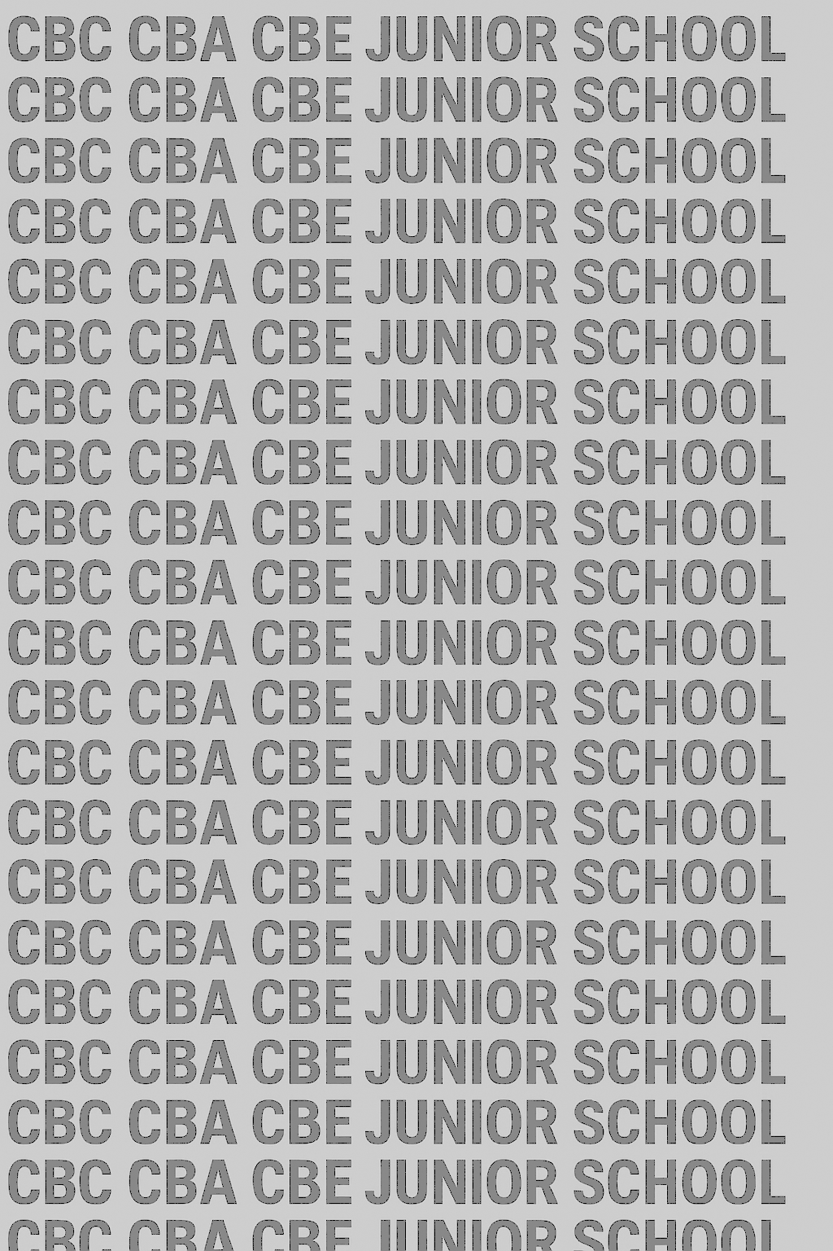
KENYA JUNIOR SCHOOL EDUCATION ASSESSMENT
GRADE 9 TERM 1 FEBRUARY 2026
ENGLISH PAPER 2 CKEAB 002

(Composition and Literary Analysis)

Time - 1 hour 45 minutes

LEARNER’S DETAILS
Name: ________________________________________________. School: _____________________________________
Assessment Number: _____________________________. Date: ______________________________.
School Code: ____________________________. Signature: ____________________________.

INSTRUCTIONS TO CANDIDATES
- Write your name and assessment number in the spaces provided.
- Write the name and code of your school in the spaces provided.
- Write the date of the assessment and sign in the spaces provided.
- This question paper consists of two sections: A and B.
- Answer ALL questions in this paper.
- Write ALL the answers in the spaces provided in this question paper.
- Do NOT remove any page from this question paper.
- Answer the questions in English.
For official use only
-ENGLISH- -002- - Paper Code 901/2-
SECTION | TASK | Maximum Score | Candidate’s Score
A | Task 1 Question 1 | 15
B | Task 2 Question 2 | 10
 | Task 3 Question 3 | 5
 | Task 4 Question 4 | 10
 | Task 5 Question 5 | 10

This paper consists of 8 printed pages. Candidates should check the question paper to ascertain that all the pages are printed as indicated and that no questions are missing.

This paper has 16 printed pages. Please check out to ensure all pages are printed
Turn over

SECTION A: COMPOSITION (15 MARKS)

TASK 1: COMPOSITION
1. Write a composition in the space provided.
Write a story beginning with the following sentence:
I never imagined that a simple trip to the market would change my life forever.
………………………………………………………………………………………………………………………………………………………………………………………………………………………………………………………………………………………………………………………………………………………………………………………………………………………………………………………………………………………………………………………………………………………………………………………………………………………………………………………………………………………………………………………………………………………………………………………………………………………………………………………………………………………………………………………………………………………………………………………………………………………………………………………………………………………………………………………………………………………………………………………………………………………………………………………………………………………………………………………………………………………………………………………………………………………………………………………………………………………………………………………………………………………………………………………………………………………………………………………………………………………………………………………………………………………………………………………………………………………………………………………………………………………………………………………………………………………………………………………………………………………………………………………………………………………………………………………………………………………………………………………………………………………………………………………………………………………………………………………………………………………………………………………………………………………………………………………………………………………………………………………………………………………………………………………………………………………………………………………………………………………………………………………………………………………………………………………………………………………………………………………………………………………………………………………………………………………………………………………………………………………………………………………………………………………………………………………………………………………………………………………………………………………………………………………………………………………………………………………………………………………………………………………………………………………………………………………………………………………………………………………………………………………………………………………………………………………………………………………………………………………………………………………………………………………………………………………………………………………………………………………………………………………………………………………………………………………………………………………………………………………………………………………………………………………………………………………………………………………………………………………………………………………………………………………………………………………………………………………………………………………………………………………………………………………………………………………………………………………………………………………………………………………………………………………………………………………………………………………………………………………………………………………………………………………………………………………………………………………………………………………………………………………………………………………………………………………………………………………………………………………………………………………………………………………………………………………………………………………………………………………………………………………………………………………………………………………………………………………………………………………………………………………………………………………………………………………………………………………………………………………………………………………………………………………………………………………………………………………………………………………………………………………………………………………………………………………………………………………………………………………………………………………………………………………………………………………………………………………………………………………………………………………………………………………………………………………………………………………………………………………………………………………………………………………………………………………………………………………………………………………………………………………………………………………………………………………………………………………………………………………………………………………………………………………………………………………………………………………………………………………………………………………………………………………………………………………………………………………………………………………………………………………………………………………………………………………………………………………………………………………………………………………………………………………………………………………………………………………………………………………………………………………………………………………………………………………………………………………………………………………………………………………………………………………………………………………………………………………………………………………………………………………………………………………………………………………………………………………………………………………………………………………………………………………………………………………………………………………………………………………………………………………………………………………………………………………………………………………………………………………………………………………………………………………………………………………………………………………………………………………………………………………………………………………………………………………………………………………………………………………………………………………………………………………………………………………………………………………………………………………………………………………………………………………………………………………………………………………………………………………………………………………………………………………………………………………………………………………………………………………………………………………………………………………………………………………………………………………………………………………………………………………………………………………………………………………………………………………………………………………………………………………………………………………………………………………………………………………………………………………………………………………………………………………………………………………………………………………………………………………………………………………………………………………………………………………………………………………………………………………………………………………………………………………………………………………………………………………………………………………………………………………………………………………………………………………………………………………………………………………………………………

SECTION B: LITERARY ANALYSIS (35 MARKS)
Answer ALL questions in this section.

TASK 2: ORAL LITERATURE
2. Read the story and answer the questions. (10 marks)
The Clever Monkey
Once upon a time, a monkey and a crocodile were friends. The crocodile invited the monkey to his home across the river. The monkey, trusting his friend, agreed to visit.
When they reached the riverbank, the crocodile revealed that he planned to eat the monkey’s heart. The monkey quickly thought of a plan.
He said, “Oh, my dear friend, I left my heart hanging on the tree. You cannot eat it without it.”
The crocodile, fooled, allowed the monkey to return to the tree. The monkey jumped to safety and never trusted the crocodile again.
Questions:
(a) Identify the part of the story that shows cleverness. (2 marks) ________________________________________________________________________________________________________________________________________________________________________________________________
(b) How would you perform this story orally to make your friends laugh? Give two suggestions. (2 marks) ________________________________________________________________________________________________________________________________________________________________________________________________
(c) Pick one character trait of the crocodile and provide evidence from the story. (2 marks) ____________________________________________________________________________________
(d) Identify two examples of dialogue from the story. (2 marks) ________________________________________________________________________________________________________________________________________________________________________________________________
(e) What lesson can we learn from this story? (2 marks) ________________________________________________________________________________________________________________________________________________________________________________________________

TASK 3: POETRY
3. Read the poem and answer the questions. (5 marks)
Poem: The Sun and the Rain
The sun smiles upon the field,
Golden light the crops shall yield.
The rain comes softly from the sky,
Watering earth, the plants grow high.
(a) How many lines are in this poem? (1 mark) ________________________________________________________________________________________________________________________________________________________________________________________________

(b) Identify the rhyming pattern of the poem. (2 marks) ________________________________________________________________________________________________________________________________________________________________________________________________
(c) What message is the poet giving about nature in the last two lines? (2 marks) ________________________________________________________________________________________________________________________________________________________________________________________________

TASK 4: PLAY
4. Read the scene and answer the questions. (10 marks)
Act One Scene Two
Setting: A classroom.
TEACHER: Students, why have your assignments not been submitted on time?
STUDENT A: Sorry, teacher, we were busy with sports practice.
TEACHER: You must plan your time better. Education comes first.
STUDENT B: Teacher, we promise to submit tomorrow.
TEACHER: I hope this will be the last delay.
(a) Where does this scene take place? (2 marks) _____________________________________________________________________________________
(b) What is the teacher trying to teach the students? (2 marks) ________________________________________________________________________________________________________________________________________________________________________________________________
(c) Identify two positive character traits of the teacher and support with evidence. (4 marks) _______________________________________________________________________________________________________________________________________________________________________________________________
(d) What does this scene teach about responsibility? (2 marks) _______________________________________________________________________________________________________________________________________________________________________________________________

TASK 5: NOVELLA
5. Read the excerpt and answer the questions. (10 marks)
Story: The Mysterious Footprints
Late at night, Lila noticed strange footprints in her garden. She called her brother, Ken, and they decided to investigate quietly.
Following the footprints, they reached the shed and discovered a cat had knocked over several pots. Lila laughed, relieved it was not a thief.
They learned to always check carefully before panicking.
(a) What is the time setting of the story? (2 marks) ________________________________________________________________________________________________________________________________________________________________________________________________

(b) Describe two traits of Lila using evidence from the story. (4 marks) _______________________________________________________________________________________________________________________________________________________________________________________________
(c) Name two characters in the play apart from Lila. (2 marks) ________________________________________________________________________________________________________________________________________________________________________________________________
(d) What is the effect of the dialogue in this story? (2 marks) ________________________________________________________________________________________________________________________________________________________________________________________________

©2026
All rights reserved
©COMPETENCE KENYA EXAMINATION AND ASSESSMENT BOARD
This is the last printed page

