
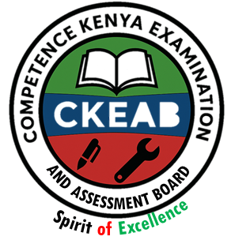
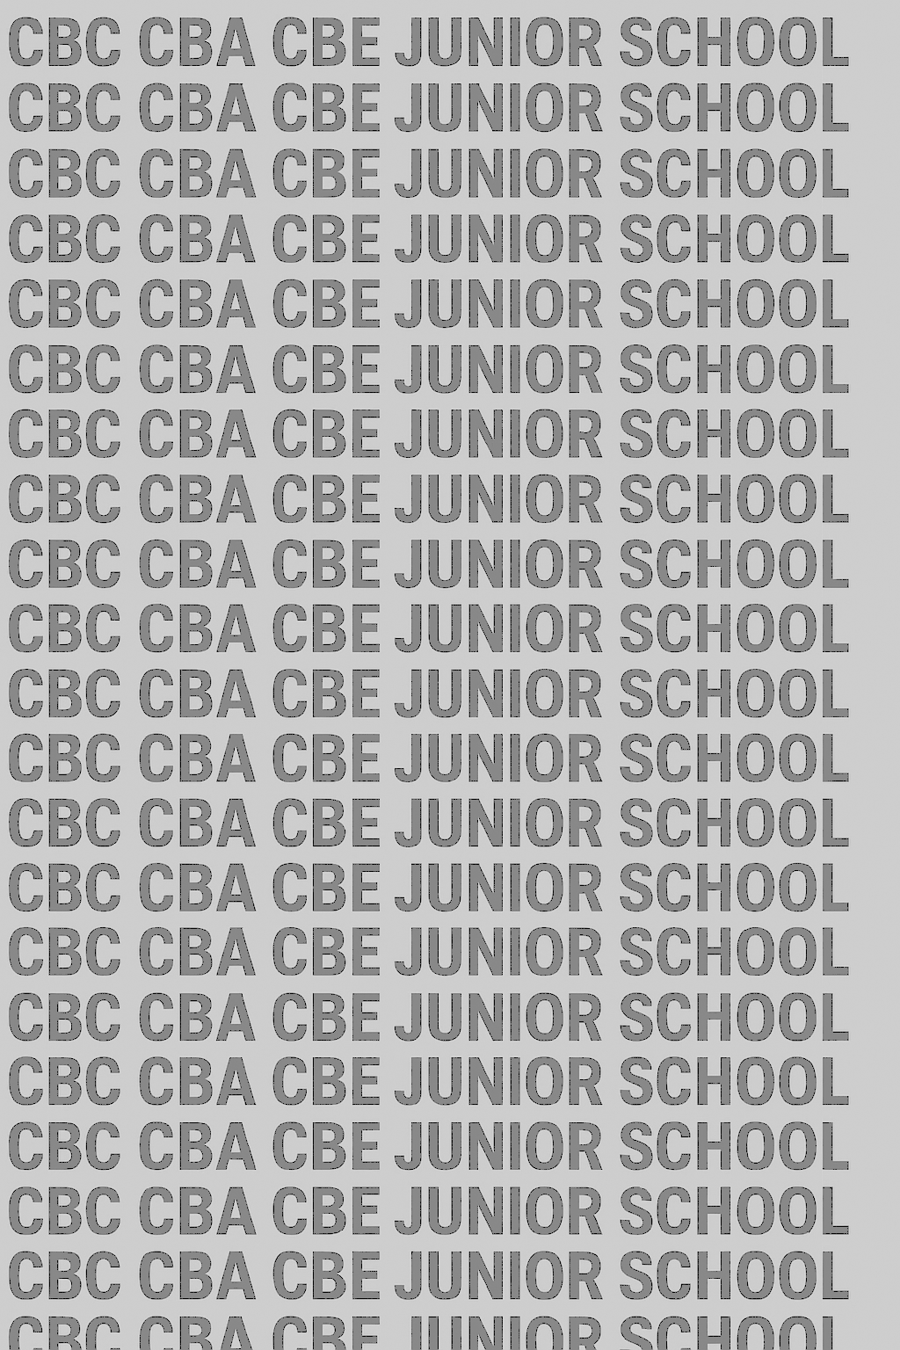
KENYA JUNIOR SCHOOL EDUCATION ASSESSMENT
GRADE 9 TERM 1 FEBRUARY 2026
901/1
ENGLISH PAPER 1 CKEAB 002

(Reading Comprehension, Oral Skills and Grammar)

Time - 1 hour 40 minutes


LEARNER’S DETAILS
Name: ________________________________________________. School: _____________________________________
Assessment Number: _____________________________. Date: ______________________________.
School Code: ____________________________. Signature: ____________________________.

INSTRUCTIONS TO CANDIDATES (Please read these instructions carefully)

You have been given this question paper and a separate answer sheet. The question paper consists of 50 Multiple Choice Questions. Answer ALL the questions.

Do any necessary rough work in this question paper.

When you have chosen your answer, mark it on the ANSWER SHEET, NOT in this question paper.

HOW TO USE THE ANSWER SHEET

Keep the answer sheet clean and do not fold it.

Use an ordinary (HB) pencil.

Confirm that the answer sheet you have been provided with has the following:

YOUR ASSESSMENT NUMBER YOUR NAME NAME OF YOUR SCHOOL NAME OF THE SUBJECT
-ENGLISH- -002- - Paper Code 901/1-

For each of the questions, 1 – 50, four choices are given. The choices are lettered A, B, C and D. The letters are written inside circles. In each case, only ONE of the four choices is correct. Choose the correct answer.

On the answer sheet, show the correct answer by completely shading inside the circle which has the letter you have chosen.

Do not make any marks outside the circles. Be sure of your answer before shading the circle.

Example: In the Question paper:

Which one of the following means the opposite of the word “better”?

Weak wrong worse wasted

The correct answer is C.

On the answer sheet: In the set of circles numbered 40, shade inside the circle with the letter C printed in it, as indicated below.
40. | 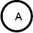 | 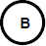 |  | 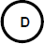

Your shading MUST be inside the circle.

For each question, shade ONLY ONE circle.

This paper has 16 printed pages. Please check out to ensure all pages are printed
Turn over

Read the passage below and then answer questions 1 to 6.
Nutrition is the basis of our well-being. It is about eating a regular and balanced diet. Good nutrition provides the essential nutrients our bodies need to thrive. Proper nutrition helps keep our energy levels up and protects us against many diseases such as heart disease, cancer, and diabetes. Good nutrition also helps fuel our bodies. The foods we eat supply the nutrients we need to maintain our brain, muscles, blood circulation, and immune system. In addition to eating a variety of nutritious foods, it is important to limit the intake of processed foods high in sugars and fats. Drinking plenty of water is also crucial for proper functioning of our bodies. Ultimately, making mindful food choices and adopting healthy eating habits can lead to increased energy levels, improved mood, and a reduced risk of health problems. By prioritising nutrition, we can nourish our bodies, and live fuller and healthier lives.
(Adapted from Harvard Health Publishing by Mallika Marshall.)

- According to the passage, nutrition is about
A. eating good proportions of foods often.
B. making our bodies to grow strong.
C. increasing our food intake levels.
D. retaining nutrients our bodies need.
- If we do not live healthier lives, we will
A. get angry.
B. become weak.
C. learn new eating habits.
D. understand the types of nutrients.
- Which one of the following statements is true according to the passage?
A. Prioritising the intake of a balanced diet leads to a happy life.
B. Illnesses like cancer and diabetes are caused by eating a lot of food.
C. Drinking adequate water is important for our bodies.
D. It is useful to include large quantities of sugar in our diet.
- The expression “fuel our bodies” as used in the passage means
A. make our bodies grow faster.
B. make our bodies work well.
C. give our bodies support.
D. give our bodies warmth.
- Which word in the passage means the same as “necessary”?
A. Mindful
B. Regular
C. Plenty
D. Essential
- Which one of the following would be the best title for this passage?
A. Healthy diet
B. Variety of foods
C. Regular eating
D. Energy giving foods

Read the passage below and then answer questions 7 to 11.
I have never seen anything as powerful as a person’s attitude. I have also not seen anything as destructive as one’s attitude. For some people, their attitude finds opportunity in every difficulty. Some people succeed because of their positive attitude while others fail because of their negative outlook. Your attitude will either attract success or repel it.
Which one of these attitudes describes you?
Before you answer that question, let me give you some good news. You can choose your attitude. How is it possible? We are each individually responsible for building our own view of life. The way we look at life and the way we do things help determine what will happen to us. Our future looks bright when the attitude is right, and it makes the present much more enjoyable too!
(Adapted from Attitudes that Attract Success by Wayne Cordeiro, 2001.)

- From paragraph one, we can say that attitudes
A. cannot be easily understood.
B. can be useful or harmful.
C. are always destructive.
D. are not usually visible.

- Which one of the following is true according to the passage?
A. Our thinking determines our achievement in life.
B. When we work together, we can change our attitude.
C. A bright future is for the people who think a lot.
D. People believe that we all have the same attitude.
- The word “attract” as used in the passage means
A. want. B. make.
C. bring. D. add.
- From the passage, “our future looks bright” means the future is
A. entertaining. B. surprising.
C. promising. D. welcoming.
- Which one of the following would be the most suitable title for this passage?
A. Good news
B. Our attitude
C. Good decisions
D. Our choices

Read the passage below and then answer questions 12 to 16.
Global warming is the rapid increase in the earth’s surface temperature due to human activities. One such human activity is deforestation. Many trees are cut either for business purposes or sometimes to give way to human development activities like farming. It has been discovered that trees clean the air, therefore, cutting trees leads to global warming.
The second human activity that causes global warming is careless disposal of garbage and human waste. Burning of plastic bags and other plastic materials releases carbon and greenhouse gases into the atmosphere, thus causing global warming. People should therefore recycle garbage and human waste. Another cause of global warming is smoke from factories and motor vehicles that use petroleum fuels. People need to use clean fuels to operate machines and drive vehicles. Smoke needs to stop as we switch to more fuel-efficient vehicles and find ways to make clean power.
Global warming has harmful effects. All the human activities mentioned above affect the ozone layer which is supposed to protect the earth’s surface from harmful sun rays. All in all, if we take good care of our environment, we can reduce global warming, and the earth will be safe.

- According to the passage, global warming is
A. an increase in the earth’s gases.
B. a quick growth of human activities.
C. an expansion of hot deserts.
D. a rise in the earth’s heat levels.
- Which one of the following would reduce global warming according to the passage?
A. Limiting farming activities
B. Protecting our forests
C. Reducing use of motor vehicles
D. Disposing garbage from factories
- The word “recycle” as used in the passage means the same as
A. retain.
B. reduce.
C. reuse.
D. rebuild.
- According to the passage, the ozone layer
A. provides energy for trees to grow.
B. keeps away too much heat from the earth.
C. increases cleanliness in the environment.
D. helps in the disposal of human waste.
- We can reduce the effect of smoke in the environment by
A. avoiding use of unclean fuel.
B. reducing visiting people.
C. reducing use of bags.
D. avoiding buying machines.

Read the passage below and then answer questions 17 to 20.
Mogaka, Danjit, Oduki and Rono are all Grade 8 learners at Matembe Junior School. Danjit and Rono like playing handball and football. Mogaka and Oduki like playing volleyball and handball. Rono sometimes plays volleyball and hockey.

- Who plays most games?
A. Mogaka
B. Danjit
C. Oduki
D. Rono
- Which game is played by most people?
A. Hockey
B. Football
C. Handball
D. Volleyball
- Which game is the least played?
A. Handball
B. Hockey
C. Football
D. Volleyball
- All the learners play volleyball except
A. Danjit.
B. Mogaka.
C. Oduki.
D. Rono.

Read the following telephone conversation between two friends, Maru and Chacha. It contains blank spaces numbered 21 to 23. For each blank space, select the best alternative from the choices given.
Maru: Hello, Chacha.
Chacha: Hello, Maru. How are you today?
Maru: 21.
Chacha: I missed your call, but I saw your text message. I was about to call you. You said you wanted to talk to me.
Maru: Yes, 22. Mine has faulty brakes.
Chacha: 23.
Maru: Then I will have to look for one elsewhere.
Chacha: Thank you for understanding.

A. I am well, talk to me. B. It is okay. We can speak.
C. I am fine. Thank you. D. It is nice. I am grateful.

A. I was wondering if you could lend me your bicycle tomorrow.
B. I wanted you to lend me your bicycle tomorrow.
C. I wish to tell you that I need your bicycle tomorrow.
D. I was informing you that I need to use your bicycle tomorrow.

A. No, I don’t have another one.
B. I am sorry, I’m using mine tomorrow.
C. No, I can’t give you my bicycle.
D. I am sorry, please try yours.

For questions 24 and 25, select the alternative that best describes what you would say in each of the situations presented.

- Your teacher of English tells you that your composition has exceeded expectation. What should you say to the teacher?
A. You are very good, Teacher.
B. Thank you, Teacher.
C. I can do better, Teacher.
D. My work was the best, Teacher.
- You have been sent by your class teacher to get a textbook from the staffroom. Reaching the staffroom, you find other teachers and you knock on the door. What will you say next?
A. Excuse me, may I come in?
B. Excuse me, do I get in, please?
C. Excuse me, I need to come in, please.
D. Excuse me, someone should let me in.

Read the passage below. It contains blank spaces numbered 26 to 35. For each blank space, choose the best alternative.
Watching television is a favourite pastime for many people. This gadget 26 become more and more common in homes. This is probably 27 it is now more affordable than it was before. Another reason 28 its popularity could be that watching television is not as demanding as reading. All one needs is to pay a little 29 to the screen. Thus, television is a convenient way of relaxing and keeping 30 boredom. Most television programmes all 31 the world are creatively prepared to make them very 32 to watch.
However, it is important to realise that watching television has its downside. It makes us inactive and 33. When we watch television, very little effort 34 mental energy may be 35 for the activity.

- A. have B. will C. has D. would
- A. as B. since C. so D. because
- A. for B. with C. about D. of
- A. patience B. consideration C. interest D. attention
- A. away B. aside C. out D. down
- A. in B. at C. over D. across
- A. important B. necessary C. useful D. interesting
- A. poor B. lazy C. weak D. tired
- A. but B. or C. yet D. if
- A. produced B. gained C. required D. allowed

For questions 36 to 45, select the alternative that best completes the sentence.
- When we arrived at the park, we saw a ___ of birds.
A. school B. swarm C. group D. flock
- Wild dogs rarely hunt alone. They hunt in ___.
A. herds B. packs C. crowds D. prides
- I cannot find my storybook. ___ must have picked it from my bag.
A. No one B. Someone C. Anyone D. Everyone
- “Did ___ come to look for me when I was away?” asked Muindi.
A. anybody B. somebody C. everybody D. nobody
- We all knew that Kubai was going to win because he was good ___ long races.
A. at B. in C. on D. by
- Your father lives in the city, ___?
A. does he B. did he C. doesn’t he D. didn’t he
- Some Grade 8 learners never make spelling mistakes, ___?
A. don’t they B. didn’t they C. did they D. do they
- ___ the dancing stage is ready, we may not dance tomorrow.
A. Since B. Except C. Unless D. Despite
- Neither a cup nor a plate ___ broken yesterday by the end of the party.
A. were B. was C. are D. is
- “These books belong to them. They are _,” said Grace.
A. theirs B. ours C. hers D. yours

- Which one of the following sentences is correctly punctuated?
A. “Where are you going to” the teacher asked Kilo.
B. “Where are you going to” the teacher asked Kilo?
C. “Where are you going to?” the teacher asked Kilo.
D. “Where are you going to, the teacher asked Kilo?”
- Which one of the following alternatives means the same as the underlined sentence?
The learner gave flowers to the visitor.
A. The visitor was given flowers by the learner.
B. The visitor was being given flowers by the learner.
C. The visitor is given flowers by the learner.
D. The visitor is being given flowers by the learner.
- Choose the alternative that correctly combines the following sentences.
It was my cousin’s wedding party. We had a good time.
A. It was my cousin’s wedding party and we had a good time.
B. It was my cousin’s wedding party but we had a good time.
C. It was my cousin’s wedding party also we had a good time.
D. It was my cousin’s wedding party until we had a good time.

For questions 49 and 50, choose the alternative that means the same as the underlined.
- Many workers resigned because they could not put up with the noise from the factory.
A. control B. avoid C. accept D. tolerate
- As a young writer, I have always looked up to William Shakespeare, the great dramatist.
A. preferred
B. enjoyed
C. admired
D. imitated

©2026
All rights reserved
©COMPETENCE KENYA EXAMINATION AND ASSESSMENT BOARD
This is the last printed page

