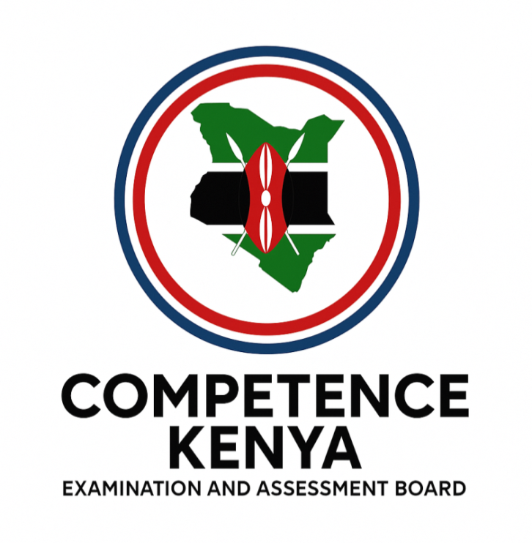
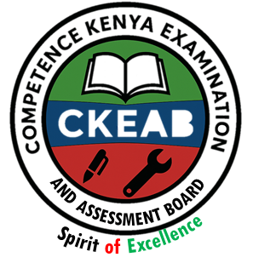
KENYA JUNIOR SCHOOL EDUCATION ASSESSMENT
GRADE 8 TERM 1 FEBRUARY 2026

PRETECHNICAL STUDIES CKEAB 001

Time - 1 hour 40 minutes

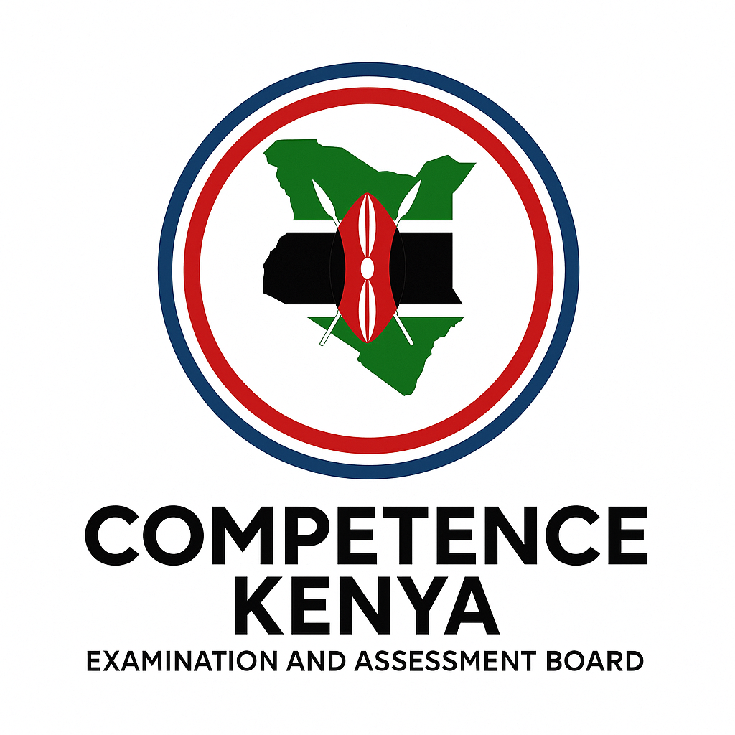
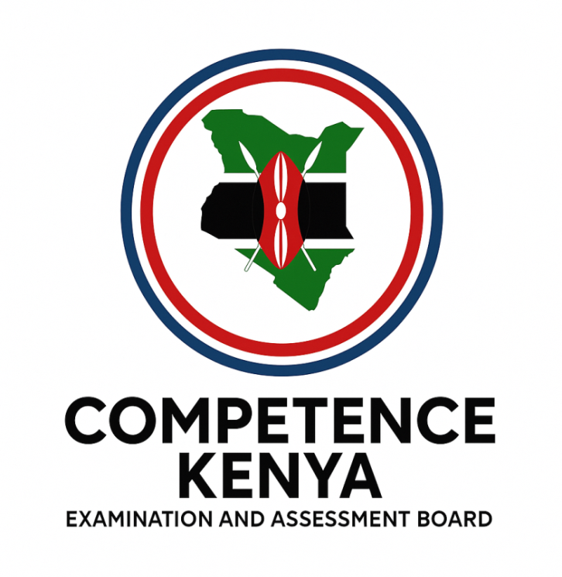
LEARNER’S DETAILS
Name: ________________________________________________. School: _____________________________________
Assessment Number: _____________________________. Date: ______________________________.
School Code: ____________________________. Signature: ____________________________.
INSTRUCTIONS TO LEARNERS
- Write your name and assessment number in the spaces provided above.
- Write the name and code of your school in the spaces provided above.
- Sign and write the date of the assessment in the spaces provided above.
- This paper consists of two sections: A and B.Section A comprises Multiple Choice Questions.
- Section B comprises Short Structured Questions.
- Answer ALL questions in Section A on the separate ANSWER SHEET provided.
- Answer ALL questions in Section B in the spaces provided in this question paper.
- Answer all questions in English.
-PRETECHNICAL STUDIES- -002- FORMATIVE ASSESSMENT - Paper Code 912/1
For official use only
SECTION A: MULTIPLE CHOICE QUESTIONS (20 Marks)
Question No. | 1 | 2 | 3 | 4 | 5 | 6 | 7 | 8 | 9 | 10 | 11 | 12 | 13 | 14 | 15 | 16 | 17 | 18 | 19 | 20 | TOTAL
Max Score | 1 | 1 | 1 | 1 | 1 | 1 | 1 | 1 | 1 | 1 | 1 | 1 | 1 | 1 | 1 | 1 | 1 | 1 | 1 | 1 | 20
Candidate’s Score
SECTION B: STRUCTURED QUESTIONS (50 Marks)
GRAND TOTAL

Section | Task | Question Numbers |  | Max Score |  | Candidate’s Score
B | Task 1 | 31–35 |  | 25
B | Task 2 | 36–42 |  | 12
B | Task 3 | 43–50 |  | 13
 | Total |  |  | 50
Level |  | Level | % Range |  | Points | Learner’s score | Remarks
Exceeding (EE) |  | EE1 | 90–100% |  | 8 |  | Exceptional mastery; exceeds expectations
 |  | EE2 | 75–89% |  | 7 |  | Very strong performance
Meeting (ME) |  | ME1 | 58–74% |  | 6 |  | Solid understanding
 |  | ME2 | 41–57% |  | 5 |  | Partial achievement
Approaching (AE) |  | AE1 | 31–40% |  | 4 |  | Limited achievement
 |  | AE2 | 21–30% |  | 3 |  | Very limited
Below (BE) |  | BE1 | 11–20% |  | 2 |  | Poor performance
 |  | BE2 | 1–10% |  | 1 |  | Extremely weak
This paper consists of 8 printed pages. Candidates should check the question paper to ascertain that all the pages are printed as indicated and that no questions are missing. This paper has 16 printed pages. Please check out to ensure all pages are printed Turn over

SECTION A: (30 MARKS)
Answer ALL questions in this section on the separate answer sheet provided.

- Study the lettering below and identify the type:
abcdefgh
A. Lower-case slanting lettering
B. Lower-case vertical lettering
C. Upper-case slanting lettering
D. Upper-case vertical lettering
- Which of the following is not a computer pointing device?
A. Joystick B. Mouse C. Light pen D. Keyboard
- Devices attached to the computer system unit are called peripherals. Which one of the following is not a peripheral?
A. Router B. Flash disk C. Laptop D. Printer
- Which of the following is not a combustible material?
A. Petrol B. Charcoal C. Paper D. Glass

- The symbol below is used in drawing activities. Identify it.

A. Arc B. Radius C. Diameter D. Area
- The following are computer storage devices. Which one is incorrect?
A. Printer B. Memory card C. Flash disk D. Hard disk
- What is the main use of a pencil in Technical Studies?
A. To make marks on drawing paper
B. To construct angles
C. To place points on paper
D. To draw straight lines
- Which of the following is not a way of communication using ICT tools?
A. Chats B. Texts C. Calls D. Phishing
- The following are categories of computer hardware. Which one is not?
A. Scanning device B. Input device C. Output device D. Storage device
- Magnetic materials are attracted by magnets. Which of the metals listed below is not attracted by a magnet?
A. Steel B. Nickel C. Copper D. Iron
- Which one of the following is a 2D shape or item?
A. Television B. Portrait C. Car D. Table
- The following are injuries caused by fire. Which one is false?
A. Burn B. Smoke choke C. Scald D. Shock
- The type of line shown below is used in drawing. Identify it.
A. Thin dashed line B. Thin chain line C. Short break line D. Long break line
- Which of the following is not a potential safety threat in the environment?
A. Slippery floors B. Poorly lit rooms C. Naked electric cables D. Protective gear
- Which of the following statements about computer characteristics is false?
A. Versatile B. Slow C. Diligent D. Accurate
- A measuring tool is used to measure a physical quantity. Which of the following is not measurable?
A. Time B. Temperature C. Ammeter D. Length
- Which of the following is not an online threat in the environment?
A. Cyberbullying B. Phishing C. Hacking D. Browsing
- Which statement about artistic drawing is false?
A. Provides accurate measurements of objects
B. Promotes products
C. Beautifies objects
D. Communicates ideas
- The following are techniques of fighting fire. Which one is not?
A. Cooling method B. Fire extinguisher C. Smothering method D. Starving method
- The following are examples of production units. Which one requires internet to operate?
A. Salon B. Barber shop C. Cyber café D. Posho mill
- Which freehand sketching technique uses dots?
A. Box method B. Stippling C. Hatching D. Centreline
- Which of the following is not a quality of a good entrepreneur?
A. Do not take risks B. Solve problems C. Seek opportunities D. Make decisions
- Identify the marking out tool shown below.
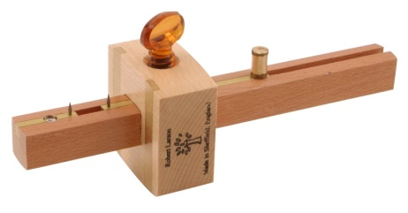
A. Scriber B. Try square C. Bevel square D. Mortise Gauge
- Which one of the following is not a metallic material?
A. Steel B. Copper C. Glass D. Iron
- In a work environment, masks are worn to protect against harmful substances. Which one of the following is not prevented by masks?
A. Smoke B. Fumes C. Light D. Dust
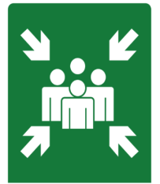
- The sign shown below is common in work environments.

Name it.
A. Fire assembly point B. Danger C. Shock D. Emergency fire exit
- The abbreviation DRG is used in drawing to represent:
A. Diameter B. Drawing C. Internal D. External
- Which of the following is not a correct statement about safety in the environment?
A. Refusing to work to avoid injuries
B. Wearing face masks to prevent dust
C. Buckling a safety belt while driving
D. Putting on overalls to protect clothes
- Which of the following dress codes for motorcyclists is false?
A. Reflective jacket for visibility
B. Hand gloves for hand protection
C. Helmet to protect the feet
D. Leather jacket to protect the body
- Which statement below about observing safety at work is incorrect?
A. Reduces accidents
B. Prevents permanent injuries
C. Improves productivity
D. Causes job losses

SECTION B: (40 MARKS)
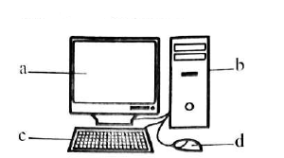
- The diagram below shows parts of a computer. Name them. (1 marks)
a. ________________________________________________
b. ________________________________________________
c. ________________________________________________
d. .________________________________________________

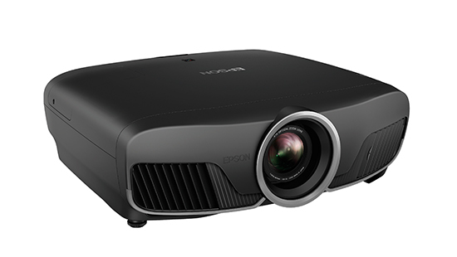
- Learners at Mapashi Junior School use the device below for class lessons.

What is the name of the ICT device?
______________________________________________________
- Identify four causes of fire in a work environment. (4 marks)
i) ___________________________________________________________________________________________.
ii) ___________________________________________________________________________________________.
iii) __________________________________________________________________________________________.
iv) __________________________________________________________________________________________.
- State five careers that require drawing skills. (5 marks)
i) ___________________________________________________________________________________________.
ii) ___________________________________________________________________________________________.
iii) __________________________________________________________________________________________.
iv) __________________________________________________________________________________________.
iv) __________________________________________________________________________________________.
- State four sources of business ideas for business ventures. (4 marks)
i) ___________________________________________________________________________________________.
ii) ___________________________________________________________________________________________.
iii) __________________________________________________________________________________________.
iv) __________________________________________________________________________________________.

- List three ICT tools used in communication. (3 marks)
i) ___________________________________________________________________________________________.
ii) ___________________________________________________________________________________________.
iii) __________________________________________________________________________________________.
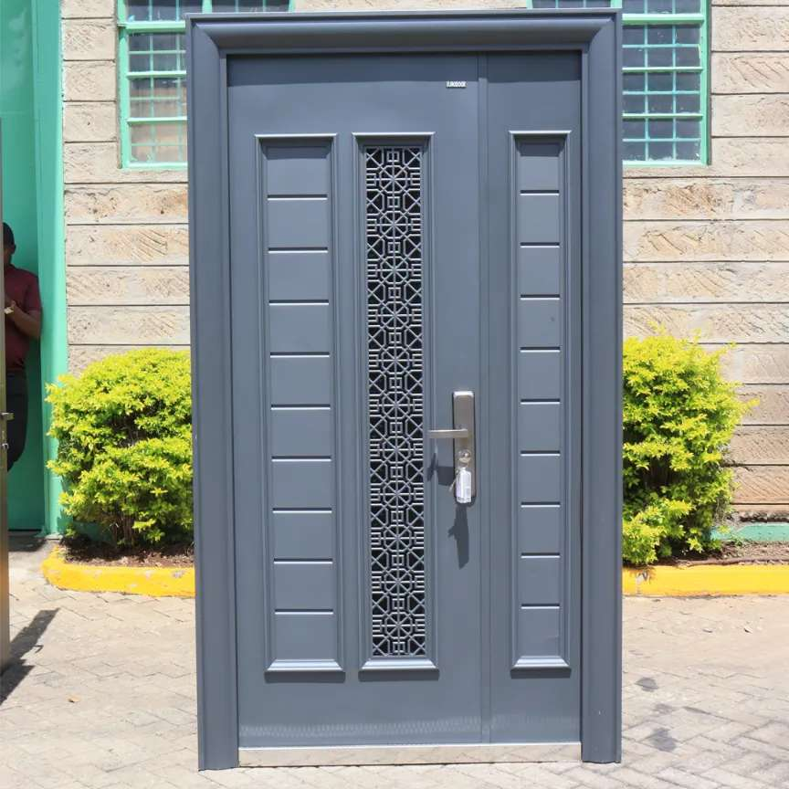
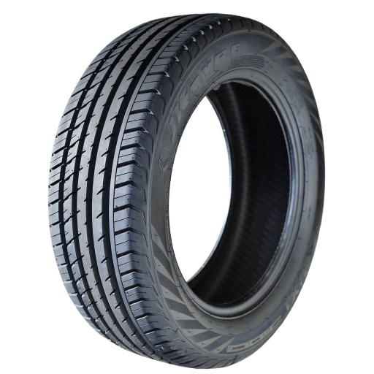
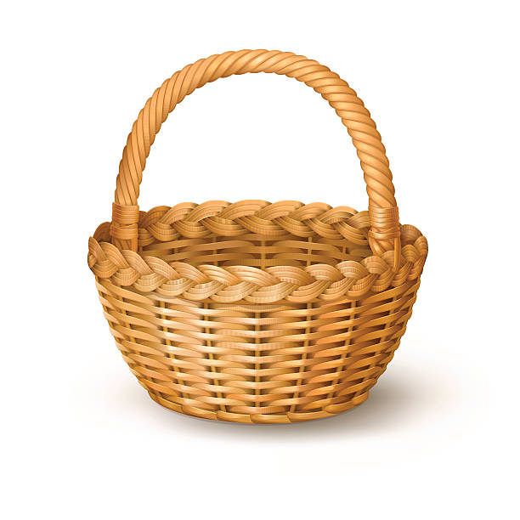
- Study the items provided below and identify the materials used to make them. (3 marks)

A B C
A) _____________________________________________________________
B)_____________________________________________________________
C) _____________________________________________________________
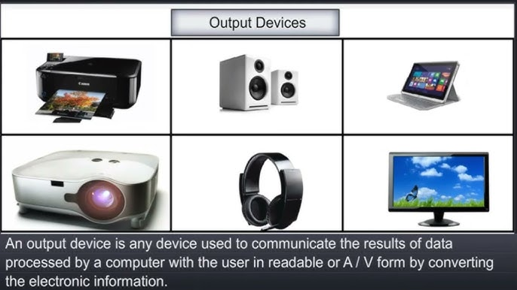
- Below are output devices of a computer.name them

Q R S
Q: __________________________
R: ___________________________
S: __________________________

- List four types of non-metallic materials in the environment. (4 marks)
i) ___________________________________________________________________________________________.
ii) ___________________________________________________________________________________________.
iii) __________________________________________________________________________________________.
iv) __________________________________________________________________________________________.
- Define the following terms: (4 marks)
i) Computer: _________________________________________________________________________________________________________________________________________________________________________________________
ii) Data: __________________________________________________________________________________________________________________________________________________________________________________________
- When setting financial goals, the acronym SMART is used. What does each letter stand for? (5 marks)
S – ._________________________________
M – .________________________________
A – _________________________________
R – _________________________________
T – .________________________________

©2026
All rights reserved
©COMPETENCE KENYA EXAMINATION AND ASSESSMENT BOARD
THIS IS THE LAST PRINTED PAGE

