
KENYA JUNIOR SCHOOL EDUCATION ASSESSMENT
GRADE 8 TERM 1 FEBRUARY 2026
COMPETENCE ASSESSMENT EXAMINATION CODE O02

LEARNER’S DETAILS
Name: _______________________________________________________________________________________.
School: ______________________________________________________________________________________.
Assessment Number: ________________________________. Date: __________________________________.

School Code: _______________________________. Signature: ________________________________.

INSTRUCTIONS TO LEARNERS
- Answer all questions in this paper.
- Section A has 20 multiple-choice questions (20 marks).
- Section B has 30 structured questions (80 marks).
- Show all your working clearly in the spaces provided.
- Do not use calculators unless instructed.
- Manage your time well.
- The total marks for this paper are 100.

Section A – Multiple Choice Questions (20 Marks)
-Mathematics- -002- -Paper Code 903-
Question Number | 1 | 2 | 3 | 4 | 5 | 6 | 7 | 8 | 9 | 10 | 11 | 12 | 13 | 14 | 15 | 16 | 17 | 18 | 19 | 20
Maximum Score | 1 | 1 | 1 | 1 | 1 | 1 | 1 | 1 | 1 | 1 | 1 | 1 | 1 | 1 | 1 | 1 | 1 | 1 | 1 | 1
Learner’s Score

Section B – Structured Questions (80 Marks)
Question Number | 1 | 2 | 3 | 4 | 5 | 6 | 7 | 8 | 9 | 10 | 11 | 12 | 13 | 14 | 15 | 16 | 17 | 18 | 19 | 20 | 21 | 22 | 23 | 24 | 25 | 26 | 27 | 28 | 29 | 30
Maximum Score | 2 | 2 | 2 | 2 | 2 | 2 | 2 | 2 | 2 | 2 | 2 | 2 | 2 | 2 | 2 | 2 | 2 | 2 | 2 | 2 | 2 | 2 | 2 | 2 | 2 | 2 | 2 | 2 | 2 | 2
Learner’s Score

Performance Levels Grid
Level | Level | % Range | Points | Learner’s score | Remarks
Exceeding (EE) | EE1 | 90–100% | 8 |  | Exceptional mastery; exceeds expectations
 | EE2 | 75–89% | 7 |  | Very strong performance
Meeting (ME) | ME1 | 58–74% | 6 |  | Solid understanding
 | ME2 | 41–57% | 5 |  | Partial achievement
Approaching (AE) | AE1 | 31–40% | 4 |  | Limited achievement
 | AE2 | 21–30% | 3 |  | Very limited
Below (BE) | BE1 | 11–20% | 2 |  | Poor performance
 | BE2 | 1–10% | 1 |  | Extremely weak

SECTION A: (20 MARKS)

Answer all the questions provided in this section

- Which one of the following statements is

correct?

A. 0.72 is greater than 8/11

B. 0.72 is equal to 8/11

C 8/11 is less than 0.72

D. 8/11 is greater than 0.72
- A saleslady earns a basic monthly salary of sh 15000. She also gets a commission of 2% on the value of goods sold above sh 250000. In a certain month she sold 10 television sets @sh 26000, 5 refrigerators @ sh 30000, 10 microwaves @ sh 16000, one cooker for sh 84000 and another for sh 52000. 1 low much did she earn that month, altogether?

A. sh 29120 B.sh 24120

C. sh 20000 D. sh 9120
- What is the next number in the pattern below?

971, 801, 671, 562,_____

A. 391 B 471 C. 491 D. 631
- In the figure below EFGFH is a rhombus and FGJ is a triangle. Angle GFJ = 56° and JGH is a straight line. Line JG = line GH.

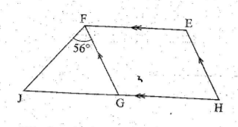

What is the size of angle HEF?

A.68°

B. 90°

C. 112°

D. 124°

WORKING SPACE

- A cultural show was attended by 986 male adults, 2 807 female adults and 5 145 children. How many more children than adults attended the show?

A. 4159

B. 3793

C. 2338

D. 1352
- What is the value of

⅗ + ¼ + ⅓ + ½

A. $\frac{11}{30}$

B. $\frac{151}{180}$

C. $\frac{11}{60}$

D. $\frac{41}{60}$
- The figure below represents a flower garden. It is in the shape of a quarter circle of radius 7 metres and a trapezium.

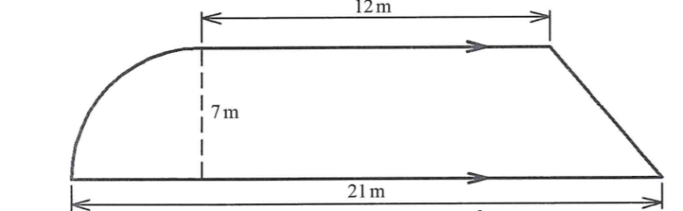

What is the area of the flower garden?

A. 220.5 m² B. 168 m²

C. 154 m² D. 129.5 m
- Ann paid sh 2 210 for a blanket after getting a 15% discount. What was the marked price of the blanket?

A. sh2 600.00 B. sh2 541.50

C. sh 1 921.70 D. sh 878.50

WORKING SPACE

- The perimeter of an isosceles triangle is 36 cm. Two of the sides of the triangle measures 13 cm and 10 cm. What is the area of the triangle?

A. 30 cm² B. 60 cm² C. 65 cm² D. 120 cm²
- The area of the trapezium EFGH shown below is 66cm² .What is the length of EF?

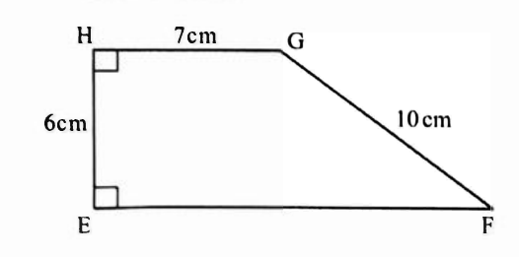

A. 4cm

B. 8cm

C. 15cm

D. 22cm
- In the figure shown below, line EF is parallel to line GH. Line MN is a transversal. Which one of the following statements is correct?

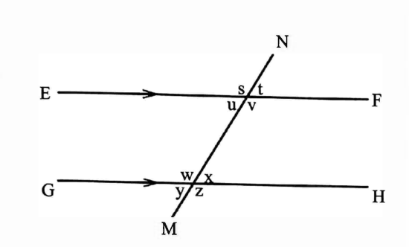

A. Angle (t + u) - 180°

B. Angle (u + x) = 180°

C. Angle (s + w) = 180°

D. Angle (u + w) = 180°

WORKING SPACE

- A tailor has a piece of cloth 15.6 m long. He uses 8.75 m for a dress and 3.5 m for a shirt. How much cloth remains?
A) 3.35 m B) 3.75 m C) 4.35 m D) 4.75 m
- Express 0.222222... as a fraction in its simplest form.
A) $\frac{2}{9}$ B) $\frac{2}{5}$ C) $\frac{1}{3}$ D) $\frac{2}{11}$
- A car travels at a constant speed of 80 km/h. How long will it take to cover a distance of 240 km? A) 2 hours B) 3 hours C) 4 hours D) 5 hours
- The diameter of a circular swimming pool is 7 m.

7m

What is its circumference? (Use π = $\frac{22}{7}$)
A) 11 m B) 22 m C) 44 m D) 33 m
- Simplify the expression
2x + 5y−x+3y.
A) 3x+8y B) x+8y
C) x+2y D) 3x+2y

WORKING SPACE

- What is the volume of a cube with a side length of 5 cm?

5cm

A) 15 cm³ B) 25 cm³ C) 125 cm³ D) 60 cm³
- A train left a station at 10:30 am and arrived at its destination at 2:15 pm. How long was the journey?
A) 3 hours 45 minutes B) 4 hours 15 minutes C) 3 hours 15 minutes D) 4 hours 45 minutes
- A water tank has a capacity of 5,000 liters.

5000Litres

If it is $\frac{2}{5}$ full, how many liters of water are in the tank?
A) 1,000 L B) 2,000 L C) 2,500 L D) 3,000 L
- A trader bought a bag of sugar for Sh. 2,000 and sold it for Sh. 1,800. What was his loss percentage?
A) 10% B) 20% C) 15% D) 25%

WORKING SPACE

Section B: Structured Questions (80 Marks)
Instructions: Answer all questions in this section. Show all your workings clearly.
Question 1 (10 Marks)
a) A farmer has 1,200 chickens. He sells $\frac{1}{4}$ of them on Monday and $\frac{2}{3}$of the remainder on Tuesday. How many chickens are left?

b) A bus covers a distance of 180 km in 2 hours and 30 minutes. Calculate the average speed of the bus in km/h.

c) Find the value of 1296 ​using factorization.

d) Simplify the expression:
(3x+2y)−(5x−y).

Question 2 (10 Marks)
a) A trader buys a TV for Sh. 15,000. He marks up the price by 20% and then offers a 10% discount. What is the final selling price of the TV?

b) A cylindrical water tank has a diameter of 2.8 m and a height of 3 m. How many liters of water can it hold?
($Use π =\frac{22}{7}$).

c) Convert the recurring decimal 0.454545... into a fraction.

d) Round off 8.7654 to:
i) 3 decimal places.

ii) 1 significant figure.

Question 3 (10 Marks)
a) The area of a trapezium is 165 cm². If the parallel sides are 12 cm and 18 cm, find the height of the trapezium.

b) Solve for x in the equation:
$3\left(x+4\right)=27$.

c) The angle of a sector in a pie chart representing a certain category is 72°. If the total number of items is 360, how many items are in that category?

d) A car leaves town A at 9:00 am and travels towards town B at 60 km/h. Another car leaves town B at 9:30 am and travels towards town A at 80 km/h. The distance between town A and town B is 300 km. At what time do the two cars meet?

Question 4 (10 Marks)
a) A sum of money is divided among three friends, Alex, Brian, and Charles, in the ratio 3:5:7. If Brian receives Sh. 2,000 more than Alex, how much money did Charles receive?

b) A cuboid has a length of 10 cm, a width of 8 cm, and a height of 5 cm. What is the volume of the cuboid?

5cm
8cm
10cm

c) A trader sells an item for Sh. 4,500, making a profit of 25%. What was the cost price of the item?

d) Given the integers -4, 0, 5, -9, 2.

i) Arrange them in ascending order.

ii) Calculate their sum.

Question 5 (10 Marks)
a) A plot of land measures 120 m by 80 m. A fence is to be put around the plot. If poles are placed at intervals of 4 m, how many poles are needed?

b) The marks scored by a student in four subjects are 75, 80, 68, and 92. What is the average mark?

c) The scale on a map is 1:200,000. The distance between two towns on the map is 5 cm. What is the actual distance in kilometers?

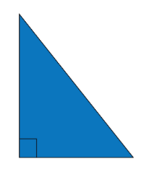
d) Using the Pythagoras theorem, find the length of the hypotenuse of a right-angled triangle with sides of 9 cm and 12 cm.

12cm

9cm

Question 6 (10 Marks)
a) Find the value of
$$\frac{54​+21​×43​}{\frac{1}{2}of\left( 34-15÷3\right)}$$

b) The bar graph below shows the composition of air in the atmosphere.

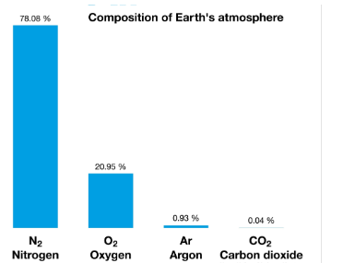

i) Which component of air is most abundant?

ii) What fraction represents carbon-dioxide as a component of air?

c) A customer pays a post office a total of Sh. 1,020 for a service. This includes a 2% transaction charge. How much was the original cost of the service?

d) A motorist is traveling at a speed of 60 km/h. How far will he travel in 45 minutes?

Question 7 (10 Marks)
a) In a certain country, the transaction charges for mobile money transfers are as follows: Sh. 25 for amounts between Sh. 1,000 and Sh. 5,000. If a person sends Sh. 4,500, how much will the recipient get, assuming the sender pays the charges?

b) Solve the inequality and state the values that satisfies the inequality
2x - 3 < 7

c) In Mtwapa Junior School, the assembly ground is circular in shape. The radius is 8.4m.a path of uniform width 1.4m surrounds the assembly ground as shown below.

8.4m

1.4m

Calculate the area of the path. (Take π=22/7

d) The marked price of a shirt is Sh. 800. A customer is given a 15% discount. How much does the customer pay for the shirt?

Question 8 (10 Marks)
a) The temperature at the base of a mountain is 15°C. For every 100 m rise in altitude, the temperature drops by 1.5°C. What is the temperature at a height of 800 m?

b) Express the ratio 3:4:5:8 as a percentage of the total.

c) A car's value depreciates by 10% each year. If a new car costs Sh. 1,500,000, what will its value be after two years?

d) In a mathematics activity, a teacher gave a group of learners of Kangema Junior School a number card with the following number line as shown below.
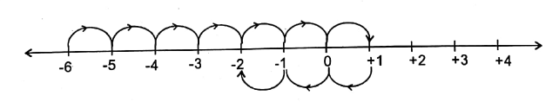
i) Write the expression that is represented on the number line above. (2 marks)

This is the last printed page

