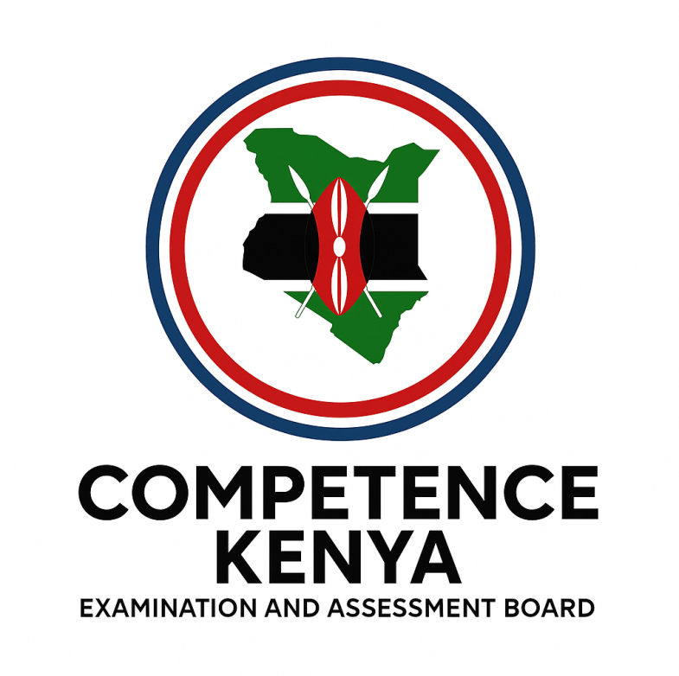
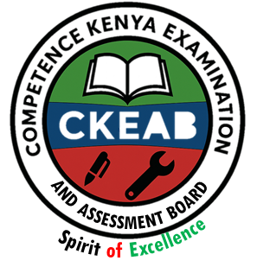
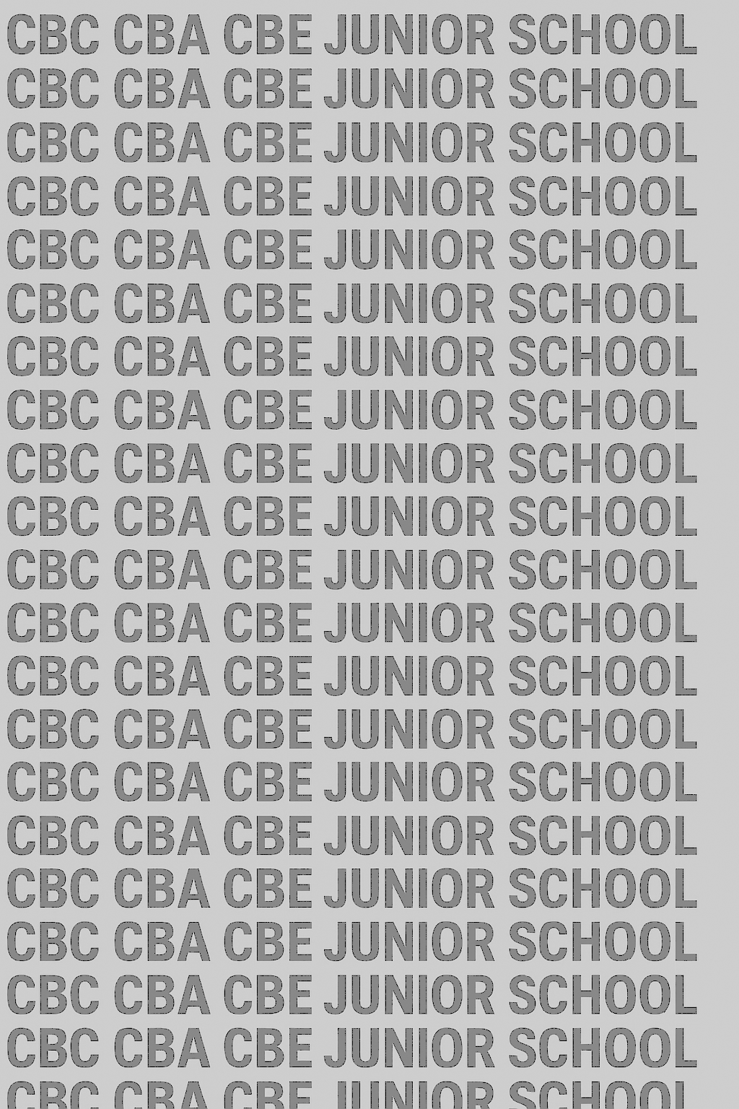
KENYA JUNIOR SCHOOL EDUCATION ASSESSMENT
GRADE 8 MUHULA WA 1 FEBRUARI 2026
KISWAHILI CKEAB 002

Muda: Saa 1 dakika 40

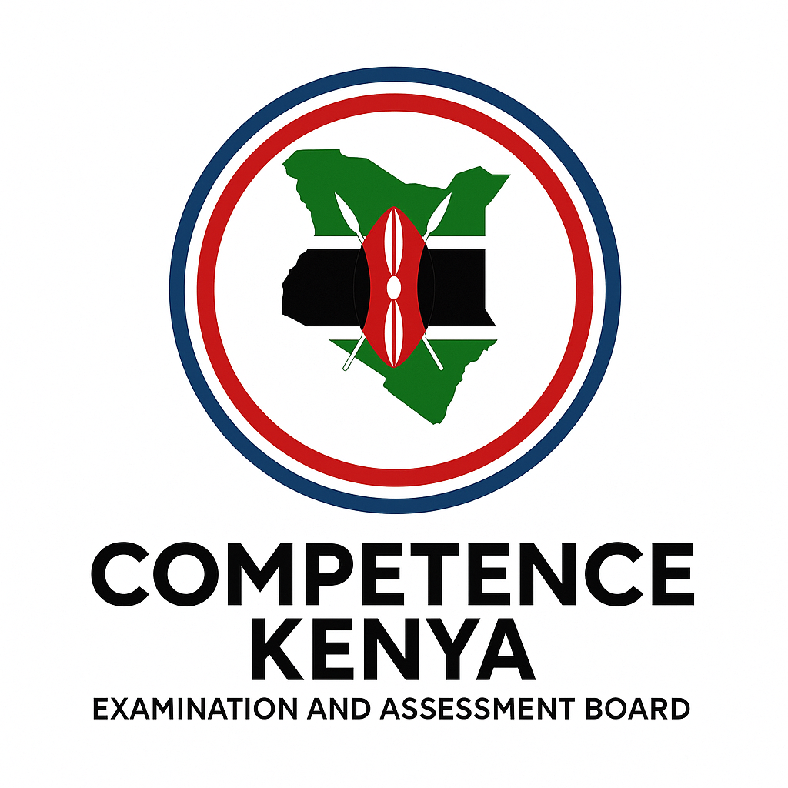
JEDWALI YA MWANAFUNZI
Jina: _____________________________________________________. Shule: ___________________________________________
Nambari ya tathmini: _______________________________________. Tarehe: _______________________________________.
Nambari ya shule: ________________________________________. Saini: _______________________________________.

MAAGIZO KWA WANAFUNZI
- Andika jina lako na nambari yako ya mtihani kwenye nafasi uliyoachiwa hapo juu.
- Andika jina na nambari ya shule yako kwenye nafasi uliyoachiwa hapo juu.
- Tia sahihi kwenye nafasi uliyoachiwa hapo juu.
- Andika tarehe ya mtihani ipasavyo.
- Jibu maswali yote.
- Andika majibu yote kwa nafasi ulizoachiwa katika kijitabu hiki.
-KISWAHILI - -002- - 902-
- Majibu yote ni lazima yaandikwe kwa lugha ya Kiswahili.
Kwa Matumizi ya Mtahini Pekee
Sehemu | Maelezo | Alama
A | Ufafanuzi wa kifungu | 10
B | Shairi | 10
C | Sarufi | 10
D | Fasihi / Novela | 10
E | Mazungumzo / Insha | 10
Jumla |  | 50

Level | Level | % Range | Points | Learner’s score | Remarks
Exceeding (EE) | EE1 | 90–100% | 8 |  | Exceptional mastery; exceeds expectations
 | EE2 | 75–89% | 7 |  | Very strong performance
Meeting (ME) | ME1 | 58–74% | 6 |  | Solid understanding
 | ME2 | 41–57% | 5 |  | Partial achievement
Approaching (AE) | AE1 | 31–40% | 4 |  | Limited achievement
 | AE2 | 21–30% | 3 |  | Very limited
Below (BE) | BE1 | 11–20% | 2 |  | Poor performance
 | BE2 | 1–10% | 1 |  | Extremely weak
Kijitabu hiki kina kurasa 8 zilizopigwa chapa.Watahiniwa ni lazima wahakikishe kwamba kurasa zote za karatasi hii zimepigwa chapa sawasawa na kuwa maswali yote yamo. Geuza

SEHEMU A: UFAHAMU (Alama 10)
Soma kifungu kifuatacho kisha ujibu maswali a–j:
Kenya ni taifa lenye utajiri mkubwa wa kiutamaduni. Kila kabila lina desturi zake, tamaduni na mila. Watu wapo weupe, weusi, wenye nywele za kipilipili au singa, wembamba au wanene, wenye pua ndogo au kubwa, midomo midogo au mikubwa.
Pwani inapendwa wali, magharibi ugali, katikati ya nchi ni irio. Mboga za kienyeji kama mchicha, managu na terere hupatikana kulingana na mandhari ya eneo. Vyakula vyote hupikwa kwa ustadi na tajriba.
Mavazi pia ni tofauti: Kanzu na buibui hupendwa pwani, kanga na leso hupendwa sehemu nyingine. Hata hivyo, watu wengi wanapendelea mavazi ya kizungu.
Licha ya tofauti hizi, Wakenya wameungana na kuwa taifa moja. Lugha ya Kiswahili imeunganisha makabila yote. Methali ya Kiswahili inasema: “Udugu umekuwa kufaana si kufanana.” Ndoa za mchanganyiko wa jamii zimezaa kizazi kipya cha taifa liitwalo Kenya.
MASWALI
a) Kenya ina makabila mengi kiasi gani? (1 alama)
…………………………………………………………………………………………………………………………………………………………………………………………………………………………………………………………
b) Mseto wa mahindi na maharagwe huitwa… (1 alama)
…………………………………………………………………………………………………………………………………………………………………………………………………………………………………………………………c) Mboga za kienyeji hupatikana vipi? (1 alama)
…………………………………………………………………………………………………………………………………………………………………………………………………………………………………………………………d) Mwandishi anapendezwa na… (1 alama)
…………………………………………………………………………………………………………………………………………………………………………………………………………………………………………………………e) Mapishi matamu ni… (1 alama)
…………………………………………………………………………………………………………………………………………………………………………………………………………………………………………………………f) Watu wanaoheshimiwa zaidi kulingana na kifungu ni… (1 alama)
…………………………………………………………………………………………………………………………………………………………………………………………………………………………………………………………g) Methali “Udugu umekuwa kufaana si kufanana” inamaanisha nini? (1 alama)
…………………………………………………………………………………………………………………………………………………………………………………………………………………………………………………………h) Fafanua msemo “Lugha ya Kiswahili imeunganisha makabila yote.” (1 alama)
…………………………………………………………………………………………………………………………………………………………………………………………………………………………………………………………i) Andika ujumbe mkuu wa kifungu hiki. (1 alama)
…………………………………………………………………………………………………………………………………………………………………………………………………………………………………………………………j) Taja mfano wa mavazi yanayopendwa pwani. (1 alama)
…………………………………………………………………………………………………………………………………………………………………………………………………………………………………………………………

SEHEMU B: SHAIRI (Alama 10)
Soma shairi hili:
Shairi: Umoja wa Taifa
Wenye rangi zote, weupe na weusi,
Wenye nywele za singa na kipilipili,
Wenye pua ndogo au kubwa,
Wenye midomo midogo au mikubwa,
Wote wakiungana, taifa linapambana.
Pwani na magharibi, katikati ya nchi,
Vyakula tofauti, mavazi tofauti,
Lakini moyo mmoja,
Umoja ndio nguzo ya taifa.
MASWALI
- Taja methali inayofanana na shairi hili. (1 alama)
…………………………………………………………………………………………………………………………………………………………………………………………………………………………………………
- Taja vitenzi vinavyotumika katika wakati uliopo (2 alama)
…………………………………………………………………………………………………………………………………………………………………………………………………………………………………………
- Fafanua ni kwa nini shairi hili linahimiza mshikamano wa taifa. (2 alama)
…………………………………………………………………………………………………………………………………………………………………………………………………………………………………………
- Taja vifaa vya lugha vinavyotumika shairini. (2 alama)
…………………………………………………………………………………………………………………………………………………………………………………………………………………………………………
- Andika maudhui matatu ya shairi. (3 alama)
…………………………………………………………………………………………………………………………………………………………………………………………………………………………………………

SEHEMU C: SARUFI (Alama 10)
- Chagua nomino za dhana:
A. Umoja, amani, maendeleo
B. Shamba, nyumba, daraja
C. Godoro, kiti, kitanda
D. Kusoma, kuimba, kucheza (1 alama)
- Kamilisha sentensi kwa nomino za makundi:
a) Waandamanaji walikabiliwa na __________ cha polisi.
b) __________ cha wanasiasa kilijadiliwa jioni. (2 alama)
- Tambua nomino za vitenzi-jina:
Kuendeleza elimu ni muhimu kwa kila mwanafunzi. (2 alama)
…………………………………………………………………………………………………………………………………………………………………………………………………………………………………………
- Tambua vitenzi vya wakati uliopo:
a) Wachezaji wanacheza kandanda.
…………………………………………………………………………………………………………………………………………………………………………………………………………………………………………
b) Mwimbaji anatetea haki za watoto.
…………………………………………………………………………………………………………………………………………………………………………………………………………………………………………
c) Wazee wanashiriki mikutano ya kijamii. (3 alama)
…………………………………………………………………………………………………………………………………………………………………………………………………………………………………………
- Andika wingi wa maneno yafuatayo:
a) Cheti kimeraruka.
…………………………………………………………………………………………………………………………………………………………………………………………………………………………………………
b) Chanda chema kimevikwa pete.
…………………………………………………………………………………………………………………………………………………………………………………………………………………………………………
c) Kiwambo cha runinga kimezeeka. (2 alama)
…………………………………………………………………………………………………………………………………………………………………………………………………………………………………………

SEHEMU D: NOVELA / FASIHI (Alama 10)
Nilijikakamua kusoma riwaya Tumaini la Mbali. Mhusika alikumbana na changamoto nyingi, watu walimdharau lakini hakukata tamaa. Hatimaye alifanikiwa kuwa msanii maarufu. Nilipomaliza riwaya, nilisoma Biblia na mafunzo ya Yusufu, Danieli na Daudi.
MASWALI
- Taja maudhui matatu. (3 alama)
…………………………………………………………………………………………………………………………………………………………………………………………………………………………………………
- Taja aina mbili za mandhari zinazojitokeza. (2 alama)
…………………………………………………………………………………………………………………………………………………………………………………………………………………………………………

- Eleza mbinu mbili za lugha zinazotumika. (2 alama)
…………………………………………………………………………………………………………………………………………………………………………………………………………………………………………
- Taja mafunzo matatu yanayopatikana. (3 alama)
…………………………………………………………………………………………………………………………………………………………………………………………………………………………………………

SEHEMU E: TAMTHILIA (Alama 10)
Soma sehemu ifuatayo ya tamthilia kisha ujibu maswali.
(Jirani wawili, Bi. Nyamlima na Bw. Msemakweli, wanajadiliana kuhusu athari za uongo katika jamii.)
Bi. Nyamlima: Nimesikia Mzee Kipato amepoteza sifa yake yote. Eti aliongoza kampuni yake vibaya kwa miaka mingi, akidanganya watu!
Bw. Msemakweli: (Akitingisha kichwa) Uongo una miguu mifupi, Bi. Nyamlima. Huwezi kudanganya milele. Ukweli ni kama jua, hata ukificha nyuma ya mawingu, mwishowe utang'aa tu. Mzee Kipato alidhani anaweza kujenga milima ya uongo, lakini sasa milima hiyo imemwangukia yeye mwenyewe.
Bi. Nyamlima: Kweli kabisa. Watoto wetu wanapaswa kujifunza hili. Nyumbani kwangu, nimekuwa nikiwafunza kuwa uaminifu ni tunu muhimu kuliko dhahabu na fedha. Uongo ni kama sumu inayoharibu roho na jamii.
Bw. Msemakweli: Naam, uongo huzaa uongo mwingine. Kila uongo ni mbegu ya uharibifu. Jamii isiyo na ukweli haina msingi thabiti, na hatimaye itaanguka kama jengo bovu. Tusiache tamaa itufanye kuwa watumwa wa uongo.
Maswali:
a) Bainisha sifa mbili za uongo kulingana na mazungumzo haya. (Alama 2)
……………………………………………………………………………………………………………………………………………
……………………………………………………………………………………………………………………………………………
b) Eleza mbinu mbili za lugha zilizotumika na Bw. Msemakweli kusisitiza hoja yake. (Alama 2)
……………………………………………………………………………………………………………………………………………
……………………………………………………………………………………………………………………………………………
c) Ni tunu gani Bi. Nyamlima anawafunza watoto wake nyumbani? (Alama 1)
……………………………………………………………………………………………………………………………………………
……………………………………………………………………………………………………………………………………………
d) Kulingana na Bw. Msemakweli, ni nini matokeo ya jamii isiyo na ukweli? Taja mawili. (Alama 2)
……………………………………………………………………………………………………………………………………………
……………………………………………………………………………………………………………………………………………
e) Ni funzo gani unalopata kutokana na mazungumzo haya? (Alama 3)
……………………………………………………………………………………………………………………………………………
……………………………………………………………………………………………………………………………………………
INSHA:
Andika barua rasmi kwa mwalimu mkuu mnaomwomba msamaha kwa kuchelewa kujiunga na gwaride la shule.
………………………………………………………………………………………………………………………………………………………………………………………………………………………………………………………………………………………………………………………………………………………………………………………………………………………………………………………………………………………………………………………………………………………………………………………………………………………………………………………………………………………………………………………………………………………………………………………………………………………………………………………………………………………………………………………………………………………………………………………………………………………………………………………………………………………………………………………………………………………………………………………………………………………………………………………………………………………………………………………………………………………………………………………………………………………………………………………………………………………………………………………………………………………………………………………………………………………………………………………………………………………………………………………………………………………………………………………………………………………………………………………………………………………………………………………………………………………………………………………………………………………………………………………………………………………………………………………………………………………………………………………………………………………………………………………………………………………………………………………………………………………………………………………………………………………………………………………………………………………………………………………………………………………………………………………………………………………………………………………………………………………………………………………………………………………………………………………………………………………………………………………………………………………………………………………………………………………………………………………………………………………………………………………………………………………………………………………………………………………………………………………………………………………………………………………………………………………………………………………………………………………………………………………………………………………………………………………………………………………………………………………………………………………………………………………………………………………………………………………………………………………………………………………………………………………………………………………………………………………………………………………………………………………………………………………………………………………………………………………………………………………………………………………………………………………………………………………………………………………………………………………………………………………………………………………………………………………………………………………………………………………………………………………………………………………………………………………………………………………………………………………………………………………………………………………………………………………………………………………………………………………………………………………………………………………………………………………………………………………………………………………………………………………………………………………………………………………………………………………………………………………………………………………………………………………………………………………………………………………………………………………………………………………………………………………………………………………………………………………………………………………………………………………………………………………………………………………………………………………………………………………………………………………………………………………………………………………………………………………………………………………………………………………………………………………………………………………………………………………………………………………………………………………………………………………………………………………………………………………………………………………………………………………………………………………………………………………………………………………………………………………………………………………………………………………………………………………………………………………………………………………………………………………………………………………………………………………………………………………………………………………………………………………………………………………………………………………………………………………………………………………………………………………………………………………………………………………………………………………………………………………………………………………………………………………………………………………………………………………………………………………………………………………………………………………………………………………………………………………………………………………………………………………………………………………………………………………………………………………………………………………………………………………………………………………………………………………………………………………………………………………………………………………………………………………………………………………………………………………………………………………………………………………………………………………………………………………………………………………………………………………………………………………………………………………………………………………………………………………………………………………………………………………………………………………………………………………………………………………………………………………………………………………………………………………………………………………………………………………………………………………………………………………………………………………………………………………………………………………………………………………………………………………………………………………………………………………………………………………………………………………………………………………………………………………………………………………………………………………………………………………………………………………………………………………………………………………………………………………………………………………………………………………………………………………………………………………………………………………………………………………………………………………………………………………………………………………………………………………………………………………………………………………………………………………………………………………………………………………………………………………………………………………………………………………………………………………………………………………………………………………………………………………………………………………………………………………………………………………………………………………………………………………………………………………………………………………………………………………………………………………………………………………………………………………………………………………………………………………………………………………………………………………………………………………………
©2026
Haki zote zimelindwa
©COMPETENCE KENYA EXAMINATION AND ASSESSMENT BOARD
HUU NDIO UKURASA WA MWISHO ULIOPIGWA CHAPA.

