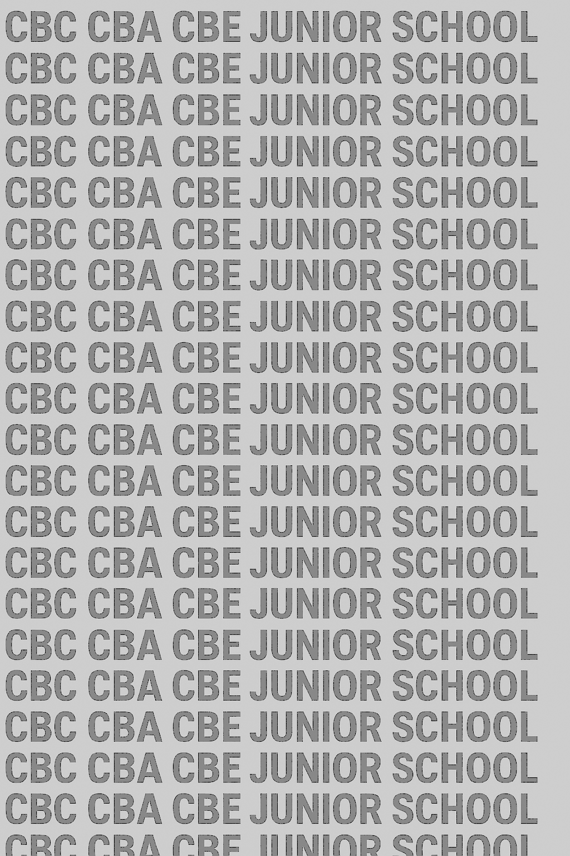
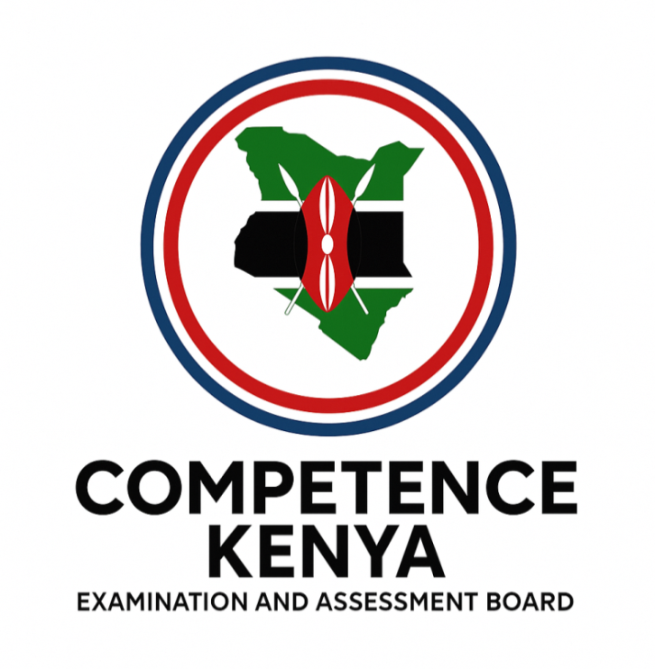
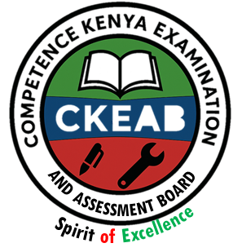
KENYA JUNIOR SCHOOL EDUCATION ASSESSMENT

GRADE 8 TERM 1 FEBRUARY 2026

ISLAMIC RELIGIOUS EDUCATION
CKEAB 002

Time - 1 hour 45 minutes

LEARNER’S DETAILS
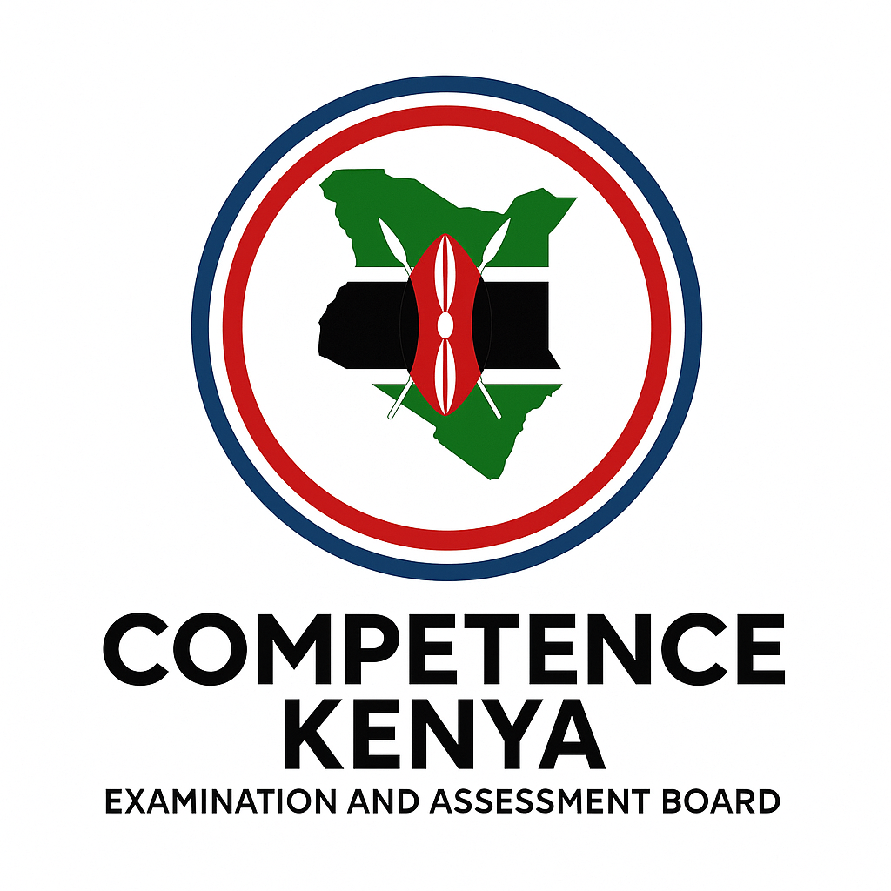
Name: ________________________________________________. School: _____________________________________
Assessment Number: _____________________________. Date: ______________________________.
School Code: ____________________________. Signature: ____________________________.
INSTRUCTIONS TO LEARNERS

- Write your name and assessment number in the spaces provided.
- Write the name and code of your school in the spaces provided.
- Write the date of the assessment and sign in the spaces provided.
- This question paper consists of two sections: A and B.
- Answer ALL questions in this paper.
- Write ALL the answers in the spaces provided in this question paper.
- Do NOT remove any page from this question paper.
- Answer the questions in English.

For official use only
SECTION A: MULTIPLE CHOICE QUESTIONS (20 Marks)
-IRE- -FORMATIVE ASSESSMENT- -002- - Paper Code 909-
Question No. | 1 | 2 | 3 | 4 | 5 | 6 | 7 | 8 | 9 | 10 | 11 | 12 | 13 | 14 | 15 | 16 | 17 | 18 | 19 | 20 | TOTAL
Max Score | 1 | 1 | 1 | 1 | 1 | 1 | 1 | 1 | 1 | 1 | 1 | 1 | 1 | 1 | 1 | 1 | 1 | 1 | 1 | 1 | 20
Candidate’s Score
SECTION B: STRUCTURED QUESTIONS (60 Marks)
Task | Qn Nos. | Max Marks | Candidate's Score  GRAND TOTAL
SECTION A | 20 | 20
SECTION B | 4 | 80
TOTAL | 24 | 100
Level |  | Level | % Range | Points | Learner’s score | Remarks
Exceeding (EE) |  | EE1 | 90–100% | 8 |  | Exceptional mastery; exceeds expectations
 |  | EE2 | 75–89% | 7 |  | Very strong performance
Meeting (ME) |  | ME1 | 58–74% | 6 |  | Solid understanding
 |  | ME2 | 41–57% | 5 |  | Partial achievement
Approaching (AE) |  | AE1 | 31–40% | 4 |  | Limited achievement
 |  | AE2 | 21–30% | 3 |  | Very limited
Below (BE) |  | BE1 | 11–20% | 2 |  | Poor performance
 |  | BE2 | 1–10% | 1 |  | Extremely weak
This paper consists of 8 printed pages. Candidates should check the question paper to ascertain that all the pages are printed as indicated and that no questions are missing. Turn over

SECTION A: (20 MARKS)
Answer all questions by choosing the correct answer

- During a school assembly, the teacher reminded learners that the Qur’an guides all aspects of life. Why was the Qur’an revealed to mankind?
A. To replace culture
B. To guide mankind to the straight path
C. To favour Arabs
D. To discourage learning
- A Muslim scholar explains that the Qur’an was revealed over 23 years. This method mainly shows Allah’s:
A. Anger
B. Mercy to mankind
C. Power over angels
D. Test of patience
- When Prophet Muhammad (S.A.W.) was meditating in Cave Hira, Jibril (A.S.) commanded him to “Read”. This teaches Muslims the importance of:
A. Silence
B. Wealth
C. Seeking knowledge
D. Travel
- Why was the Qur’an revealed in portions and not all at once?
A. To confuse believers
B. For ease of understanding and practice
C. To delay Islam
D. To test memory only
- A learner who consults the Qur’an when making decisions is using it as:
A. A history book
B. A law book only
C. Divine guidance for humanity
D. A cultural text
- Surah Ad-Dhuha was revealed to console the Prophet (S.A.W.) during a difficult time. What lesson does this teach Muslims?
A. Allah abandons believers
B. Hardship lasts forever
C. Allah always cares for His servants
D. Wealth is permanent
- A student helps an orphan after learning Surah Ad-Dhuha. Which teaching influenced this action?
A. Punishment of sinners
B. Care for the needy
C. Wealth accumulation
D. Migration
- Surah Al-Balad encourages believers to take the “steep path.” This refers to:
A. Easy living
B. Social responsibility and sacrifice
C. Isolation
D. Travel
- Which Surah reminds mankind that success comes through patience and good deeds?
A. Al-Ikhlas B. Al-Balad
C. Al-Fatiha D. Al-Nas
- When learners dramatize kindness to the poor after studying Surah Ad-Dhuha, they are demonstrating:
A. Memorisation
B. Application of Qur’anic teachings
C. Debate
D. Recitation skills
- A teacher defines Hadith as the sayings, actions and approvals of the Prophet (S.A.W.). This definition mainly refers to:
A. Sunnah B. Tafsir C. Fiqh D. Sharia
- Which of the following is NOT a form of Hadith?
A. Qaul B. Fiil C. Taqrir D. Ijtihad
- Hadith that contains Allah’s message but is not part of the Qur’an is known as:
A. Hadith Nabawy B. Hadith Qudsy
C. Tafsir D. Athar
- Why is Hadith important in the life of a Muslim?
A. It replaces the Qur’an
B. It explains the Qur’an
C. It is optional
D. It applies only to scholars
- The Hadith “Actions are judged by intentions” teaches Muslims to:
A. Seek praise B. Focus on intention
C. Avoid actions D. Delay worship
- A learner avoids bad company after learning a Hadith on friendship. What lesson is applied?
A. Friends influence character
B. Wealth defines success
C. Solitude is best
D. Authority is supreme
- The example of the musk seller represents:
A. Bad influence
B. Neutral influence
C. Good influence
D. Punishment
- Belief in the oneness of Allah is called:
A. Shirk B. Tawheed
C. Akhlaq D. Sunnah
- Which action shows belief in Tawheed?
A. Wearing charms
B. Praying to Allah alone
C. Worshipping ancestors
D. Visiting fortune tellers
- Tawheed is important because it:
A. Encourages fear
B. Is the foundation of Islamic faith
C. Separates people
D. Promotes materialism

SECTION B: (80 MARKS)
Answer all questions.

21. During an Islamic lesson, learners discussed how the Qur’an was revealed and its significance to humanity.
a) Discuss the rationale for the revelation of the Qur’an as a guide to mankind. (5 marks)
________________________________________________________________________________________________________________________________________________________________________________________________________________________________________________________________________________________________________________________________________________________________________________________________________________________________________________________________________________________________
b) Describe the stages of revelation of the Qur’an as a sign of mercy to mankind. (5 marks)
________________________________________________________________________________________________________________________________________________________________________________________________________________________________________________________________________________________________________________________________________________________________________________________________________________________________________________________________________________________________c) Describe the incident of the first revelation at Cave Hira and explain its lesson on seeking knowledge. (6 marks)
________________________________________________________________________________________________________________________________________________________________________________________________________________________________________________________________________________________________d) Explain reasons why the Qur’an was revealed in portions for ease of implementation. (4 marks)
________________________________________________________________________________________________________________________________________________________________________________________________________________________________________________________________________________________________________________________________________________________________________________________________________________________________________________________________________________________________

22. A Muslim family uses the Qur’an when making personal and social decisions.
a) Assess the importance of the Qur’an in the day-to-day life of a Muslim. (6 marks)
________________________________________________________________________________________________________________________________________________________________________________________________________________________________________________________________________________________________________________________________________________________________________________________________b) Explain how the Qur’an acts as divine guidance for humanity. (4 marks)
________________________________________________________________________________________________________________________________________________________________________________________________________________________________________________________________________________________________________________________________________________________________________________________________c) Describe ways Muslims can show respect and value for the Qur’an. (5 marks)
________________________________________________________________________________________________________________________________________________________________________________________________________________________________________________________________________________________________________________________________________________________________________________________________________________________________________________________________________________________________d) Explain the benefits of applying Qur’anic teachings in society today. (5 marks)
________________________________________________________________________________________________________________________________________________________________________________________________________________________________________________________________________________________________________________________________________________________________________________________________________________________________________________________________________________________________

23. Learners recited and discussed Surah Ad-Dhuha and Surah Al-Balad during group presentations.
a) Explain the meaning of Surah Ad-Dhuha (Q.93:1-11). (6 marks)
________________________________________________________________________________________________________________________________________________________________________________________________________________________________________________________________________________________________________________________________________________________________________________________________b) Explain the meaning of Surah Al-Balad (Q.90:1-20). (6 marks)
________________________________________________________________________________________________________________________________________________________________________________________________________________________________________________________________________________________________c) Discuss lessons learnt from Surah Ad-Dhuha regarding treatment of orphans and the needy. (4 marks)
________________________________________________________________________________________________________________________________________________________________________________________________________________________________________________________________________________________________________________________________________________________________________________________________

d) Describe how the teachings of Surah Al-Balad can be applied in daily life. (4 marks)
________________________________________________________________________________________________________________________________________________________________________________________________________________________________________________________________________________________________________________________________________________________________________________________________________________________________________________________________________________________________

24. During an IRE club meeting, learners discussed Hadith, Tawheed and moral conduct.
a) Explain the meaning of Hadith and describe its forms (Qaul, Fiil, Taqrir, Sifat). (6 marks)
________________________________________________________________________________________________________________________________________________________________________________________________________________________________________________________________________________________________________________________________________________________________________________________________________________________________________________________________________________________________b) Differentiate between Hadith Qudsy and Hadith Nabawy. (4 marks)
________________________________________________________________________________________________________________________________________________________________________________________________________________________________________________________________________________________________________________________________________________________________________________________________c) Explain lessons learnt from the Hadith on intention and its relevance in a Muslim’s life. (5 marks)
________________________________________________________________________________________________________________________________________________________________________________________________________________________________________________________________________________________________________________________________________________________________________________________________d) Explain the significance of Tawheed and ways Muslims can demonstrate belief in Tawheed. (5 marks)
________________________________________________________________________________________________________________________________________________________________________________________________________________________________________________________________________________________________________________________________________________________________________________________________
©2026
All rights reserved
©COMPETENCE KENYA EXAMINATION AND ASSESSMENT BOARD
This is the last printed page

