MARKING SCHEME
GRADE 8 INTEGRATED SCIENCE PRACTICAL KJSEA TERM 1, FEBRUARY 2026

TASK 1 – SIMPLE ELECTRIC CIRCUIT (20 MARKS)
TASK 1: Electric Circuit (20 Marks)
Materials Provided: Dry cell, bulb, switch, connecting wires
a) Assemble a simple electric circuit that lights the bulb (8 marks)
Marking Scheme:
- 2 marks: Proper connection of dry cell to the circuit
- 2 marks: Proper connection of bulb to the circuit
- 2 marks: Inclusion and correct positioning of switch
- 2 marks: Bulb lights when circuit is complete
Procedure / Steps (Suggested Answer / Guide):
- Place the dry cell on a stand or holder.
- Connect one terminal of the dry cell to one terminal of the bulb using a wire.
- Connect the other terminal of the bulb to one terminal of the switch.
- Connect the other terminal of the switch back to the remaining terminal of the dry cell.
- Close the switch. The bulb should light up, showing the circuit is complete.
Teacher’s Notes / Tips:
- Award marks for correct connections even if the bulb does not light (if incomplete/loose connection, partial marks).
b) Draw and label the circuit (6 marks)
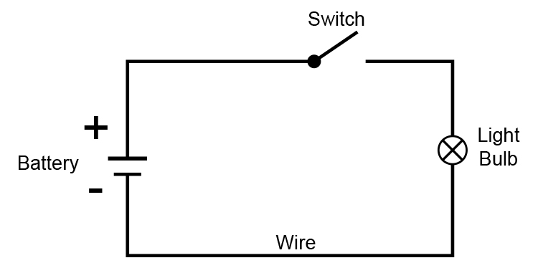Marking Scheme:
- 2 marks: Draw a neat circuit diagram (use symbols for cell, bulb, switch, wires)
- 2 marks: Correct labeling of all components
- 2 marks: Correct flow of current indicated
c) State THREE safety precautions observed during the activity (6 marks)
Marking Scheme: 2 marks each correct safety precaution (any 3)
i. Ensure hands are dry when handling the electric circuit.
ii. Do not touch the bulb or wires when the circuit is switched on.
iii. Switch off the circuit immediately after the experiment.
iv. Handle the dry cell carefully to avoid leakage.
v. Avoid connecting wires directly to cause a short circuit.
vi. Use proper holders for bulbs and cells.
TASK 2: Magnetism (10 Marks)
Materials Provided: Bar magnet, iron filings, paper, plastic object
a) Identify one magnetic and one non-magnetic material (4 marks)
Magnetic Material | Non-Magnetic Material
Iron filings | Plastic
 | Paper
Marking Scheme:
- 2 marks for correctly identifying magnetic material
- 2 marks for correctly identifying non-magnetic material
Procedure / Guide:
- Place the plastic object and iron object on a table.
- Bring the bar magnet near each object.
- Observe which object is attracted (magnetic) and which is not (non-magnetic).
b) Describe what you observe when iron filings are sprinkled near the magnet (4 marks)
Marking Scheme:
- 1 mark: Iron filings move or are attracted to the magnet
- 1 mark: Filings arrange along lines of magnetic force
- 1 mark: Filings form a pattern showing the magnetic field
- 1 mark: Lines curve from one pole of the magnet to the other
Answer:
- The iron filings are attracted to the bar magnet.
- They form curved lines around the magnet.
- The filings show a pattern that represents the magnetic field.
- The lines are denser near the poles of the magnet.
c) State ONE application of magnets demonstrated in this activity (2 marks)
Marking Scheme:
- 2 marks for any correct application
Answers:
- Magnets can be used to separate magnetic materials from non-magnetic ones.
- Magnets are used in compasses for navigation.
- Magnets are used in electric motors and generators.
- Magnets are used in magnetic locks and security devices.
Overall Marking Summary (Section A)
Task | Maximum Marks | Learner Score
TASK 1 | 20
TASK 2 | 10
TOTAL | 30
Performance Levels Grid (for Reference)
Level | % Range | Points | Description
Exceeding (EE1) | 90–100% | 8 | Exceptional mastery; exceeds expectations
Exceeding (EE2) | 75–89% | 7 | Very strong performance
Meeting (ME1) | 58–74% | 6 | Solid understanding
Meeting (ME2) | 41–57% | 5 | Partial achievement
Approaching (AE1) | 31–40% | 4 | Limited achievement
Approaching (AE2) | 21–30% | 3 | Very limited
Below (BE1) | 11–20% | 2 | Poor performance
Below (BE2) | 1–10% | 1 | Extremely weak

