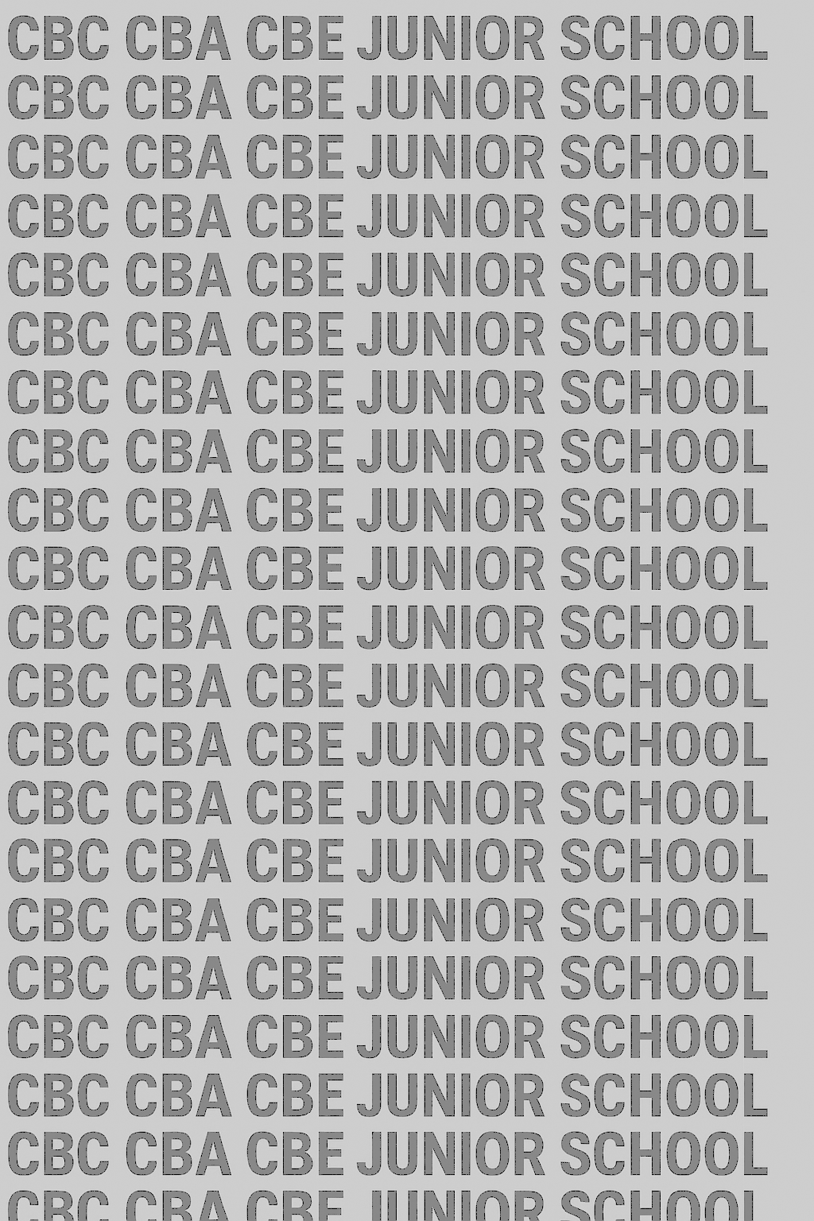
KENYA JUNIOR SCHOOL EDUCATION ASSESSMENT
GRADE 8 TERM 1 FEBRUARY 2026
INTEGRATED SCIENCE PRACTICAL CKEAB 002

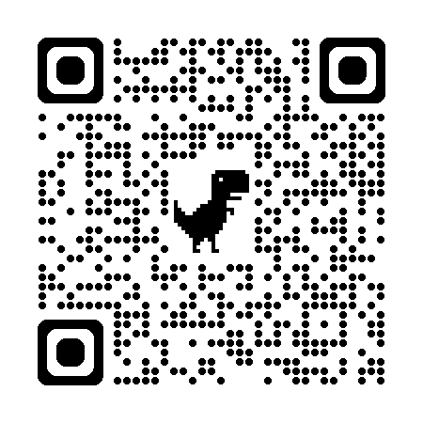
LEARNER’S DETAILS
Name: _______________________________________________________________________________________.
School: ______________________________________________________________________________________.
Assessment Number: ________________________________. Date: __________________________________.
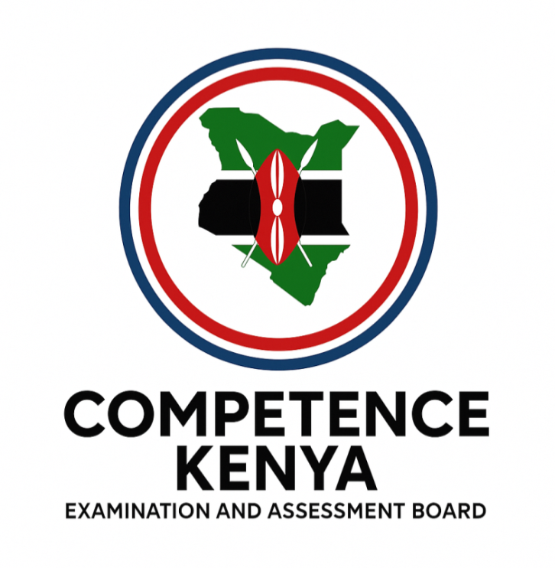
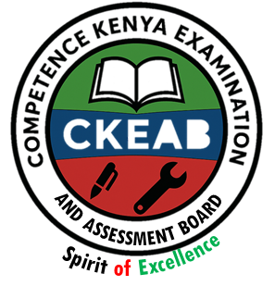
School Code: _______________________________. Signature: ________________________________.

INSTRUCTIONS TO CANDIDATES
- Write your name and admission number in the spaces provided above.
- Answer all questions in the spaces provided.
- Read each question carefully and observe all safety instructions in the laboratory.
- Marks for each question are shown in brackets.

SECTION A: MULTIPLE CHOICE QUESTIONS (30 Marks)
-INTEGRATED SCIENCE- -002- - Paper Code 905/2-
Section | Maximum Marks | Learner’s Score | LEVEL
TASK 1 | 20
TASK 2 | 10
TOTAL | 30

Performance Levels Grid
Level | Level | % Range | Points | Learner’s score | Remarks
Exceeding (EE) | EE1 | 90–100% | 8 |  | Exceptional mastery; exceeds expectations
Exceeding (EE) | EE2 | 75–89% | 7 |  | Very strong performance
Meeting (ME) | ME1 | 58–74% | 6 |  | Solid understanding
Meeting (ME) | ME2 | 41–57% | 5 |  | Partial achievement
Approaching (AE) | AE1 | 31–40% | 4 |  | Limited achievement
Approaching (AE) | AE2 | 21–30% | 3 |  | Very limited
Below (BE) | BE1 | 11–20% | 2 |  | Poor performance
Below (BE) | BE2 | 1–10% | 1 |  | Extremely weak

This paper has 16 printed pages. Please check out to ensure all pages are printed
Turn over
TASK 1: (20 MARKS)
You are provided with
- A dry cell,
- A bulb,
- A switch and
- Connecting wires.
a) Assemble a simple electric circuit that lights the bulb. (8 marks)
b) Draw and label the circuit you have assembled. (6 marks)

c) State THREE safety precautions observed during the activity. (6 marks)
- ____________________________________________________________________________________.
- ____________________________________________________________________________________.
- ____________________________________________________________________________________.
TASK 2: (10 MARKS)
You are provided with a
- Bar magnet,
- Iron filings,
- Paper and
- A plastic object.
a) Use the magnet to identify one magnetic and one non-magnetic material. (4 marks)
 | Magnetc Material | Non Magnetic Material

b) Describe what you observe when iron filings are sprinkled near the magnet. (4 marks)
________________________________________________________________________________________________.
________________________________________________________________________________________________.
________________________________________________________________________________________________.
________________________________________________________________________________________________.
c) State ONE application of magnets demonstrated in this activity. (2 marks)
________________________________________________________________________________________________.
________________________________________________________________________________________________.
________________________________________________________________________________________________.

©2026
All rights reserved
©COMPETENCE KENYA EXAMINATION AND ASSESSMENT BOARD
This is the last printed page

