MARKING SCHEME
GRADE 8 INTEGRATED SCIENCE KJSEA TERM 1, FEBRUARY 2026

SECTION A – MULTIPLE CHOICE (30 MARKS)
No. | Answer | Explanation / Guide
1 | D | The sperm duct (vas deferens) carries sperm from the testes to the urethra.
2 | D | Fertilisation normally occurs in the oviduct (fallopian tube).
3 | C | Breaking of voice is a physical change unique to boys during puberty.
4 | B | Seeking guidance from a trusted adult helps manage emotional changes.
5 | B | Sweat glands regulate body temperature through perspiration.
6 | C | Kidneys remove waste products like urea and excess salts from the blood.
7 | C | Drinking enough clean water promotes kidney health.
8 | C | Infections can lead to kidney disorders.
9 | B | Solar panels and dry cells are sources of electricity.
10 | D | A battery, wires, and switch are needed to complete a simple electric circuit.
11 | A | Water conducts electricity; touching appliances with wet hands is dangerous.
12 | C | Electrical energy is converted into light energy in a bulb.
13 | C | Iron is attracted to a magnet; other materials are not.
14 | B | The ends of a magnet that show strong attraction are called poles.
15 | B | Magnets are used to hold refrigerator doors closed.
16 | A | Fires involving paper and wood are Class A fires.
17 | B | Heat is a component of the fire triangle (fuel, heat, oxygen).
18 | C | Carbon dioxide extinguishers are suitable for electrical fires.
19 | B | Melting ice into water is a physical change; no new substance is formed.
20 | C | Adding impurities (salt) raises the boiling point of water.
21 | C | Ink spreads in water because particles of matter are in constant motion.
22 | C | Particles are closest together in solids.
23 | A | An atom is the smallest particle of an element.
24 | B | The chemical symbol for oxygen is O.
25 | C | Water is a compound made of hydrogen and oxygen.
26 | A | Hydrogen + Oxygen → Water is the correct word equation.
27 | B | Copper is commonly used in electrical wires.
28 | C | Gold is commonly used to make jewellery.
29 | C | Rusting of iron is a chemical change.
30 | C | Melting wax is a reversible physical change.

SECTION B – STRUCTURED QUESTIONS (40 MARKS)

31. Changes during adolescence
a) Physical changes in girls
- Development of breasts
- Widening of hips
- Onset of menstruation
(Other possible: growth of pubic hair, growth spurt, body odor, acne, increase in body fat, mood swings, underarm hair, ovulation, voice changes, increased height, body shape changes, breast tenderness, hair growth on limbs, hip rounding, fat distribution, skin changes, menstrual cramps, hormonal changes, sweat gland activity, emotional sensitivity)
b) Emotional challenges
- Mood swings
- Confusion or self-consciousness
(Other possible: anxiety, low self-esteem, stress, peer pressure, anger, jealousy, fear of failure, excitement, restlessness, impatience, sensitivity, depression, shyness, insecurity, frustration, curiosity, desire for independence, confusion about identity, emotional dependence, irritability)
c) Way of managing
- Seeking guidance from a trusted adult or counselor
(Other: talking to parents/teachers, journaling, practicing meditation, peer support, joining clubs, physical exercise, stress management, maintaining routines, positive thinking, goal setting, deep breathing, hobbies, time management, avoiding negative influences, religious guidance, healthy sleep, talking to friends, relaxation techniques, self-reflection, problem solving)

32. Kidney and skin health
a) Parts of urinary system (A–D)
- A: Kidney
- B: Renal Vein (blood vessel)
- C: Ureter
- D: Bladder
b) Functions of parts (D and E)
Organ | Function(s)
D  Bladder | - Stores urine temporarily until it is convenient to urinate  - Maintains continence using muscular walls  - Sends signals to the brain when full  - Protects the kidneys by preventing backflow of urine
E  Urethra | - Conducts urine from the bladder to the outside of the body  - Controls urine flow with sphincter muscles  - In males, also carries semen and helps prevent infections from reaching the bladder
c) Two causes of kidney disorders
- Infections (urinary tract infection)
- Excessive salt or poor diet
(Other: dehydration, kidney stones, high blood pressure, diabetes, drug abuse, hereditary factors, poisoning, alcohol abuse, urinary retention, obstruction, physical injury, viral infections, bacterial infections, high sugar intake, hypertension, kidney inflammation, autoimmune disorders, excess protein intake, toxins, poor hygiene)

33. Electric circuits
a) Circuit components
- Battery, wires, switch, bulb (draw and label accordingly)
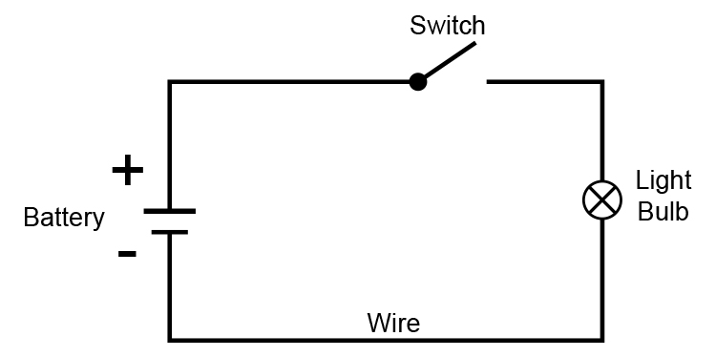
b) Two safety measures
- Avoid touching wires with wet hands
- Switch off appliances when not in use
(Other: use insulated wires, do not overload sockets, avoid damaged cords, keep liquids away, wear rubber-soled shoes, avoid running wires across water, supervise children, follow instructions, use fuses, use earthing, avoid metal objects near live circuits, check appliances before use, switch off during repairs, avoid broken bulbs, store safely, proper labeling, avoid bare wires, maintain safe distance, use correct voltage, avoid DIY high voltage setups)

34. Magnetism
a) Define magnet
- A magnet is a material that attracts iron, nickel, cobalt, or other magnetic materials.
(Other: produces a magnetic field, has north and south poles, can induce magnetism in materials, used in compasses, attracts certain metals, repels/attracts other magnets, creates force without touching, aligns particles, found in natural and artificial forms, guides navigation, produces electricity in generators, holds objects, part of electronic devices, used in MRI, makes magnetic recording possible, used in motors, used in sensors, has invisible magnetic field lines, can be temporary or permanent, influences magnetic materials nearby)
b) Magnetic / Non-magnetic
Material | Magnetic | Non-magnetic
Iron nail | ☑
Plastic ruler |  | ☑
Copper wire |  | ☑
Candle wax |  | ☑
c) Two uses of magnets
- Holding refrigerator doors closed
- In electric motors and generators
(Other: compass navigation, speakers, magnetic recording, MRI machines, cranes for scrap metal, magnetic locks, sensors, magnetic switches, data storage, toys, magnetic therapy, scientific experiments, detecting metals, measuring devices, separating metals, education tools, industrial machinery, attracting jewelry, levitation experiments, cleaning magnetic surfaces, detecting landmines, magnetic bracelets)

35. Physical and chemical changes
a) Distinction
- Physical change: changes appearance or state but no new substance is formed (e.g., melting ice)
- Chemical change: forms a new substance with different properties (e.g., rusting)
b) Classify changes
Change | Physical Change | Chemical Change
i. Melting of ice into water | ☑
ii. Rusting of an iron nail |  | ☑
iii. Burning of a piece of paper |  | ☑
iv. Dissolving sugar in water | ☑
v. Cooking of food |  | ☑
c) Two apparatus to measure volume
- Measuring cylinder
- Beaker
(Other: pipette, burette, graduated flask, volumetric flask, syringe, scoopula, funnel, conical flask, dropper, test tube, cylinder, displacement vessel, scoop, volumetric cup, stirring rod, balance for mass-volume conversions, burette stand, measuring spoon, flask with graduations, pouring cylinder)
d) Two effects of impurities on boiling point
- Boiling point increases
- Distillation is affected
(Other: slows evaporation, affects taste, can cause scorching, increases solution density, affects freezing point, lowers purity, affects chemical reactions, reduces efficiency, changes color, affects solubility, can lead to uneven heating, corrosion, produces foam, affects viscosity, alters pressure, affects steam generation, changes refractive index, affects conductivity, may release gases, contaminates product)
e) Two applications of change of state
- Melting ice to cool drinks
- Evaporation of water in cooking
(Other: condensation in water cycle, refrigeration, making ice cubes, drying clothes, distillation of liquids, boiling for sterilization, freezing food, formation of dew, making butter from cream, industrial metal casting, water purification, steam generation for turbines, air conditioning, salt extraction from seawater, candle making, heating liquids in labs, cooling metals, crystallization, evaporation in drying grains, solar stills)

