
KENYA JUNIOR SCHOOL EDUCATION ASSESSMENT
GRADE 8 TERM 1 FEBRUARY 2026
INTEGRATED SCIENCE CKEAB 002


LEARNER’S DETAILS
Name: _______________________________________________________________________________________.
School: ______________________________________________________________________________________.
Assessment Number: ________________________________. Date: __________________________________.


School Code: _______________________________. Signature: ________________________________.

INSTRUCTIONS TO LEARNERS
- Write your name and class on the answer sheet provided.
- Answer ALL questions in Section A and Section B.
- For questions with pictures, study the pictures carefully before answering.
- Ensure your work is neat and clear.

SECTION A: MULTIPLE CHOICE QUESTIONS (30 Marks)
Question Number | 1 | 2 |  | 3 | 4 |  | 5 | 6 | 7 |  | 8 | 9 | 10 | 11 | 12 | 13 | 14 | 15
Maximum Score | 1 | 1 |  | 1 | 1 |  | 1 | 1 | 1 |  | 1 | 1 | 1 | 1 | 1 | 1 | 1 | 1
Candidate’s Score
Question Number | 16 |  | 17 |  |  | 18 |  | 19 |  | 20 |  | 21 | 22 | 23 | 24 | 25 | 26 | 27 | 28 | 29 | 30 | Total score
Maximum Score | 1 |  | 1 |  |  | 1 |  | 1 |  | 1 |  | 1 | 1 | 1 | 1 | 1 | 1 | 1 | 1 | 1 | 1 | 30
Candidate’s Score

SECTION B: STRUCTURED QUESTIONS. (40 Marks)
-INTEGRATED SCIENCE- -002- - Paper Code 905/1-
Qn No. | 31 | 32 | 33 |  | 34 | 35 | Total
Max Score | 6 | 8 | 6 |  | 7 | 13 | 40
Cand score
Section |  |  |  | Maximum Marks |  |  |  | Learner’s Score | Percentage (%)
A. Multiple Choice |  |  |  | 30
B. Structured Questions |  |  |  | 40
TOTAL |  |  |  | 70

Performance Levels Grid
Level | Level | % Range | Points | Learner’s score | Remarks
Exceeding (EE) | EE1 | 90–100% | 8 |  | Exceptional mastery; exceeds expectations
Exceeding (EE) | EE2 | 75–89% | 7 |  | Very strong performance
Meeting (ME) | ME1 | 58–74% | 6 |  | Solid understanding
Meeting (ME) | ME2 | 41–57% | 5 |  | Partial achievement
Approaching (AE) | AE1 | 31–40% | 4 |  | Limited achievement
Approaching (AE) | AE2 | 21–30% | 3 |  | Very limited
Below (BE) | BE1 | 11–20% | 2 |  | Poor performance
Below (BE) | BE2 | 1–10% | 1 |  | Extremely weak
This paper has 6 printed pages. Please check out to ensure all pages are printed
Turn over

SECTION A: MULTIPLE CHOICE QUESTIONS (30 MARKS)
Answer all the questions. Choose the correct answer for each.

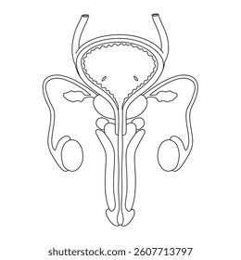
- During a biology lesson, learners observed a diagram of the male reproductive system displayed on the classroom wall.

Which part carries sperm from the testes to the outside of the body?
A. Penis B. Testis C. Urethra D. Sperm duct
- A nurse educating learners about human reproduction explained where fertilisation normally takes place in the female body. Which part was she referring to?
A. Uterus B. Cervix C. Vagina D. Oviduct
- While discussing changes experienced at puberty, a teacher asked learners to identify a physical change that occurs only in boys. Which one is correct?
A. Widening of hips B. Growth of breasts
C. Breaking of voice D. Beginning of menstruation
- A learner feels confused and moody due to changes experienced during adolescence. What is the MOST appropriate way to manage such emotional changes?
A. Keeping all problems secret
B. Seeking guidance from a trusted adult
C. Avoiding family members
D. Missing school frequently
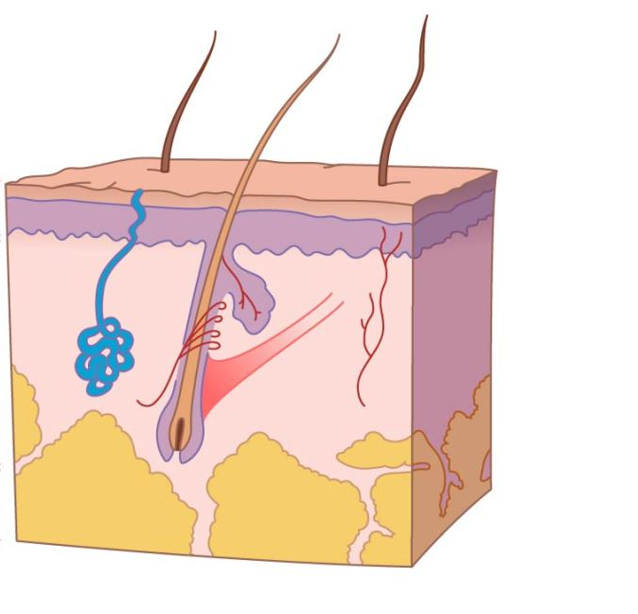
- During a hygiene lesson, learners discussed how the body controls temperature.

Which part of the skin performs this function?
A. Epidermis B. Sweat glands
C. Hair shaft D. Nails
- In a health club discussion, learners learned about the importance of kidneys in the human body. What is the main function of the kidneys?
A. Digestion of food
B. Pumping blood
C. Removal of waste products
D. Absorption of oxygen
- A doctor advised learners on ways of keeping their kidneys healthy. Which of the following habits best promotes kidney health?
A. Drinking very little water
B. Eating excess salty foods
C. Drinking enough clean water
D. Holding urine for long periods
- During a class presentation on kidney disorders, learners listed possible causes. Which of the following can cause kidney disorders?
A. Balanced diet B. Drinking clean water
C. Infections D. Regular exercise
- Learners visited a nearby village and observed solar panels and dry cells being used. These are examples of:
A. Electrical appliances
B. Sources of electricity
C. Electric circuits
D. Conductors
- A learner tried lighting a bulb using wires and a battery at home. Which set of components is necessary to complete the circuit?
A. Switch only B. Wires only
C. Battery only D. Battery, wires and switch
- During a safety talk, learners were warned not to touch electrical appliances with wet hands. Why is this important?
A. Water conducts electricity
B. Appliances become dirty
C. Electricity weakens
D. It saves power
- A learner switched on a bulb in a dark room. Which energy change took place?
A. Electrical to heat
B. Electrical to sound
C. Electrical to light
D. Light to electrical
- During a magnetism experiment, learners tested different materials. Which of the following materials was attracted by a magnet?
A. Plastic
B. Wood
C. Iron
D. Glass
- When iron filings were sprinkled on a bar magnet, learners noticed strong attraction at certain regions. What are these regions called?
A. Centres
B. Poles
C. Fields
D. Sides
- Learners observed a refrigerator door closing firmly by itself. Which use of magnets does this demonstrate?
A. Cooking food
B. Holding refrigerator doors closed
C. Producing electricity
D. Producing sound
- During a fire safety drill, learners learned that fires involving paper and wood belong to which class?
A. Class A B. Class B
C. Class C D. Class D
- A science teacher explained that fire requires three things to burn. Which of the following is a component of the fire triangle?
A. Smoke
B. Heat
C. Ash
D. Water
- During a fire emergency involving electrical equipment, which fire extinguisher is most suitable?
A. Water
B. Foam
C. Carbon dioxide
D. Sand
- A learner placed ice cubes in a bowl and observed them change into water. This change is an example of:
A. Chemical change
B. Physical change
C. Burning
D. Rusting
- When salt was added to water before heating, learners noticed it boiled at a higher temperature. What caused this change?
A. Cooling
B. Stirring
C. Adding impurities
D. Removing impurities
- A drop of ink placed in water slowly spread throughout the container. This showed that particles of matter:
A. Are stationary
B. Do not mix
C. Are in constant motion
D. Exist only in solids
- Learners compared solids, liquids and gases. In which state are particles closest together?
A. Gas B. Liquid
C. Solid D. Plasma
- During a chemistry lesson, learners defined an atom. Which statement is correct?
A. Smallest particle of an element
B. Group of elements
C. Mixture of substances
D. A compound
- While labelling elements on a periodic table chart, learners were asked to identify the symbol for oxygen. Which is correct?
A. Ox
B. O
C. Og
D. On
- Water is formed when hydrogen reacts with oxygen. What type of substance is water?
A. Mixture
B. Element
C. Compound
D. Solution
- Which word equation correctly represents the formation of water?
A. Hydrogen + Oxygen → Water
B. Water → Hydrogen + Oxygen
C. Oxygen + Carbon → Water
D. Hydrogen + Nitrogen → Water
- Learners observed electrical wires during construction of a classroom. Which element is commonly used to make such wires?
A. Gold
B. Copper
C. Iron
D. Silver
- During a visit to a jewellery shop, learners noticed shiny ornaments. Which element is commonly used to make jewellery?
A. Aluminium
B. Copper
C. Gold
D. Lead
- A learner left an iron nail outside in the rain and later observed rust. This process is a:
A. Physical change
B. Temporary change
C. Chemical change
D. Change of state
- Which of the following changes can be reversed easily?
A. Burning wood
B. Cooking food
C. Melting wax
D. Rusting iron

SECTION B: (40 MARKS)
Answer ALL questions in the spaces provided.
- During a guidance and counselling session, learners discussed changes experienced during adolescence.
a) State THREE physical changes that occur in girls during adolescence. (3 marks)
  - __________________________________________________________________________________.
  - __________________________________________________________________________________.
  - __________________________________________________________________________________.

b) Describe TWO emotional challenges experienced during adolescence. (2 marks)

  - __________________________________________________________________________________.
  - __________________________________________________________________________________.
c) State ONE way of managing these challenges. (1 mark)
__________________________________________________________________________________________________________________________________________________________________________________________
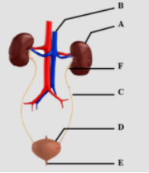
- During a health club meeting, learners discussed kidney and skin health.
a) Name the parts of the urinary system labelled A,B,C and D. (4 marks)

  - _________________________________________________________________________________.
  - _________________________________________________________________________________.
  - _________________________________________________________________________________.
  - _________________________________________________________________________________.
b) State the functions of the parts labelled E and F. (2 marks)
 | PART | NAME | FUNCTION
 | D
 | E
c) Give TWO causes of kidney disorders. (2 marks)
i. _________________________________________________________________________________________.
ii. _________________________________________________________________________________________.
- A learner attempted to light a bulb using simple materials at home.
a) Draw and label a simple electric circuit. (4 marks)

b) State TWO safety measures observed when using electricity at home. (2 marks)
i. _________________________________________________________________________________________.
ii. _________________________________________________________________________________________.
- Learners carried out an experiment to separate materials using a magnet.
a) Define a magnet. (1 mark)
__________________________________________________________________________________________________________________________________________________________________________________________
b) Classify the following as magnetic or non-magnetic: (4 marks)
i) Iron nail
ii) Plastic ruler iii) copper wire iv) candle wax
Magnetic | Non magnetic
c) State TWO uses of magnets in daily life. (2 marks)
i. _________________________________________________________________________________________.
ii. _________________________________________________________________________________________.
- A learner heated salty water during a science experiment.
a) Distinguish between physical and chemical changes. (2 marks)
_______________________________________________________________________________________________________________________________________________________________________________________________________________________________________________________________________________________

b)A group of learners observed the following changes taking place in their daily activities:
i. Melting of ice into water
ii. Rusting of an iron nail
iii. Burning of a piece of paper
iv. Dissolving sugar in water
v. Cooking of food
a) Classify each of the above changes as either a physical change or a chemical change. (5 marks)
Change | Physical Change | Chemical Change
i Melting of ice into water | ☐ | ☐
ii Rusting of an iron nail | ☐ | ☐
iii Burning of a piece of paper | ☐ | ☐
iv Dissolving sugar in water | ☐ | ☐
v Cooking of food | ☐ | ☐
b) Name two apparatus used to measure volume of substances in the laboratory. (2 marks)
i. _________________________________________________________________________________________.
ii. _________________________________________________________________________________________.
b) State TWO effects of impurities on the boiling point of water. (2 marks)
i. _________________________________________________________________________________________.
ii. _________________________________________________________________________________________.
c) Give TWO applications of change of state of matter in daily life. (2 marks)
i. _________________________________________________________________________________________.
ii. _________________________________________________________________________________________.

©2026
All rights reserved
©COMPETENCE KENYA EXAMINATION AND ASSESSMENT BOARD
This is the last printed page

